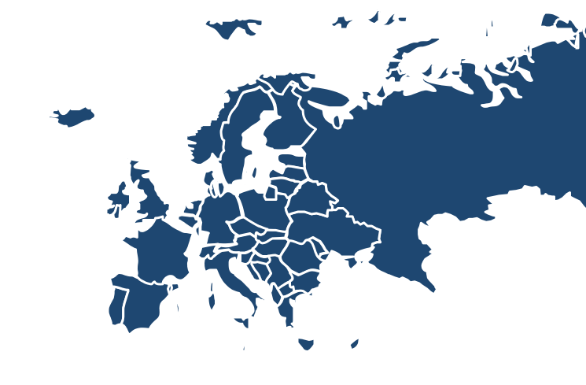
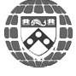
EUROPEAN SUMMIT

October 3, 2015
THINK TANK SUMMIT REPORT
THINK TANKS & CIVIL SOCIETIES PROGRAM
The Lauder Institute
The University of Pennsylvania

Think Tanks and Civil Societies Program

“Helping to bridge the gap between knowledge and policy”

Researching the trends and challenges facing think tanks, policymakers, and policy-oriented civil society groups...

Sustaining, strengthening, and building capacity for think tanks around the world...

Maintaining the largest, most comprehensive database of over 6,500 think tanks...

All requests, questions, and comments should be directed to: James G. McGann, Ph.D.
Senior Lecturer, International Studies Director
Think Tanks and Civil Societies Program The Lauder Institute University of Pennsylvania Telephone: (215) 746-2928
Email: jmcgann@wharton.upenn.edu

2015 Copyright: All rights reserved. No part of this report may be reproduced or utilized in any form or by any means, electronic or mechanical, including photocopying, recording, or by information storage or retrieval system, without written permission from the University of Pennsylvania, Think Tanks and Civil Societies

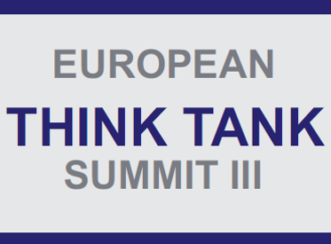

2015 EUROPEAN THINK TANK SUMMIT REPORT
Growth and Security: In Search of a European Response

Institute for International Political Studies
Palazzo Clerici, Milan, Italy

3 October, 2015

The 2015 European Think Tank Summit Brought Together Leading European Institutions to Discuss Growth and Security in a European Context with European Solutions
Introduction

This summit brought together 58 participants from 24 European countries to narrow the discussions from the 2015 Global Think Tank Summit on regional solutions to contemporary issues of security, economics, integration, and innovation. The purpose of this summit was to bring together leading minds from European think tanks to develop concrete recommendations for policymakers, donors and the greater European think tank community.
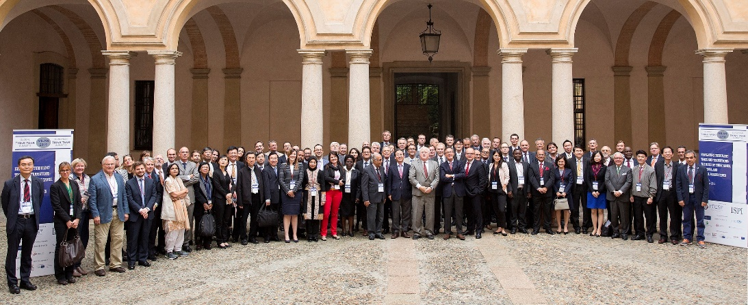
© ISPI

The 2015 European Think Tank Summit convened to provide recommendations and suggestions centered around four main issues: the security and migration crises on eastern and southern borders, the economic Eurozone crisis, European integration, and the need for Europe-centric think tank innovation. The conference was conducted under the Chatham House rule, in order that participants, panelists, and chairs could speak freely and engage in productive and thoughtful debate.
The questions and suggestions raised throughout the summit were framed by a political and economic landscape of overlapping and concurrent crises throughout Europe. Between rising tensions in the East with Russian militarization, the eruption of the post-colonial order in the Middle East and North Africa region, and ever-increasing migration of refugees and economic migrants to the European continent, many of the assumptions that have been held about the European order were been brought into question. Additionally, the proliferation of terrorist attacks from Copenhagen to Paris and concerns regarding cyberattacks ignited questions regarding physical and non-physical borders and raised concerns regarding the future of cyber security.
The European summit also discussed in great length the migration crisis facing Europe, which is reaching unprecedented numbers and creating new challenges for EU Member States. Over the past few months, migrants have faced mixed responses from Eastern and Western European countries. One participant remarked that a “siege mentality” has begun to form in the minds of Europeans, and that this has created a spectrum of questions about how we look at physical borders. Participants discussed how best to formulate a regional response to the migration crisis while also remaining sensitive to national interests over maintaining job security, cultural and national identity, and national and regional security. One participant remarked that twenty years ago, Europe faced a similar crisis in the Balkans with conflict, state collapse, and displaced migrants and that many lessons can be learned from this historical example. From this point, discussions led to the conclusion that think tanks play an important role in providing much needed historical contexts to complex issues for European policymakers, particularly the migration crisis, which will continue to affect European society in the future.
Thus, the role of think tanks in the face of quickly proliferating fears across Europe is to keep the debate at a rational level in order to counter fears and myths from policymakers and civil societies throughout Europe. Thus, while the future of Europe lies directly in the hands of policymakers, it is the duty of think tanks to provide critical, innovative, and immediate recommendations that pragmatically address the issues facing the region.

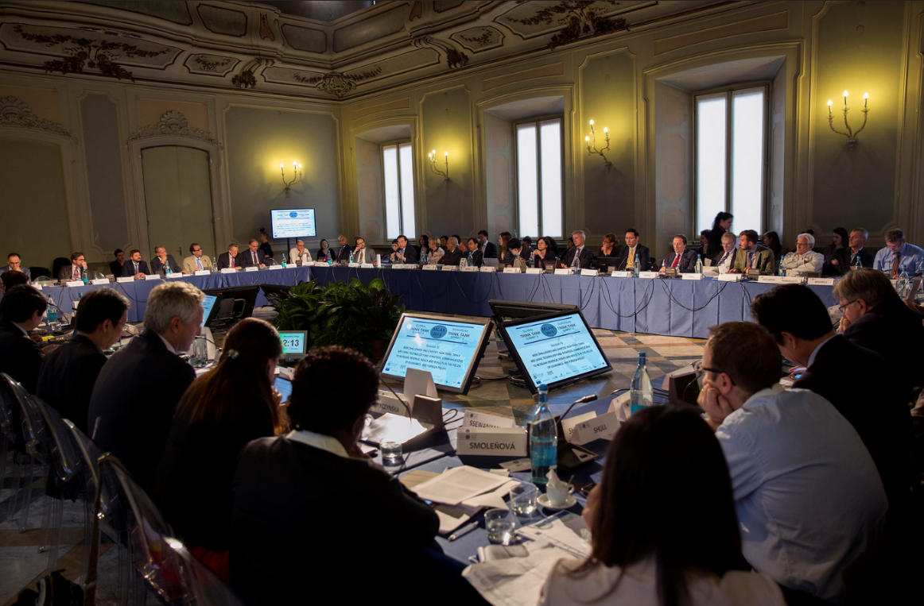
© ISPI
Policy and Institutional Challenges
Migration and Collective Security
The most current and visible crisis currently facing Europe is that of the influx of migrants from Middle East and Northern Africa at Europe’s eastern and southern borders. As such, collective security has risen up on the agenda for the region, as all European countries must face the human consequences of escalated violence and chaos in the Middle East. To address the large influx of displaced Syrian migrants seeking refuge within Europe’s borders, panelists argued that think tanks must find innovative responses and tools to communicate with different audiences. Due to concerns over xenophobia throughout the region, panelists stressed the public fear over migrants and xenophobia for future immigrant integration efforts. Panelists remarked that the think tank community has a responsibility to prevent the issue of xenophobia from widening any further and that think tanks must provide accurate information regarding the socioeconomic, cultural, and political consequences of a large immigrant presence in the continent. By helping to contextualize a highly complex issue that overlaps with national security interests, think tanks can help allay xenophobic fears amongst the public and provide policymakers with context on the real-life experiences facing migrant populations in Europe.
For other collective security challenges, participants discussed how for the past century, Western Europe has relied on American guarantees, but that the American decline has placed renewed importance on creating a new and more “European” defense system. Some participants remarked that Eastern European defense investments and engagements are increasing, but are balanced tenuously on faltering economies. While Western Europe united over sanctions against Russia, it was out of a desire to avoid further conflict and entrenchment rather than a formation of a coherent security strategy or regime. Additionally, collective security remains a complex and relevant issue in the face of collapsing Western European defense budgets that will most likely fall short on their “2/20” NATO pledges. One participant contended that Europe countries have generally outsourced its security and mainly on the welfare of their own citizens. This system worked well in times of peace, but upon the threat of conflict, one of only real tools left for countries to address conflicts is through economic sanctions. This led to discussion on how think tanks can play an instrumental role in analyzing the logistics of these changes to the European security regime.

European Integration? Or Autonomy?
Discourse on collective security and migration quickly led into analysis of European integration. One panelist noted that Europeans are “united in diversity and united in perplexity”; they have had much in common for centuries but also possess established and deeply ingrained differences that make quick and effective action difficult. Another panelist remarked that the recent economic and migration crises have exacerbated minor differences that Europeans have not paid close enough attention to during the integration process, particularly in the realm of foreign policy. When such crises hit, the differences unraveled quickly and spoiled the opportunity for a collective and efficient response. As such, the panelists argued that think tanks should play a more active role in overcoming these differences in the future and in providing much needed support for future collective action amongst policymakers.
With the question of whether to integrate further or defend autonomy reverberating through all levels of governance, think tanks, thus, must find innovative ways to contribute to national and regional policy decisions. Specifically, they can contribute by providing multiple options of frameworks for either further integration or for defending autonomy. Think tanks have the potential to serve as rational and results-oriented voices in a debate that is often affected by the fervor of national identities, and European think tanks must step forward and be ready to take on this new role.
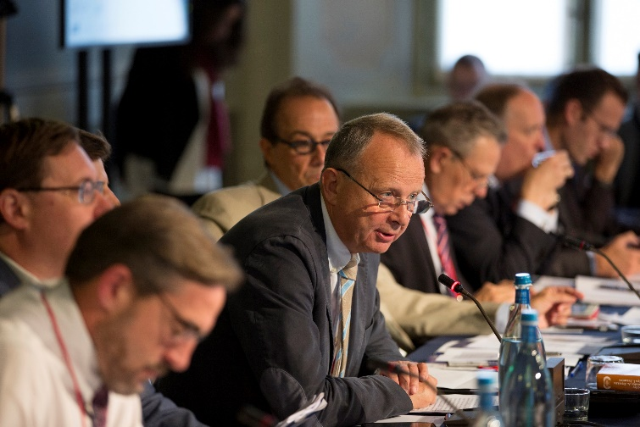
© ISPI

Europe in Crisis: Time for Innovation
Despite the difficult questions about European integration, participants agreed that there is a growing need for Europe to avoid stagnation. The stigma surrounding European policymakers and think tanks is that there is a lack of effective ‘follow through’ on problems discussed at the intellectual, or “elite” level. One panelist argued that think tanks must be a catalyst for spurring European motion and decision-making. To do so, think tank innovation can serve to both drive policymakers to faster and more informed decision-making while also connect and inform European civil societies on current, ever-evolving issues.
One panelist suggested that think tanks focus on four key areas: trust, communication, international networks, and timeliness. From this framework, a general consensus was formed in that think tanks must re-examine their role and give up the idea of a one-size-fits-all approach. Participants agreed that think tanks should invest in building trust and communication with policymakers as well the public, while also finding new innovative solutions in addressing organizational concerns of funding and strategic communication.
Another panelist suggested that as we move towards a multipolar world, think tanks must also cover a broader array of topics and to address more countries. However, it is key to acknowledge that one cannot cover everything, therefore, think tanks should make thoughtful choices on what topics and regions they can best research based upon their strategic communication abilities, expertise, etc. Think tank could also tailor their research questions and requests based on the needs of partners, such as universities, the media, donors, policymakers, etc.
As think tanks change their organizational approaches, another panelist raised questions regarding how best to track think tank accomplishments: Is it really possible to track the impact of think tanks on policymakers? How do we determine that the timing was “right” and that the advice communicated by think tanks directly influenced policy outcomes? Several suggestions were proposed regarding organization changes for think tanks to consider. One panelist remarked that his organization engages in an exercise every three years where an independent panel of experts produces a report analyzing the impact of the organization’s research projects. After the report is presented, the organization then engages in an internal discussion on organizational improvements. Participants agreed that such internal evaluation exercises are worthwhile across all types of think tanks and should be analyzed and compared at future European summits.

Conclusions
In the European context, the biggest difficulty facing the think tank community is how best to address political and socioeconomic questions through a collective regional response. The think tank community can play an important role in serving as the facilitator of constructive dialogue amongst various policymakers in national and transnational decision-making structures while also helping to contextualize and provide accurate information to the general public. By recognizing the unique role of think tanks within the European context, think tanks must work together to share best practices on effective strategies of outreach to a diverse audience.
By being an active participant in today’s discourse on ongoing crises, think tanks can maintain relevancy by providing context and long-term solutions to policymakers while also remaining present on current debates and discussions in the media. To do so, European think tanks must engage in a moment of self-reflection to assess what internal organizational changes are needed to ensure that think tanks make sufficient impact upon regional policy decision-making processes and in shaping European societal views on future security and socio-economic concerns. The hope is that through greater collaboration and sharing of ideas, the region will develop into a collaborative think tank community where collective responses can be swift, thoughtful, and make significant impact upon future regional policies.

Recommendations
- Identify the long-term impact of the refugee crisis for the European continent and develop means by which think tanks can share information and reports to better impact European policymakers on a regional response to the migration crisis.

- Determine the role of think tanks for the future of European integration through more open discourse on how best to balance Economic integration efforts with economic and security needs.

- Increase regional collaboration to ensure access to European policymaking structures and develop ways to track and measure think tank impact on European policies.

- Discuss regional best practices for European think tanks at future think tank summits.

- Develop collaborative projects on regional economic and security crises to increase think tank engagement.

- Share ideas on organizational strategies to ensure think tank relevancy and to broaden access for think tanks to a diverse and broader audience.

- Maintain high integrity in research while also recognizing the importance of think tanks in being engaged with the immediate needs of the public and policymakers on developing crises.

- European think tanks should engage in more partnerships with other regional think tanks to capture global narratives of complex issues facing the region.

Attachment 1: 2015 European Think Tank Summit Agenda 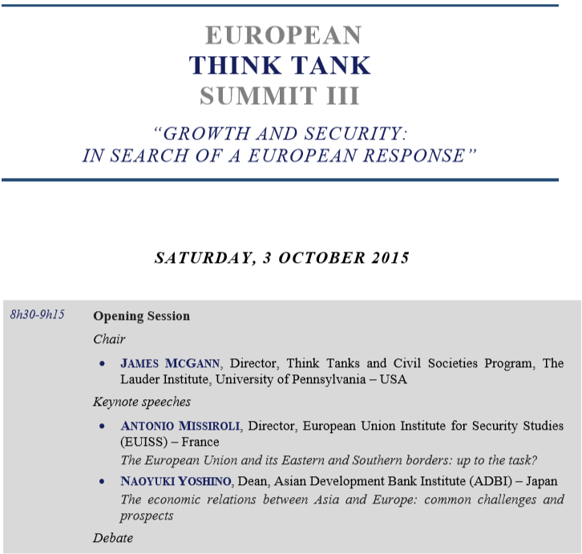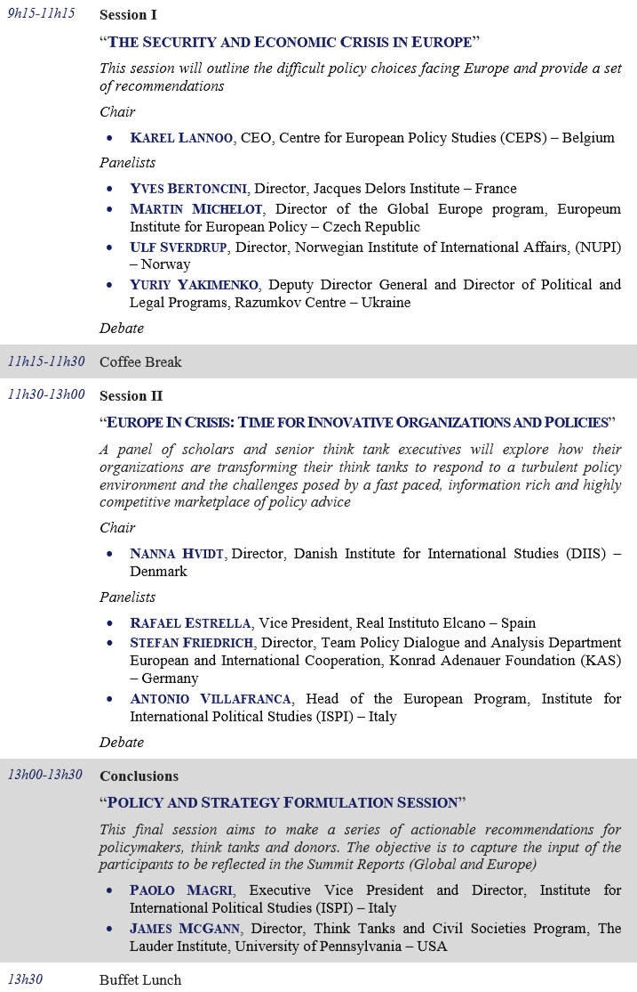
Attachment 2: Participant List
Participant Name | Participant Title | Organization | Country
Abdulluh, Jamal | Researcher, Gulf Studies Unit | Al Jazeera Centre for Studies | Qatar
Al, Nazife | Secretary General | Centre for Economic and Foreign Policy Studies (EDAM) | Turkey
Alloisio, Isabella | Senior Researcher | Fondazione Eni Enrico Mattei (FEEM) | Italy
Al-Nuaimi, Sanad Ali | Commander | Strategic Studies Center | Qatar
Aragona, Giancarlo | President | Institute for International Political Studies (ISPI) | Italy
Arnold, Tom | Director General | Institute for International Political Studies (IIEA) | Ireland
Bacaria, Jordi | Director | Barcelona Centre for International Affairs (CIDOB) | Spain
Banerjee, Dipankar | Co-Founder; Member Board of Governors | Institute for Peace and Conflict Studies (IPCS); Forum for Strategic Initiatives (FSI) | India
Barbi, Fernando | Economist | Quantum Global Research Lab | Switzerland
Bertoncini, Yves | Director | Jacques Delors Institute | France
Biersteker, Thomas Joseph | Gasteyger Professor of International Security and Director | Program for the Study of International Governance, The Graduate Institute | Switzerland
Çağlar, Esen | Deputy Managing Director | Economic Policy Research Foundation of Turkey (TEPAV) | Turkey
Carnero, Carlos | Managing Director | Fundación Alternativas | Spain
Castro, Celso | Dean, School of Sciences | Fundação Getulio Vargas (FGV) | Brazil
Chicoma, Jose Luis | Director General | Ethos Public Policy Lab Mexico | Mexico
Chirathivat, Suthiphand | Executive Director, ASEAN Studies Center | Chula Global Network, Chulalongkorn University | Thailand
Cohen-Hadria, Emmanuel | Chief Officer for Euro-Mediterranean Policies | European Institute of the Mediterranean (IEMed) | Spain
Çolakoglu, Selcuk | Vice President | International Strategic Research Organization (USAK) | Turkey
Colombo, Alessandro | General Director | Éupolis | Italy
Cowger, Sela | Rapporteur | Think Tanks and Civil Societies Program | USA
Dann, Matt | Secretary General | Bruegel | Belgium
Drobyshevskiy, Sergey | Academic Director | Gaidar Institute for Economic Policy (IEP) | Russia
Durkalec, Jacek | Manager, Non-Proliferation and Arms Control Project | Polish Institute of International Affairs (PISM) | Poland
Dynkin, Alexander | Director | Institute of World Economy and International Relations (IMEMO RAS) | Russia
El Aynaoui, Karim | Managing Director | OCP Policy Center | Morocco
El Diwany, Sherif | Executive Director | Egyptian Center for Economic Studies | Egypt
Estrella, Rafael | Vice President | Real Instituto Elcano | Spain
Flôres, Renato | Director | Fundação Getulio Vargas/International Intelligence Unit (FGV) | Brazil
Friedrich, Stefan | Director, Team Policy Dialogue and Analysis Department European and International Cooperation | Konrad Adenauer Foundation (KAS) | Germany
Glovinsky, Steve | Special Advisor to the Executive Secretary | UN Economic Commission for Africa (UNECA) | Ethiopia
Gomart, Thomas | Director | Institut Français des Relations Internationales (IFRI) | France
Greco, Ettore | Director | Instituto Affari Internazionali (IAI) | Italy
Grevi, Giovanni | Director | Fundación para las Relaciones Internacionales y el Diálogo Exterior (FRIDE) | Spain
Guruswamy, Mohan | President; Member Board of Governors | Centre for Policy Alternatives; Forum for Strategic Initiatives (FSI) | India
Hamdok, Abdalla | Deputy Executive Secretary and Chief Economist | UN Economic Commission for Africa (UNECA) | Ethiopia
Hanafi, Ali Khaled Mahmoud | Senior Researcher | Regional Center for Strategic Studies (RCSS) | Egypt
Hendytio, Medelina | Deputy Executive Director | Center for Strategic and International Studies (CSIS) | Indonesia
Hove, Seedwell | Macroeconomist | Quantum Global Research Lab | Switzerland
Huang, Youyi | Secretary-Genearl of the International Advisory Board | The Charhar Institute | People’s Republic of China
Hussein, Elkamel | International Cooperation Senior Partner | Egyptian Council for Foreign Affairs | Egypt
Hvidt, Nanna | Director | Danish Institute for International Studies (DIIS) | Denmark
Iijima, Toshiro | Deputy Director-General | The Japan Institute of International Affairs (JIIA) | Japan
Ingram, Kelsey | Rapporteur | Think Tanks and Civil Societies Program | USA
Jaramillo, Ricardo Miguel | Executive Director | Group for the Analysis of Development (GRADE) | Peru
Jordan, Mary Beth | Executive Officer to the President and Director of Strategic Initiatives | Center for Strategic and International Studies (CSIS) | USA
Ke, Yinbin | Secretary-General | The Charhar Institute | People’s Republic of China
Kim, Heungchong | Senior Research Fellow | Korea Institute for International Economic Policy (KIEP) | Korea
Lamberti, Alba | Senior Director for Advocacy | European Council on Foreign Relations (ECFR) | UK
Lange, Nico | Deputy Director for Political Consulting | Konrad Adenauer Foundation (KAS) | Germany
Lannoo, Karel | CEO | Centre for European Policy Studies (CEPS) | Belgium
Lauster, Gitta | Special Assistant to the Director | German Institute for International and Security Affairs (SWP) | Germany
Lee, Ha-Yan | Senior Economist | Asian Development Bank Institute (ADBI) | Japan
Lee, Siwook | Executive Director of the Center for International Development | Korean Development Institute (KDI) | Korea
Li, Xia | Supervisor of International Communication | The Charhar Institute | People’s Republic of China
Liow, Chin Yong Joseph | Dean, S. Rajaratnam School of International Studies | Nanyan Technological University (RSIS) | Singapore
Lladós, José María | Academic Director | Argentine Council for International Relations | Argentina
Lodal, Jan M. | Distinguished Fellow | Atlantic Council | USA
Lukacs, Richard | Advisor, Global Governance, Platforms, Think Tanks & Environment | Federal Department of Foreign Affairs, Permanent Mission of Switzerland to the United Nations Office and to the other international organizations in Geneva | Switzerland
Magri, Paolo | Executive Vice President and Director | Institute for International Political Studies (ISPI) | Italy
Maniga, Paola | Development Manager | Bruegel | Belgium
Margelletti, Andrea | President | Centro Studi Internazionali (CeSI) | Italy
McCarthy, John | President | Australian Institute of International Affairs (AIIA) | Australia
McGann, James | Director | Think Tanks and Civil Societies Program, The Lauder Institute, University of Pennsylvania | USA
Miao, Lu | Executive Secretary General | Center for China and Globalization (CCG) | People’s Republic of China
Michelot, Martin | Director of the Global Europe Program | Europeum Institute for European Policy | France
Missiroli, Antonio | Director | European Union Institute for Secretary Studies (EUISS) | France
Monti, Mario | Former Italian Prime Minister; Former EU Commissioner; Honorary President | Breugel, Bocconi University | Italy
Musso, Carlo | Head of Studies, Research and Market Analysis | Finmeccanica | Italy
Nixey, James | Head, Russia and Eurasia Programme | Chatham House (the Royal Institute of International Affairs) | UK
Ochieng, Cosmas Milton Obote | Executive Director | African Center for Technology Studies | Kenya
Onokerhoraye, Andrew Godwin | Executive Director | Center for Population and Environmental Development (CPED) | Nigeria
Palacio, Vicente | Deputy Director | Fundación Alternativas | Spain
Piccone, Theodore | Senior Fellow Foreign Policy | Brookings Institution | USA
Pinitpuvadol, Kamalinne | Executive Director | International Institute for Trade and Development (ITD) | Thailand
Pola, Giancarlo | President | Éupolis Lombardia | Italy
Prakash, Anita | Director General Policy Relations | Economic Research Institute for ASEAN and East Asia (ERIA) | Indonesia
Rachok, Anatoliy | Director General | Razumkov Centre | Ukraine
Ratti, Sabina | Executive Director | Fondazione Eni Enrico Mattei (FEEM) | Italy
Rogov, Sergey | Director | Institute for the U.S. and Canadian Studies (ISKRAN) | Russia
Rogova, Natalia | Senior Research Fellow | Institute for the U.S. and Canadian Studies (ISKRAN) | Russia
Sainsbury, Tristram | Acting Director | Lowy Institute for International Policy | Australia
Schippa, Camilla | Director | Institute for Economics and Peace | Australia
Seif Afjei, Massoumeh Minou | Deputy Director for Europe | Institute for Political & International Studies (IPIS) | Iran
Selee, Andrew | Executive Vice President | Woodrow Wilson Center | USA
Selmani-Bornstein, Zarife | Advisor | Federal Department of Foreign Affairs | Switzerland
Shimazoe, Junko | Director, Institutional Cooperation and Networking (ICoN) Division and Senior Research Fellow, Research and Planning Department | Institute of Developing Economies (IDE-JETRO) | Japan
Shin, Bongkil | President | Institute of Foreign Affairs and National Security (IFANS) | Korea
Shull, Aaron | Chief of Staff & General Counsel | Center for International Governance Innovation (CIGI) | Canada
Smoleňová, Ivana | Communications and Outreach Manager | Prague Security Studies Institute | Czech Republic
Ssewanyana, Sarah | Executive Director | Economic Policy Research Center (EPRC) | Uganda
Stycznska, Isabela | Vice-President of Management Board | Center for Social and Economic Research (CASE) | Poland
Sverdrup, Ulf | Director | Norwegian Institute of International Affairs (NUPI) | Norway
Tan, Khee Giap | Co-Director, Asia Competitiveness Institute | Lee Kuan Yew School of Public Policy, National University of Singapore | Singapore
Tavoni, Massimo | Deputy Coordinator, Climate Change and Sustainable Development Programme | Fondazione Eni Enrico Mattei (FEEM) | Italy
Techau, Jan Christian Friedrich | Director | Carnegie Europe | Belgium
Villafranca, Antonio | Senior Research Fellow and Head of the Europe Programme | Institute for International Political Studies (ISPI) | Itlay
Wang, Huiyao | President | Center for China and Globalization (CCG) | People’s Republic of China
Ward, Adam | Director of Studies | The International Institute for Strategic Studies (IISS) | UK
Yahya, Maha | Acting Director | Carnegie Middle East Center | Lebanon
Yakimenko, Yuriy | Deputy Director General and Director of Political and Legal Programs | Razumkov Centre | Ukraine
Yoshino, Naoyuki | Dean | Asian Development Bank (ADBI) | Japan
Yu, Bokhwan | Deputy Dean | Asian Development Bank (ADBI) | Japan
Zhao, Kejin | Senior Fellow | The Charhar Institute | People’s Republic of China

Summit Organizers, Hosts, and Partners

ORGANIZERS AND HOSTS
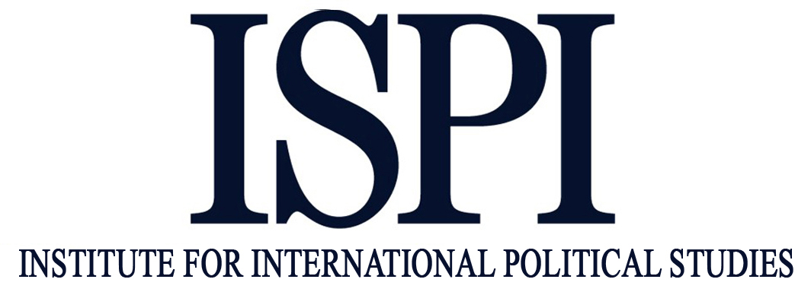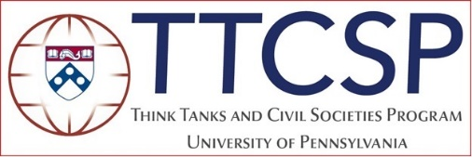

GLOBAL PARTNERS
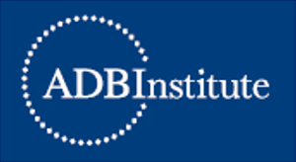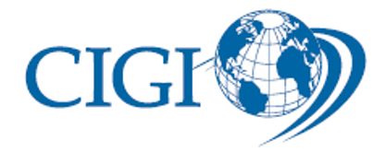

REGIONAL PARTNERS
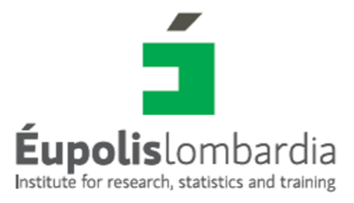
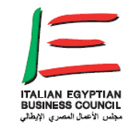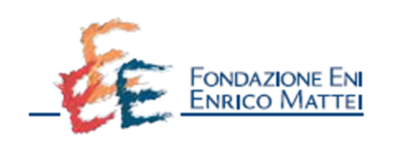
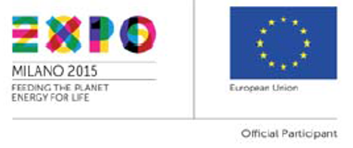

About ISPI

INSTITUTE FOR INTERNATIONAL POLITICAL STUDIES
The Institute for International Political Studies (ISPI) is an independent think tank serving as a resource for government officials, business executives, journalists, civil servants, students and the all wishing to better understand international issues. Founded in Milan in 1934, ISPI approach international affairs in a sound pragmatic manner, monitoring geopolitical areas as well as major global trends. Comprehensive interdisciplinary analysis is ensured by close collaboration with specialists, academic and non-academic, in political, economic, legal, historical and strategic studies and an ever-growing network of think tanks, research centers and universities in Europe and abroad.
The Institute’s activities branch out in four major directions:
- producing reports with original research and policy prescriptions on central international topics;
- providing up-to-date information and insights on world events and Italy/Europe’s perspectives through its website and online publications;
- convening meetings at its headquarters in Milan, as well as in Rome and other cities, where policymakers, business leaders, and high-level thinkers join ISPI’s experts to discuss major international issues;
- training the future generations of Italian diplomats and professionals of governmental and non-governmental international organizations.

About TTCSP

THINK TANKS AND CIVIL SOCIETIES PROGRAM
The Think Tanks and Civil Societies Program (TTCSP) of the Lauder Institute at the University of Pennsylvania conducts research on the role policy institutes play in governments and civil societies around the world. Often referred to as the “think tanks’ think tank,” TTCSP examines the evolving role and character of public policy research organizations. Over the last 25 years, the TTCSP has developed and led a series of global initiatives that have helped bridge the gap between knowledge and policy in critical policy areas such as international peace and security, globalization and governance, international economics, environmental issues, information and society, poverty alleviation, and healthcare and global health. These international collaborative efforts are designed to establish regional and international networks of policy institutes and communities that improve policy making while strengthening democratic institutions and civil societies around the world.
The TTCSP works with leading scholars and practitioners from think tanks and universities in a variety of collaborative efforts and programs, and produces the annual Global Go To Think Tank Index that ranks the world’s leading think tanks in a variety of categories. This is achieved with the help of a panel of over 1,900 peer institutions and experts from the print and electronic media, academia, public and private donor institutions, and governments around the world. We have strong relationships with leading think tanks around the world, and our annual Think Tank Index is used by academics, journalists, donors and the public to locate and connect with the leading centers of public policy research around the world. Our goal is to increase the profile and performance of think tanks and raise the public awareness of the important role think tanks play in governments and civil societies around the globe. Since its inception in 1989, the TTCSP has focused on collecting data and conducting research on think tank trends and the role think tanks play as civil society actors in the policymaking process. In 2007, the TTCSP developed and launched the global index of think tanks, which is designed to identify and recognize centers of excellence in all the major areas of public policy research and in every region of the world. To date TTCSP has provided technical assistance and capacity building programs in 81 countries. We are now working to create regional and global networks of think tanks in an effort to facilitate collaboration and the production of a modest yet achievable set of global public goods. Our goal is to create lasting institutional and state-level partnerships by engaging and mobilizing think tanks that have demonstrated their ability to produce high quality policy research and shape popular and elite opinion and actions for public good.

THE LAUDER INSTITUTE OF MANAGEMENT AND INTERNATIONAL STUDIES
The Lauder Institute of Management and International Studies offers an MA in international studies, and conducts fundamental and policy-oriented research on current economic, political, and business issues. It organizes an annual conference that brings academics, practitioners and policy makers together to examine global challenges such as financial risks, sustainability, inequality, and the future of the state.
UNIVERSITY OF PENNSYLVANIA
The University of Pennsylvania (Penn) is an Ivy League school with highly selective admissions and a history of innovation in interdisciplinary education and scholarship. A world-class research institution, Penn boasts a picturesque campus in the middle of a dynamic city. Founded by Benjamin Franklin in 1740 and recognized as America’s first university, Penn remains today a world-renowned center for the creation and dissemination of knowledge. It serves as a model for research colleges and universities throughout the world.

