THE HARD AND SOFT TISSUE DIMENSIONAL CHANGES FOLLOWING EXTRACTION AND RIDGE PRESERVATION WITH DIFFERENT MEMBRANES – A PILOT STUDY

THESIS

Master of Science in Oral Biology
University of Pennsylvania School of Dental Medicine

By
Noor AlAsaad, BDS

Advisors:
Yu-Cheng Chang, DDS, MS, DMD

Thesis Committee:
Jonathan Korostoff, DMD,PhD
Joseph P. Fiorellini, DMD, DMSc
Rodrigo Neiva, DDS, MS

May 2024

© Copyright by
Noor AlAsaad
2024

Abstract:

Introduction:
Following tooth extraction, bone resorption can be expected, especially on the buccal wall. An alveolar ridge preservation procedure (ARP) is commonly performed to maintain appropriate ridge volume for future implant placement. Various materials and methods can be utilized during ARP, however, there is no consensus on the membrane selection when the intact buccal plate is present after tooth extraction. The objective of this study is to investigate the dimension changes of the hard and soft tissue followed by alveolar ridge preservation with different membranes used.
Materials and Methods:
This prospective randomized clinical trial aims to enroll 50 subjects divided into 5 groups of 10. Each group underwent RP with mixing allograft and xenograft(1:1 ratio) and received 1 of 5 membranes: absorbable collagen dressing (ACD), non-resorbable d-polytetrafluoroethylene (d-PTFE), cross-linked collagen membrane (CLCM), non-crosslinked ECM membrane (N-CLCM), or dehydrated human de-epithelialized amnion-chorion membrane (DHDA-C). An intraoral scan was obtained before the extraction. Immediately following the extraction, a Cone Beam CT was taken to evaluate the extraction socket (Initial-CT). 4 months after ARP, a second CBCT(Post-CT) and an intraoral scan were obtained. Measurements were performed using implant planning software. Intraoral scan files were superimposed on Initial and Post-CT. A region of interest (ROI) guide was utilized to provide an accurate slice for measurement and a horizontal reference line at 1 mm interval from the bone crest. Following the ROI guide, horizontal measurements were taken at 0-9 mm level for hard tissue and 0-3 mm level for soft tissue.
Results:
A total of 35 patients were enrolled in the randomized clinical trial when the report was written. After removing insufficient data, only 29 patients’ data were included in bone measurement (Fig 3) and 21 for soft tissue measurements (Fig 4). ANOVA test was used for analyzing the results. The results showed no statistically significant differences in dimensional changes in hard tissue (p=0.3) and soft tissue volume (p=0.7) among different kinds of membranes used in the intact defects.
Conclusion:
There were no significant differences in the dimensional changes of hard and soft tissue between the membrane groups, suggesting that the membranes are equally effective in intact sockets. The rationale of the material selection is mostly a clinician’s choice. A larger sample size is needed to confirm these findings.

Dedication

First and foremost, I would like to dedicate this thesis to my loving mother, brother, and sister for their continuous support especially my mother who I wouldn’t be able to do all this without her.

I would like to thank all my outstanding research team for all their continuous help and support and committee members for their guidance and support throughout this study. It was an honor to work closely with each one of them and I appreciate their precious time they devoted for this project.

TABLE OF CONTENTS
Abstract…………..…………..…………..…………..…………..…………..…………..………..3
Dedication…………..…………..…………..…………..…………..…………..………………....4
Chapter One (Literature review):
- Introduction…………..…………..…………..…………..…………..………...…..….6
- Anatomical Implication of Unassisted Alveolus Healing of The Extraction Sockets.……… ..………..… ..………..… ..………..… ..………..… ..…….…...…..6
- Alveolar Ridge Preservation…...…………..…………..…………..……………..…...7
- Healing of The Extraction Socket …………..…………..…………..…………...……8
- Bone Grafting in Extraction Sockets ………..…………..…………..…………..…....9
- Usage of Allograft and a Membrane………………………………………………….9
- Barrier Membranes…………………………………………………………………....9
- Non Resorbable Membranes…………………………………………………………..9
- Resorbable Membranes………………………………………………………………10

Chapter Two (Manuscript):
- Introduction……..…………..…………..…………..…………..……..……..………12
- Materials and Methods………....…………..…………..…………...…….………….13
- Results……..…………..…………..…………..…………..…….………….………..17
- Discussion…………..…………..…………..…………...…………..……………….21
- Conclusion…………..…………..…………...…………..…………..…………..…..23
- References…..…………...…………..…………..…………..…………..…………...24

Chapter one
Literature review

- Introduction

Extraction is usually indicated when the tooth is deemed unrestorable. Tooth loss has impacted the quality of life by impairing mastication, speaking, and socializing^{[1]}. The absence of a tooth in the alveolar ridge can initiate a cascade of biological events that impact both hard and soft tissue^{[2]}. Following tooth extraction, remodeling occurs in the alveolar bone. When a tooth is extracted, multiple treatment options are available to replace the missing tooth. Implants are frequently seen as a viable alternative for tooth replacement. The adequacy of alveolar bone volume after tooth extraction is a significant factor influencing both functional and esthetic outcomes. In an unassisted extraction where alveolar ridge preservation is not performed, both horizontal and vertical dimensions are affected by bone loss. According to Schropp et al. A reduction of an average of 1 mm and about 50% of the width of the alveolar ridge is observed. The majority of alveolar ridge resorption takes place within the initial 2-3 months following extraction ^{[3]}. The alveolar ridge dimensional changes that can influence implant placement in the future^{[4]}. Alveolar ridge deficiencies have played a role in tooth replacement therapy, particularly when implant-supported restorations are planned ^{[5]}. Therefore, the alveolar ridge preservation (ARP) procedures has become the clinical standard method of care in maintaining the socket volume if implant placement is planned in the future ^{[6]}. The primary objective of this review is to emphasize the advantages associated with ridge preservation during the extraction process.

- ANATOMICAL IMPLICATIONS OF UNASSISTED ALVEOLUS HEALING OF THE EXTRACTION SOCKETS

Although the presence of newly formed bone within the socket, the resulting defect will only experience partial reconstruction, the extent of crest reabsorption following extraction is contingent upon the bone level at the extraction site, regardless of the bone level of the neighboring teeth ^{[2]}. The process of bone resorption after extraction leads to a reduction in the width and height of the ridge, leading to a displacement of the ridge towards a more palatal or lingual position ^{[7]}. The presence of a displaced ridge poses challenges in achieving an appropriate position for implant restorations since it may result in a buccal bone dehiscence following implant placement^{[8]}. Ohta conducted a study that described the healing process of extraction sockets in monkeys, which occurred in five stages ^{[9]}. The initial phase is referred to as the granulation stage, which spans a duration of five days. This stage is characterized by the emergence of granulation tissue at the base of the socket, which then extends laterally along the walls of the socket. The initial angiogenic stage which is the second stage that happens with the granulation stage within the first week. The bottom of the socket begins to fill with trabeculae, and blood. The blood clot that is formed in the center begins to minimize. The third phase, known as the new bone development stage, commences around two weeks following the extraction process. Sinusoid formation yields bone trabeculae and osteoid can be detected. The majority of bone formation occurs in the apical area. In the fourth stage, bone development occurs, characterized by the formation of thick and well-developed trabeculae that now occupy two-thirds of the socket. The process lasts around 4-5 weeks after extraction. The bone re-organization stage, which occurs around six weeks post extraction, is the fifth and final stage. Where lamellar bone is developed and is high towards the apical end of the socket^{[9].} Following extraction wound healing has been evaluated in humans by Amler ^{[10]}. Shortly after extraction, clot formation occurs and is replaced by granulation tissue, osteoid is seen at the base of the socket all within 7 days. By day 20 the replacement of granulation tissue by connective tissue occurs. At least two-thirds of the extraction socket is filled by trabecular bone at day thirty-eight. Apical proliferation occurs and is seen in the fourth day after extraction^{[10]}. Studies have demonstrated that horizontal buccal bone resorption can extend as much as 56% while lingual bone resorption has been reported to be up to 30%^{[11]}. The resorptive process may result in the anticipated outcome of a narrower and shorter ridge. Therefore, the process of resorption will commonly lead to relocation of the ridge towards a more lingual position ^{[12]} . Immediately after tooth extraction the lack of soft tissue covering the extraction socket entrance leaving the socket defect healing by secondary intention. In the following weeks cell proliferation will lead in an increase of soft tissue volume, ultimately resulting in the formation of soft tissue coverage that will seal the socket entrance^{[13]}. Socket healing in the maxilla progresses faster due to the vascular supply than the mandible, which often leads to a faster resorption pattern^{[14]}. Bone grafts are frequently used for ridge preservation to preserve the ridge integrity.

- ALVEOLAR RIDGE PRESERVATION

Alveolar ridge preservation (ARP) refers to a surgical procedure aimed at halting or reducing the resorption of the alveolar ridge after tooth extraction, with the purpose of facilitating future prosthodontic therapy, such as the placement of dental implants ^{[15]}. In the year 1982, the term "ARP" was first used as "bone maintenance" ^{[16]}. ARP utilizes a range of graft materials, which can be either obtained from the host or transplanted, to fill an extraction socket after tooth extraction ^{[17]}. ARP offers several potential benefits, including preserving the current soft and hard tissue structure, maintaining a stable ridge volume to enhance functional and aesthetic results, and simplifying subsequent treatment procedures by generating sufficient soft and hard tissue volume for implant placement ^{[6]}. The objective of ARP is to preserve the structure of the horizontal and vertical alveolar ridges through the utilization of bone grafts (such as autografts, allografts, xenografts, or alloplastic materials), with resorbable or non-resorbable barriers, biologically active materials (growth factors), or a combination of these methods. The goal is to minimize the reduction in height and width of the coronal alveolar bone ^{[18]}.

- BONE GRAFTING IN EXTRACTION SOCKETS.

Bone grafts for alveolar ridge preservation preserve the ridge integrity. The success of bone grafting procedures is mainly dependent on the remodeling and revascularization of the bone. Bone grafting helps restore the alveolar bone and minimize alveolar bone loss for future implant placements. Bone grafts are generally classified as autografts, allografts, xenograft, and alloplasts^{[19]}. Allografts refers to the process of transferring tissue from an individual of the same species to another. This type of graft became widely used as it eliminates second surgeries that are needed to obtain autografts and decreases host morbidity. The bone particle size of FDBA for hard tissue grafting was investigated by Shapoff et al. According to the report, the optimal particle size of 100-300 um would facilitate the preservation of bone particles for an adequate duration while optimizing vascularization. Particles that are <125 um are considered too small and provokes a macrophage reaction and are resorbed quickly with little to no bone formation. Large particles may restrict interparticle space for revascularization ^{[20]}.
Although, the potential disease transmission in donor tissues is possible, there are no reports of viral contamination from FDBA or DFDBA ^{[20-24]}. With extreme rigorous testing and screening of donor materials, the disease transfer possibility is around 1 in 2 million ^{[25]}. A study was conducted by Wood and Mealey that involved of 40 extraction sockets into two distinct groups^{[26]}. A random selection of either FDBA or DFDBA was made and then grafted into the extraction socket. After 4-5 months a histological specimen was obtained post-grafting at the time of implant placement. The study found that there was no significant difference when comparing the dimensional changes in alveolar ridge of the two groups. DFDBA had a significantly greater percentage of vital bone than FDBA (38.42% vs. 24.63%). DFDBA had significantly lower mean percentage of residual graft particles when compared to FDBA (8.88% vs. 25.42%). A study by Eskow and Mealey compared the use of Cancellous versus cortical FDBA from a single donor in ridge preservation. 38 patients were enrolled in the study, and histological analysis was performed on 33 cores that were obtained at 18 weeks post-extraction. The histological findings revealed a higher presence of residual graft material in the cortical samples, whereas the formation of new bone for cancellous and cortical FDBA at 18 weeks was seen to be only 13-16%. The ridge dimensions of both materials exhibited comparable changes, characterized by a decrease in both height and width. Cortical FDBA demonstrated a greater preservation of lingual/palatal ridge height compared to cancellous FDBA ^{[27]}.

Xenografts refer to tissue transplants that are transplanted from one species to another. Several studies have shown that the use of biomaterials in extraction sockets might potentially enhance bone development and ridge preservation, but it may also cause a delay in the healing process. Some studies evaluated the long-term effect on bone formation and the amount of ridge augmentation that can occur by using Bio-Oss Collagen® (Geistlich Pharma North America, Inc.) a xenograft in five beagle dogs in an extraction socket was placed. Non-grafted sites were served as control. The Bio-Oss collagen® served as a scaffold for tissue modeling, but not new bone formation. The grafted socket was compared with the non-grafted site and showed improved preservation of the alveolar ridge. It was concluded that the grafted extraction socket may modify remodeling and prevent marginal ridge contraction following tooth extraction^{[28]}. The most commonly used xenograft is deproteinized bovine bone mineral (DBBM) more commonly known as Bio-Oss® (Geislitch Pharma). A study that evaluated the extraction sockets that were grafted with DBBM at 9 months. Histologically, the specimens were analyzed in the coronal, mid, and apical third of the extraction socket. The vital bone average ranged from 26.4%-35.1% and the most vital bone presented in the apical portion of the socket while the least vital bone was in the coronal third. The coronal portion of the extraction socket was mostly filled with connective tissue (63.9%). At 9 months the DBBM grafting material was still present and was uniformly present throughout the extraction socket as residual graft 30% ^{[29]}. A year later the authors conducted a follow up study which analyzed the amount of lamellar versus woven bone present in the 3 extraction socket regions. They have also found that while DBBM still remained in the socket at 9 months, no connective tissue was in contact with the graft thus concluding that DBBM is a biocompatible material that can be used for ridge preservation procedures ^{[30]}.

- USAGE OF ALLOGRAFTS AND A MEMBRANE

In a study that was conducted by Hammerle and Jung in 2003, using a bone graft material in conjunction with a membrane has a higher success rate in treating of horizontal ridge defects when compared to bone grafting without using a membrane. The membrane usage is to exclude unwanted epithelial cells ^{[31]}. The characteristics of an ideal barrier membrane are biologically stable, which helps in stabilizing the clot formation and containing the graft material at the surgical site. It should be rigid to maintain space in the surgical site but flexible enough to allow ease of adaptation. The membrane material should be predictable and cost effective. A resorbable membrane will eliminate the need for a second surgery to remove the membrane. Ridge preservation techniques in extraction sockets with allograft and membranes significantly reduce the loss of bucco-lingual bone dimension. Ridge preservation minimizes horizontal ridge dimension loss to 27 to 30% as opposed to unassisted extractions 50% ^{[20, 32]}.

- BARRIER MEMBRANES

The development of several types of barrier membrane materials has been seen. The various membranes may be classified into two categories: resorbable membranes and non-resorbable membranes.

- NON-RESORBABLE MEMBRANES

Nyman et al. first employed a membrane composed of Millipore® filters made of cellulose acetate. With the increasing popularity of this method, the initial commercial membrane was manufactured using Teflon®, which is an expanded polytetrafluoroethylene (e-PTFE). The membrane was composed of two distinct components: a collar part, which included porous gaps to facilitate the formation of connective tissue and inhibit the migration of epithelial cells; and an occlusive part, which served to prevent the flap tissues from establishing contact with the root surface ^{[33]}. The membrane was incorporated with titanium to address both osseous and periodontal defects ^{[34]}. Nevertheless, the occurrence of complications during the healing process following the application of non-resorbable membranes was frequently seen. Non-resorbable membranes necessitate retrieval at a second surgical procedure, potentially disrupting the healing process ^{[35]}. The occurrence of membrane exposure resulting from flap sloughing throughout the healing process has been a recurring issue after surgical procedures involving non-resorbable membranes ^{[36]}. The porous membrane exposure facilitated bacterial adherence ^{[37]}. In order to address some complications caused by exposure to non-resorbable porous membrane (e-PTFE), a high-density polytetrafluoroethylene (d-PTFE) non-porous membrane has been developed. This membrane is especially designed for preserving ridges after extraction. A study conducted retrospectively in a private practice revealed that the utilization of d-PTFE, which was left exposed after extraction and maintained in its site for a duration of 4 weeks, led to a significant retention of the alveolar ridge in 276 sockets. The use of exposed d-PTFE did not have any impact on the results, and the non-porous membrane exhibits impermeable properties against bacteria because of its surface characteristics ^{[38]}.

- RESORBABLE MEMBRANES

Collagen membranes, similar to other resorbable membranes, often do not need an additional surgical procedure for retrieval. Patient’s value eliminating the need for a second surgical procedure, as well as reduced morbidity. Collagen serves as the primary constituent of connective tissue, offering essential support as a structure to many tissues inside the body [35]. Collagen functions as an agent of hemostasis. It has the capacity to promote platelet adherence and strengthen fibrin connection, thereby aiding in the early formation and stability of blood clots, resulting in improved regeneration ^{[39]}. There are two distinct classifications of collagen barrier membranes, which are determined by their crosslinking status: crosslinked and non-crosslinked. Research suggests that the process of cross-linking the collagen barrier membrane might slow down the absorption rate, Maintaining the volume of the grafted bone for a prolonged duration ^{[40]}. The process of collagen membrane resorption typically spans a duration of 4 to 12 weeks ^{[39]}. One of the main goals of non-crosslinked collagen matrices is to ensure the preservation of barrier function for a minimum duration of 30 days and can last from eight to twelve weeks ^{[41-43]}. Nevertheless, a cross-linked collagen matrix was utilized with the anticipation that it would retain its barrier function for an extended duration around 24 weeks. This has the potential to improve results by reducing the collapse of the grafting material ^{[43, 44]}. However, the resorption rate of collagen membranes increases when they are not fully covered by soft tissue and are exposed to the oral cavity. The variation in the breakdown rates of collagen membranes upon exposure may be contingent upon the degree of cross-linking of collagen within a specific membrane, as demonstrated in a recent in-vitro investigation conducted by Sela et al ^{[45]}. Human amniotic tissue-derived membranes have recently emerged as viable options for guided tissue and guided bone regeneration procedures. Collagen types III, IV, and VI are present inside the amnion layer ^{[46]}. Collagen Types I, III, IV, V, and VI are present in the chorion layer ^{[47]}. Amniotic tissue is well recognized as a tissue with immunological advantages. Individuals who possess immunological advantage are unlikely to elicit an immune response or contribute to graft versus host rejection ^{[48]}. The amnion tissue has an anti-inflammatory function, as indicated by a decrease in the quantity of inflammatory cells seen at the site of healing. Moreover, amnion tissue has antibacterial characteristics by preventing bacterial infiltration, hence leading to reduced incidence of post-surgical infections ^{[49]}. Furthermore, the amnion contains many growth factors, such as epidermal growth factor, transforming growth factor-p, transforming growth factor-a, basic fibroblast growth factor, and keratinocyte growth factor ^{[50]}.

Chapter Two
Manuscript

Introduction:

An indication of extraction is necessary when the tooth is unrestorable. Tooth loss is associated with impairment of Oral Health-Related Quality of Life (OHRQoL) ^{[1]}. It can initiate a cascade of biological events that has an impact on both soft and hard tissue^{[2]}. Bone resorption occurs after tooth extraction that are carried out without preserving the ridge^{[3]}. Clinical studies have shown that post extraction leads to volumetric alterations^{[51]}. These volumetric alterations are in both the width (horizontal) and height (Vertical) of hard and soft tissue dimensions^{[13]}. Furthermore, these dimensional changes following tooth extraction primarily manifest within the first 2-3 months post extraction^{[7]}. Studies have demonstrated that horizontal buccal bone resorption can extend as much as 56% while lingual bone resorption has been reported to be up to 30%. While the total reduction in the width of the horizontal has been reported to reach as much as 50%^{[11]}. The resorptive process may result in the anticipated outcome of a narrower and shorter ridge, which commonly leads to the malposition of the implants ^{[12]}. Immediately after tooth extraction, the lack of soft tissue covering the extraction socket entrance leaves the socket defect healing by secondary intention. In the following weeks, cell proliferation will ultimately result in the formation of soft tissue coverage that will seal the socket entrance^{[13]}. The deterioration of the alveolar ridge can greatly impact the decision of tooth replacement. Particularly when an implant-supported prosthesis is considered an option^{[5]}. Buccal plate thickness and its integrity play an important role in socket healing. They are often used as a reference to determine whether alveolar ridge preservation is needed^{[52]}. consequently, alveolar ridge preservation procedure has become the clinical standard method of care in maintaining the socket volume if implant placement becomes an option of treatment in the future^{[6]}. It limits the horizontal and vertical alterations that can affect the ridge in post extraction sites^{[53]}. An overall reduction in a ridge resorption in alveolar ridge preservations was 1-2.5 mm when compared to unassisted healing associated with changes in the buccal coronal aspect of the ridge^{[54]}. Alveolar ridge preservation is effective in improving soft tissue outcomes. ^{[18]} Various materials and methods have been utilized for ridge preservation^{[55]}. To achieve optimal outcomes, graft materials require an adequate blood supply. However, determining the optimal material to preserve the ridge dimension remains ambiguous, particularly for membrane placement that facilitates as a space maintainer for the grafting material^{[56]}. Furthermore, within the current literatures, there is no consensus on superiority of any specific technique over others. All acknowledged ridge preservation procedures have demonstrated effectiveness^{[57]}. The application of bone graft materials in conjunction with the membrane may contribute to the enhancement of the outcome^{[58]}. Membrane serves as a barrier and a space maintainer^{[56]}. There are two distinct categories of membranes: resorbable and non-resorbable, both have the purpose of protecting the graft material from exposure into the oral cavity^{[59]}. Some nonresorbable membranes have the advantage of being exposed to the oral cavity, where no primary closure is needed. As resorbable membranes does not require a second surgery for retrieval. It has less morbidity and acts as a hemostatic agent that can stimulate platelet attachment. It also plays a role in the enhancement of fibrin linkage^{[60]}. However, the question remains: Is it necessary to use a membrane for epithelial exclusion, or can any surgical dressing material adequately maintain the volume of the extracted ridge? The objective of this study is to investigate, radiographically and histologically, whether the type of membrane used affects the amount of bone present after four months of healing^{[6, 58]}.

Material and Methods:

This prospective randomized clinical trial was conducted at the University of Pennsylvania in the periodontics department. In accordance to approved IRB protocol (IRB #828879) It aims to enroll 50 subjects divided into 5 groups of 10. Each group underwent RP with mixing allograft and xenograft, using a 1:1 ratio and received 1 of 5 different types of membranes: absorbable collagen dressing (ACD), non-resorbable d-PTFE (d-PTFE), cross-linked collagen membrane (CLCM), non-cross linked ECM membrane (N-CLCM), or dehydrated human deepithelialized amnion-chorion membrane (DHDA-C). Subjects were enrolled sequentially as they met the eligibility criteria and provided consent. The inclusion criteria were as follows: (1) age between 18-80 years, (2) removal of at least one Maxillary or Mandibular premolar tooth, (3) should benefit from an implant supported crown, (4) voluntarily sign the informed consent, (5) ASA I or ASA II patient. Randomization occurred on the day of the extraction and socket grafting. All study groups followed the same schedule of assessments. 391 subjects were screened and only 77 subjects were enrolled due to the systemic exclusion criteria which are medical conditions requiring the use of steroids, History of leukocyte dysfunction or deficiencies, bleeding deficiencies, renal failure, uncontrolled endocrine disorders, acquired immunodeficiency syndrome or hepatitis. History of neoplastic disease requiring the use of chemotherapy or irradiation to head and neck, diabetes mellitus, undergone administration of any investigational drug or device within 30 days of enrollment in the study, Alcohol or drug abuse, heavy smokers (greater than 10 cigarettes per day or cigar equivalents) or chew tobacco, Conditions or circumstances, which would prevent completion of study participation or interfere with analysis of study results, such as a history of non-compliance or unreliability. Also, subjects were excluded due to Local exclusion criteria: Subjects who have mucocutaneous disorder, Bone defects that exclude implant restoration, Persistent intra-oral infection, acute abscess in the tooth to be extracted or in the adjacent teeth to the extraction site, inadequate oral hygiene or unmotivated for adequate home care. After reviewing the data by following the inclusion and exclusion criteria only 77 patients were included. 29 patients were included in the for hard tissue measurements and 21 patients were included for the soft tissue volume measurements. An intraoral scan (pre-intraoral scan) was obtained prior to tooth extraction. Sulcular incisions were performed around the recipient and adjacent teeth under local anesthesia. Periotomes were used to separate the periodontal ligaments. Extractions were carried out using elevators to minimize the loss of the buccal plate. After evaluating the socket clinically, a CBCT was taken to evaluate the extraction socket (Initial-CT). The socket was debrided and filled with 1:1 ratio allograft and xenograft mixed. Randomization of the membrane was made and placed to the extraction socket and sutured using interrupted and horizontal mattress suturing. Primary wound closure was not attempted (Figure. 1). Patients were instructed to rinse twice daily with a chlorhexidine gluconate solution and prescribed analgesics and antibiotics for 3 to 5 days. All patients were followed up 10-14 days after the procedure for the removal of suture material. The d-PTFE membrane was removed 14 days after the surgery. Measurements were performed using implant planning software (BlueSky Bio®) where the Dicom files were exported. A region of interest (ROI) guide was placed on the extrication socket and utilized in the measurement process to provide an accurate slice for measurement and the horizontal reference line at 1 mm interval from the bone crest in the extraction socket. An implant was placed virtually to ensure precise accuracy of the ROI guide position in BlueSky®. Following the ROI guide, horizontal measurements were taken at 0-9 mm level for hard tissue buccal-palatal/Lingual. The buccal plate thickness was measured at 0-9 mm level of the buccal bone crest. The STL Pre-intraoral scan file was superimposed on Initial-CT and soft tissue volume was measured at 0-3 mm level (Figure 2). Four months after alveolar ridge preservation, a second CBCT (Post-CT) and a Post- intraoral scan were obtained. Measurements were performed using implant planning software (BlueSky Bio®). Both initial CT scan and ROI guide were segmented individually. The exported ROI guide and segmented initial CT, which shared the same 3D coordinate in STL format, are superimposed onto the post-CBCT image to identify the same slice that was measured on the pre-CBCT image. The Post- intraoral scan file was superimposed on Pre-CT and Post-CT. The region of interest (ROI) guide was utilized in the measurement process to provide an accurate slice for measurement and the horizontal reference line at 1 mm interval from the bone crest. Implant placement and positioning was used for precise accuracy. Following the ROI guide, horizontal measurements from the buccal to the palatal/lingual wall were taken at 0-9 mm level for hard tissue and 0-3 mm level for soft tissue. Implant planning is planned by using implant planning software (BlueSky Bio®) and (Post-CT). The implant is planned, and in the edentulous grafted area, and the Post-intraoral scan, file was superimposed on Post-CT. Implant guide was fabricated and printed (Figure. 3). At 5 months after the extraction and ARP, a histological specimen was obtained using a trephine bur for histological assessment. Sulcular incisions were performed around the recipient and adjacent teeth under local anesthesia. A periodontal full-thickness flap was reflected, and the guide was seated. Trephine bur was used to obtain 10 mm of bone core. Implant drills protocol was used to prepare the osteotomy, and the implant was placed, and flaps were sutured using interrupted sutures. Primary wound closure was attempted (Figure. 4). Patients were instructed to rinse twice daily with a chlorhexidine gluconate solution and prescribed analgesics and antibiotics for 3 to 5 days. All patients were followed up 10-14 days after the procedure for the removal of suture material.
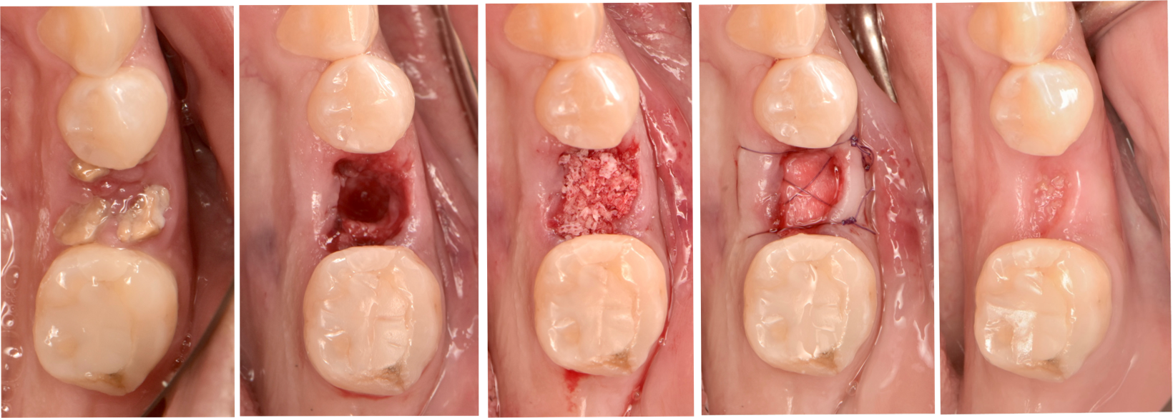
FIGURE 1. clinical photographs illustrating the surgical protocol of extraction and ridge preservation procedure (A) Upper left premolar before extraction. (B) Minimally traumatic tooth extraction following intrasulcular incision. (C) Filling of the extraction socket with 1:1 ratio of allograft and xenograft mixed. (D) Membrane was used and sutured to seal the socket aperture. (E) 14 days follow up after suture removal.

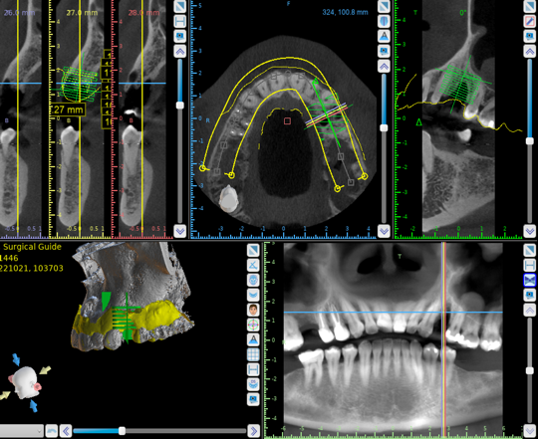
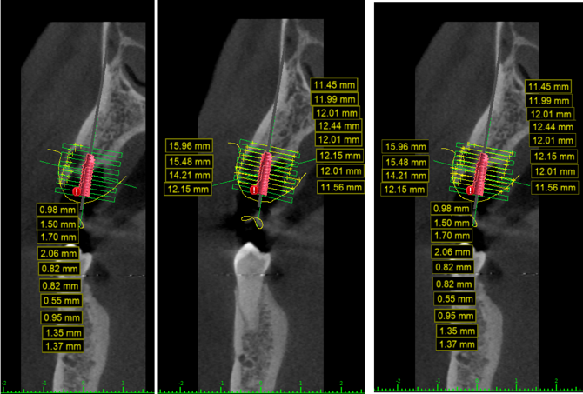

FIGURE 2. (A) Pre-CT Measurements were performed using implant planning software (BlueSky Bio®). (B) Region of interest (ROI) guide was placed on the extrication socket. (C) horizontal measurements were taken at 0-9 mm level for buccal bone thickness. (D) horizontal measurements were taken at 0-9 mm level for hard tissue buccal- Palatal/Lingual and soft tissue was measured at 0-3 mm level. (E) horizontal measurements were taken for Soft tissue volume, hard tissue and buccal plate thickness.

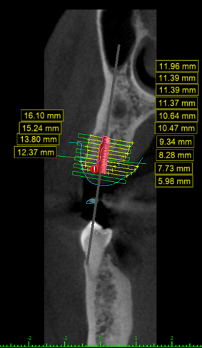
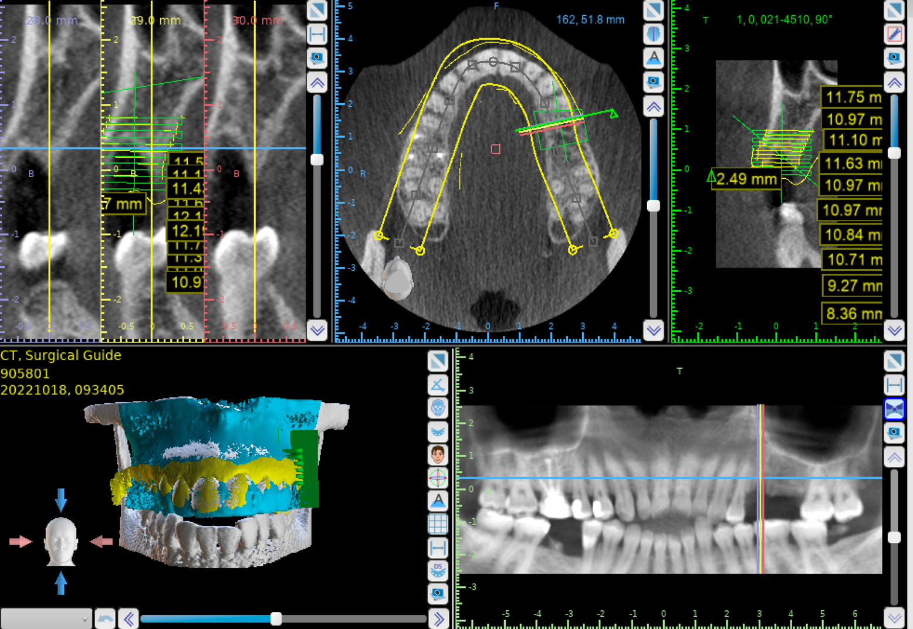

FIGURE 3. (A) Post-CT Measurements were performed using implant planning software (BlueSky Bio®). (B) The exported ROI guide and segmented initial-CT in STL format are superimposed onto the post-CBCT image to identify the same slice that was measured on the pre-CBCT image. (C) horizontal measurements were taken at 0-9 mm level for hard tissue buccal- Palatal/Lingual and soft tissue was measured at 0-3 mm level.

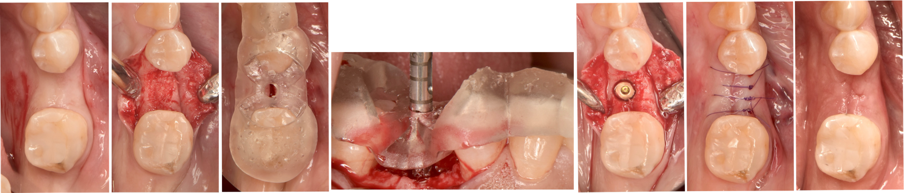

FIGURE 4. clinical photographs illustrating the surgical implant placement procedure. (A) soft tissue healing after 5 months post-extraction and RP. (B) periodontal full thickness flap was reflected before implant osteotomy. (C) guide seated on alveolar ridge. (D) trephine bur used for harvesting bone core. (D) implant placement. (E) Flaps were sutured, and primary closure was achieved. (F) 14 days follow up after suture removal.

Results:

391 patients were initially screened, a total of 77 patients were enrolled in the randomized clinical trial due to the systemic exclusion criteria. when the report was written only 29 patients’ data were included in bone measurement, 21 for soft tissue volume measurements, and 29 for buccal thickness measurements. ACD (n=7), CLCM (n=7), d-PTFE (n=7), DHDA-C (n=7), N-CLCM (n=7) (fig 9.) for bone and buccal thickness dimensions. For soft tissue volume, ACD (n=5), CLCM (n=6), d-PTFE (n=6), DHDA-C (n=5), N-CLCM (n=7) (fig 10.). ANOVA test was used for analyzing the results.

Bone Dimensional Change:
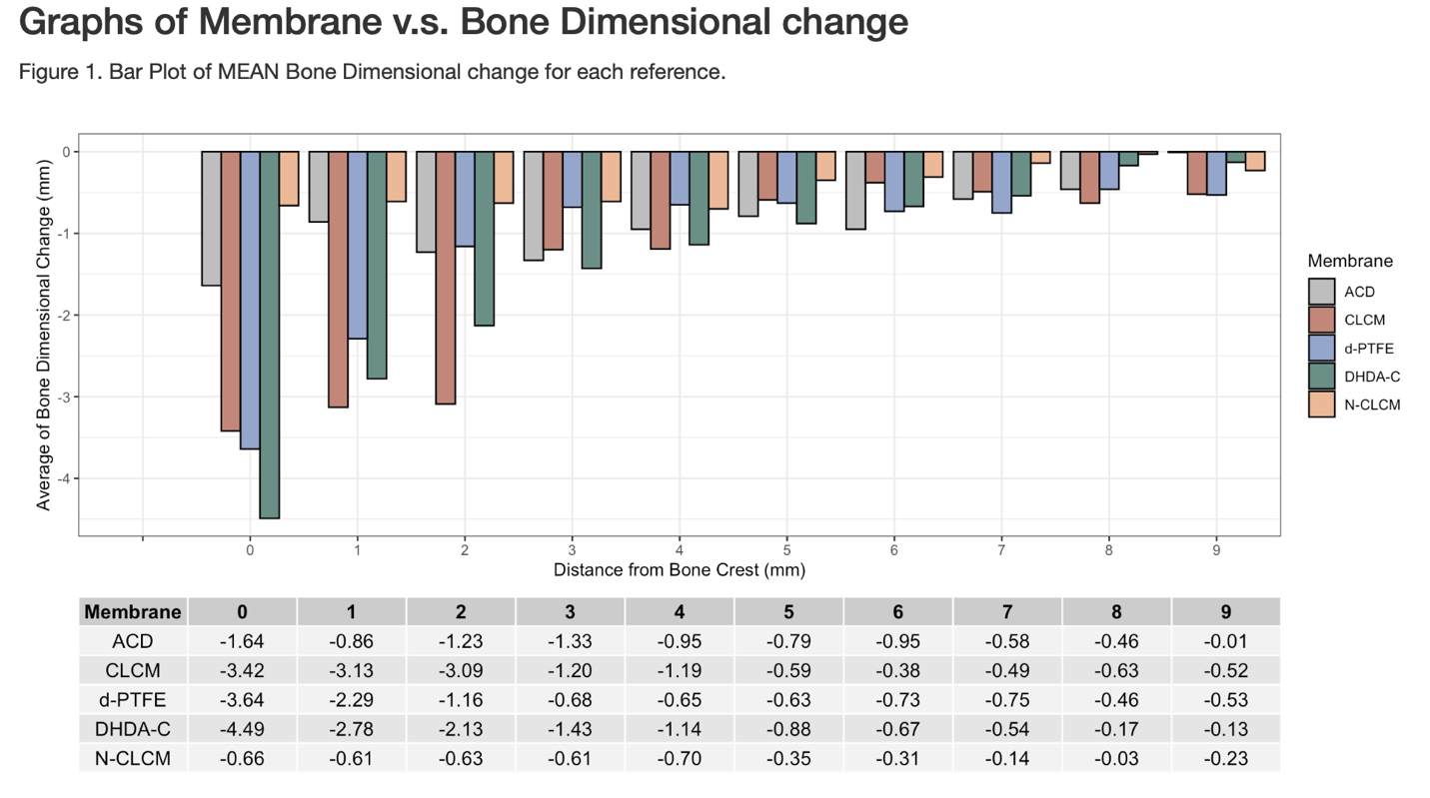
5
2

The ANOVA results showed no significant differences among the membrane types (p=0.365), suggesting that none of the membranes significantly outperformed the others in preserving bone dimensions. Bone dimensional change was assessed across five different membrane types: (ACD), (CLCM), (d-PTFE), (DHDA-C), and (N-CLCM). The bone dimensional change was measured at distances ranging from 0 to 9 mm from the bone crest. The bar plot (fig.5) reveals that all evaluated membranes exhibit varying degrees of bone dimensional reduction across the measured distance 0-9mm. Notably, the CLCM membrane shows the most substantial reduction in bone dimensions -14.64. In contrast, other membrane types like N-CLCM show less pronounced changes -4.27. with the smallest change observed at 0 mm, around -0.66 mm. The reduction generally diminishes as the distance from the bone crest increases, with all types showing minimal changes at the 9 mm distance.

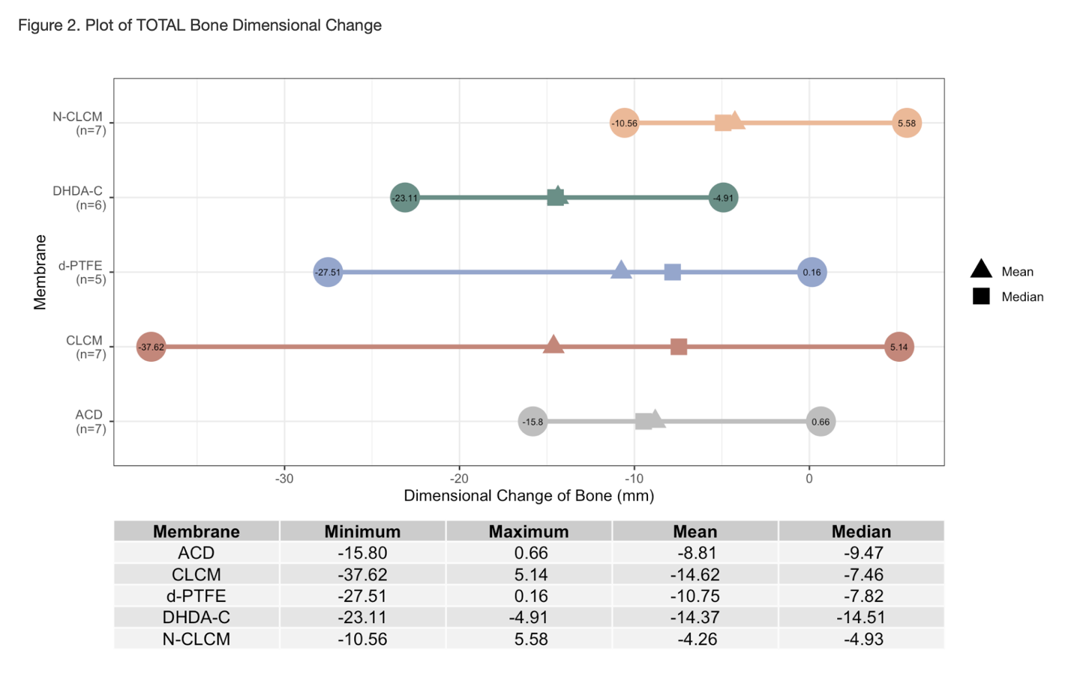
6

The results in (figure 6) provide a comprehensive analysis of total bone dimensional changes associated with the five membrane types used in ARP for bone repair and regeneration. Each membrane demonstrated unique characteristics in terms of bone dimensional stability post-implementation, capturing both bone loss and gain scenarios. ACD the dimensional change of bone ranged from -15.80 mm to 0.66 mm, with a mean change of -8.81 mm and a median change of -9.47 mm. CLCM dimensional change of bone ranged from -37.62 mm to 5.14 mm, with a mean change of -14.62 mm and a median change of -7.46 mm. d-PTFE demonstrated changes ranging from -27.51 mm to 0.16 mm, with a mean change of -10.75 mm and a median change of -7.82 mm. N-CLCM demonstrated dimensional change of bone ranged from -10.56 mm to 5.58 mm, with a mean change of -4.26 mm and a median change of -4.93 mm. The results indicate that the CLCM and DHDA-C membranes showed the most significant mean reduction in bone dimensions, while the N-CLCM membrane demonstrated the least reduction. The d-PTFE membrane had a moderate reduction in bone dimensions compared to the others. The negative means for all types of membranes indicate a general trend of bone dimensional loss across all groups. The overall mean of -1.04 with a standard deviation of 1.68 suggests that, on average, there is a reduction in bone dimensions among the different membranes.

Soft tissue Dimensional Change:
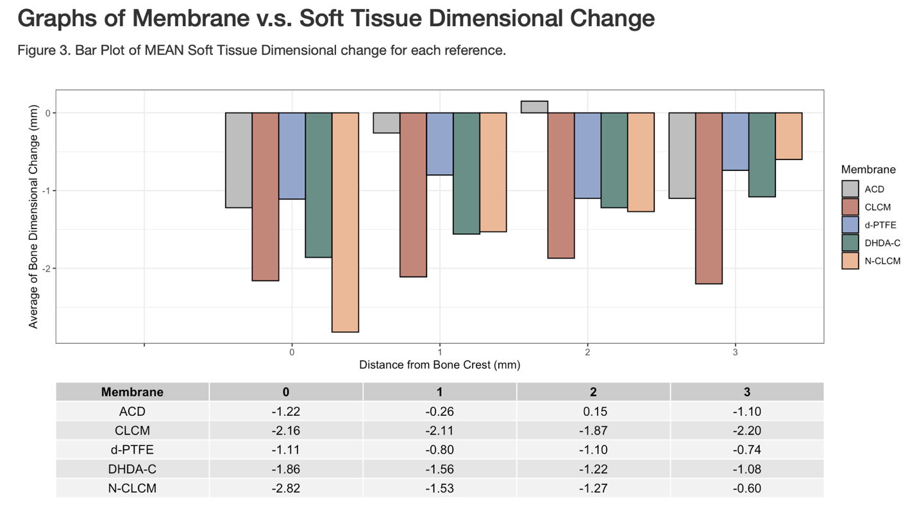
7
The mean dimensional change in soft tissue volume associated with various membrane types at different distances from the bone crest. Figure 7 presents a bar plot illustrating the average soft tissue volume (in millimeters) for each membrane type at distances of 0, 1, 2, and 3 mm from the bone crest. The findings suggest that at the initial distance (0 mm from the bone crest), the dimensional changes were primarily negative for all types of membranes, indicating a decrease in soft tissue volume after extraction and ridge preservation. The membrane types and their dimensional changes at 0 mm were as follows: ACD (-1.22 mm), CLCM (-1.68 mm), d-PTFE (-1.11 mm), DHDA-C (-1.86 mm), and N-CLCM (-2.82 mm). Significantly, N-CLCM exhibited the most substantial decrease. As the distance from the bone crest increased to 1 mm and 2 mm intervals, a decrease in trend in dimensional change was observed. At a measurement of 1 mm, the following changes were observed: ACD decreased by 0.26 mm, CLCM decreased by 2.11 mm, d-PTFE decreased by 0.80 mm, DHDA-C decreased by 1.56 mm, and N-CLCM decreased by 1.53 mm. At a measurement of 2 mm interval, there was a slight change in dimensions: ACD decreased by 0.15 mm, CLCM decreased by 1.87 mm, d-PTFE decreased by 1.10 mm, DHDA-C decreased by 1.22 mm, and N-CLCM decreased by 1.27 mm. At 3 mm interval, all membranes except showed a consistent negative change in dimensions. The dimensional changes were as follows: ACD (-1.10 mm), CLCM (-2.20 mm), d-PTFE (-0.74 mm), DHDA-C (-1.08 mm), and N-CLCM (-0.60 mm). The ANOVA results has a (p=0.716) which concludes that there is no significant effect of the type of membrane used on the sum of soft tissue volume changes. This suggests that within the scope of the measured variables and the sample size, the choice of membrane does not significantly influence soft tissue volume outcomes.

8
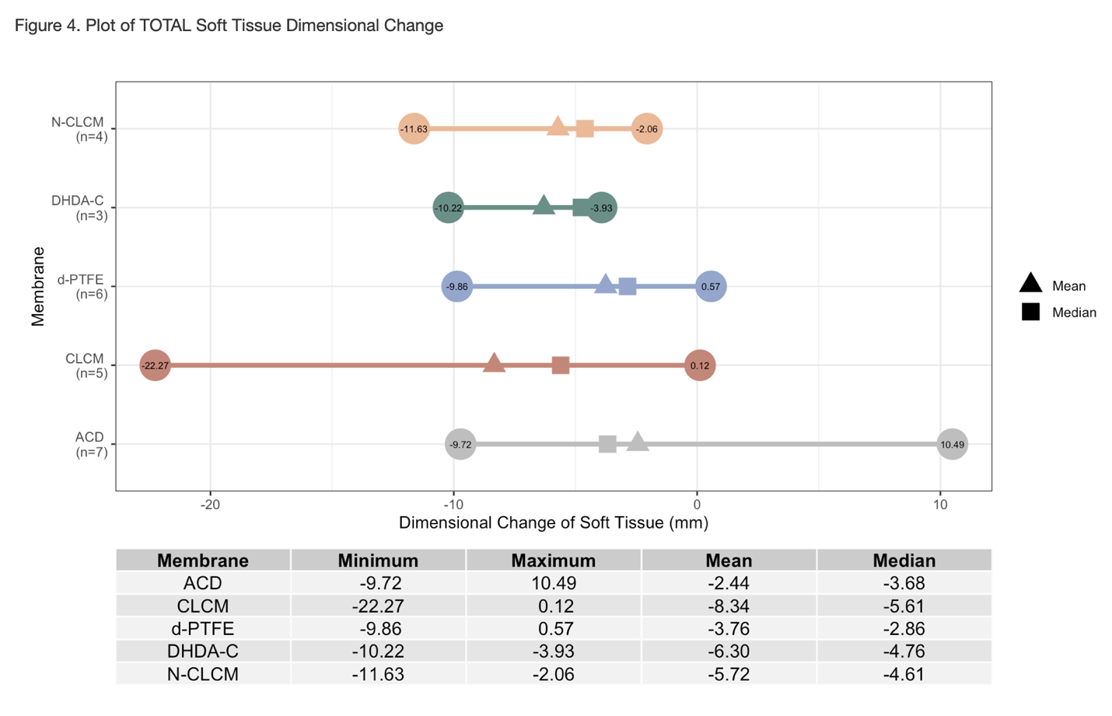
Soft tissue volume change was also assessed across the same membrane types as shown in Figure 8. Similarly, ANOVA showed no significant differences between groups (p = .716). The mean and median soft tissue volume changes were evaluated, ACD the soft tissue volume ranged from -9.72 mm to 10.49 mm, with a mean change of -2.44 mm (SD = 7.07) and a median change of -3.68 mm. CLCM the soft tissue volume ranged from -22.27 mm to 0.12 mm, with a mean change of -8.34 mm (SD = 10.04) and a median change of -5.61 mm. d-PTFE the soft tissue volume ranged from -9.86 mm to 0.57 mm, with a mean change of -3.76 mm and a median change of -2.86 mm. DHDA-C the soft tissue volume ranged from -10.22 mm to -3.93 mm, with a mean change of -6.30 mm and a median change of -4.76 mm. N-CLCM the soft tissue volume ranged from -11.63 mm to -2.06 mm, with a mean change of -5.72 mm and a median change of -4.61 mm. The total mean for soft tissue volume is -1.281 for all types of membranes indicate tha soft tissue volume loss across all membranes. The overall standard deviation of 1.89 suggests that, on average, there is a reduction in soft tissue volume among the different membranes.

Buccal thickness Dimensional Change:
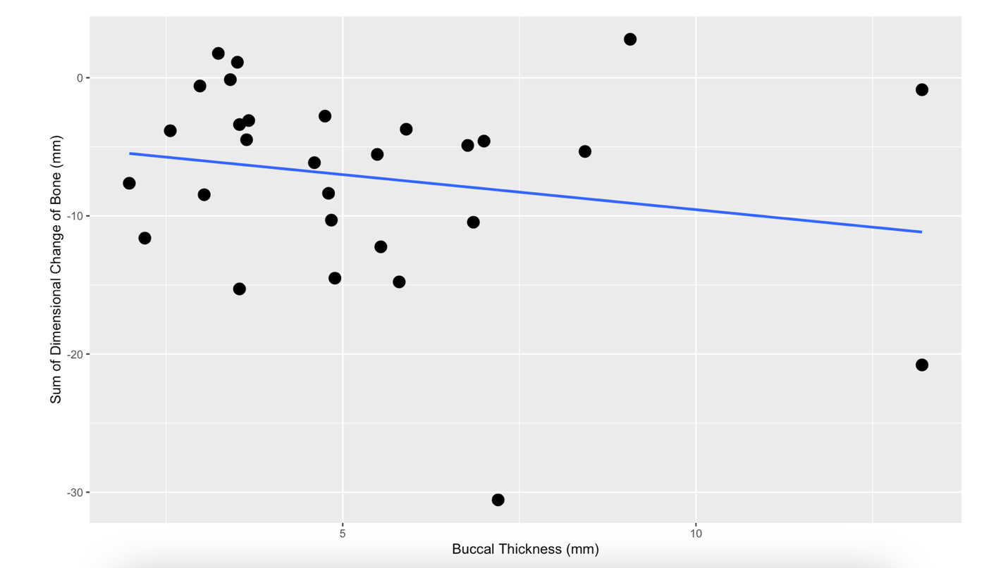
The Linear regression is utilized to investigate the relationship between buccal thickness and sum of bone dimensional change following tooth extraction (figure 9). The analysis indicates a slight negative correlation (β = -0.5070), where an increase in buccal thickness tends to correspond with loss in bone dimensional change. However, this association was not statistically significant (p-value = 0.302). Furthermore, the low R-squared value of 0.03933 implies that buccal thickness alone does not strongly predict the variability in bone dimensional changes, accounting for only 3.933% of the variation. This observation could be due to random variation and lower sample size. Other factors should be considered for a more comprehensive understanding.

Discussion:

The present study provides a comprehensive analysis of the effectiveness of various types of membrane on bone and soft tissue volume changes following tooth extraction and alveolar ridge preservation (ARP). We included 29 patients for bone measurements, 21 for soft tissue volume assessments, and 29 for buccal wall thickness measurement, using ANOVA for statistical analysis with a particular focus on the changes in bone and soft tissue volume dimensions after tooth extraction and buccal wall thickness dimension. The results of our study indicate that there were no significant variations observed in bone dimensions when comparing different types of membranes. These findings align with a wide range of existing literature that suggests the overall effectiveness of ARP techniques, although there may be slight differences depending on the specific materials and methods employed. It has demonstrated a marked dimensional change in both hard and soft tissue following extraction and ridge. The reduction of the buccal wall height was more pronounced than the lingual aspect of the extraction socket. Following tooth extraction, the observation that was noted in the vertical bone loss became more pronounced on the buccal than the lingual wall. The current finding is in an agreement with Botticelli (2004) ^{[11]}. Araujo (2005) assessed dimensional alteration in the alveolar ridge during a 4-month period following implant placement in a fresh extraction socket. They concluded that during the 4 months following extraction the buccal bone dimension had undergone horizontal resorption about 56% and the lingual/palatal resorption was 30%. The findings of our study are consistent with the research conducted by Araújo and Lindhe (2005), which examined the natural dimensional changes of the alveolar ridge after tooth extraction and highlighted the potential benefits of alveolar ridge preservation (ARP) to reduce these changes^{[7]}. Similarly, Avila-Ortiz et al. (2014) conducted a systematic review and meta-analysis, finding that while ARP generally helps in preserving bone dimensions, the differences between specific techniques and materials often are not statistically significant, which aligns with our findings^{[58]}. Further supporting our observations, in a systematic review that was conducted by Horváth et al. (2013), highlighted the variable efficacy of different ARP techniques, indicating that no single method universally outperforms others in all clinical scenarios ^{[18]}. This determines the importance of selecting ARP techniques based on specific patient needs, membrane properties, and clinical situations, as suggested by Vittorini Orgeas et al. (2013), who reviewed various surgical techniques for ARP, finding that each has distinct advantages and limitations ^{[61]}.

Bone dimensional change

The analysis showed that there were no statistically significant differences in bone dimensional changes among the five types of membranes (p=0.365). This finding aligns with the broader literature, suggesting that while various membranes can be used effectively for ridge preservation, no single type consistently outperforms others across all clinical scenarios
For instance, Avila-Ortiz et al. (2014) found that different physical properties of membranes might influence new bone formation rates but did not conclusively favor one type significantly over others in all clinical situations^{[58]}. Another study by Horváth et al. (2013) also did not find significant differences in bone preservation among different membrane types^{[18]}. Although there were no significant differences, the DHDA-C membrane exhibited the greatest reduction at the crest level (-4.28 mm), indicating a possible variation that might be significant in clinical scenarios where minimum bone loss is crucial. Studies, such as the one conducted by Melcher et al. (2010) have shown that factors such as membrane architecture and material properties can affect tissue responses and should be considered in clinical decision-making^{[62]}.

Soft tissue volume change

There were no significant differences in soft tissue volume among the groups (p = 0.716). However, the range of changes observed with DHDA-C and N-CLCM suggests that the physical and biochemical properties of membranes could affect soft tissue healing and aesthetics. Research by Lundgren et al. (2008) supports this, indicating that certain membranes can promote better soft tissue attachment and stability. The importance of maintaining soft tissue architecture for aesthetic and functional outcomes has been extensively documented. Studies by Araújo and Lindhe (2005) and Botticelli et al. (2004) have emphasized the crucial role of soft tissue preservation in the overall success of implant therapies^{[7, 11]}.

Conclusion:

The conclusion of this study has shown that none of the membranes seems to be able to completely prevent ridge resorption. Thus, 4 months after tooth extraction all groups resulted in a significant ridge reduction in height and width. There were no significant changes of hard and soft tissue between the membrane groups, suggesting that membranes are equally effective in intact sockets. Thus, the rational of the material selection is mostly a clinician’s choice, based on factors such as handling characteristics, clinical experience, and patient-specific considerations. Furthermore, Anatomical morphology, buccal plate integrity, and buccal wall thickness plays an important role in determining the final outcome. The presence of the buccal plate and its thickness are of significant predictive importance for the self-regenerative process of socket healing and affects the overall success of ARP techniques. A larger sample size is needed to confirm these findings.

1. Gerritsen, A.E., et al., Tooth loss and oral health-related quality of life: a systematic review and meta-analysis. Health Qual Life Outcomes, 2010. 8: p. 126.
2. Van der Weijden, F., F. Dell'Acqua, and D.E. Slot, Alveolar bone dimensional changes of post-extraction sockets in humans: a systematic review. J Clin Periodontol, 2009. 36(12): p. 1048-58.
3. Schropp, L., A. Wenzel, L. Kostopoulos, and T. Karring, Bone healing and soft tissue contour changes following single-tooth extraction: a clinical and radiographic 12-month prospective study. Int J Periodontics Restorative Dent, 2003. 23(4): p. 313-23.
4. Pietrokovski, J. and M. Massler, Alveolar ridge resorption following tooth extraction. J Prosthet Dent, 1967. 17(1): p. 21-7.
5. Seibert, J.S. and H. Salama, Alveolar ridge preservation and reconstruction. Periodontol 2000, 1996. 11: p. 69-84.
6. Hammerle, C.H., M.G. Araujo, M. Simion, and G. Osteology Consensus, Evidence-based knowledge on the biology and treatment of extraction sockets. Clin Oral Implants Res, 2012. 23 Suppl 5: p. 80-2.
7. Araujo, M.G. and J. Lindhe, Dimensional ridge alterations following tooth extraction. An experimental study in the dog. J Clin Periodontol, 2005. 32(2): p. 212-8.
8. Iasella, J.M., et al., Ridge preservation with freeze-dried bone allograft and a collagen membrane compared to extraction alone for implant site development: a clinical and histologic study in humans. J Periodontol, 2003. 74(7): p. 990-9.
9. Ohta, Y., Comparative changes in microvasculature and bone during healing of implant and extraction sites. J Oral Implantol, 1993. 19(3): p. 184-98.
10. Amler, M.H., P.L. Johnson, and I. Salman, Histological and histochemical investigation of human alveolar socket healing in undisturbed extraction wounds. J Am Dent Assoc, 1960. 61: p. 32-44.
11. Botticelli, D., T. Berglundh, and J. Lindhe, Hard-tissue alterations following immediate implant placement in extraction sites. J Clin Periodontol, 2004. 31(10): p. 820-8.
12. Pinho, M.N., et al., Titanium membranes in prevention of alveolar collapse after tooth extraction. Implant Dent, 2006. 15(1): p. 53-61.
13. Tan, W.L., T.L. Wong, M.C. Wong, and N.P. Lang, A systematic review of post-extractional alveolar hard and soft tissue dimensional changes in humans. Clin Oral Implants Res, 2012. 23 Suppl 5: p. 1-21.
14. Soehren, S.E. and R.L. Van Swol, The healing extraction site: a donor area for periodontal grafting material. J Periodontol, 1979. 50(3): p. 128-33.
15. Atieh, M.A., et al., Interventions for replacing missing teeth: alveolar ridge preservation techniques for dental implant site development. Cochrane Database Syst Rev, 2015. 2015(5): p. CD010176.
16. Ashman, A. and P. Bruins, A new immediate hard tissue replacement (HTR)TM for bone in the oral cavity. J Oral Implantol, 1982. 10(3): p. 419-52.
17. Jung, R.E., et al., Radiographic evaluation of different techniques for ridge preservation after tooth extraction: a randomized controlled clinical trial. J Clin Periodontol, 2013. 40(1): p. 90-8.
18. Horvath, A., et al., Alveolar ridge preservation. A systematic review. Clin Oral Investig, 2013. 17(2): p. 341-63.
19. Allegrini, S., Jr., et al., Alveolar ridge sockets preservation with bone grafting--review. Ann Acad Med Stetin, 2008. 54(1): p. 70-81.
20. Shapoff, C.A., et al., The effect of particle size on the osteogenic activity of composite grafts of allogeneic freeze-dried bone and autogenous marrow. J Periodontol, 1980. 51(11): p. 625-30.
21. Committee on Research, S. and P. Therapy of the American Academy of, Tissue banking of bone allografts used in periodontal regeneration. J Periodontol, 2001. 72(6): p. 834-8.
22. Schwartz, Z., et al., Ability of commercial demineralized freeze-dried bone allograft to induce new bone formation. J Periodontol, 1996. 67(9): p. 918-26.
23. Zaner, D.J. and R.A. Yukna, Particle size of periodontal bone grafting materials. J Periodontol, 1984. 55(7): p. 406-9.
24. Mellonig, J.T., A.B. Prewett, and M.P. Moyer, HIV inactivation in a bone allograft. J Periodontol, 1992. 63(12): p. 979-83.
25. Buck, B.E., T.I. Malinin, and M.D. Brown, Bone transplantation and human immunodeficiency virus. An estimate of risk of acquired immunodeficiency syndrome (AIDS). Clin Orthop Relat Res, 1989(240): p. 129-36.
26. Wood, R.A. and B.L. Mealey, Histologic comparison of healing after tooth extraction with ridge preservation using mineralized versus demineralized freeze-dried bone allograft. J Periodontol, 2012. 83(3): p. 329-36.
27. Eskow, A.J. and B.L. Mealey, Evaluation of healing following tooth extraction with ridge preservation using cortical versus cancellous freeze-dried bone allograft. J Periodontol, 2014. 85(4): p. 514-24.
28. Araujo, M.G. and J. Lindhe, Ridge preservation with the use of Bio-Oss collagen: A 6-month study in the dog. Clin Oral Implants Res, 2009. 20(5): p. 433-40.
29. Artzi, Z., H. Tal, and D. Dayan, Porous bovine bone mineral in healing of human extraction sockets. Part 1: histomorphometric evaluations at 9 months. J Periodontol, 2000. 71(6): p. 1015-23.
30. Artzi, Z., H. Tal, and D. Dayan, Porous bovine bone mineral in healing of human extraction sockets: 2. Histochemical observations at 9 months. J Periodontol, 2001. 72(2): p. 152-9.
31. Hammerle, C.H. and R.E. Jung, Bone augmentation by means of barrier membranes. Periodontol 2000, 2003. 33: p. 36-53.
32. Engler-Hamm, D., et al., Ridge preservation using a composite bone graft and a bioabsorbable membrane with and without primary wound closure: a comparative clinical trial. J Periodontol, 2011. 82(3): p. 377-87.
33. Scantlebury, T.V., 1982-1992: a decade of technology development for guided tissue regeneration. J Periodontol, 1993. 64(11 Suppl): p. 1129-37.
34. Hardwick, R., B.K. Hayes, and C. Flynn, Devices for dentoalveolar regeneration: an up-to-date literature review. J Periodontol, 1995. 66(6): p. 495-505.
35. Wang, H.L. and M.J. Carroll, Guided bone regeneration using bone grafts and collagen membranes. Quintessence Int, 2001. 32(7): p. 504-15.
36. Murphy, K.G., Postoperative healing complications associated with Gore-Tex Periodontal Material. Part II. Effect of complications on regeneration. Int J Periodontics Restorative Dent, 1995. 15(6): p. 548-61.
37. Lang, N.P., et al., Guided tissue regeneration in jawbone defects prior to implant placement. Clin Oral Implants Res, 1994. 5(2): p. 92-7.
38. Hoffmann, O., et al., Alveolar bone preservation in extraction sockets using non-resorbable dPTFE membranes: a retrospective non-randomized study. J Periodontol, 2008. 79(8): p. 1355-69.
39. Bunyaratavej, P. and H.L. Wang, Collagen membranes: a review. J Periodontol, 2001. 72(2): p. 215-29.
40. Brunel, G., et al., Regeneration of rat calvarial defects using a bioabsorbable membrane technique: influence of collagen cross-linking. J Periodontol, 1996. 67(12): p. 1342-8.
41. Parashis, A.O., C.J. Kalaitzakis, D.N. Tatakis, and K. Tosios, Alveolar ridge preservation using xenogeneic collagen matrix and bone allograft. Int J Dent, 2014. 2014: p. 172854.
42. Ghanaati, S., et al., Evaluation of the tissue reaction to a new bilayered collagen matrix in vivo and its translation to the clinic. Biomed Mater, 2011. 6(1): p. 015010.
43. Mardas, N., V. Chadha, and N. Donos, Alveolar ridge preservation with guided bone regeneration and a synthetic bone substitute or a bovine-derived xenograft: a randomized, controlled clinical trial. Clin Oral Implants Res, 2010. 21(7): p. 688-98.
44. Han, H.S., et al., Effectiveness of a collagen matrix seal and xenograft in alveolar ridge preservation: an experimental study in dogs. Sci Rep, 2024. 14(1): p. 163.
45. Sela, M.N., et al., Degradation of collagen-guided tissue regeneration membranes by proteolytic enzymes of Porphyromonas gingivalis and its inhibition by antibacterial agents. Clin Oral Implants Res, 2009. 20(5): p. 496-502.
46. Hodde, J., Naturally occurring scaffolds for soft tissue repair and regeneration. Tissue Eng, 2002. 8(2): p. 295-308.
47. Niknejad, H., et al., Properties of the amniotic membrane for potential use in tissue engineering. Eur Cell Mater, 2008. 15: p. 88-99.
48. Kubo, M., Y. Sonoda, R. Muramatsu, and M. Usui, Immunogenicity of human amniotic membrane in experimental xenotransplantation. Invest Ophthalmol Vis Sci, 2001. 42(7): p. 1539-46.
49. Rinastiti, M., Harijadi, A.L. Santoso, and W. Sosroseno, Histological evaluation of rabbit gingival wound healing transplanted with human amniotic membrane. Int J Oral Maxillofac Surg, 2006. 35(3): p. 247-51.
50. Koizumi, N.J., et al., Growth factor mRNA and protein in preserved human amniotic membrane. Curr Eye Res, 2000. 20(3): p. 173-7.
51. Lekovic, V., et al., A bone regenerative approach to alveolar ridge maintenance following tooth extraction. Report of 10 cases. J Periodontol, 1997. 68(6): p. 563-70.
52. Steigmann, L., R. Di Gianfilippo, M. Steigmann, and H.L. Wang, Classification Based on Extraction Socket Buccal Bone Morphology and Related Treatment Decision Tree. Materials (Basel), 2022. 15(3).
53. Darby, I., S. Chen, and R. De Poi, Ridge preservation: what is it and when should it be considered. Aust Dent J, 2008. 53(1): p. 11-21.
54. Tonetti, M.S., et al., Management of the extraction socket and timing of implant placement: Consensus report and clinical recommendations of group 3 of the XV European Workshop in Periodontology. J Clin Periodontol, 2019. 46 Suppl 21: p. 183-194.
55. Mardas, N., et al., Is alveolar ridge preservation an overtreatment? Periodontol 2000, 2023. 93(1): p. 289-308.
56. Corbella, S., et al., Histomorphometric Results After Postextraction Socket Healing with Different Biomaterials: A Systematic Review of the Literature and Meta-Analysis. Int J Oral Maxillofac Implants, 2017. 32(5): p. 1001-1017.
57. Tomlin, E.M., S.J. Nelson, and J.A. Rossmann, Ridge preservation for implant therapy: a review of the literature. Open Dent J, 2014. 8: p. 66-76.
58. Avila-Ortiz, G., et al., Effect of alveolar ridge preservation after tooth extraction: a systematic review and meta-analysis. J Dent Res, 2014. 93(10): p. 950-8.
59. Bassir, S.H., et al., Systematic Review and Meta-Analysis of Hard Tissue Outcomes of Alveolar Ridge Preservation. Int J Oral Maxillofac Implants, 2018. 33(5): p. 979-994.
60. Darby, I., S.T. Chen, and D. Buser, Ridge preservation techniques for implant therapy. Int J Oral Maxillofac Implants, 2009. 24 Suppl: p. 260-71.
61. Vittorini Orgeas, G., M. Clementini, V. De Risi, and M. de Sanctis, Surgical techniques for alveolar socket preservation: a systematic review. Int J Oral Maxillofac Implants, 2013. 28(4): p. 1049-61.
62. Melcher, A.H., On the repair potential of periodontal tissues. J Periodontol, 1976. 47(5): p. 256-60.

