Character Strengths and Well-being: Advancing the Cystic Fibrosis Foundation’s Compass Program Case Management

Briana Donaldson, Joshua Howard, Justin Rindos

Master of Applied Positive Psychology Program, University of Pennsylvania

MAPP 714: Service Learning Project

Advisor: KC White

May 6, 2024
Abstract
Given the complex challenges of living with cystic fibrosis (CF) and the intense demands it places on Compass case managers (CCMs) at the Cystic Fibrosis Foundation (CFF) who support the CF community, this study explored the integration of positive psychology interventions to enhance CCM well-being. CFF’s Compass program provides crucial support to individuals battling CF, focusing on personalized assistance through insurance, financial, and legal challenges. Despite the invaluable support they provide, CCMs face significant emotional and logistical stresses that can impact their mental health and job satisfaction. This study recommends implementing positive psychology practices to develop and spot character strengths, foster high-quality connections, and support resilience to improve CCMs’ well-being and mitigate the risk of burnout. The implications of these recommendations suggest that such positive psychology interventions are essential for maintaining the health of the Compass workforce by improving CCM subjective well-being through enhanced resilience and satisfaction. This approach underscores the necessity of comprehensive strategies in highly stressful situations where emotional demands and lack of viable positive outcomes are extreme.

Keywords: Character Strengths, Strength-Spotting, Strengths-based Organization, Well-being, Positive Psychology, Resilience, Remote Work, Organizational Change, Positive Psychology Interventions, Case Manager
Table of Contents

Situation Analysis 4
Introduction 4
Cystic Fibrosis Foundation 6
CFF Compass Program 7
Potential Organizational Changes 9
Literature Review 10
Thriving in Organizational Change 10
Remote Work 10
Positive Change 11
Developing Character Strengths 12
Character Strengths Overview 12
The Overuse of Character Strengths 14
Strengthening Resilience Through Cultivation of Protective Factors 15
Measuring Well-Being in the Workplace 16
Application Plan 17
Introduction 17
Take the VIA Adult Assessment 18
Managerial Training and Reference Guide on Character Strengths 19
Implement Strengths Language in Check-in Meetings 21
Create Strength-Spotting Acknowledgements for Compass Team Members 22
Measurement 24
Application Materials 26
Conclusion 26
References 28
Appendix A 34
Appendix C 36
Appendix D 38
Appendix E 51
Appendix F 59
Appendix G 83

The Cystic Fibrosis Foundation (CFF) plays a pivotal role in supporting individuals affected by cystic fibrosis (CF), a challenging genetic disorder that severely impacts respiratory and digestive functions (Cystic Fibrosis Foundation, 2023a). Through substantial efforts and the development of comprehensive programs like Compass, CFF has significantly enhanced the quality of life and increased the longevity of those with CF (Cystic Fibrosis Foundation, 2023e). However, the emotional and logistical demands on Compass case managers (CCMs) can significantly impact their well-being, both at work and at home. First, we explain the background of CF and the operations and impact of CFF and its Compass program. Next, we explore the structure and goals of the Compass program—providing a comprehensive overview of the interplay between patient care and caregiver support in the context of cystic fibrosis. Finally, we provide a detailed exploration of the challenges faced by CCMs, the role of positive psychology in enhancing CCMs’ well-being, and the potential organizational changes and positive psychology interventions within the Compass program aimed at improving the well-being of CCMs.
Situation Analysis
Introduction
CFF and its vital Compass program play a significant role in the lives of those affected by CF, a genetic disorder that compromises the respiratory and digestive functions of individuals (Cystic Fibrosis Foundation, 2023a). CFF has made significant efforts to enhance the quality of life and extend the longevity of individuals with CF (Cystic Fibrosis Foundation, 2023e). Significantly, CFF’s Compass program is known for its commitment to helping CF patients and their families navigate the intricate healthcare landscape (Cystic Fibrosis Foundation, 2023c). Unfortunately, the emotional and logistical challenges CCMs face have a significant impact on their well-being on the job and at home (J. Fraser, personal communication, January 24, 2024). Positive psychology can be applied to address Compass’ objective of improving the well-being of CCMs, including, but not limited to, preventing burnout.
Cystic Fibrosis Background
CF is a complex genetic disorder primarily affecting the respiratory and digestive systems that result from mutations in the cystic fibrosis transmembrane conductance regulator (CFTR) gene, which disrupts the function of the CFTR protein (Cystic Fibrosis Foundation, 2023a). This disruption produces thick, sticky mucus that accumulates in the lungs, pancreas, and other organs. This mucus blocks airways in the lungs, causing difficulty breathing, chronic lung infections, and decreased lung function. In the pancreas, CF hampers the release of digestive enzymes, leading to malabsorption of nutrients and issues with weight gain in children (Cystic Fibrosis Foundation, 2023a). In addition, individuals inflicted with CF are advised against being in the same room with one another for a high risk of infection (J. Fraser, personal communication, January 24, 2024).
This life-shortening disease varies greatly in severity, with symptoms appearing at different ages and intensities (Cystic Fibrosis Foundation, 2023a). However, recent decades have seen remarkable improvements in life expectancy and quality of life for those living with CF, largely due to enhanced treatments and specialized care. Compared to a decade ago, individuals born with CF now have an expected lifespan of 56 years, up by almost 20 years. The number of people living with CF in the United States has grown to approximately 40,000, primarily due to the improved longevity (Cystic Fibrosis Foundation, 2023a).
One of the significant challenges in managing CF is its individualized nature (Cystic Fibrosis Foundation, 2023a). Treatment often requires a combination of medication, airway clearance techniques, and close monitoring of nutritional and respiratory status (Cystic Fibrosis Foundation, 2023a). The development of CFTR modulators (such as TRIKAFTA), which target the underlying genetic cause of the disease, has marked a turning point in treatment, offering hope for improved health outcomes (Cystic Fibrosis Foundation, 2023a); however, such CFTR modulators like TRIKAFTA generally require treatment every 12 hours (or as often as the medication is no longer present in a patient’s system) leading to significant cost and burden (Cystic Fibrosis Foundation, 2024). Contributing to this challenge is a patchwork of inconsistent insurance coverage of various treatments across numerous carriers and states (J. Fraser, personal communication, January 24, 2024).
Cystic Fibrosis Foundation
CFF has been a pivotal force in the battle against CF since its inception in 1955 (Cystic Fibrosis Foundation, 2023d). The organization’s mission revolves around funding research, advocating for better care, and providing support to individuals with CF and their families (Cystic Fibrosis Foundation, 2023e). CFF has significantly contributed to the advancements in CF treatments and care methodologies, greatly improving life expectancy and quality of life for those affected by the disease (Cystic Fibrosis Foundation, 2023e).
The role of CFF extends beyond patient support (see discussion of the Compass program below in “CFF Compass Program”) to include significant investment in research (USD 248m in 2020) (Cystic Fibrosis Foundation, 2023f). CFF funds groundbreaking studies and clinical trials aimed at developing new treatments and, ultimately, finding a cure for CF (Cystic Fibrosis Foundation, 2023f). Additionally, CFF is affiliated with a network of accredited care centers, ensuring that individuals with CF have access to high-quality, specialized care across the United States (Cystic Fibrosis Foundation, 2023b).
The CFF's impact is evident not just in the medical advancements and care for CF but also in its comprehensive support to the CF community (Cystic Fibrosis Foundation, 2023e). CFF sponsors approximately 70 chapters and offices nationwide engaged in fundraising, organizing events (including virtual and outdoor activities), and volunteering (Cystic Fibrosis Foundation, 2023g). These locations also serve as community centers where individuals affected by cystic fibrosis can connect and share experiences (Cystic Fibrosis Foundation, 2023g).
CFF Compass Program
The Compass program, a hallmark initiative of CFF, offers personalized support and assistance to people with CF and their families (Cystic Fibrosis Foundation, 2023c). Jessica Fraser, Director of Compass Programs and Operations, leads the Compass program and has provided valuable information below regarding the program’s responsibilities and the team’s organization. CCMs, who are AIRS-certified (demonstrating expertise in information and referral services in the health and human services field), specialize in navigating the complexities associated with CF care (Cystic Fibrosis Foundation, 2023c; J. Fraser, personal communication, January 24, 2024). They provide expert guidance on insurance options, financial assistance, legal queries, and planning for major medical procedures (Cystic Fibrosis Foundation, 2023c). The program’s focus on individualized support reflects an understanding of the varied and specific challenges faced by those living with CF, with approximately 70% of CCM’s time spent on supporting insurance coverage and access inquiries (Cystic Fibrosis Foundation, 2023c). CCMs are available by phone during regular hours from Monday to Thursday from 9 a.m. to 7 p.m. ET, and on Friday from 9 a.m. to 5 p.m. ET. They are also available on holidays, via email, or through an online request. To maintain continuity, Compass strives to assign the same CCM to returning clients, depending on the content and availability, with CCMs generally being allocated based on subject matter expertise.
Compass offers favorable benefits for CCMs, including remote work for nearly all staff and some mental health support. To mitigate complexities associated with a near-fully remote staff, Compass employees convene annually for a highly anticipated retreat. Despite the benefits of remote work such as supporting work-life balance, elimination of commuting, and more flexible scheduling, there is a desire for more in-person interactions to enhance support levels, something that virtual settings (such as communication via Microsoft Teams) struggle to replicate.
Compass addresses the multifaceted nature of living with CF (see Appendix A as an example) by offering a holistic approach to care that encompasses physical, financial, legal, and emotional support. As a result, CCMs routinely face many complex issues and clients who have multiple needs, such as housing, food, medical, education, and domestic violence issues. Furthermore, the uncertainty surrounding Alternative Funding Programs due to a lack of regulation exacerbates stress, as insurance carriers may inconsistently cover CF services. This perceived lack of control and unpredictability in Alternative Funding Programs adds to the complexity of the CCM’s roles. Additionally, CCMs assist clients in preparing for meetings with the client’s employer to advocate for better medical coverage. While this holistic approach has been critical in empowering individuals with CF and their families to lead fuller, more manageable lives, it significantly hinders CCMs’ well-being.
Many CCMs have a personal connection to CF, fueling a strong desire to resolve client issues—a mentality they often carry into their personal lives. CCMs must exercise patience and attentiveness to extract actionable solutions from the stories clients share. Yet, stressors for CCMs are ever present and include (a) the inability to provide a complete solution for every client, (b) a never-ending queue of cases, (c) the emotional toll of difficult stories, and (d) a sense of isolation that can develop while working in a fully remote environment.
Within the organization, CCM well-being is a focal point, but existing well-being initiatives such as available personal time off seem to be underutilized or unsuccessful. Compass management generally gathers employee feedback through (a) annual surveys and biweekly identifiable pulse surveys without any systematic tracking and (b) team members using internal channels to express opinions and emotions. Currently, Compass does not have a structured data benchmarking system, but they plan to implement one in 2024. The organization does not appear to be fully aware of the specifics contributing to the resilience (and success) of some CCMs, but anecdotally, these CCMs appear to be logical, solution-focused, and direct clients to suitable resources efficiently. Through interviews with two CCMs, we learned that over time, case managers tend to develop personalized strategies to preserve work-life balance, such as taking breaks from the computer or engaging in leisurely activities like walking with a pet. While it is unclear whether any CCM would be considered “flourishing,” a CCM meeting this definition would ideally exhibit resilience and avoid burnout. The average CCM is estimated to have a well-being index of +3 on a scale of -10 (institutionalized) to +10 (ultimate flourishing).
Potential Organizational Changes
Compass intends to implement changes in its organizational structure by restructuring individual teams, introducing new hires, and reassigning current employees to different teams. Each team member will receive a detailed job description and an overview of the revised organizational framework. The leadership at Compass aims to enhance clarity regarding roles and career progression opportunities, fostering team engagement to collectively shape how the team works going forward. It is imperative for Compass's leadership to evaluate how this restructuring, under new director-level leadership may impact team culture and leadership’s ability to effectively support the well-being of the team.
Literature Review
Along with Jessica Fraser, we agree that the well-being of the CCM team within Compass must be prioritized and that subsidiary effects on the clients and care center partners may happen organically. Given our understanding of the Compass program, the CCMs’ roles, responsibilities, and well-being struggles, and anticipated organizational adjustments, three areas of focus arise for potential positive interventions to make a valuable impact on Compass:
- Thriving in Organizational Change;
- Developing Character Strengths; and
- Strengthening Resilience Through Cultivation of Protective Factors.
Thriving in Organizational Change
As noted above, Compass has planned actions for organizational restructuring and implementing individual employee goals, which present an opportunity to support change management from a positive psychology perspective. As a result, there are several potential areas for consideration including, but not limited to, remote work and positive change.
Remote Work
The Compass team is located across the United States and has leveraged remote work, working at their own residence or other location outside of the Compass central physical office, to successfully serve their clients. In addition to flexibility for employees, remote work conditions can positively impact job and life satisfaction (Kondratowicz et al., 2021). Kondratowicz et al. (2021) found that the level of job and life satisfaction was increased with remote work and that remote work created conditions with reduced stress and increased self-esteem and self-efficacy. This is important for Compass because the nature of their work can be stress-inducing. Compass employees can leverage self-efficacy, their belief in their own abilities without tangible results, to impact subjective well-being (Kondratowicz et al., 2021). Self-efficacy can also influence commitment, activity, and effort toward goals (Locke & Latham, 2002). Despite some of the negative consequences of remote work (e.g., loneliness) (Beckel & Fisher, 2022), we believe the benefits noted above outweigh these negative aspects which can be addressed through some of the other positive interventions noted below.
Positive Change
As a part of the organizational changes envisioned by Compass, each impacted individual will determine whether these changes are negative or positive, as they will be perceived differently throughout the organization (Golden-Biddle & Mao, 2011). Golden-Biddle and Mao (2011) propose three activity clusters to strengthen organizations undergoing change. The first cluster engages compassion to sympathize with the less than desirable experience someone may be having. Managers play a key role in paying attention to the suffering their teams may experience, acknowledging it by creating safe spaces to share emotions and providing resources or opportunities to extend compassion to others in need (Golden-Biddle & Mao, 2011).
Golden-Biddle and Mao's (2011) second cluster encourages agentic behavior in individuals at every level in the organization while going through change. This can be encouraged by confronting tension created by competing interests or allowing individuals to act and contribute to the changes. The third and final cluster promotes the importance of continuity of the culture by bringing attention to the meaning of the culture today, sustaining and bringing that meaning into the future of the organization’s culture while allowing for the things that will change. Golden-Biddle and Mao's (2011) emphasis is on small daily clusters of activities that together enable more positive experiences in the change process.
Developing Character Strengths
The benefit of character strengths to well-being and overuse of specific strengths that may be detrimental to CCMs well-being should be of utmost importance to the Compass leadership team. We believe there is potential for teaching strengths-spotting to CCMs to support self-awareness and team building that may organically enhance interactions with their clients and partners in the care centers.
Character Strengths Overview
Character strengths can be described as personality traits and give context to identity (Niemiec, 2020). When optimally used, character strengths lead to positive outcomes for the individual and a greater good for the whole. Six virtues—wisdom, courage, humanity, justice, transcendence, and temperance—are further broken down into 24 different character strengths (such as wisdom, curiosity, judgment, love of learning and perspective with respect to the virtue of wisdom; see Appendix B for more details). Individuals who complete the Values in Action (VIA) Survey can evaluate the ranking of how naturally each character strength appears in their personality with the highest strengths being considered their signature strengths. Signature strengths are shown to be energizing, benefit happiness, goal progress, positive experiences at work, and meaning and purpose and, therefore, can be important contributors to thriving (Niemiec, 2020).
Niemiec (2020) proposes six functions of character strengths to support individuals in adversity and opportunity. Before and after an adverse or opportune event, the priming, buffering, appreciation, and resilience functions can be engaged. The priming function employs resource priming, bringing attention to an individual’s strength as a resource prior to an event to increase the probability that the specific strength will be used (Niemiec, 2020). This attention to strengths is also referred to as strengths-spotting, a skill for identifying strengths in displayed behaviors of oneself or others and naming the strength. The appreciation function takes strengths-spotting a step further by not only identifying and naming the character strength but also conveying the value of the individual’s strength. This appreciation and expansion of attention to strengths can lend to improved relationships and opportunities for savoring and sharing positive events to improve the individual’s well-being as well as others.
The buffering function similarly brings attention to specific character strengths but in the context of an adverse event to decrease a problem, change the impact of a risk, or reduce the chance of the risk resulting in a problem (Niemiec, 2020). In this way, each of the 24 character strengths can act as a protective factor by providing individuals with the tools necessary to both weather the storm impending adverse events and emerge even stronger. This is an example of how the buffering and resilience functions feed each other. Character strengths can also emerge from suffering and be used to help individuals manage suffering (Niemiec, 2020).
During adverse or opportune events, mindfulness and reappraisal functions help individuals with awareness and interpretation of realities (Niemiec, 2020). Mindfulness refers to an individual’s ability to regulate their attention, improving the acknowledgment of a breadth of positives, negatives, and opportunities in the present moment. Niemiec (2020) suggests that the awareness that mindfulness promotes enables individuals to use and consequently benefit from their character strengths. In adverse circumstances, this awareness can enable reappraisal, or a reframing of the meaning or assessment of an event. Character strengths can also inform the language used to explain problems from the perspective of underuse or overuse of strengths (Niemiec, 2020).
The Overuse of Character Strengths
One character strength of note for Compass is kindness, an orientation toward the common good influencing helping behaviors that are not motivated by personal gain (Peterson & Seligman, 2004). An enabler of kindness is empathy/sympathy, which are emotions experienced when an individual has a sensitivity to the plight of another, whether through vicarious concern or direct, related experience of the affective state of the other person (Peterson & Seligman, 2004). Kindness contributes to societal improvement through the influence of volunteerism, which in turn plays a positive role in the psychological and physical health of the volunteer (Peterson & Seligman, 2004). While there are societal and individual benefits to well-being for leveraging the strength of kindness (Peterson & Seligman, 2004), there are also concerns about the overuse of this character strength (Niemiec, 2019) that may exist for CCMs and their managers alike.
Overuse of character strengths is described in the context of a given situation as being leveraged too strongly, leading to a negative impact. This is in contrast to optimal use, which leads to positive outcomes for individual and collective well-being (Niemiec, 2019). Overuse can occur when an individual attempts to force the use of the strength inappropriately, impulsively uses the strength without consideration of the impact on others, becomes cognitively immobile while overthinking their use of the strength, or exhausting themselves in pursuit of perfectionistic standards. Descriptions of the overuse of kindness fall into the latter category. Niemiec (2019) describes overuse of kindness as occurring when a focus on others has intruded on boundaries that would protect individual well-being and the individual’s needs have been disregarded, leading to fatigue.
Several strategies can be used to avoid or reverse the overuse of character strengths. Direct questioning can be tailored to discuss overuse (Niemiec, 2017). The Aware-Explore-Apply model can make individuals aware of their strengths, explore their use (or overuse), and apply an action to monitor use going forward. Improving mindfulness can bring attention to the use of the strength and create opportunities for optimal use. Strengths-spotting can be expanded to overuse-spotting, underuse-spotting, and optimal use-spotting. Using a feedback tool, such as the Character Strengths-360 activity provided by Niemiec (2017), is a systematic way to receive feedback from others regarding one’s use of character strengths and provide examples of each. Finally, an overused character strength can be balanced or tempered by exploring the individual’s other strengths (Niemiec, 2017).
Strengthening Resilience Through Cultivation of Protective Factors
We hypothesize that high-quality connections can contribute to CCM’s well-being by improving resilience and their ability to manage the emotional impact of the interactions they have with their clients. High-quality connections (HQCs) are important micro, short-term interactions between two people that are subjectively positive experiences (Stephens et al., 2011). The quality of the connection is marked by subjective experiences, including feeling positive energy, being positively regarded and respected, and feeling there is mutual participation. In work settings, HQCs have been linked to positive outcomes like improved individual functioning, individual development and growth, facilitating recovery or adaptation to illness, career transitions, or needing help with tasks, more psychological safety, and creating moments of learning in organizational change (Stephens et al., 2011). Cognitive, emotional, and behavioral mechanisms influence the building and strengthening of these connections. Organizations can incorporate those mechanisms in appropriate contexts to foster high-quality connections formally or informally. One example of this is installing communication practices that formulate norms around taking turns speaking and incorporating play to encourage people to know each other in different ways and open up about the challenges they have, leading to higher-quality connections (Stephens et al., 2011).
Closeness and trust in relationships are key for improving the resilience of teams (Stephens et al., 2013). When emotions are shared constructively in teams, it garners a more constructively resilient response from the team. For example, emotional carrying capacity plays a role in the quality of a connection, and the expression of emotion can facilitate resilience as the emotions are expressed and individuals are learning and increasing resources from the shared experience. Thus, we should consider how an organization can encourage verbal and non-verbal expression of emotion in virtual and in person contexts, how leadership can model the behavior of emotional expression in positive and challenging times, and ensuring that the expression is frequent and constructive, but that emotions are manageable and not too intense (Stephens et al., 2013). Where the connection between employees is critical in remote work settings like Compass, HQCs can provide an opportunity to foster well-being within remote teams.
Measuring Well-Being in the Workplace
With the coming organizational change, Compass management should measure the success of the proposed interventions herein by assessing employee well-being. Subjective well-being is a measure that evaluates the individual’s perception of their life by the experience of emotions or their satisfaction with life (Bakker & Oerlemans, 2011). This measure can be applied to workplace well-being in the same way as job satisfaction or an evaluation of experienced emotions at work (Bakker & Oerlemans, 2011). Job satisfaction can be operationalized using the generic job satisfaction scale, which was developed for use across industries and occupations and includes factors like physical safety, stress, social interaction, and interest (Macdonald & Maclntyre, 1997). While the scale does not weigh the importance of each factor based on the respondent’s preferences, it does focus on common factors that can be evaluated across the diverse roles in an organization (Macdonald & Maclntyre, 1997).
Application Plan
Introduction
The Compass team is known for its dedicated case managers. These individuals go above and beyond to support their clients, often carrying the weight of their work beyond the remote office. While this dedication is commendable, it can lead to employee burnout – a concern shared by the Compass leadership team. Our application plan offers a solution that aligns with the leadership team's priorities of enhancing staff well-being and fostering a sustainable work environment, as they prepare to implement changes in their organizational structure. We will work with the leadership team by leveraging character strengths and fostering trust and consistent buy-in from case managers. Character strengths are positive personality traits that form the core of who we are. They are more than simply skills or talents; they are the underlying capacities for thinking, feeling, and behaving in ways that benefit us and others and can support helping professionals (Peterson & Seligman, 2004). For example, Vertilo and Gibson (2014) explain that character strengths interventions improved mental health outcomes for social workers. Similarly, further research by Niemiec (2019) explores the concept of the “golden mean,” suggesting that utilizing character strengths in a balanced way leads to optimal results.
Further, using strengths-based reflective practices to manage change (Dutton et al., 2001) is a concept directly applicable to support Compass’s leadership in navigating our recommendations. Building upon an organization’s “positive core” — its inherent strengths and capacities — is crucial to sustained habits (Cooperrider & Srivastva, 1987). Additionally, research suggests that focusing on an individual’s signature strengths can lead to greater benefits than working on lesser strengths (Proyer et al., 2015). Our proposed interventions reflect this finding and aim to guide Compass leadership in leveraging the power of signature strengths within their teams:
- Take the VIA Adult Assessment;
- Managerial training and reference guide on character strengths;
- Implement character strengths language in check-in meetings; and
- Create strength-spotting acknowledgements for Compass team members.
Take the VIA Adult Assessment
Like a computer's central operating system, character strengths are more than just personality traits; they are the building blocks of human potential (Niemiec & Pearce, 2021). These 24 core attributes, as identified by the VIA Institute on Character (2020), represent the positive aspects of our personality that influence how we think, feel, and behave. Research suggests that strengths-based interventions lead to a cascade of positive outcomes, including increased optimism, resilience, and overall well-being (Seligman et al., 2005). Furthermore, recognizing and utilizing our character strengths at work can enhance team collaboration, communication, and job satisfaction (Harter et al., 2002). To cultivate a strengths-based culture at Compass, we recommend that the management team be the first to embark on this journey of self-discovery. By completing the VIA Character Strengths survey, a scientifically validated 96-question assessment, managers will gain valuable insights into their top strengths and how they can leverage them to lead more effectively (VIA Institute on Character, 2020). The VIA assessment takes approximately 15 minutes and provides a personalized report outlining an individual’s top character strengths. After equipping the Compass management team with basic knowledge of character strengths and an idea of how to incorporate them into their leadership capabilities, we recommend using the retreat as a launching pad for character strengths integration into the Compass culture. The VIA assessment can be taken by all employees and results aggregated into each manager’s team which provides an overview of each team members’ signature strengths, showing the coverage of each virtue and an understanding of any gaps and unique contributions. Compass can empower its managers and staff to thrive personally and professionally by prioritizing character strengths. This initiative aligns well with the organization’s focus on employee well-being and has the potential to create a more positive, productive, and resilient work environment.
Managerial Training and Reference Guide on Character Strengths
The Compass team successfully leverages their complete remote work, with Compass employees reporting increased life satisfaction due to the flexible workflow similar to other remote workers in the United States (Kondratowicz et al., 2021). They eagerly anticipate the annual all-hands spring staff retreat, a chance to connect in person.
We propose an introductory activity for Compass leadership that aligns with the organization’s existing strengths-based personality tool called Ntrinsx. Ntrinsx is a color-based personality framework that illustrates how individuals present themselves and see the world at home and in the workplace (Ntrinsx, 2022). We recommend integrating VIA Character Strengths with this existing framework to foster increased buy-in and build upon the work already accomplished. This combined approach allows for a more nuanced understanding of the Compass team to facilitate better collaboration. The “Introducing and Exploring Character Strengths” handout (Niemiec, 2018) provides valuable guidance for this activity which was referenced in the creation of our Compass training materials. We will begin with a concise overview of character strengths and then delve into a series of questions designed to spark discovery. These questions will explore how identifying character strengths could benefit Compass management and case managers. A line of discovery questions may be used to bridge the connection between Ntrinsx and VIA Character Strengths. For example, one may ask the leadership team to identify character strengths associated with a “green” (i.e., competence) mindset within Ntrinsx. Following this, we can progress to scenario-based questions illustrating how character strengths translate into action. For example, we may present “Lindsay,” a green-lens case manager with the character strength of prudence, dealing with a challenging call. Green individuals prioritize logic and see the big picture as opposed to finite details. The scenario would explore how Lindsay might approach a call from a distressed client needing help navigating benefits with their employer. From this scenario, the management team can use their knowledge of Ntrinsx to identify what strengths-based language will help them understand how to support Lindsay's unique approach to a call from a distressed client needing help navigating benefits with their employer. In addition, each manager will receive a handy character strengths reference sheet as a takeaway from the retreat (see Appendix B). This one-page reference sheet will provide a quick guide to the 24 VIA character strengths and brief descriptions to aid in self-reflection and strength-spotting within their teams. This interactive session aims to build trust with the core management team and equip them with practical tools, one of which they are familiar with, to implement character strengths within the organization.
Implement Strengths Language in Check-in Meetings
Compass supervisors hold weekly team meetings to discuss caseloads and updated policies. These meetings can be transformed into opportunities to build “strengths-sight” and cultivate a passion for the work (Dubreuil et al., 2014; Lottman et al., 2017). Instead of starting with a numerical well-being survey, managers are encouraged to consider a more engaging icebreaker question such as: “How have you used or plan to use your character strengths this week optimally?” This simple shift in focus prompts team members to consider their character strengths and how they can leverage them in their work. Similarly, it reinforces that character strengths are a core part of who we are at Compass and a foundation for a positive and successful work environment, serving as a positive institution (Southwick et al., 2014). By focusing on the positive aspects of their core selves, team members naturally cultivate optimism, a critical protective factor against burnout (Southwick et al., 2014). Encouraging self-identification and the discussion of character strengths within the team allows colleagues to develop “strengths-sight” in a comfortable setting. This practice strengthens relationships, fosters collaboration, and equips team members to identify and appreciate strengths in others—all developing high-quality connections within the team (Niemiec, 2017). Thus, by leveraging character strengths in a team environment, employees are more likely to experience passion for their work (Dubreuil et al., 2014). When individuals can utilize their character strengths, they feel a sense of engagement, mastery, and purpose, all of which contribute to increased passion and motivation. By integrating strengths-spotting into team meetings, Compass supervisors can promote a positive and supportive work environment, improve communication and collaboration, reduce burnout, and cultivate a more passionate workforce.
Create Strength-Spotting Acknowledgements for Compass Team Members
With the entire staff working remotely, it is hard to recreate the water cooler moments that existed prior to COVID-19. A Twingate (2020) report highlights that many employees lack social connections, human contact, and a clear separation between work and home while working remotely. These informal interactions were often where colleagues acknowledged and appreciated each other’s efforts, fostering a sense of camaraderie and belonging (Woo et al., 2023).
Therefore, we recommend that Compass leverage existing tools, systems, communication channels and/or reward/acknowledgment systems for “strength-spotting.” These positive praises should be rooted in character strengths, allowing staff to flex their strength-spotting muscle and fostering a more positive and supportive remote work environment. This intervention goes beyond a simple “good job” by explicitly calling out the character strengths individuals use in their work. For example, if a team member demonstrates exceptional patience and care while working with a complex case, they could be awarded a “Patience” badge (see Appendix C). This motivational-driven approach recognizes the individual’s accomplishment and reinforces the value of that character strength to the entire team (Brown & Ryan, 2015). Whether intrinsic or extrinsic, motivation plays a dynamic role in shaping our actions and our emotional and cognitive experiences. Among the many motivational forces, autonomous, self-driven motivation emerges as a dominant influencer in enhancing our well-being. Cultivating environments that foster autonomy, relatedness, and competence is essential in nurturing autonomous behaviors (Brown & Ryan, 2015). Regularly acknowledging and celebrating character strengths can cultivate a more positive and appreciative work environment.
In addition, this innovative acknowledgment engages all aspects of PERMA, including the five essential elements for well-being: positive emotion, engagement, relationships, meaning, and accomplishment (Seligman, 2011). When team members feel valued and recognized for their character strengths, it can contribute to all these elements:
- Positive emotion: Recognition through strength badges evokes positive emotions in both the recipient and the giver;
- Engagement: The program fosters engagement by encouraging colleagues to identify and appreciate character strengths in others;
- Relationships: Strength badges strengthen relationships by acknowledging individual contributions and fostering a sense of teamwork;
- Meaning: Recognition based on strengths connects individual work to the team’s overall purpose, creating a sense of meaning; and
- Accomplishment: Strength badges celebrate accomplishments achieved through character strengths, reinforcing a sense of achievement.
Furthermore, research suggests that strengths-based recognition can foster a growth mindset (Jimenez et al., 2022; Liu & Tong, 2022). A growth mindset encourages individuals to view their abilities as developable rather than fixed. When team members receive recognition for their character strengths, they are more likely to believe they can continue to develop those strengths and acquire new ones. Compass’ existing human resources recognition program presents an opportunity to acknowledge optimal use of character strengths across Compass teams and reap the benefit from strengths-spotting.
Measurement
We estimate that successful implementation of all or some of these suggestions would lead to increased well-being of the Compass team through (a) increased job satisfaction, (b) improved resiliency responses, and (c) enhanced internal relationships. Compass’ leadership team can utilize character strengths to facilitate employee feedback and performance reviews making them more effective at knowing how to coach employees based on their strengths. Strengths-based coaching in the workplace leads to more work engagement and, subsequently, work-related well-being (Peláez et al., 2020). Employees will be able to use their awareness of their character strengths to explore new ways to leverage signature and middle strengths for preparing and responding to opportunities and challenges. When facing challenges, character strengths can provide access to resilience and opportunities to reframe or prepare to face adverse situations (Niemiec, 2020). With increased awareness of others’ character strengths, the entire Compass team has an opportunity to practice strengths spotting and appreciate others’ strengths to build relationships with new and current team members. Character strengths support us in initiating and maintaining positive relationships (Wagner et al., 2020). To validate the outcomes of these interventions we recommend Compass measures employee well-being with a self-report survey to collect feedback from Compass team members on the topics of job satisfaction, satisfaction with management, and colleague support and feedback immediately following the retreat and 90 days thereafter (Bakker & Oerlemans, 2011; Macdonald & Maclntyre, 1997).
Summary
While both Compass and our team are eager to implement character strengths, we recognize the time commitment required for the VIA assessment and training. These timely investments can pay off, leading to improved well-being and reduced exhaustion (Noe, 2016). To optimize the limited window of the annual retreat, we propose microlearning sessions or asynchronous learning modules. Additionally, the VIA assessment should be framed as a tool for self-discovery and professional growth to incentivize participation. As introducing new practices can create resistance (Dutton et al., 2001), we intend to focus on securing leadership buy-in and communicating the benefits for staff and the program.
Maintaining a strengths-based culture requires ongoing effort. Therefore, we recommend integrating these practices into existing workflows and systems, such as weekly meetings and Ntrinsx, respectively, and providing ongoing coaching for managers. Regularly celebrating successes and highlighting the positive impact will further reinforce this approach. Our hope is that by utilizing and exploring character strengths within the organization, the Compass leadership team will be supported with their upcoming organizational restructuring and support the case managers in their resilience.
Despite these potential limitations, implementing a strengths-based approach through the interventions proposed in this plan offers a promising solution to address potential burnout among CCMs while supporting the upcoming organizational restructuring. By leveraging the VIA Character Strengths assessment and integrating it with the familiar Ntrinsx framework, Compass leadership can cultivate a deeper understanding of their team’s character strengths. In turn, we believe these interventions will foster a more positive and resilient work environment, allowing staff to thrive personally and professionally. By empowering the Compass leadership team to embrace a strengths-based culture, the organization can navigate change effectively and create a sustainable, resilient future for its dedicated employees.
Application Materials
A retreat of all employees of Compass was held on May 2, 2024 as a launching pad for character strengths integration into the culture at Compass. The two-hour training consisted of individual reflection and application of character strengths as well as an opportunity for teams to work together to cultivate their norms and culture from a character strengths perspective (see Appendix D). Putting strengths-spotting in practice, we conducted a Character Strengths Introduction activity (Niemiec, 2017) that incorporated Strengths-Spotting Bingo (see Appendix E). We provided a guidebook that can be used outside of the training to promote the development of character strengths in individuals (see Appendix F). One goal of the training was to carry the character strengths conversation from the retreat into the daily interactions at Compass. Leveraging the ideas of all team members, each team was able to discuss their unique character strengths profile, how it may or may not be advantageous, and discuss the strengths resources they have within the team to achieve their goals. We supported these conversations with guidance for the use of VIA team reports along with our suggested prompts for the team leaders to facilitate the discussion (see Appendix G).
Conclusion
In conclusion, CFF and its Compass program play an essential role in addressing the complex challenges faced by individuals with CF and their caregivers. The introduction of positive psychology principles within the Compass program is poised to significantly enhance the well-being of CCMs, who are at the forefront of this struggle. By implementing strategies such as developing and spotting character strengths, fostering high-quality connections, and enhancing resilience, the Compass program aims to create a more supportive and sustainable environment for CCMs. The planned organizational changes and positive psychology interventions are expected to not only mitigate the risk of burnout among CCMs but also improve their capacity to deliver effective support to their clients. While the scope of these interventions maintained a focus on internal benefits to Compass, there may also be future considerations for the Compass team to expand to external use cases. As the Compass team gains proficiency with strengths-spotting, acknowledging and appreciating the character strengths of their service partners and clients can also improve CCMs’ relationship-building skills and ability to tailor communications that align with others’ motivations. This strategic shift towards a strengths-based approach underlines CFF's commitment to nurturing its workforce as much as it is dedicated to the fight against CF, ensuring that both CCMs and those they support can look forward to a future of better health and increased hope.
References
Bakker, A. B., & Oerlemans, W. G. M. (2011). Subjective well-being in organizations. In G. M. Spreitzer & K. S. Cameron (Eds.), The Oxford Handbook of positive organizational scholarship (pp. 179–189). Oxford University Press.
Beckel, J. L. O., & Fisher, G. G. (2022). Telework and worker health and well-being: A review and recommendations for research and practice. International Journal of Environmental Research and Public Health, 19(7), 3879. https://doi.org/10.3390/ijerph19073879
Brown, K. W., & Ryan, R. M. (2015). A self-determination theory perspective on fostering healthy self-regulation from within and without. In S. Joseph (Ed.), Positive psychology in practice promoting human flourishing in work, health, education, and everyday life (2nd Ed., pp. 139–157). John Wiley & Sons, Inc.
Cooperrider, D., & Srivastva, S. (1987). Appreciative inquiry in organizational life. In W. Pasmore & R. Woodman (Eds.), Research in organization change and development (Vol. 1, pp. 129–169). JAI Press.
Cystic Fibrosis Foundation. (2023a). About Cystic Fibrosis. https://www.cff.org/intro-cf/about-cystic-fibrosis
Cystic Fibrosis Foundation. (2023b). Care centers. https://www.cff.org/managing-cf/care-centers
Cystic Fibrosis Foundation. (2023c). Get help with CF Foundation Compass. https://www.cff.org/support/get-help-cf-foundation-compass
Cystic Fibrosis Foundation. (2023d). Our history. https://www.cff.org/about-us/our-history
Cystic Fibrosis Foundation. (2023e). Our mission. https://www.cff.org/about-us/our-mission
Cystic Fibrosis Foundation. (2023f). Research we fund. https://www.cff.org/research-clinical-trials/research-we-fund
Cystic Fibrosis Foundation. (2023g). Support. https://www.cff.org/support
Cystic Fibrosis Foundation. (2024). CFTR modulator therapies. https://www.cff.org/managing-cf/cftr-modulator-therapies
Dubreuil, P., Forest, J., & Courcy, F. (2014). From strengths use to work performance: The role of harmonious passion, subjective vitality, and concentration. The Journal of Positive Psychology, 9(4), 335–349. https://doi.org/10.1080/17439760.2014.898318
Dutton, J. E., Ashford, S. J., O’Neill, R. M., & Lawrence, K. A. (2001). Moves that matter: Issue selling and organizational change. Academy of Management Journal, 44(4), 716–736. https://doi.org/10.2307/3069412
Golden-Biddle, K., & Mao, J. (2011). What makes an organizational change process positive? In G. M. Spreitzer & K. S. Cameron (Eds.), The Oxford Handbook of positive organizational scholarship (pp. 763–772). Oxford University Press. https://doi.org/10.1093/oxfordhb/9780199734610.013.0058
Harter, J. K., Schmidt, F. L., & Hayes, T. L. (2002). Business-unit-level relationship between employee satisfaction, employee engagement, and business outcomes: A meta-analysis. Journal of Applied Psychology, 87(2), 268–279. https://doi.org/10.1037/0021-9010.87.2.268
Jimenez, W. P., Hu, X., Garden, R., & Xie, X. (2022). Toward a more PERMA(nent) conceptualization of worker well-being?: A cross-cultural study of the workplace PERMA profiler. Journal of Personnel Psychology, 21(2), 94–100. https://doi.org/10.1027/1866-5888/a000288
Kondratowicz, B., Godlewska-Werner, D., Połomski, P., & Khosla, M. (2021). Satisfaction with job and life and remote work in the COVID-19 pandemic: The role of perceived stress, self-efficacy and self-esteem. Current Issues in Personality Psychology, 10(1), 49–60. https://doi.org/10.5114/cipp.2021.108097
Liu, Q., & Tong, Y. (2022). Employee growth mindset and innovative behavior: The roles of employee strengths use and strengths-based leadership. Frontiers in Psychology, 13, 814154. https://doi.org/10.3389/fpsyg.2022.814154
Locke, E. A., & Latham, G. P. (2002). Building a practically useful theory of goal setting and task motivation: A 35-year odyssey. American Psychologist, 57(9), 705–717. https://doi.org/10.1037/0003-066X.57.9.705
Lottman, T. J., Zawaly, S., & Niemiec, R. (2017). Well-being and well-doing: Bringing mindfulness and character strengths to the early childhood classroom and home. In C. Proctor (Ed.), Positive psychology interventions in practice (pp. 83–105). Springer International Publishing. https://doi.org/10.1007/978-3-319-51787-2_6
Macdonald, S., & Maclntyre, P. (1997). The generic job satisfaction scale: Scale development and its correlates. Employee Assistance Quarterly, 13(2), 1–16. https://doi.org/10.1300/J022v13n02_01
Niemiec, R. M. (2017). Character strengths interventions: A field guide for practitioners. Hogrefe.
Niemiec, R. M. (2019). Finding the golden mean: The overuse, underuse, and optimal use of character strengths. Counselling Psychology Quarterly, 32(3–4), 453–471. https://doi.org/10.1080/09515070.2019.1617674
Niemiec, R. M. (2020). Six functions of character strengths for thriving at times of adversity and opportunity: A theoretical perspective. Applied Research in Quality of Life, 15(2), 551–572. https://doi.org/10.1007/s11482-018-9692-2
Niemiec, R. M., & Pearce, R. (2021). The practice of character strengths: Unifying definitions, principles, and exploration of what’s soaring, emerging, and ripe with potential in science and in practice. Frontiers in Psychology, 11, 590220. https://doi.org/10.3389/fpsyg.2020.590220
Noe, R. A. (2016). Employee training and development (Seventh edition). McGraw-Hill Education.
Ntrinsx. (2022). About Ntrinsx [White Paper]. https://ntrinsx.com/Files/Library/1659543342AboutNtrinsxv7.pdf
Peláez, M. J., Coo, C., & Salanova, M. (2020). Facilitating work engagement and performance through strengths-based micro-coaching: A controlled trial study. Journal of Happiness Studies, 21(4), 1265–1284. https://doi.org/10.1007/s10902-019-00127-5
Peterson, C., & Seligman, M. E. P. (2004). Character strengths and virtues: A handbook and classification. American Psychological Association.
Proyer, R. T., Gander, F., Wellenzohn, S., & Ruch, W. (2015). Strengths-based positive psychology interventions: A randomized placebo-controlled online trial on long-term effects for a signature strengths- vs. a lesser strengths-intervention. Frontiers in Psychology, 06. https://doi.org/10.3389/fpsyg.2015.00456
Seligman, M. E. P. (2011). Flourish: A new understanding of happiness and well-being - And how to achieve them. Nicholas Brealey Publishing.
Seligman, M. E. P., Steen, T. A., Park, N., & Peterson, C. (2005). Positive psychology progress: Empirical validation of interventions. American Psychologist, 60(5), 410–421. https://doi.org/10.1037/0003-066X.60.5.410
Southwick, S. M., Bonanno, G. A., Masten, A. S., Panter-Brick, C., & Yehuda, R. (2014). Resilience definitions, theory, and challenges: Interdisciplinary perspectives. European Journal of Psychotraumatology, 5(1), 25338. https://doi.org/10.3402/ejpt.v5.25338
Stephens, J. P., Heaphy, E. D., Carmeli, A., Spreitzer, G. M., & Dutton, J. E. (2013). Relationship quality and virtuousness: Emotional carrying capacity as a source of individual and team resilience. The Journal of Applied Behavioral Science, 49(1), 13–41. https://doi.org/10.1177/0021886312471193
Stephens, J. P., Heaphy, E., & Dutton, J. E. (2011). High-quality connections. In G. M. Spreitzer & K. S. Cameron (Eds.), The Oxford Handbook of positive organizational scholarship (pp. 385–399). Oxford University Press.
Twingate. (2020, October 13). What employees miss. https://www.twingate.com/research/what-employees-miss
Vertilo, V., & Gibson, J. M. (2014). Influence of character strengths on mental health stigma. The Journal of Positive Psychology, 9(3), 266–275. https://doi.org/10.1080/17439760.2014.891245
VIA Institute on Character. (2020). Character strengths. https://www.viacharacter.org/character-strengths-via
Wagner, L., Gander, F., Proyer, R. T., & Ruch, W. (2020). Character strengths and PERMA: Investigating the relationships of character strengths with a multidimensional framework of well-being. Applied Research in Quality of Life, 15(2), 307–328. https://doi.org/10.1007/s11482-018-9695-z
Woo, D., Endacott, C. G., & Myers, K. K. (2023). Navigating water cooler talks without the water cooler: Uncertainty and information seeking during remote socialization. Management Communication Quarterly, 37(2), 251–280. https://doi.org/10.1177/08933189221105916

Appendix A
Model CF Care Team

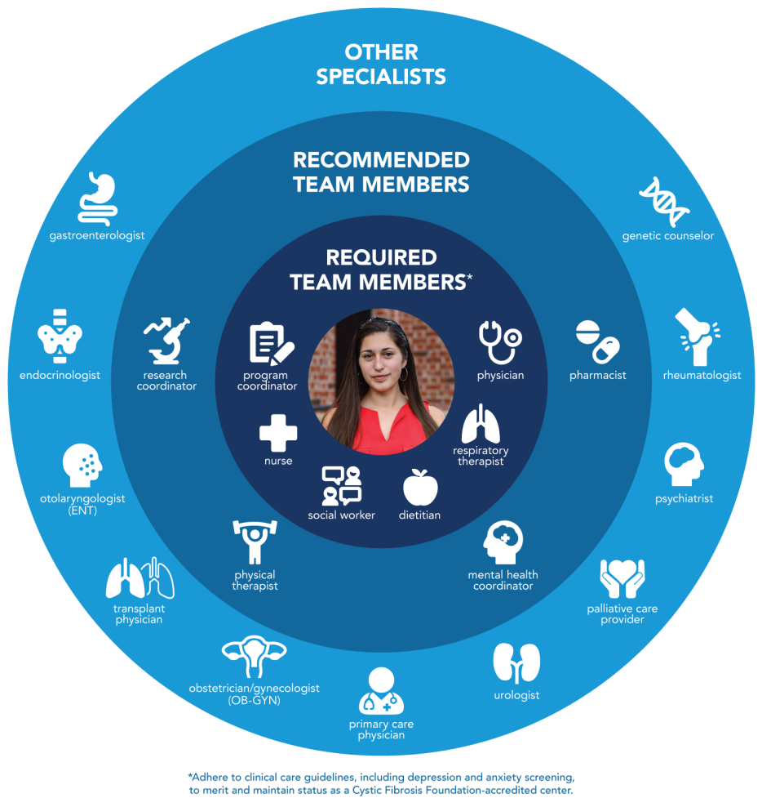
Appendix B
Manager Training Character Strengths Reference Page
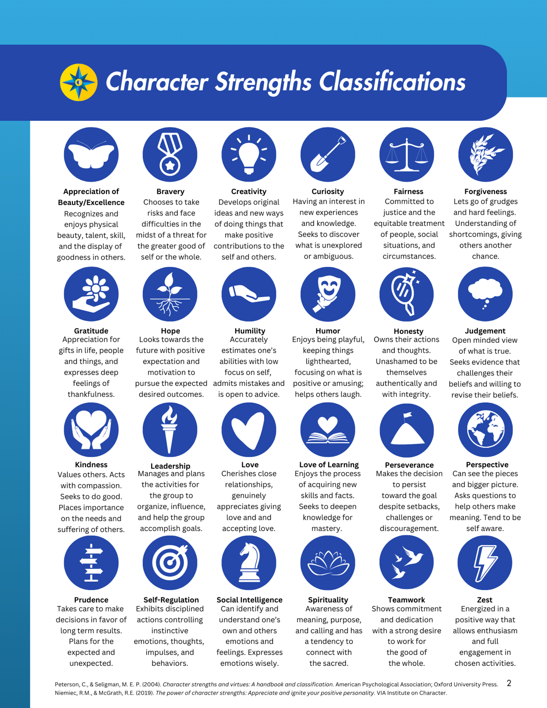

Appendix C
Character Strengths Badges

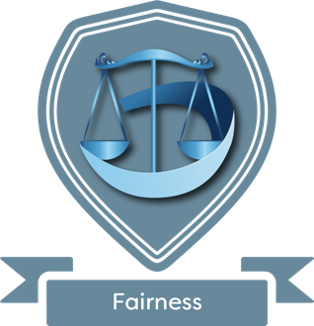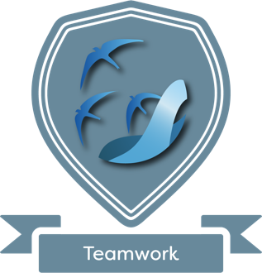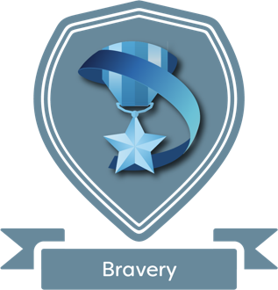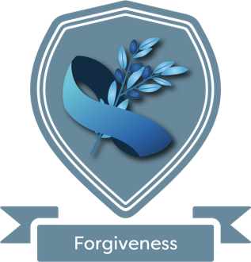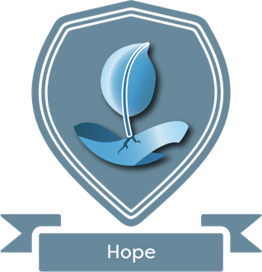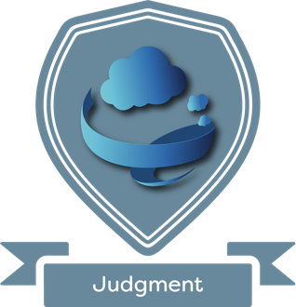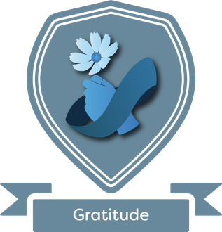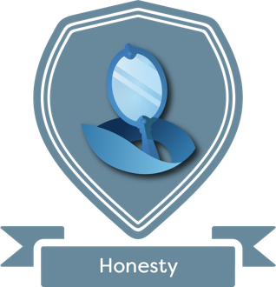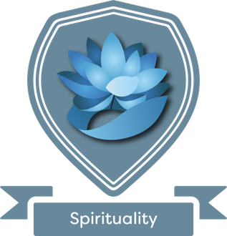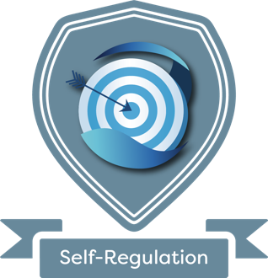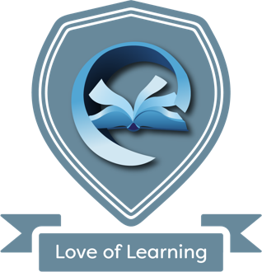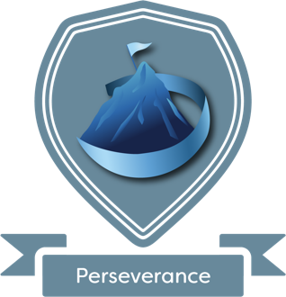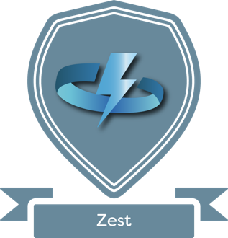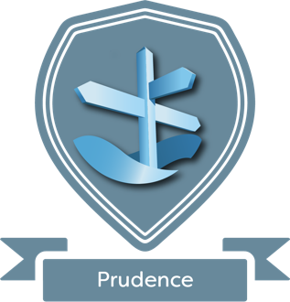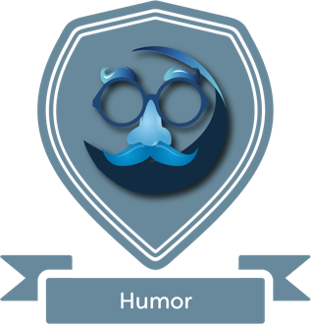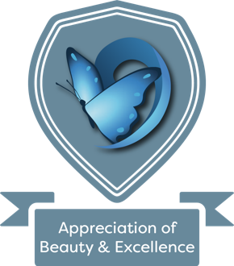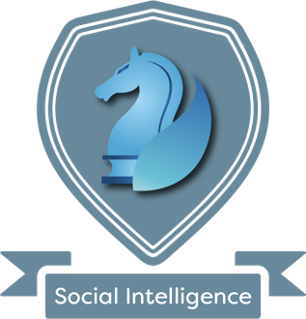
Appendix D
Introduction to Character Strengths- Retreat Training
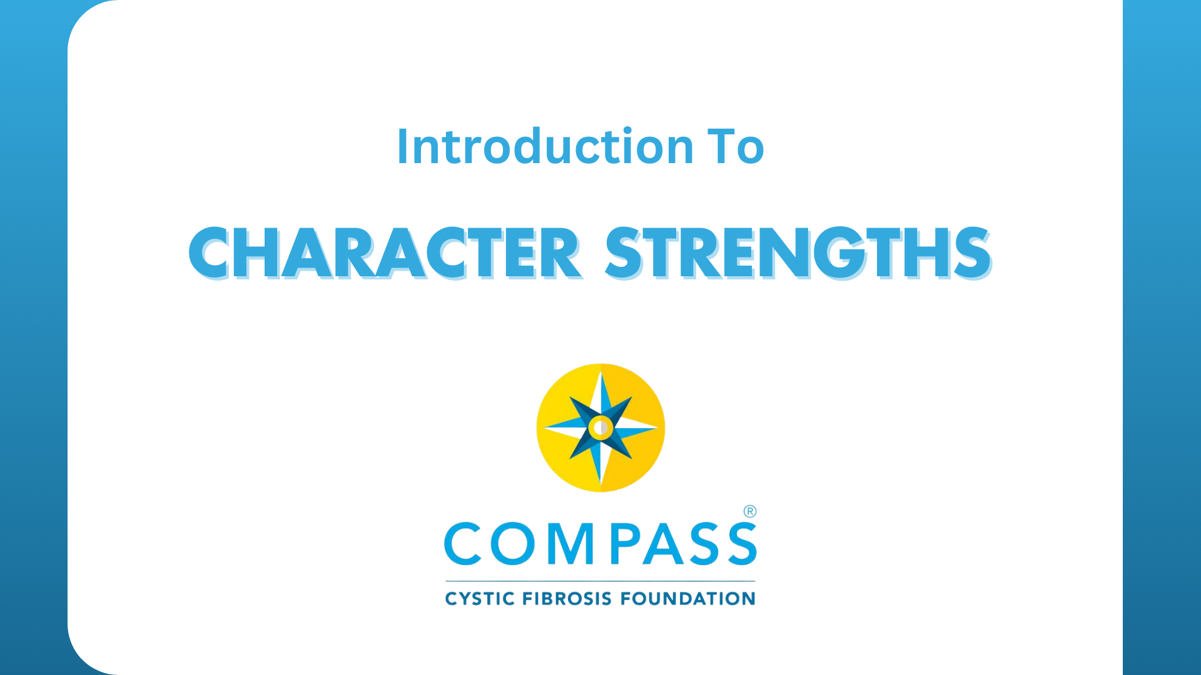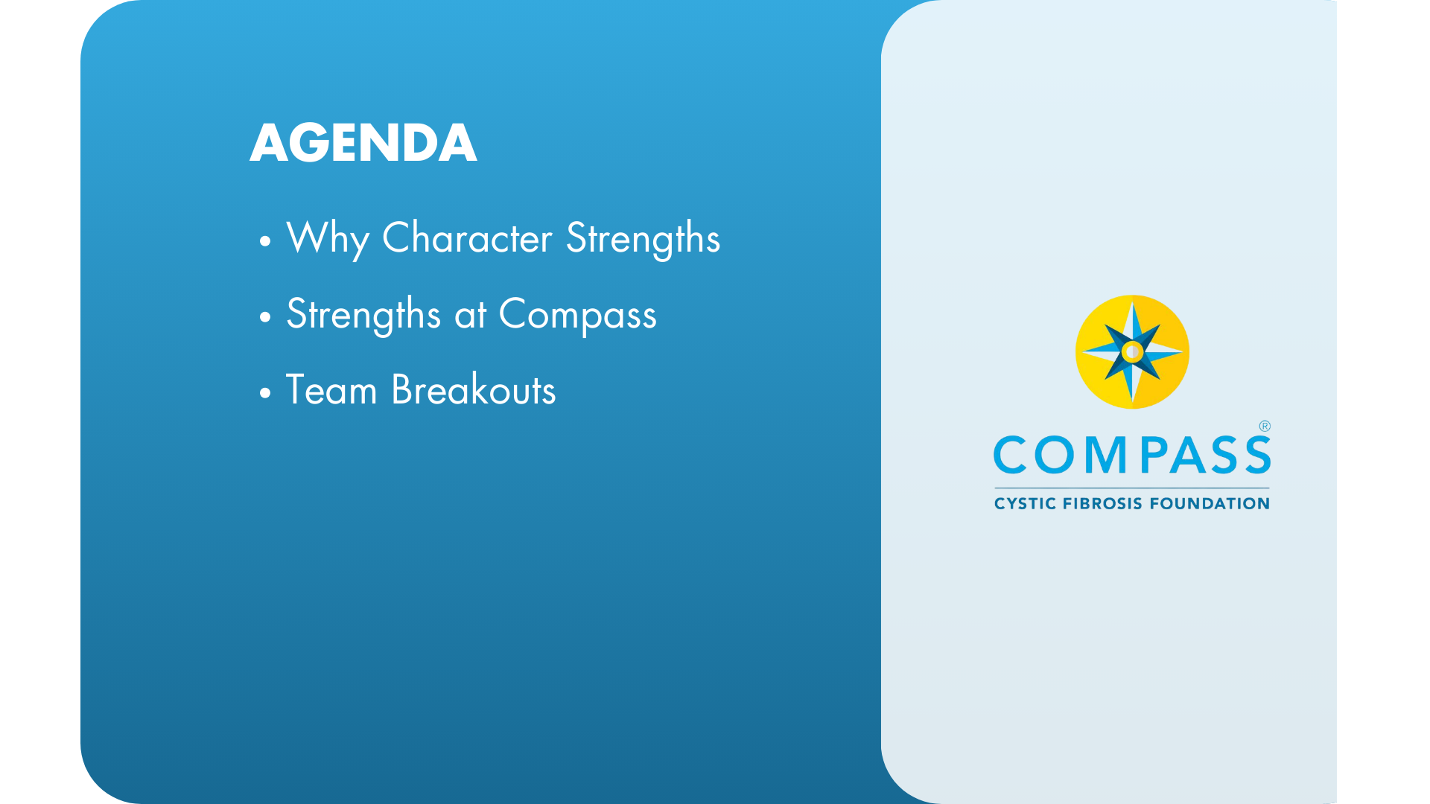
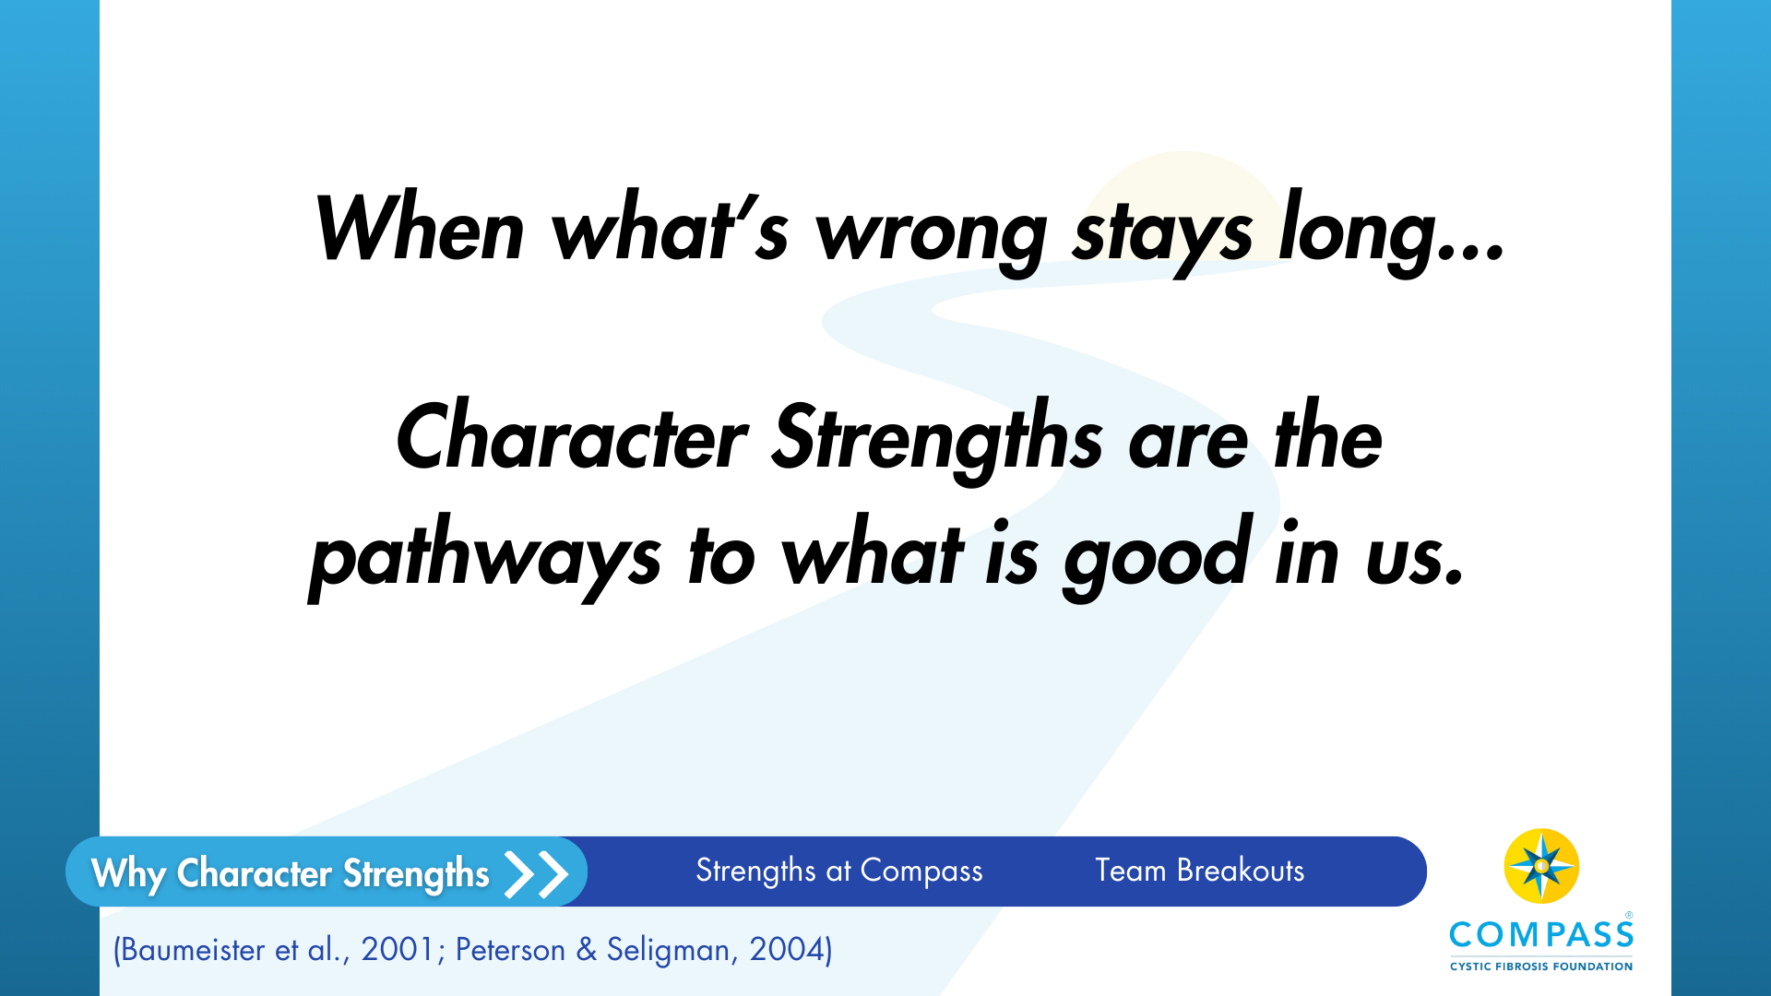
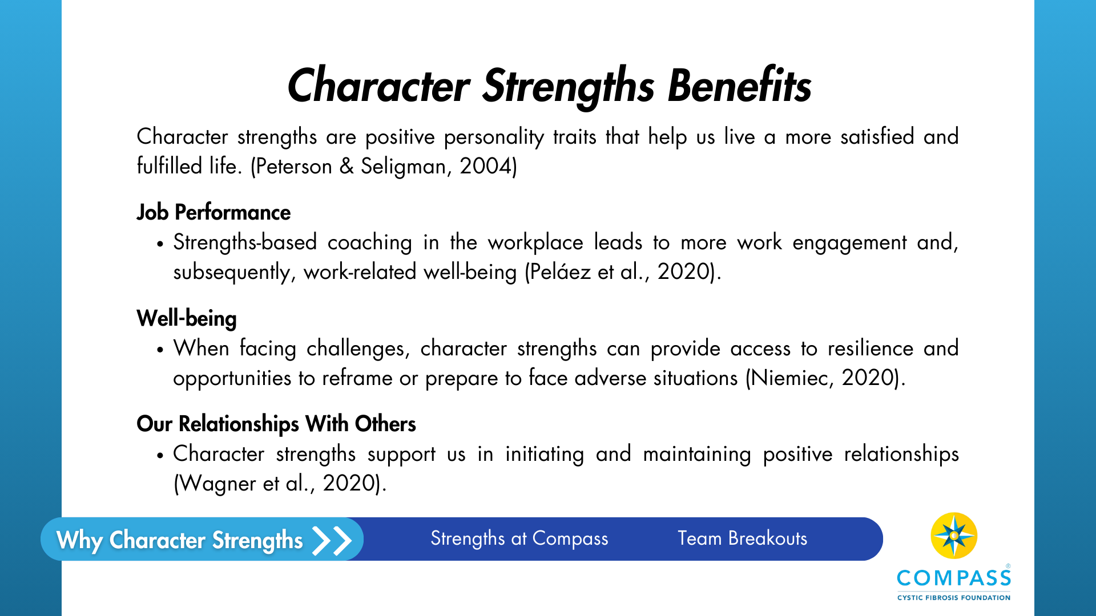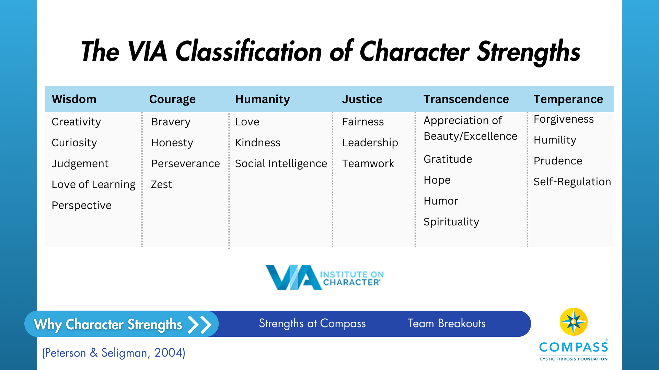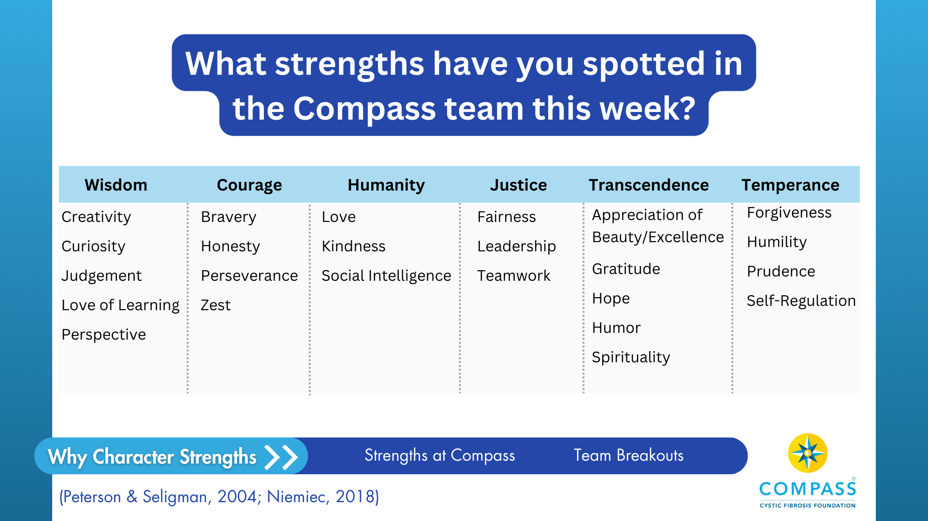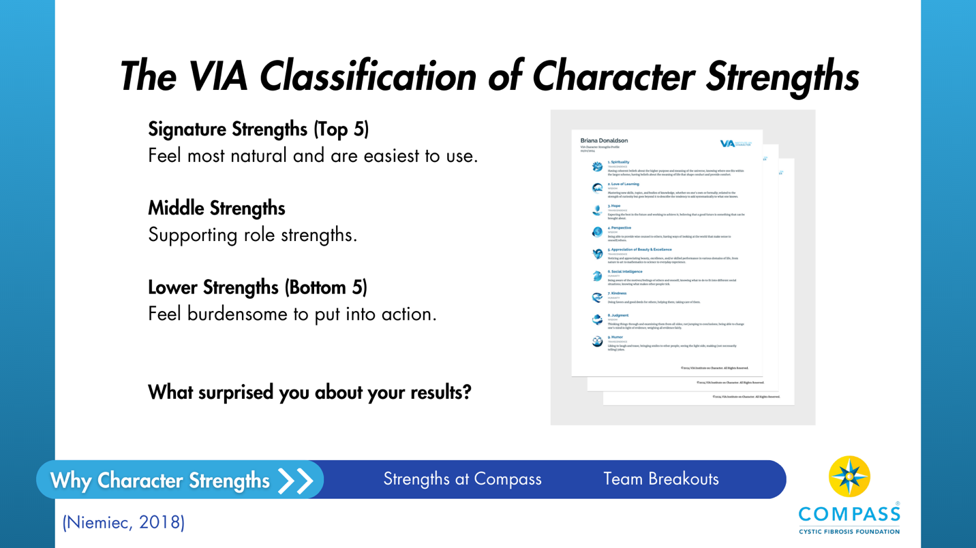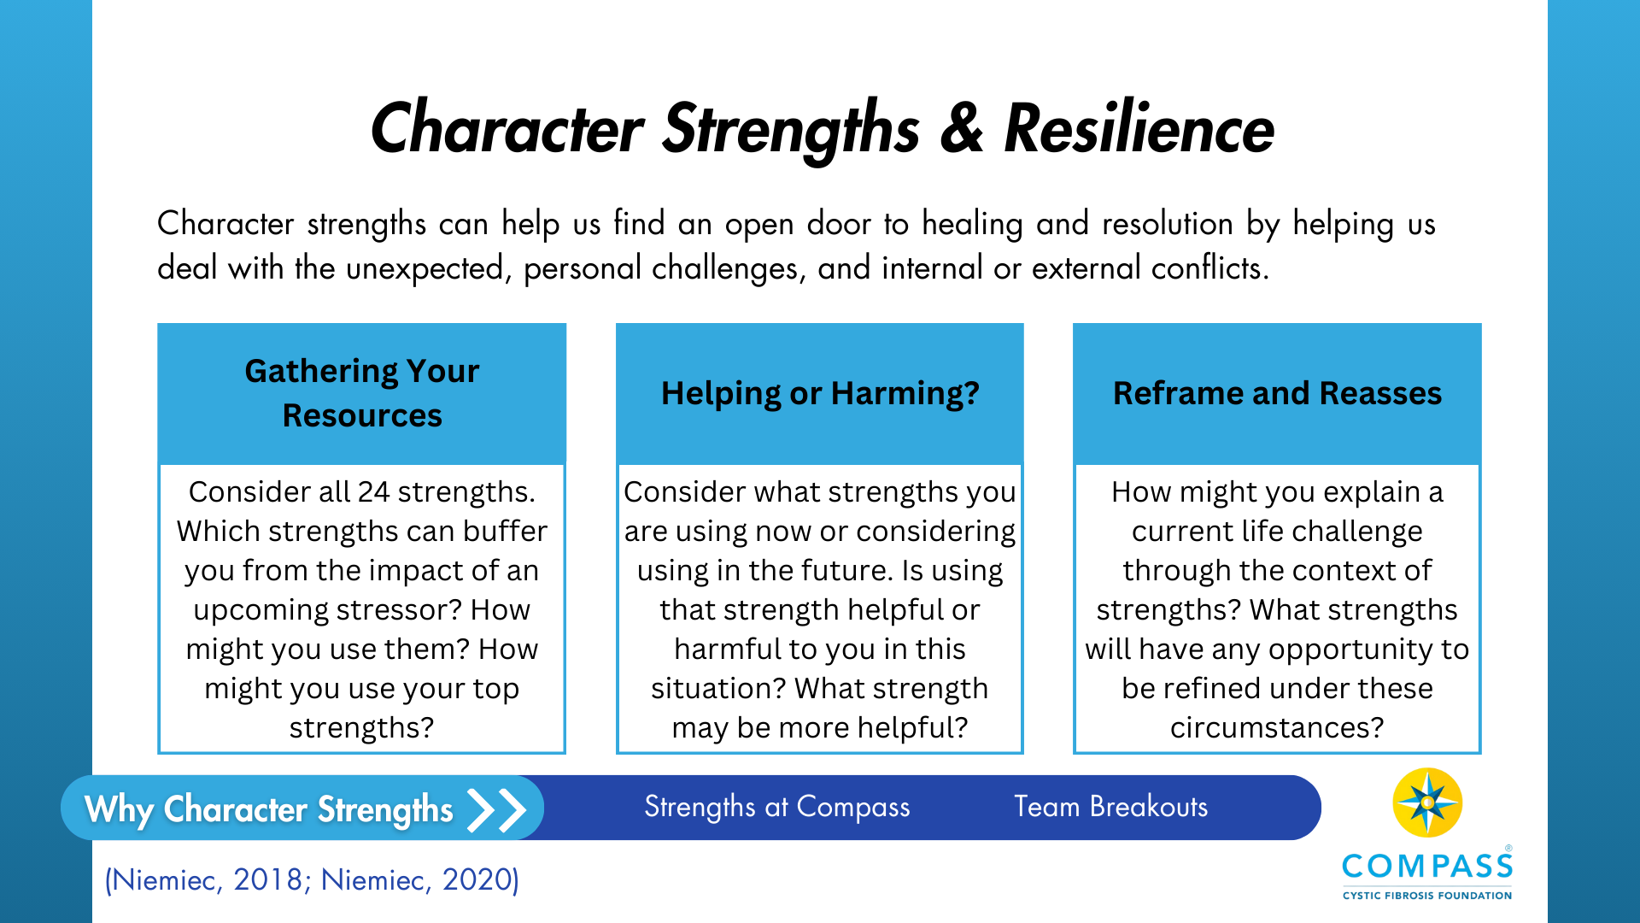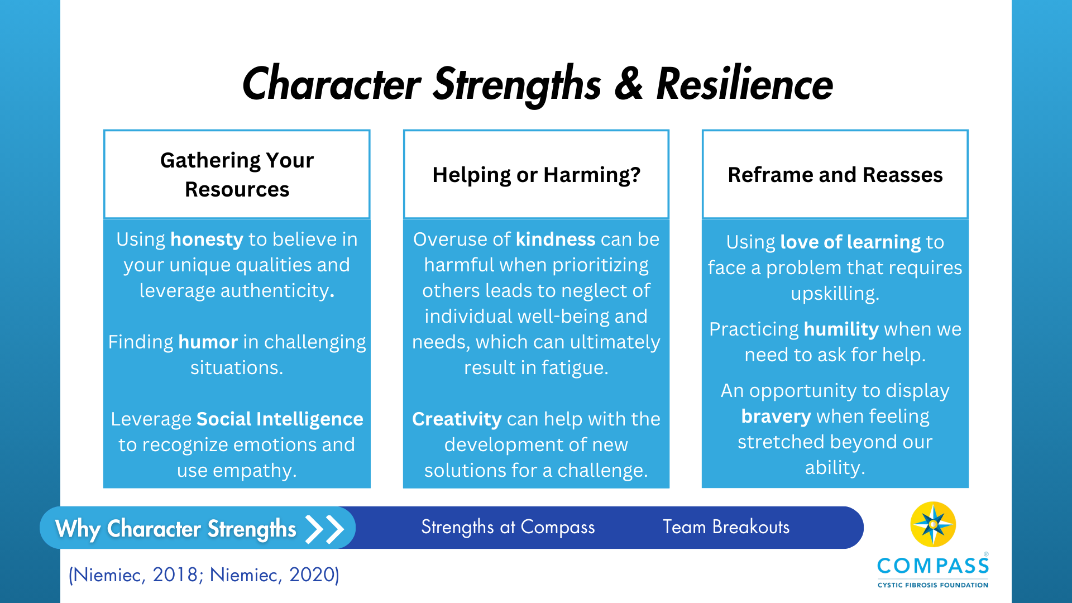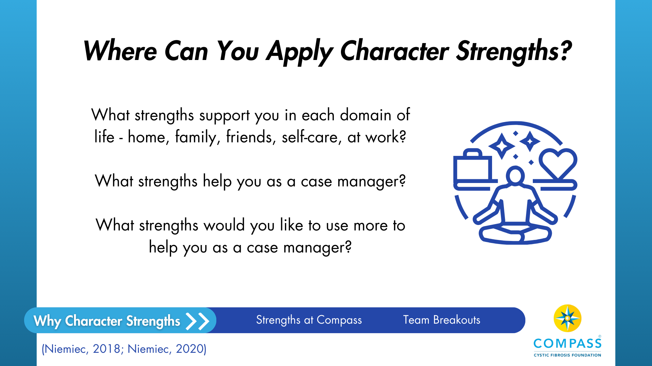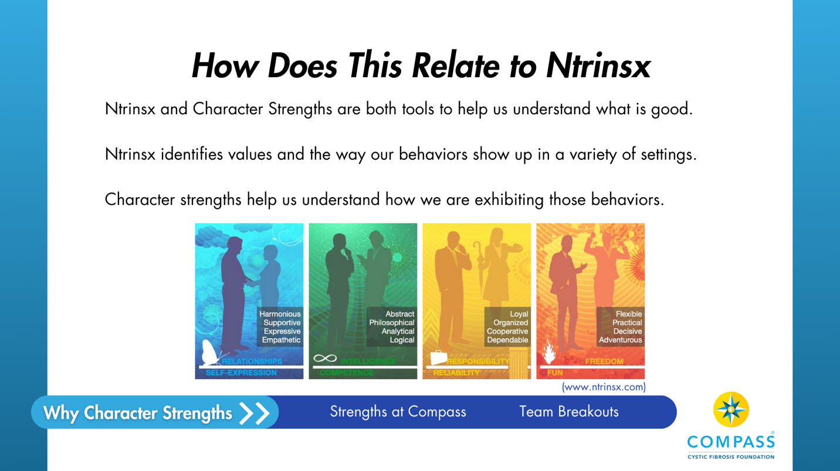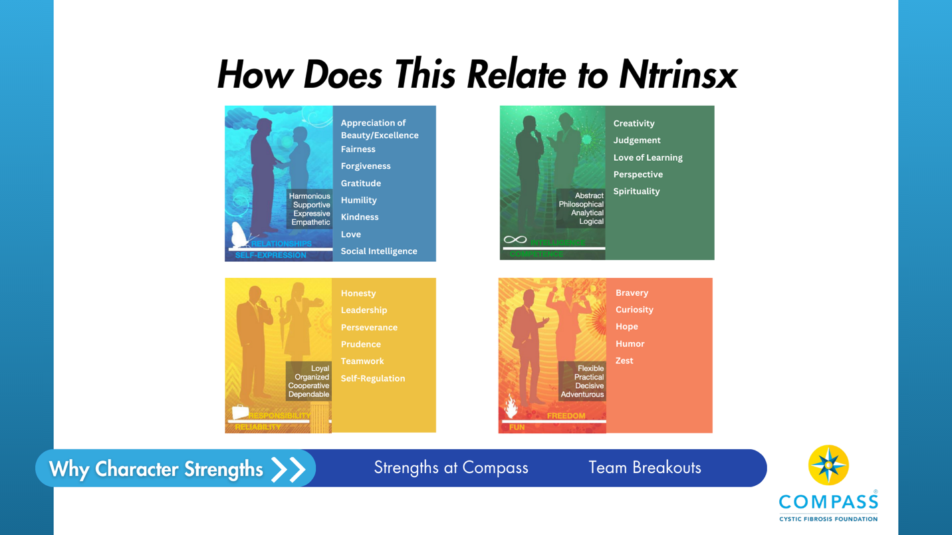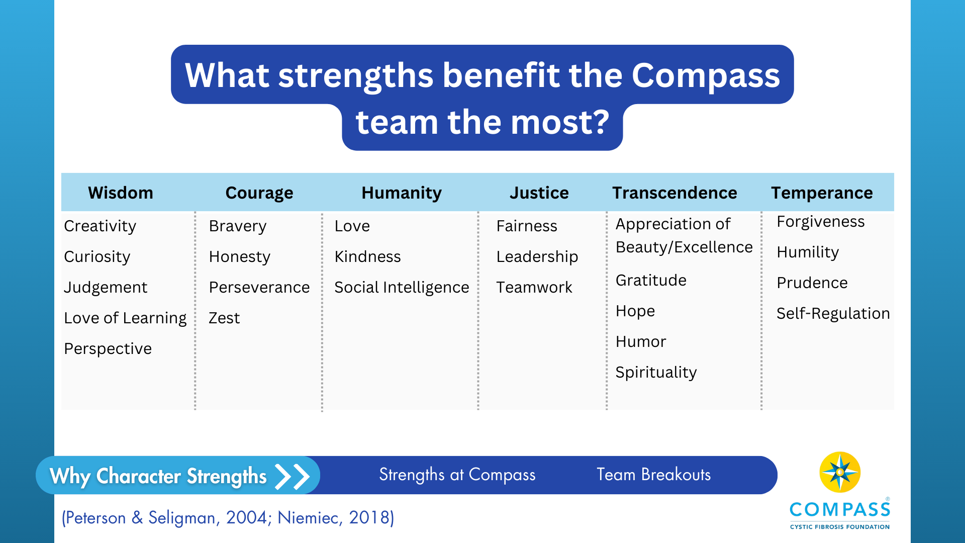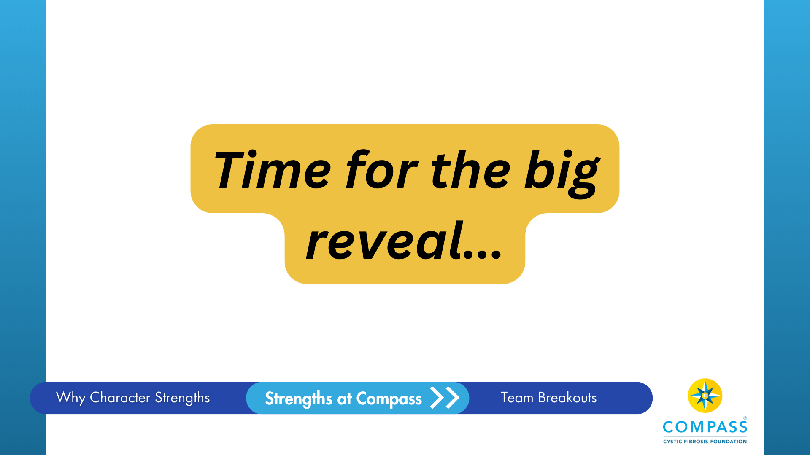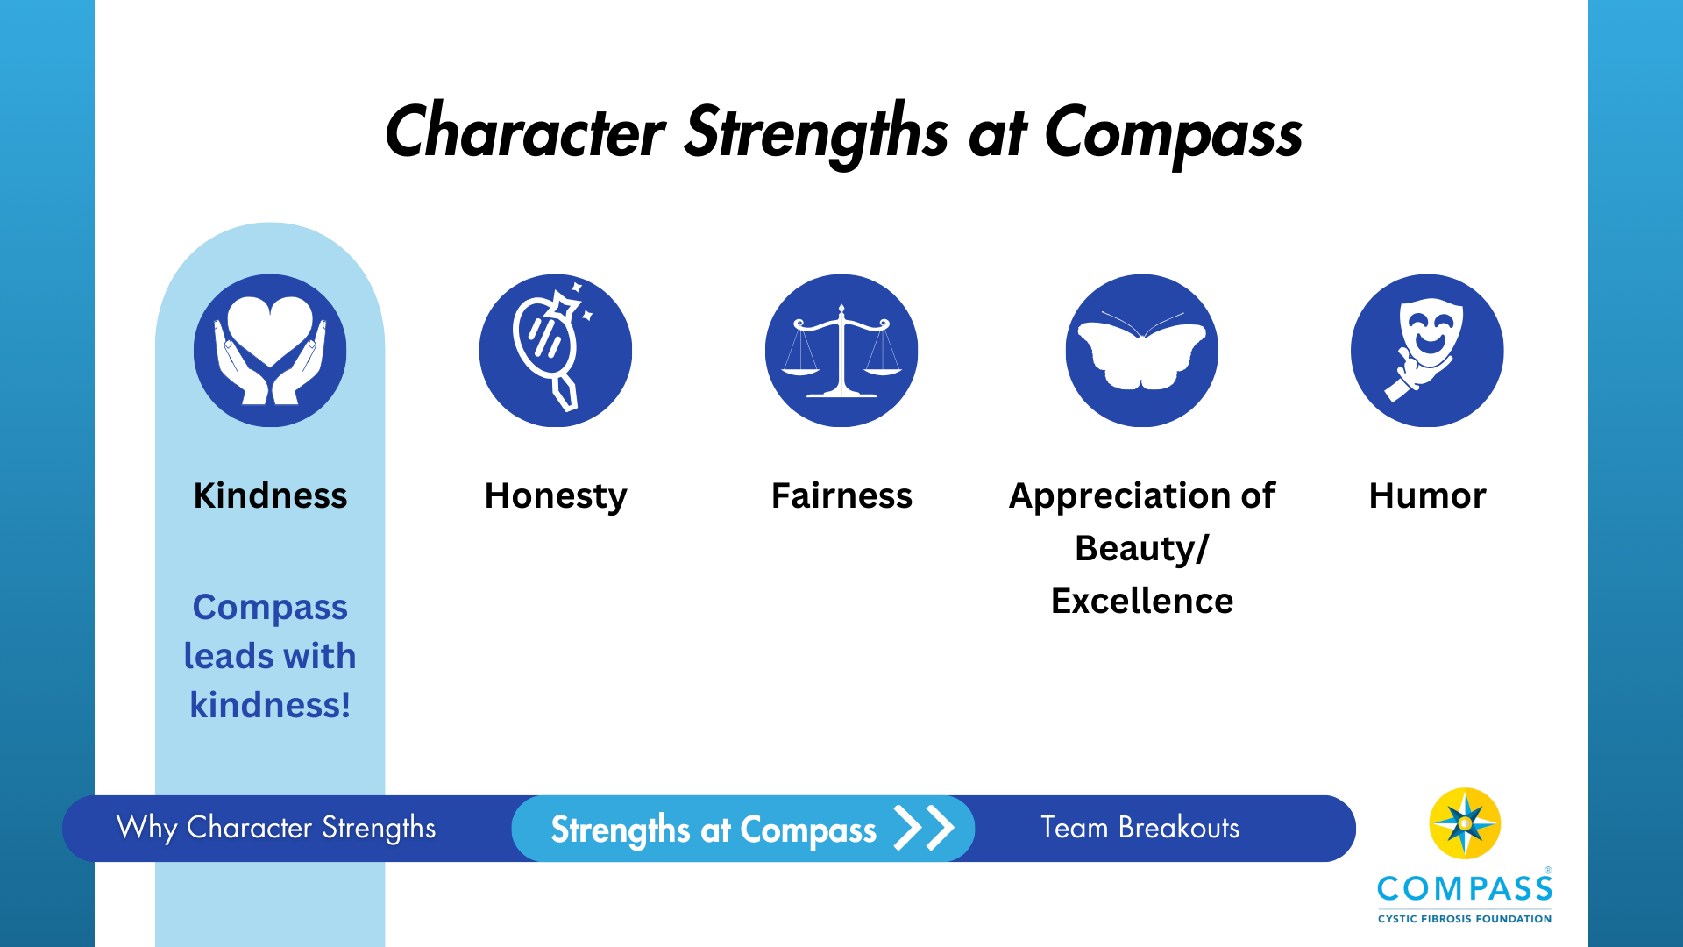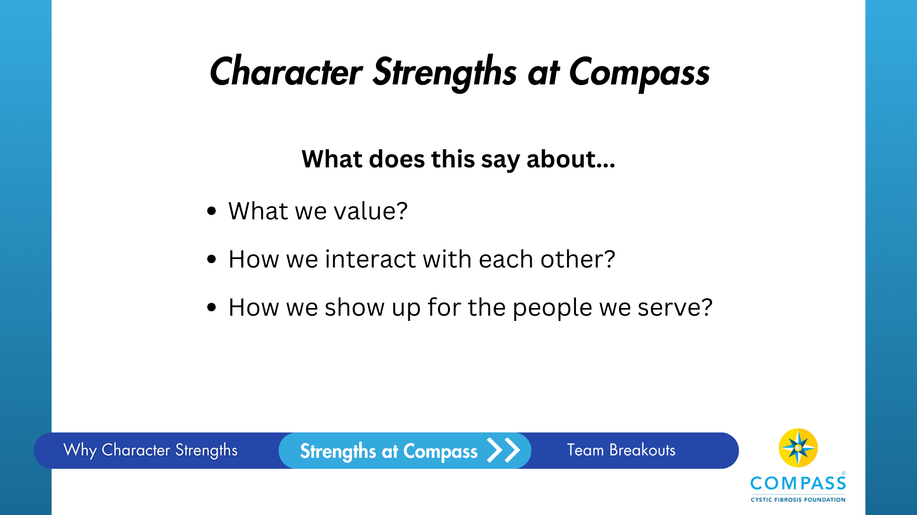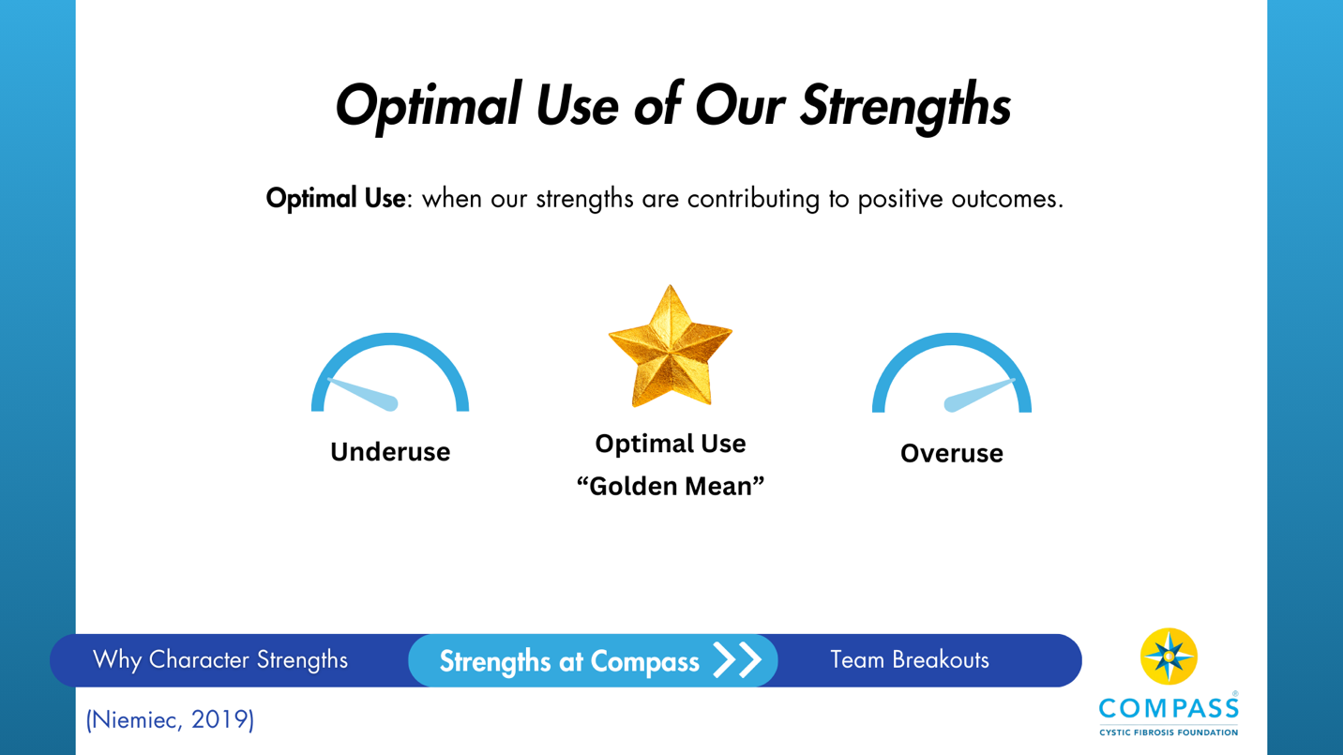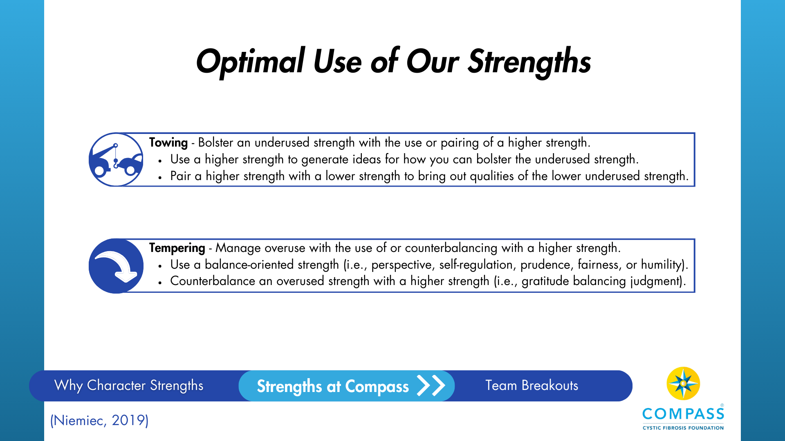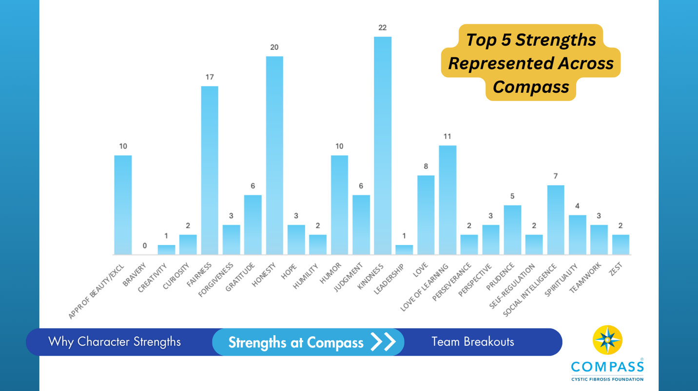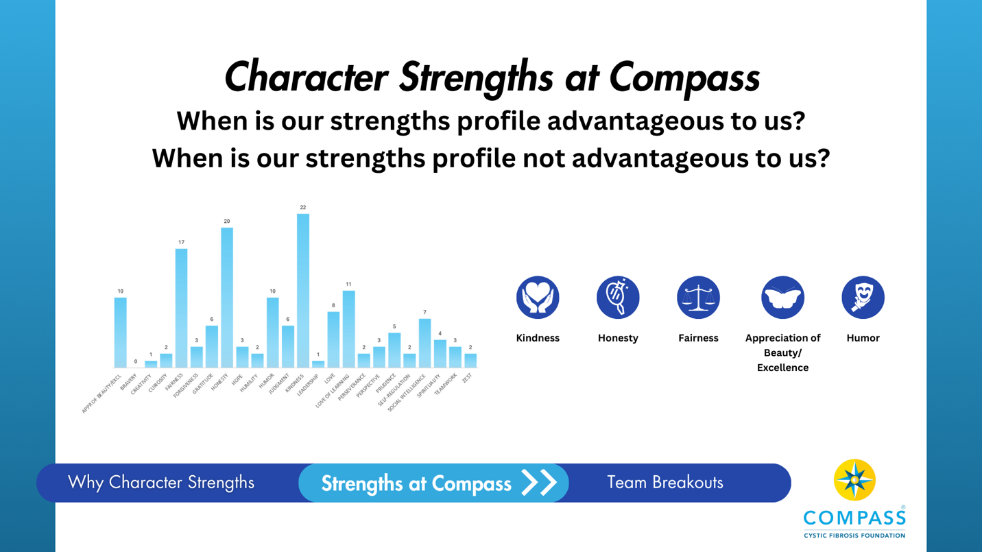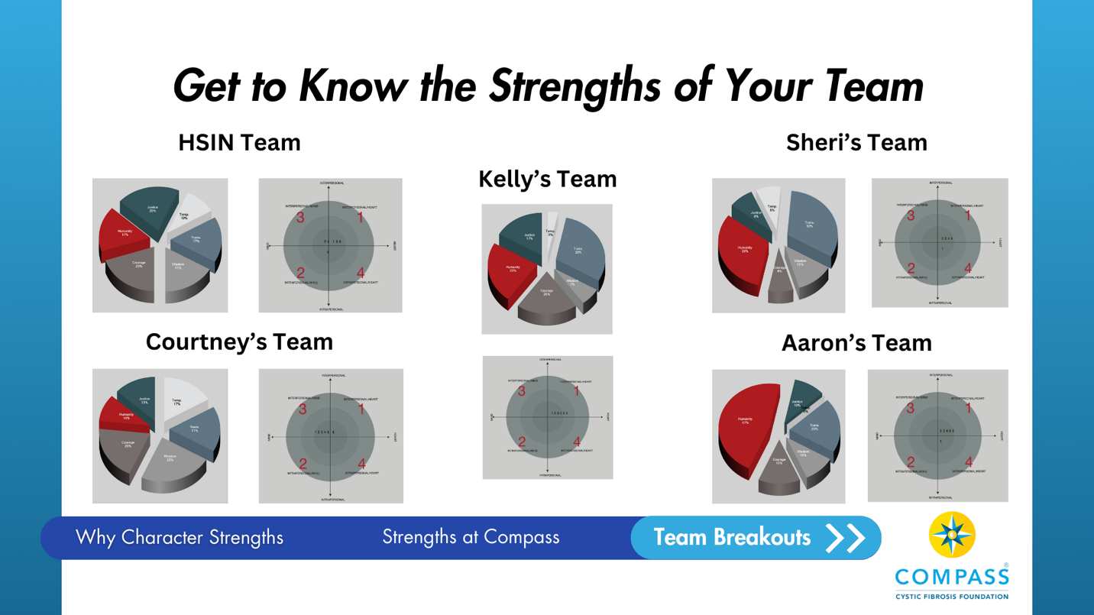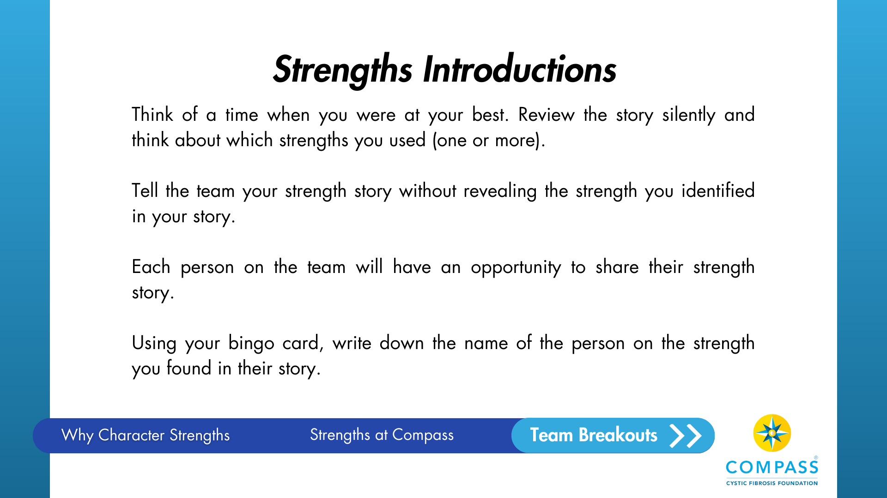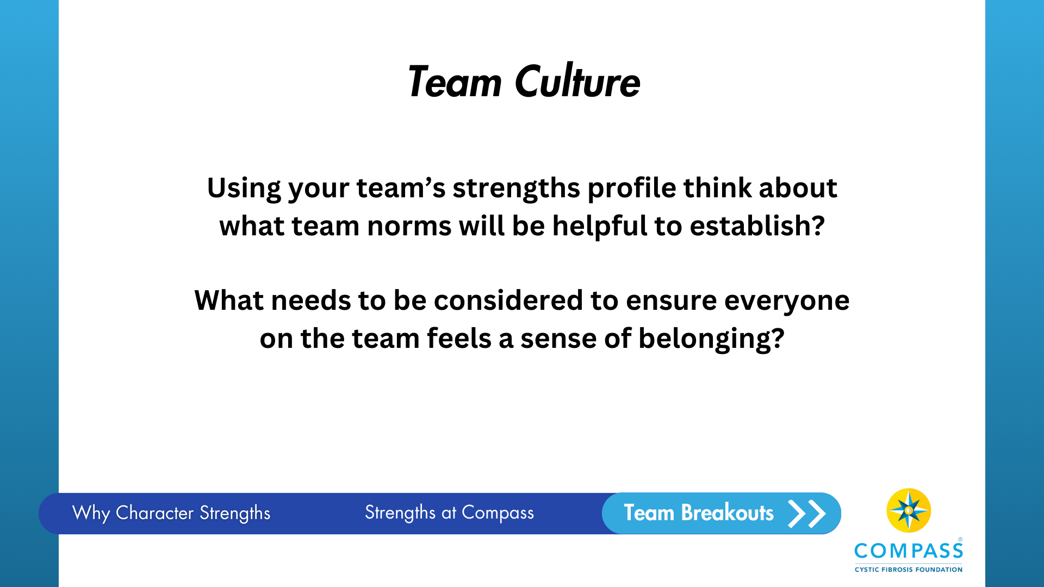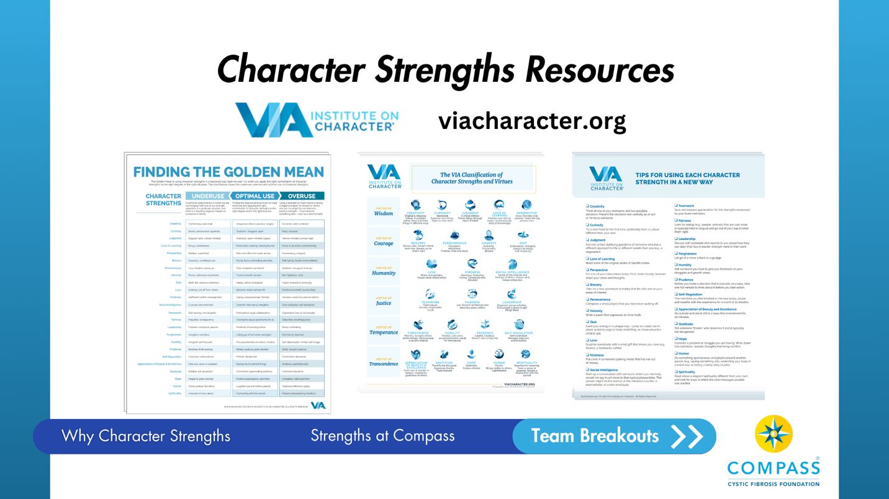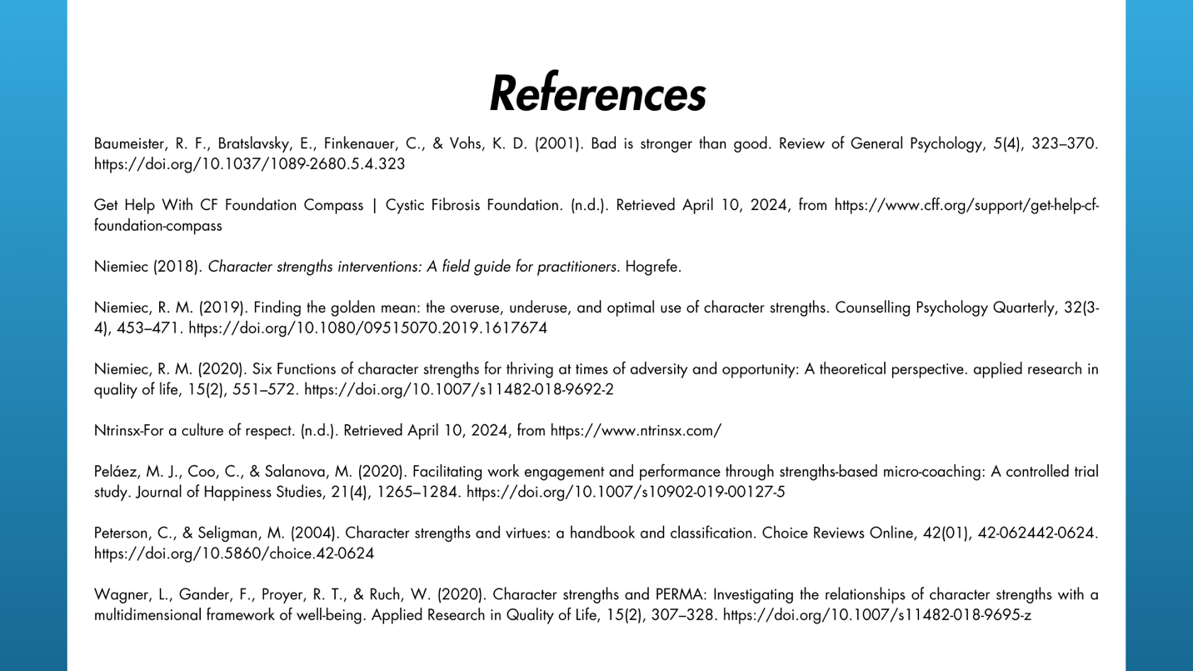

Appendix E
Strengths-Spotting Bingo Cards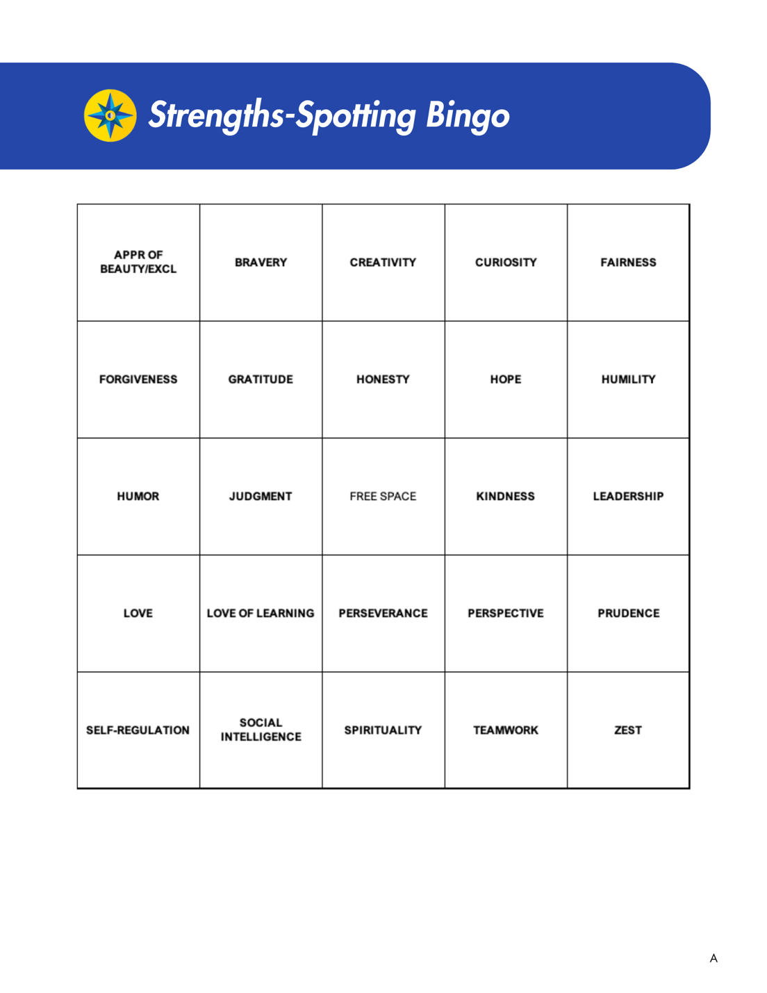
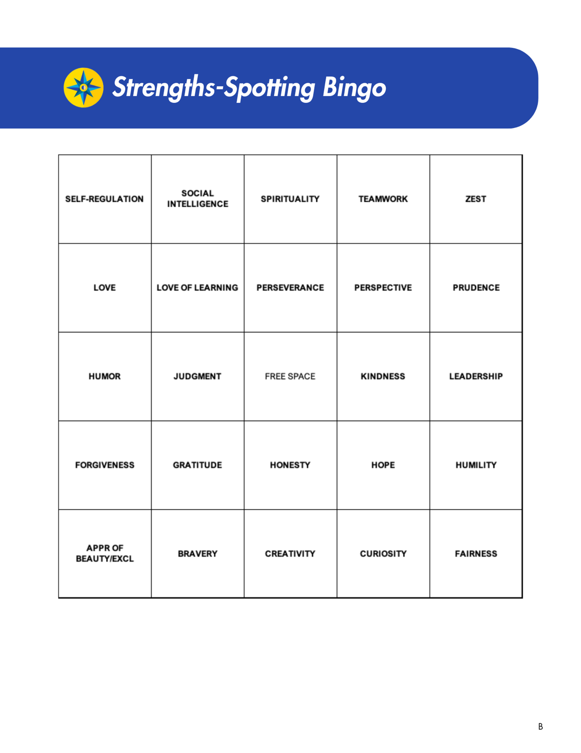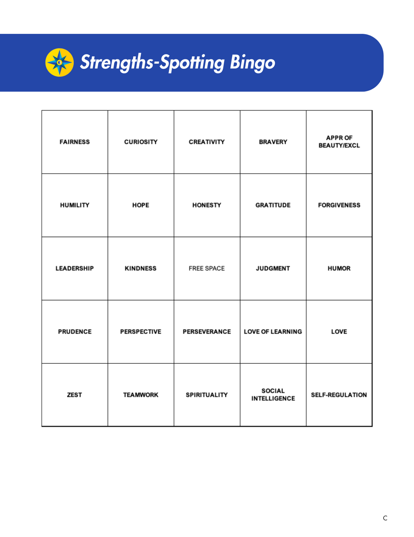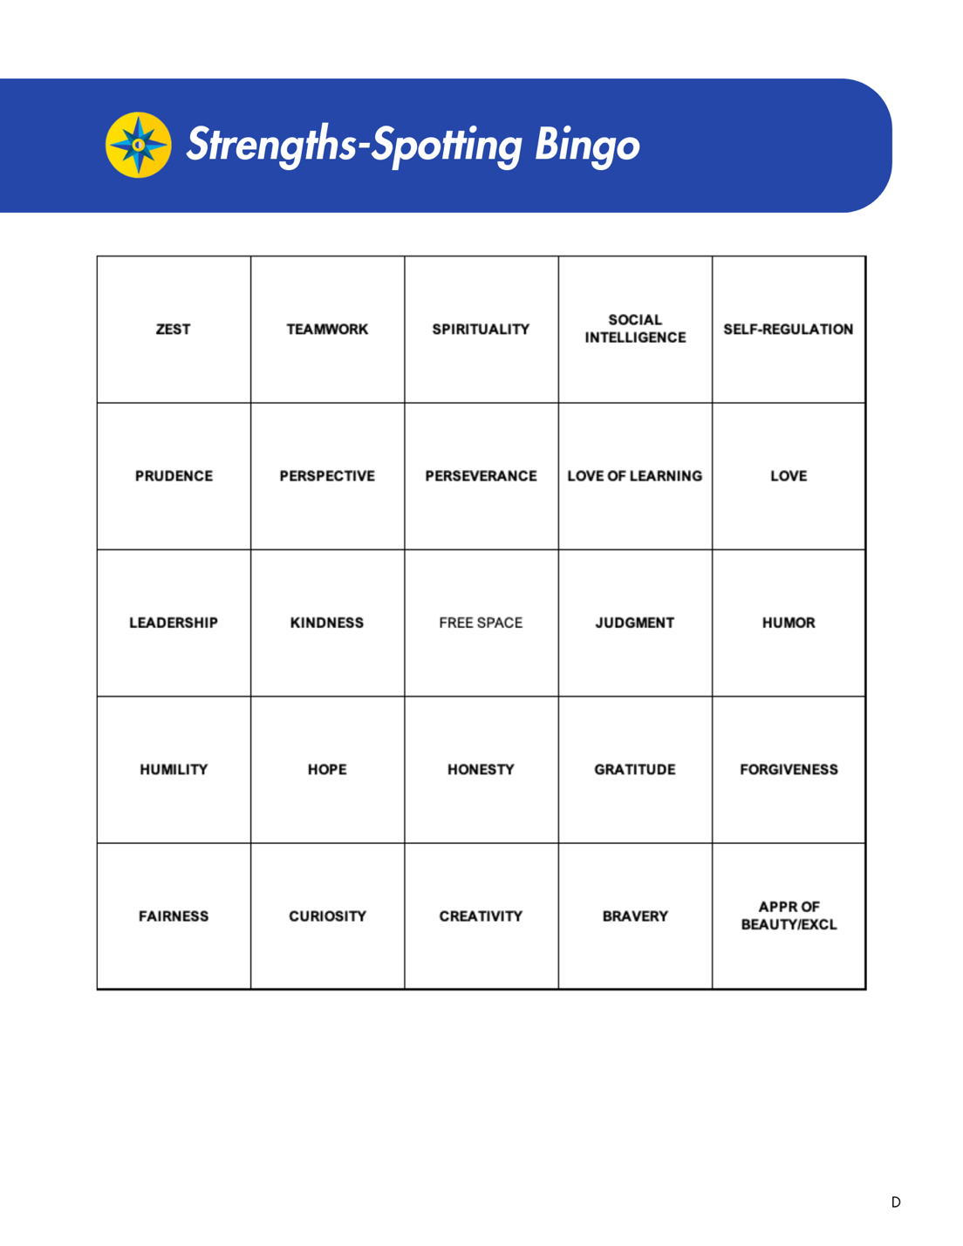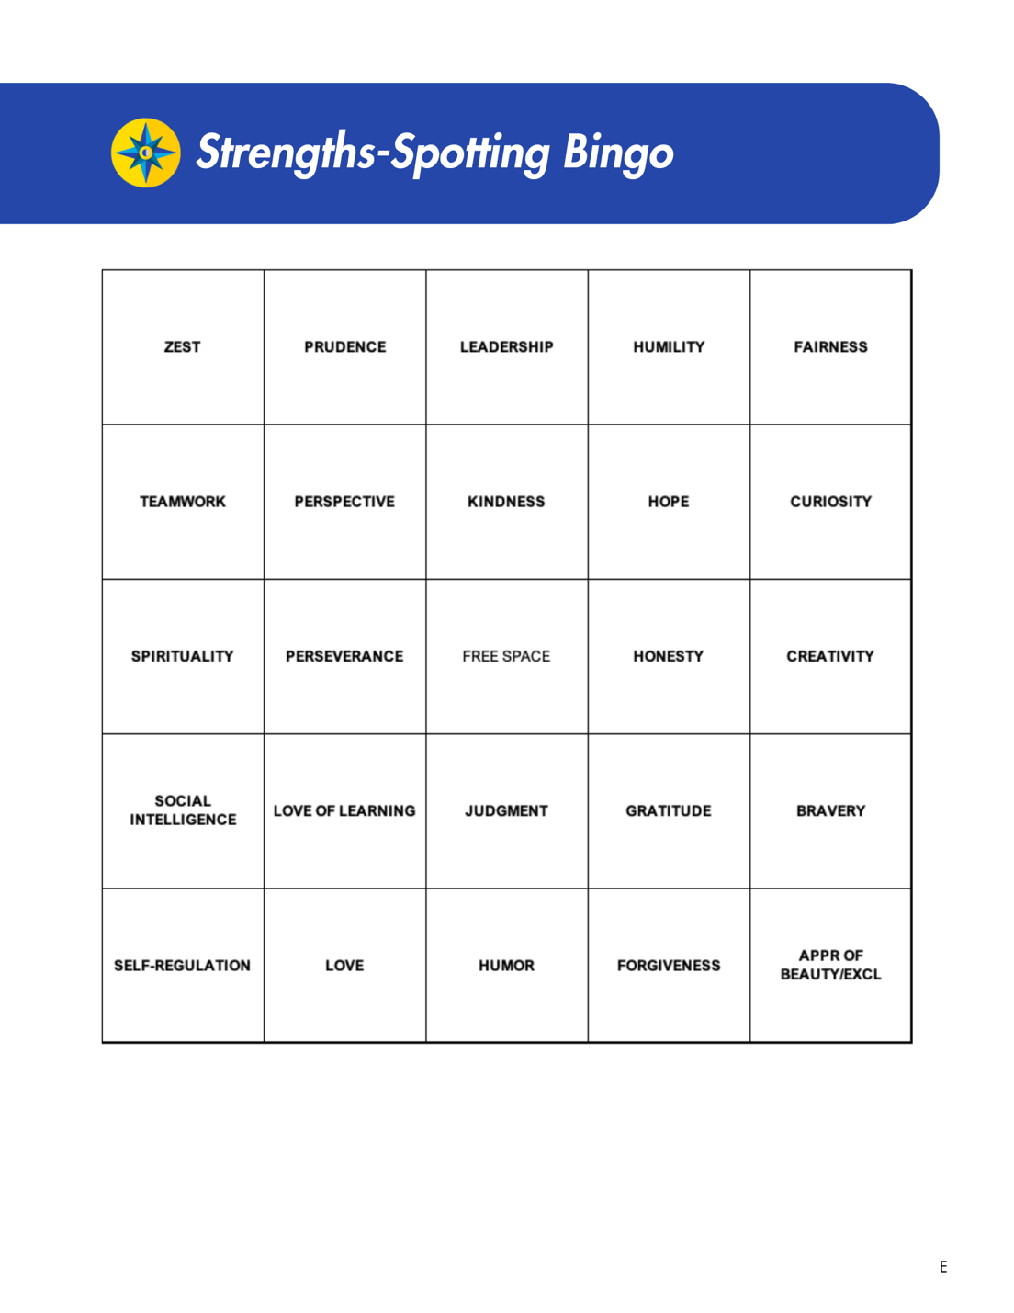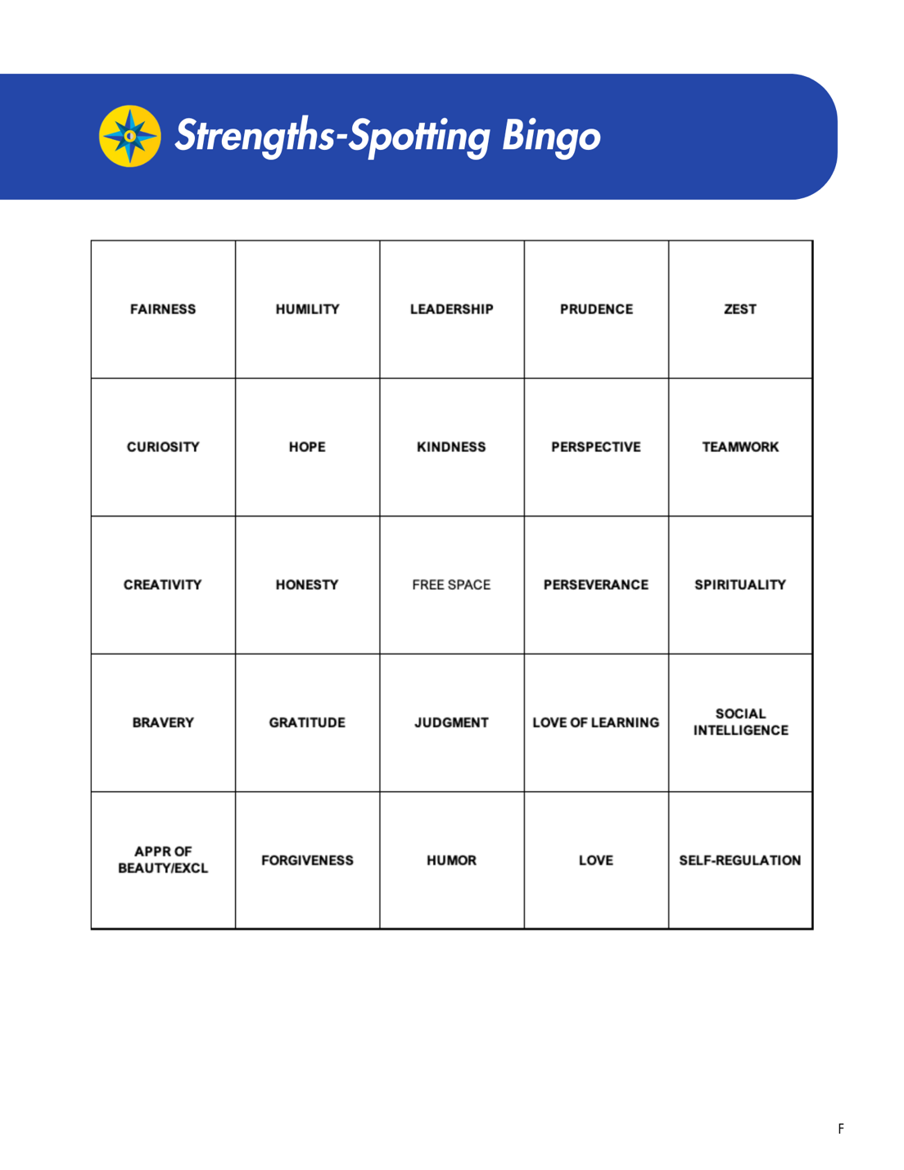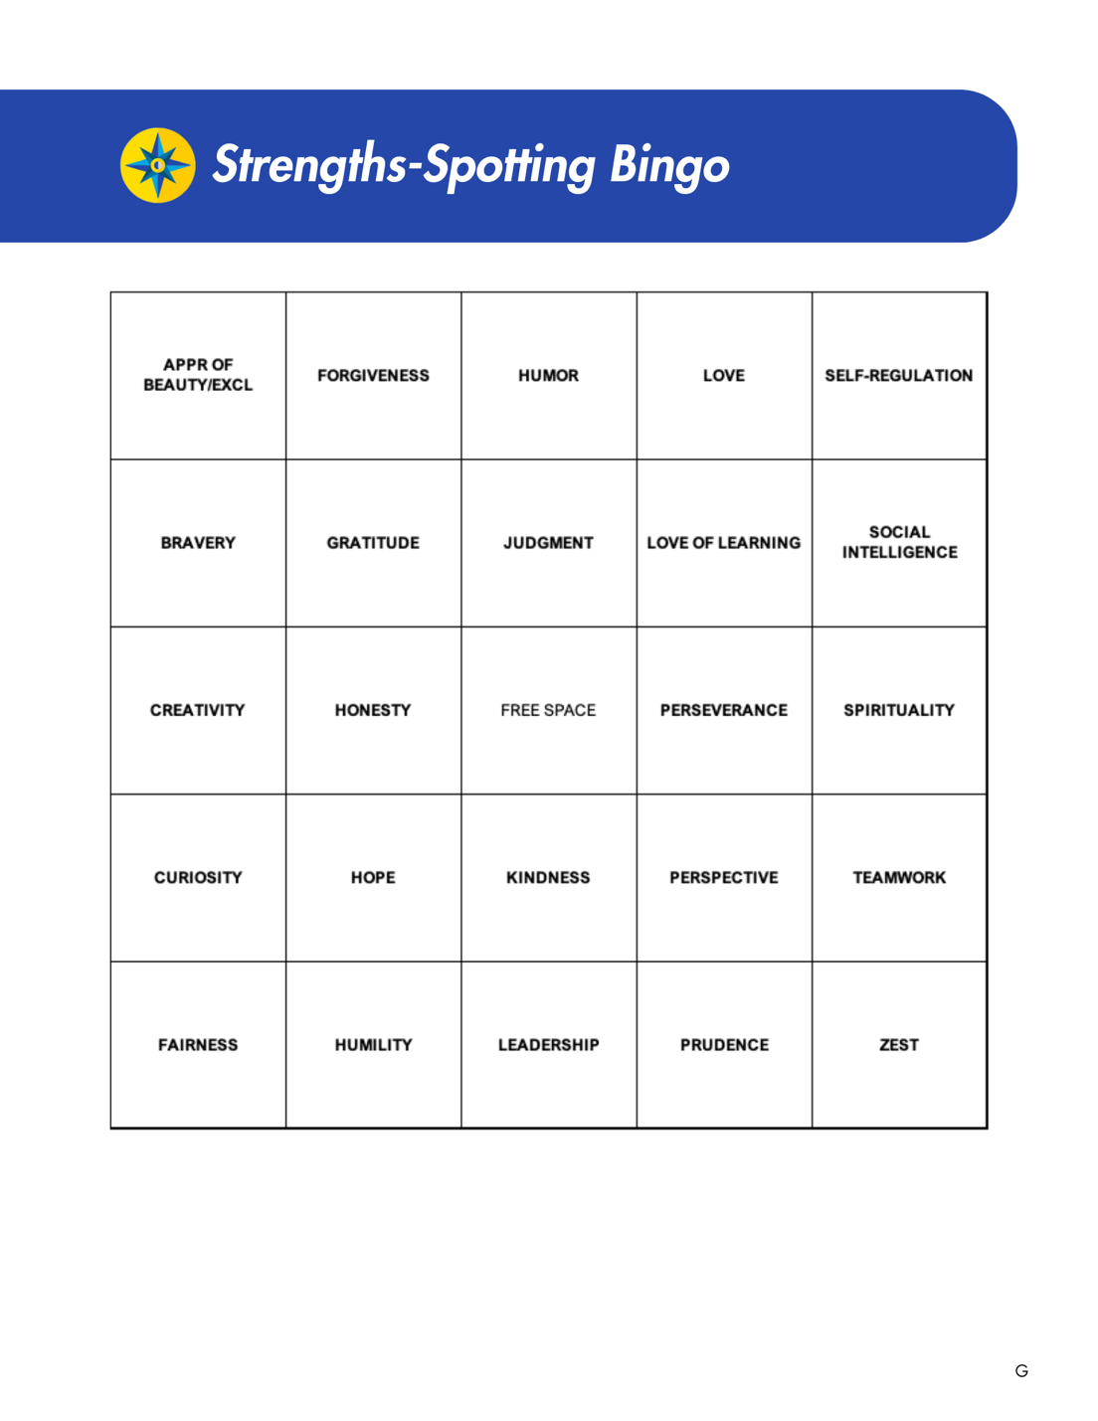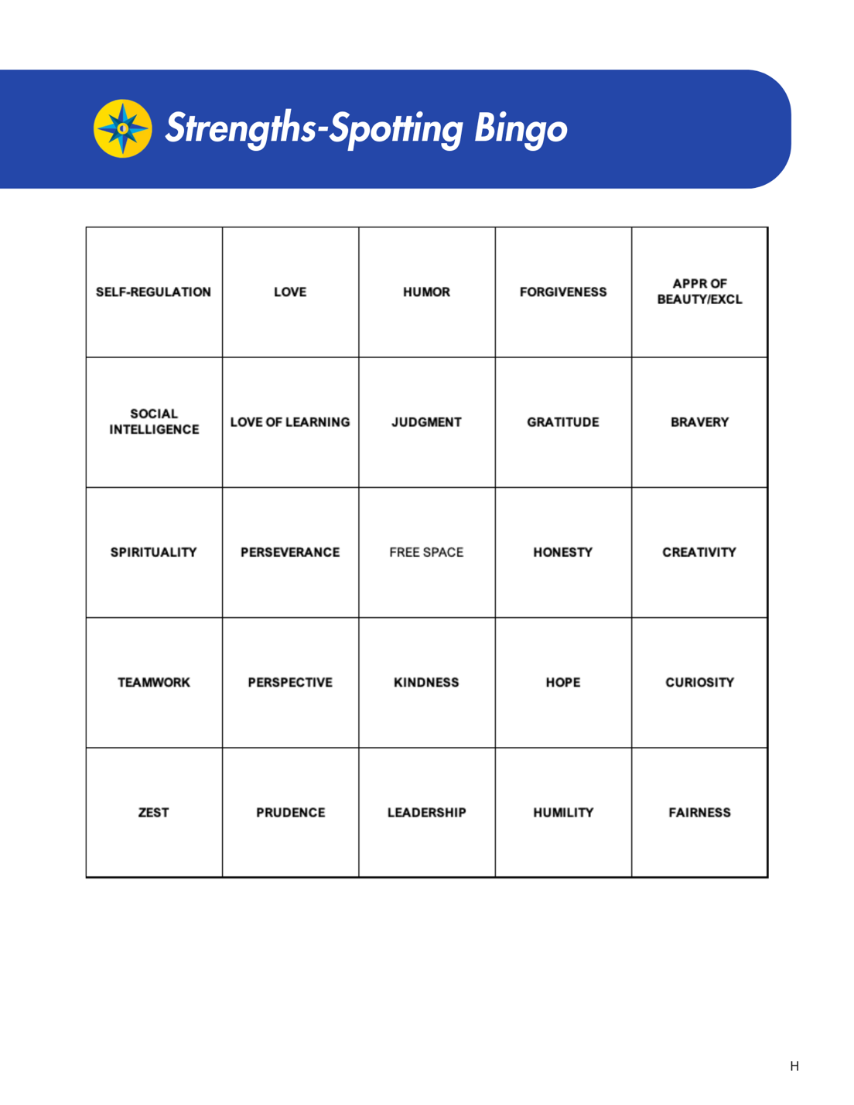

Appendix F
Compass Character Strengths Guidebook
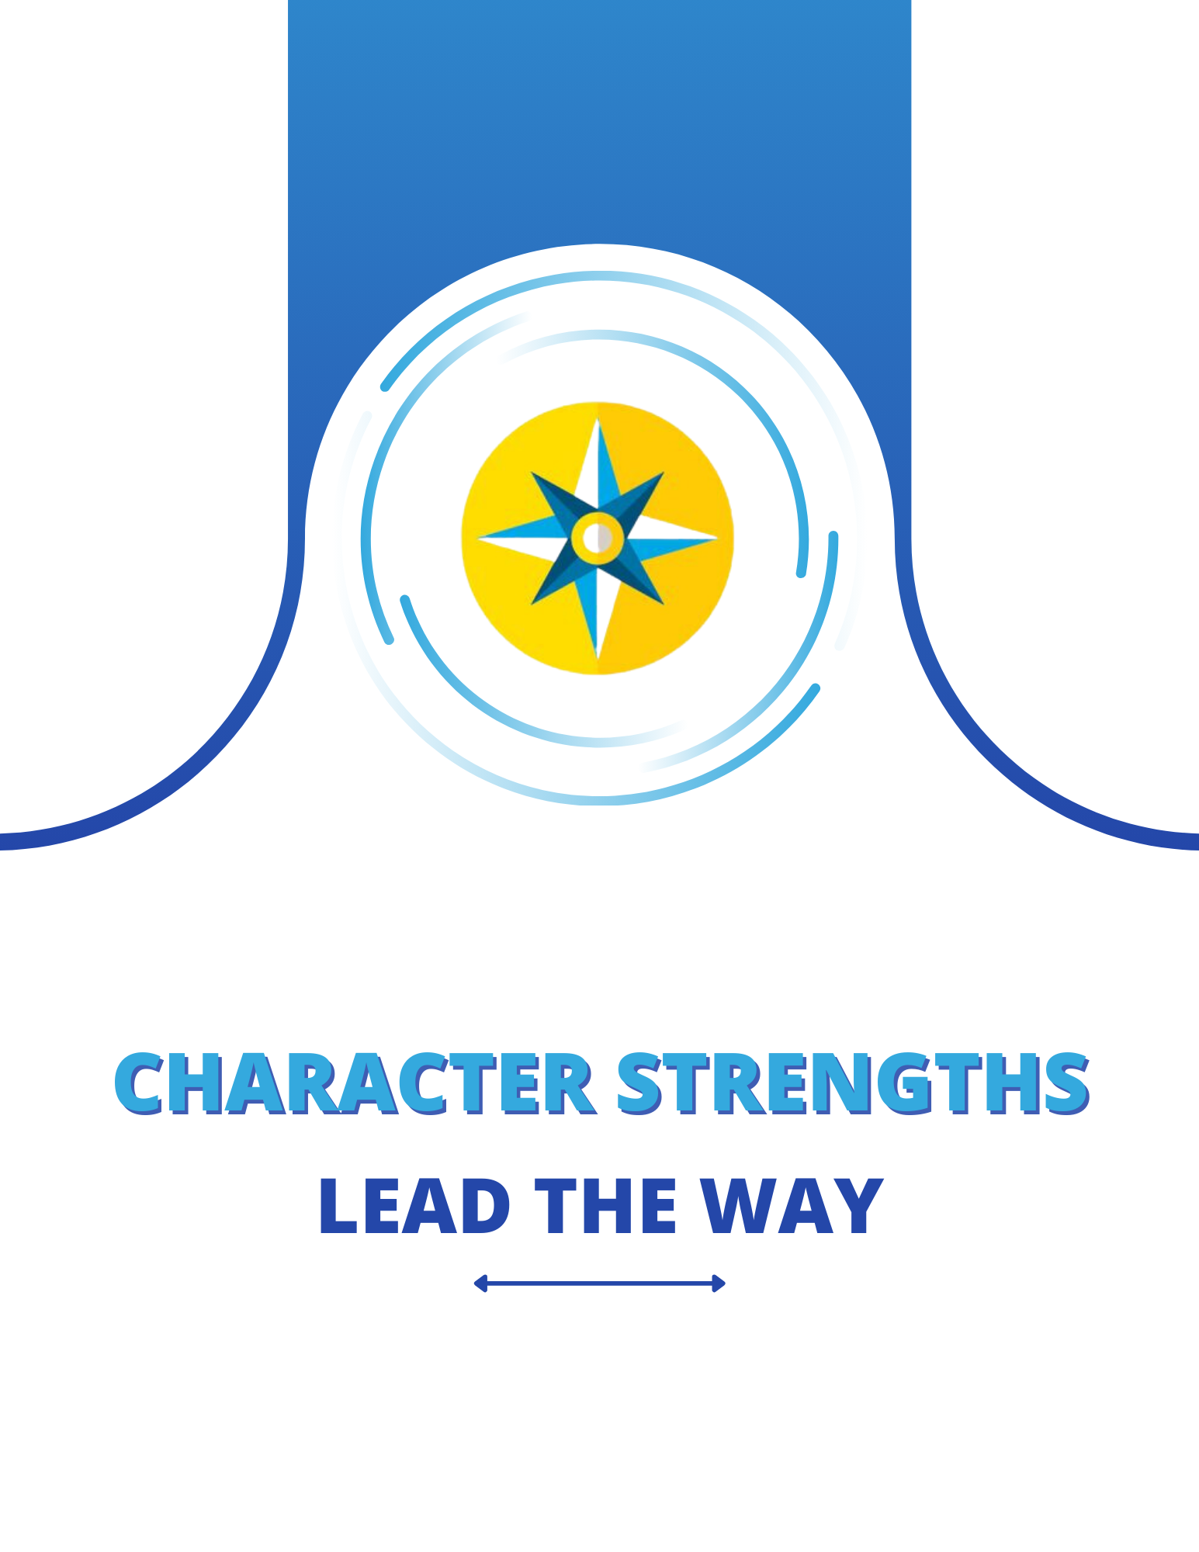
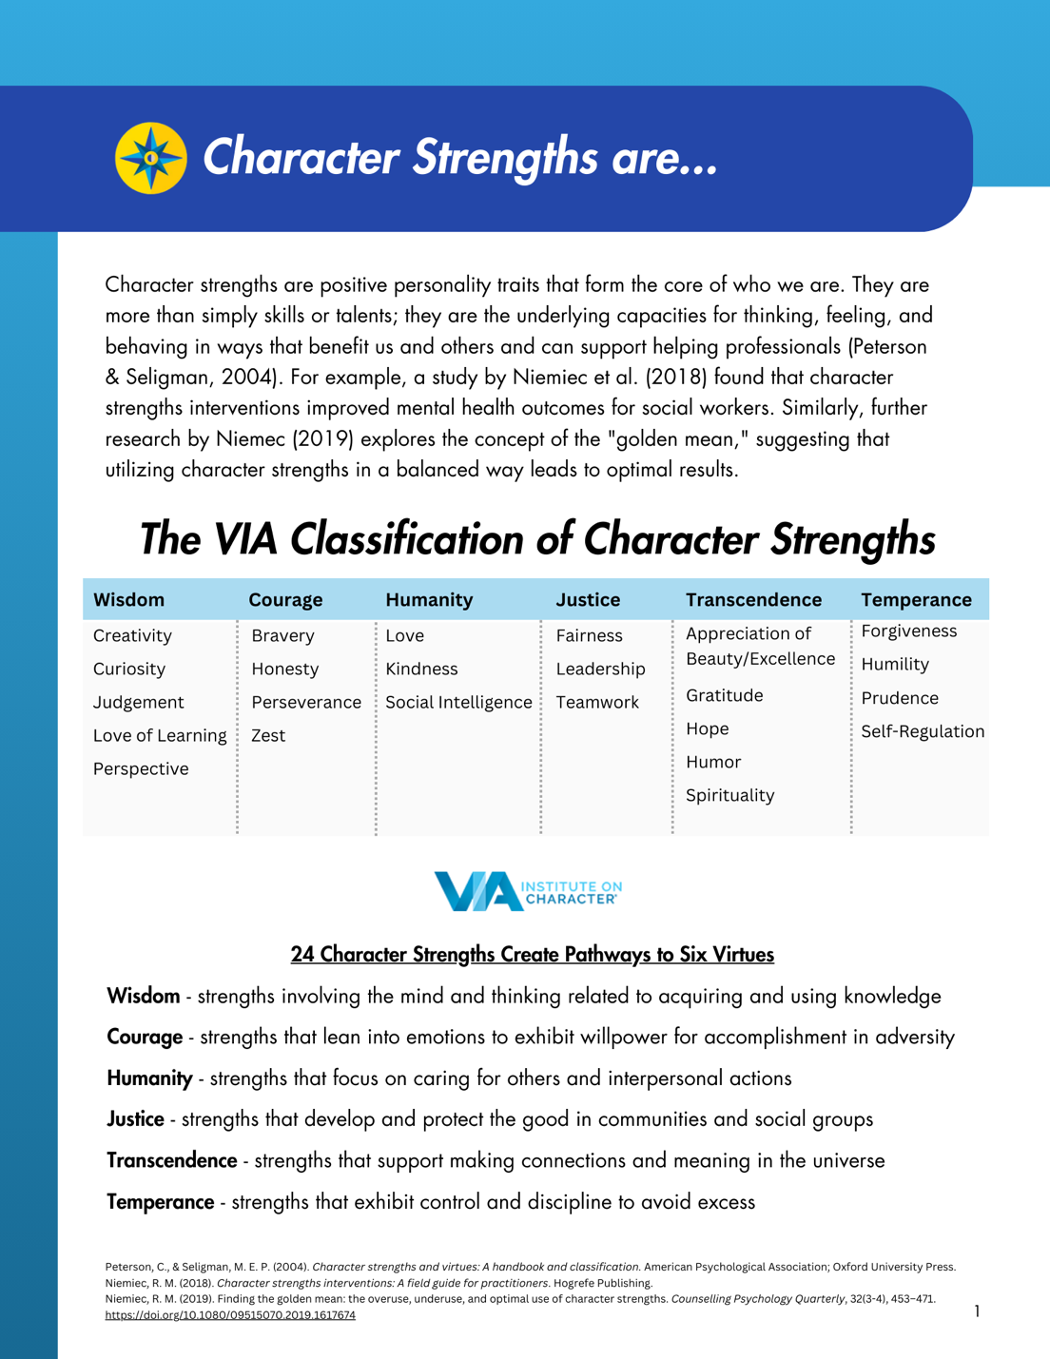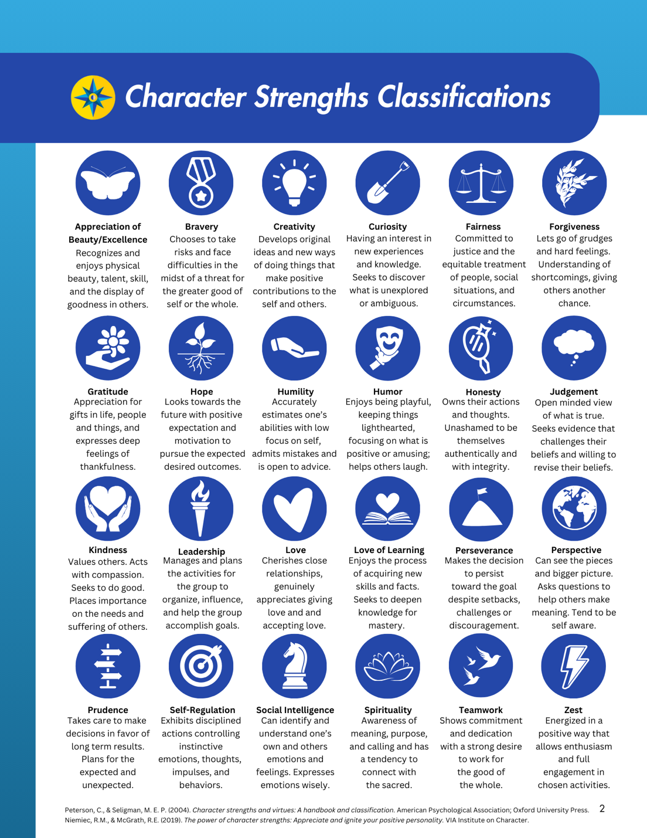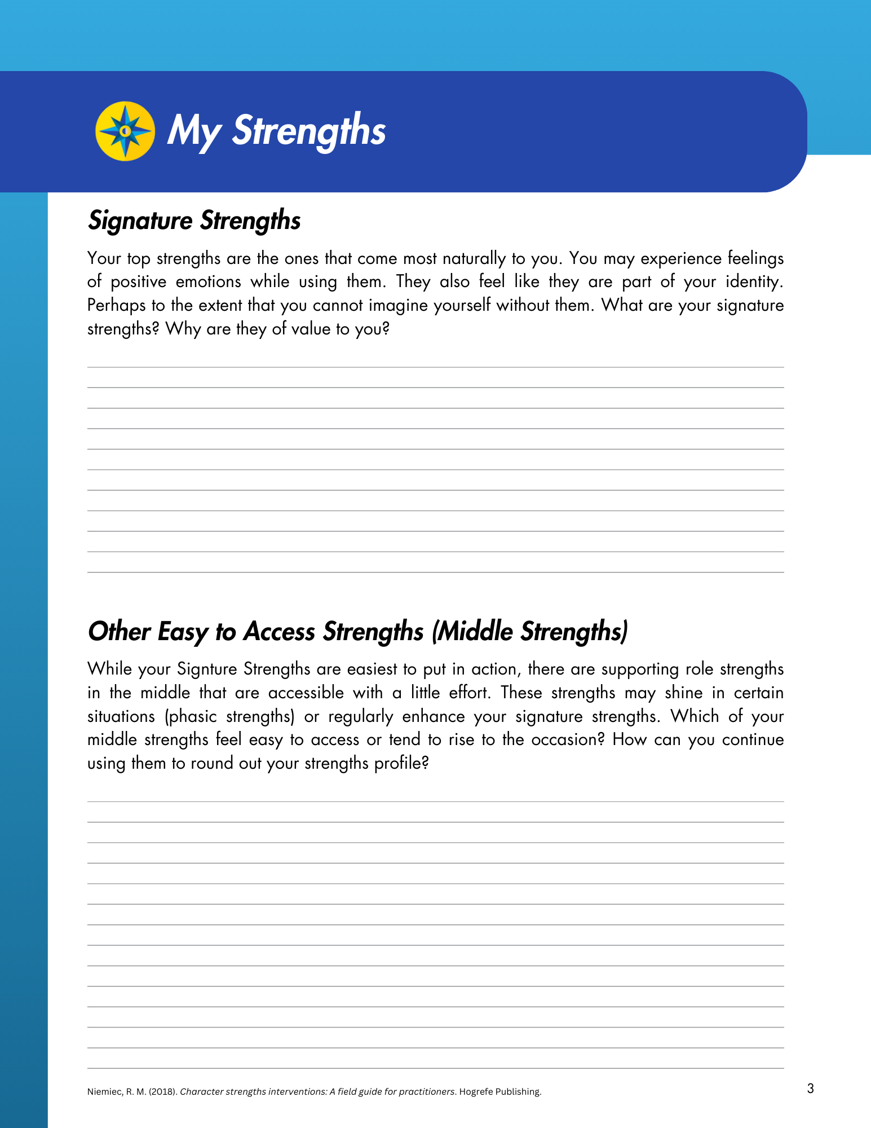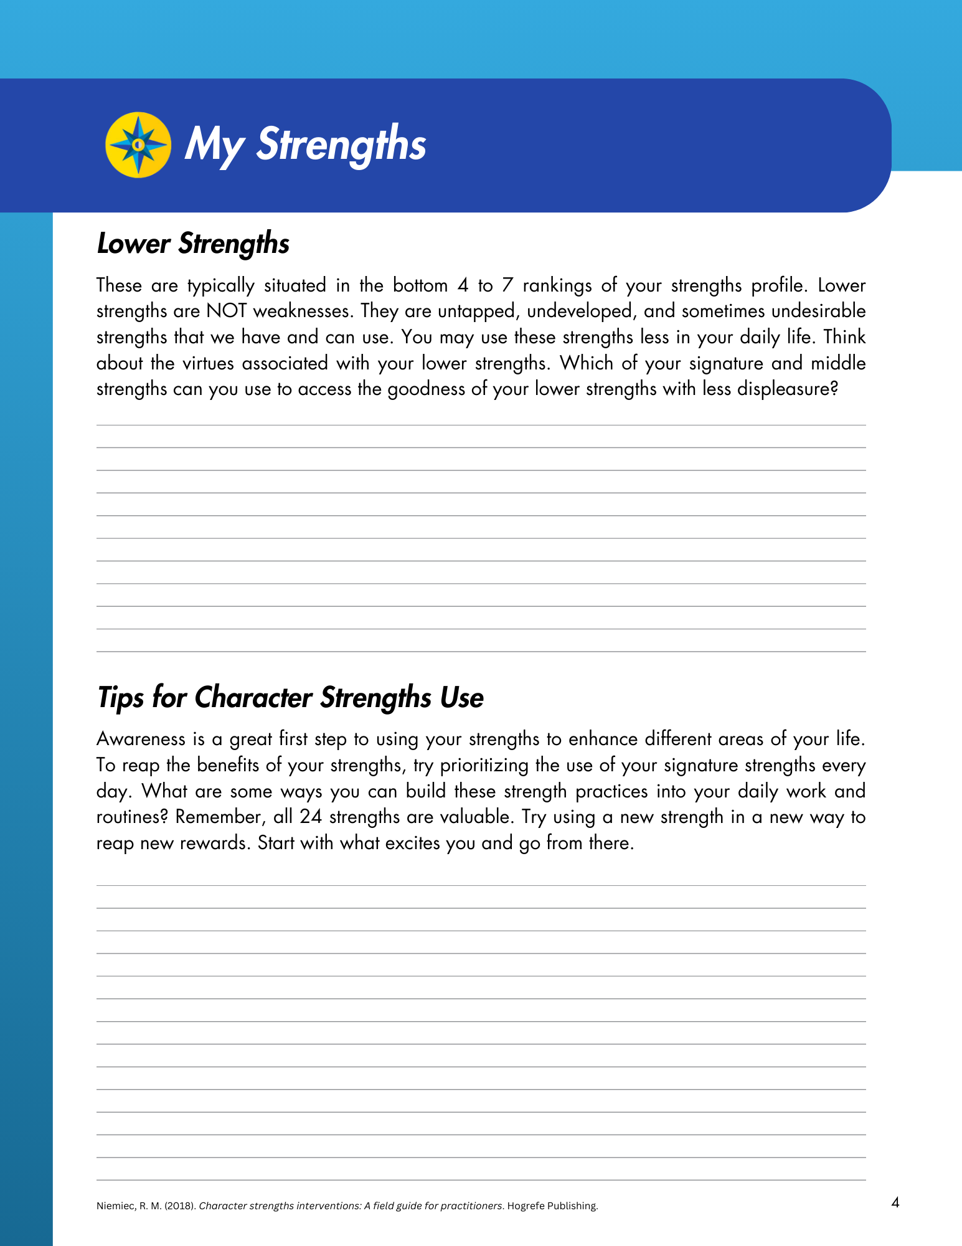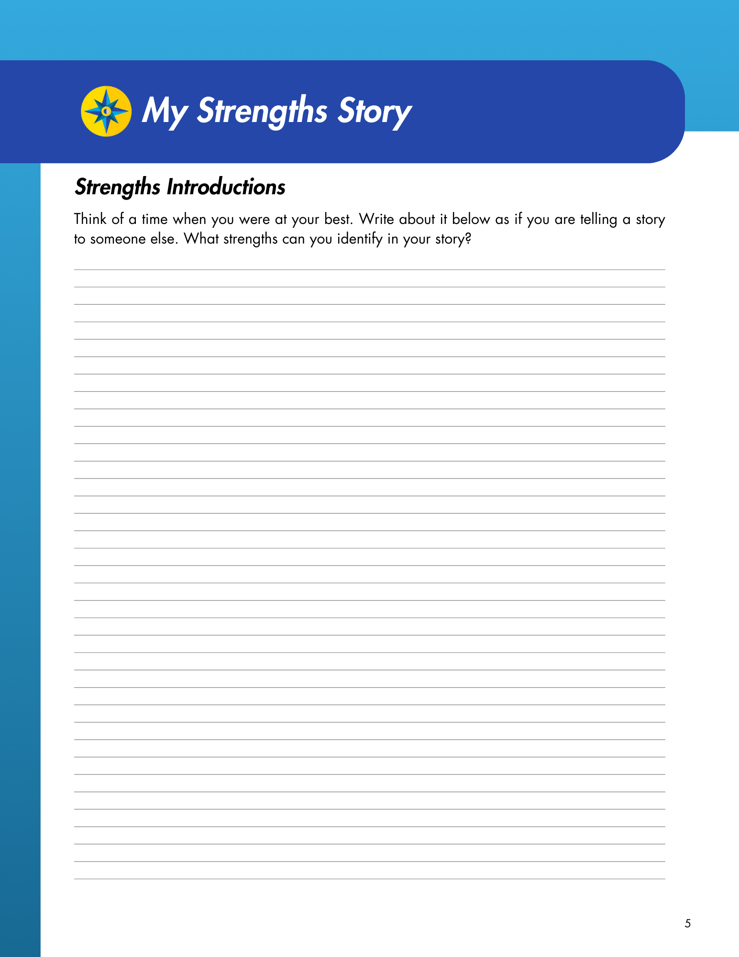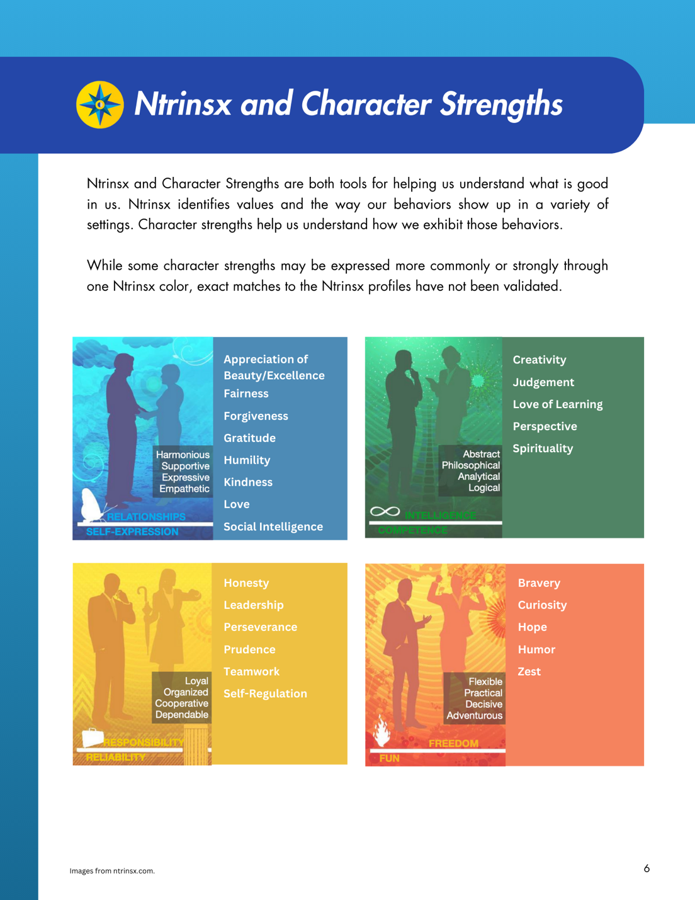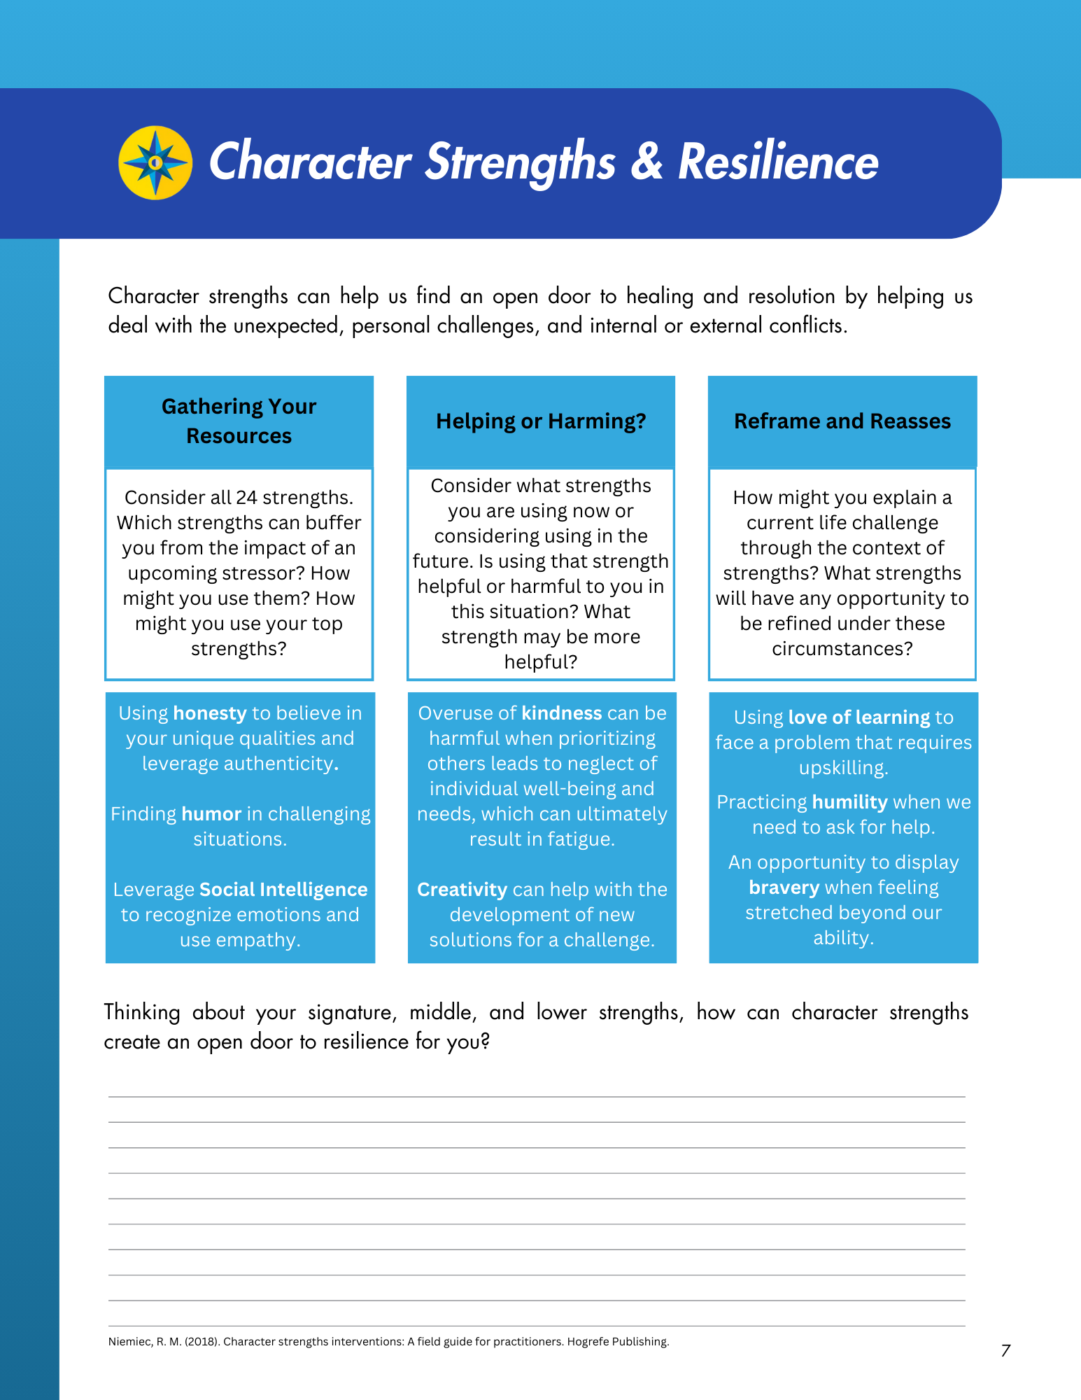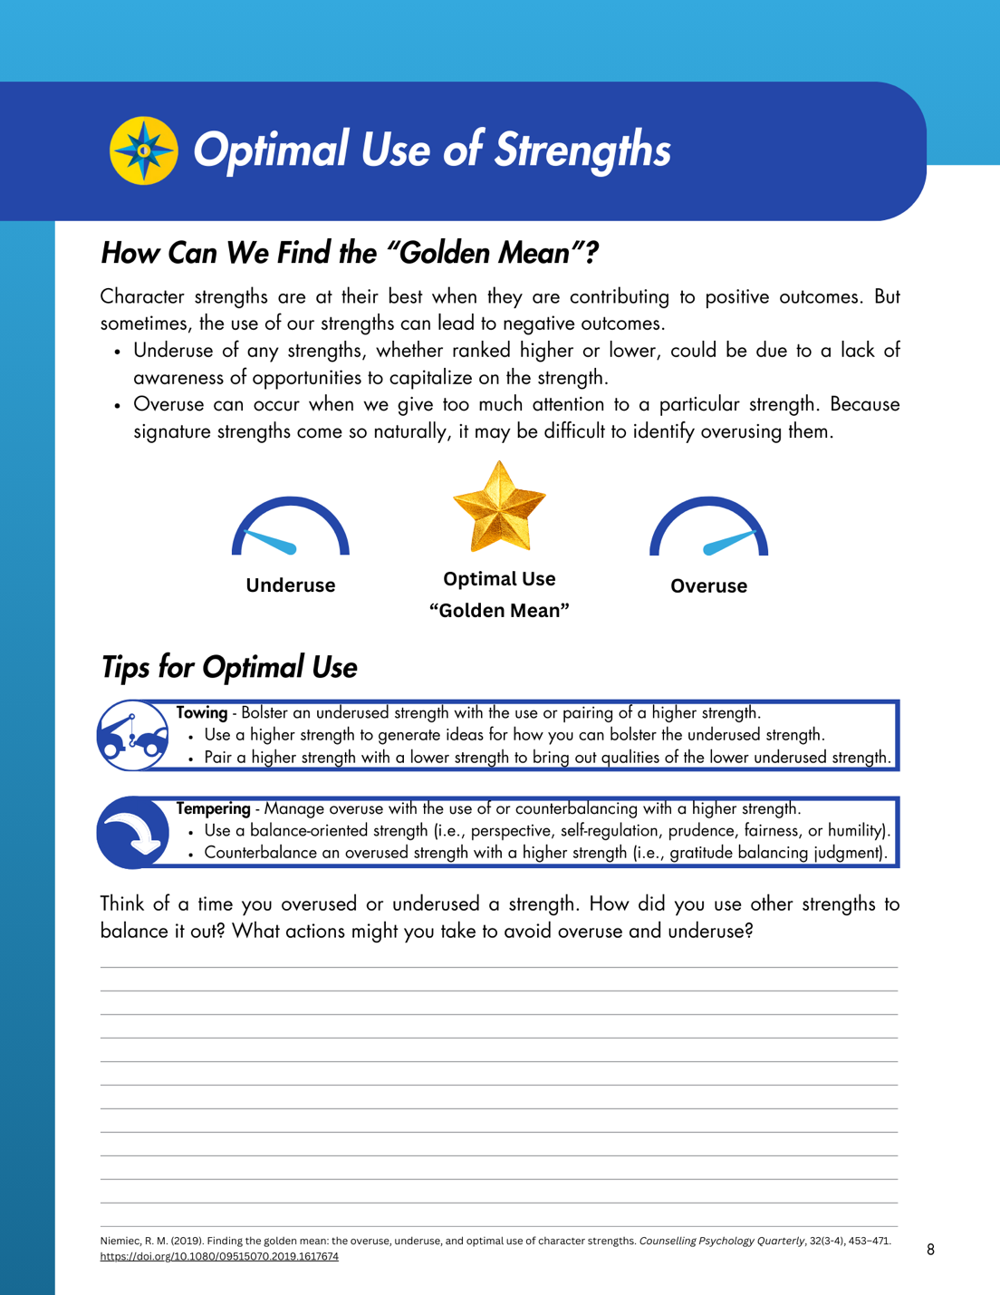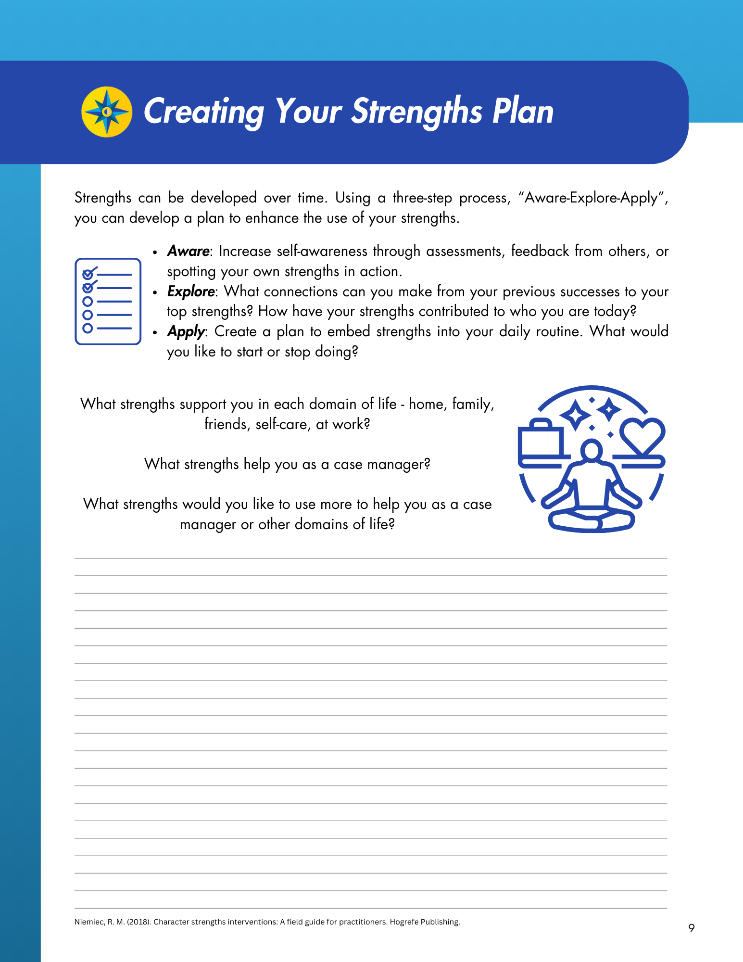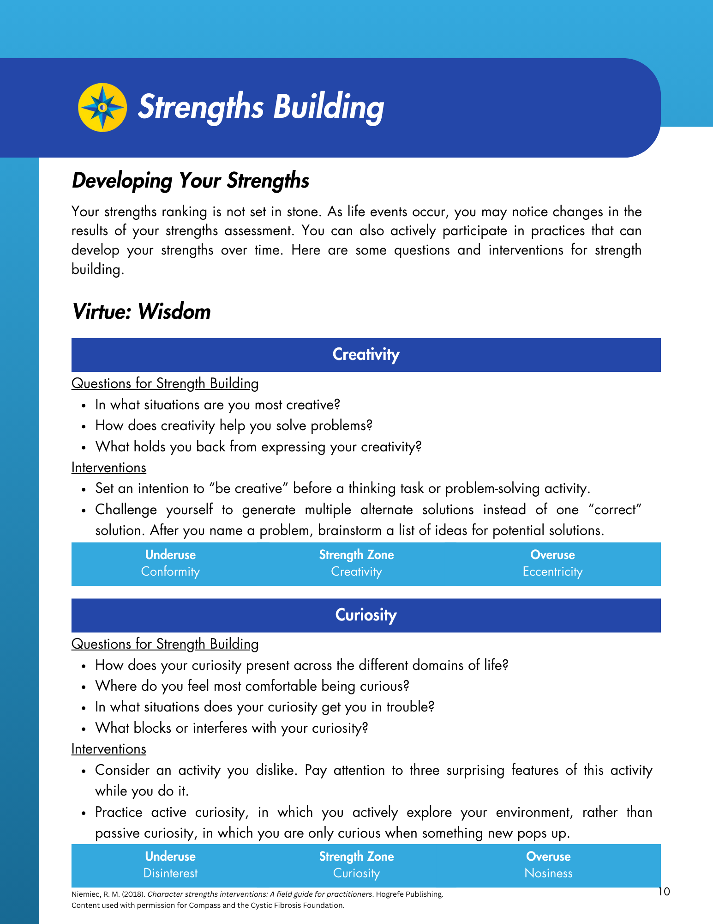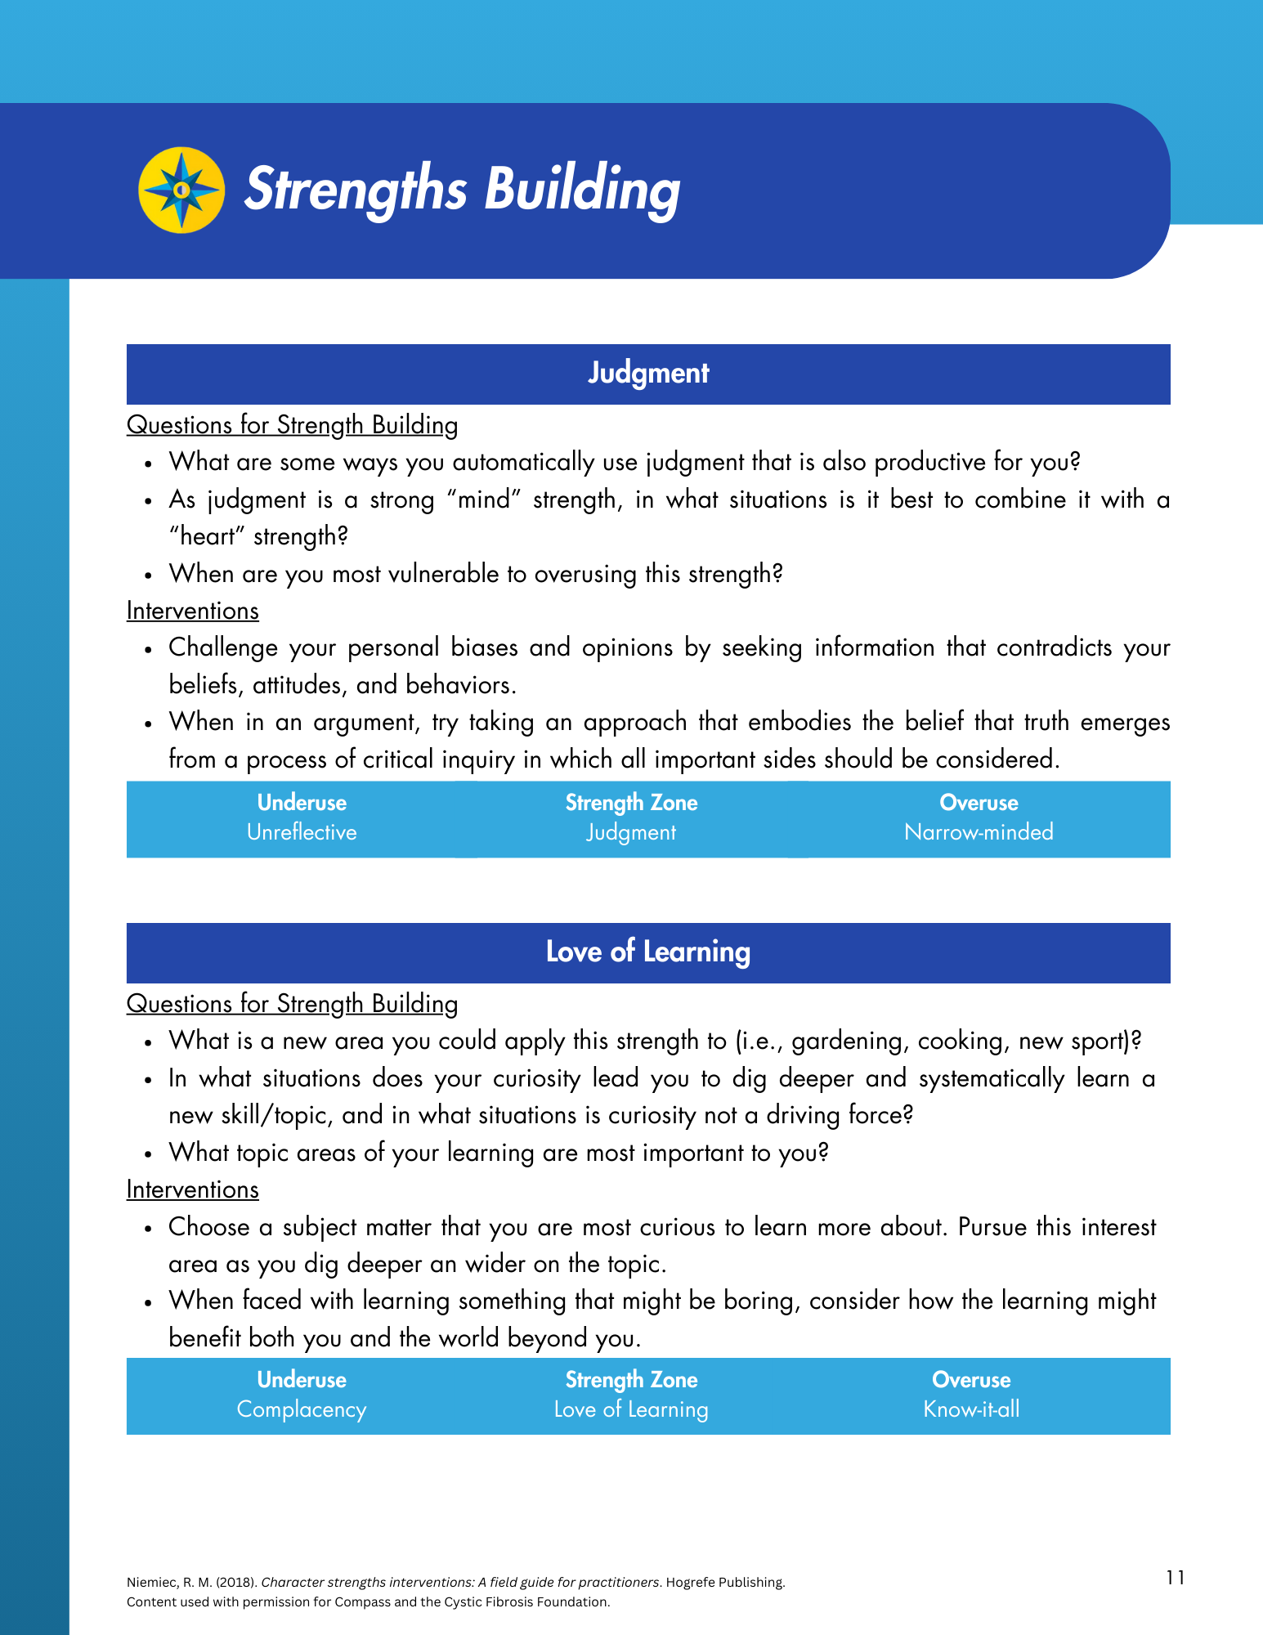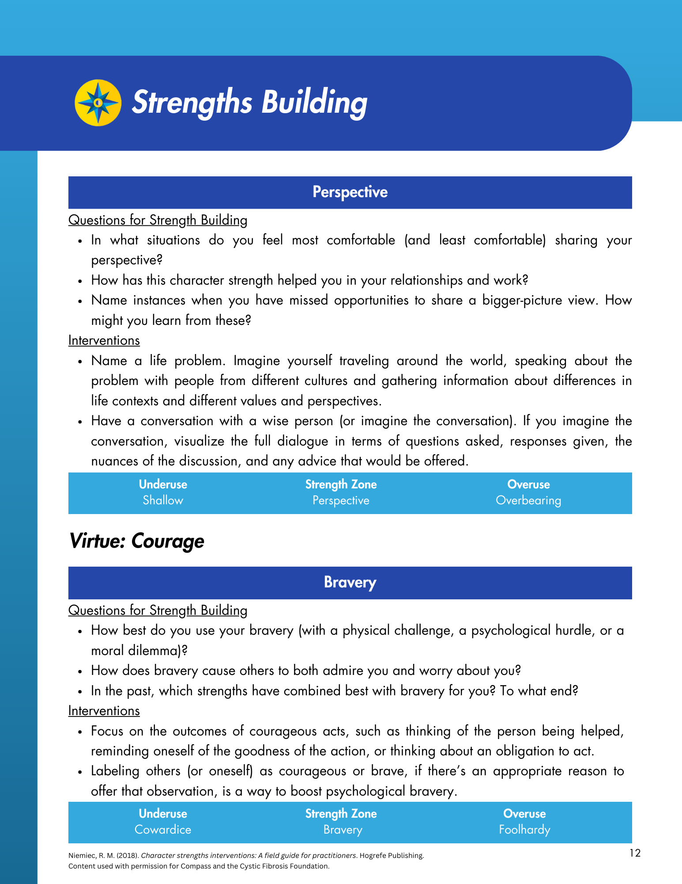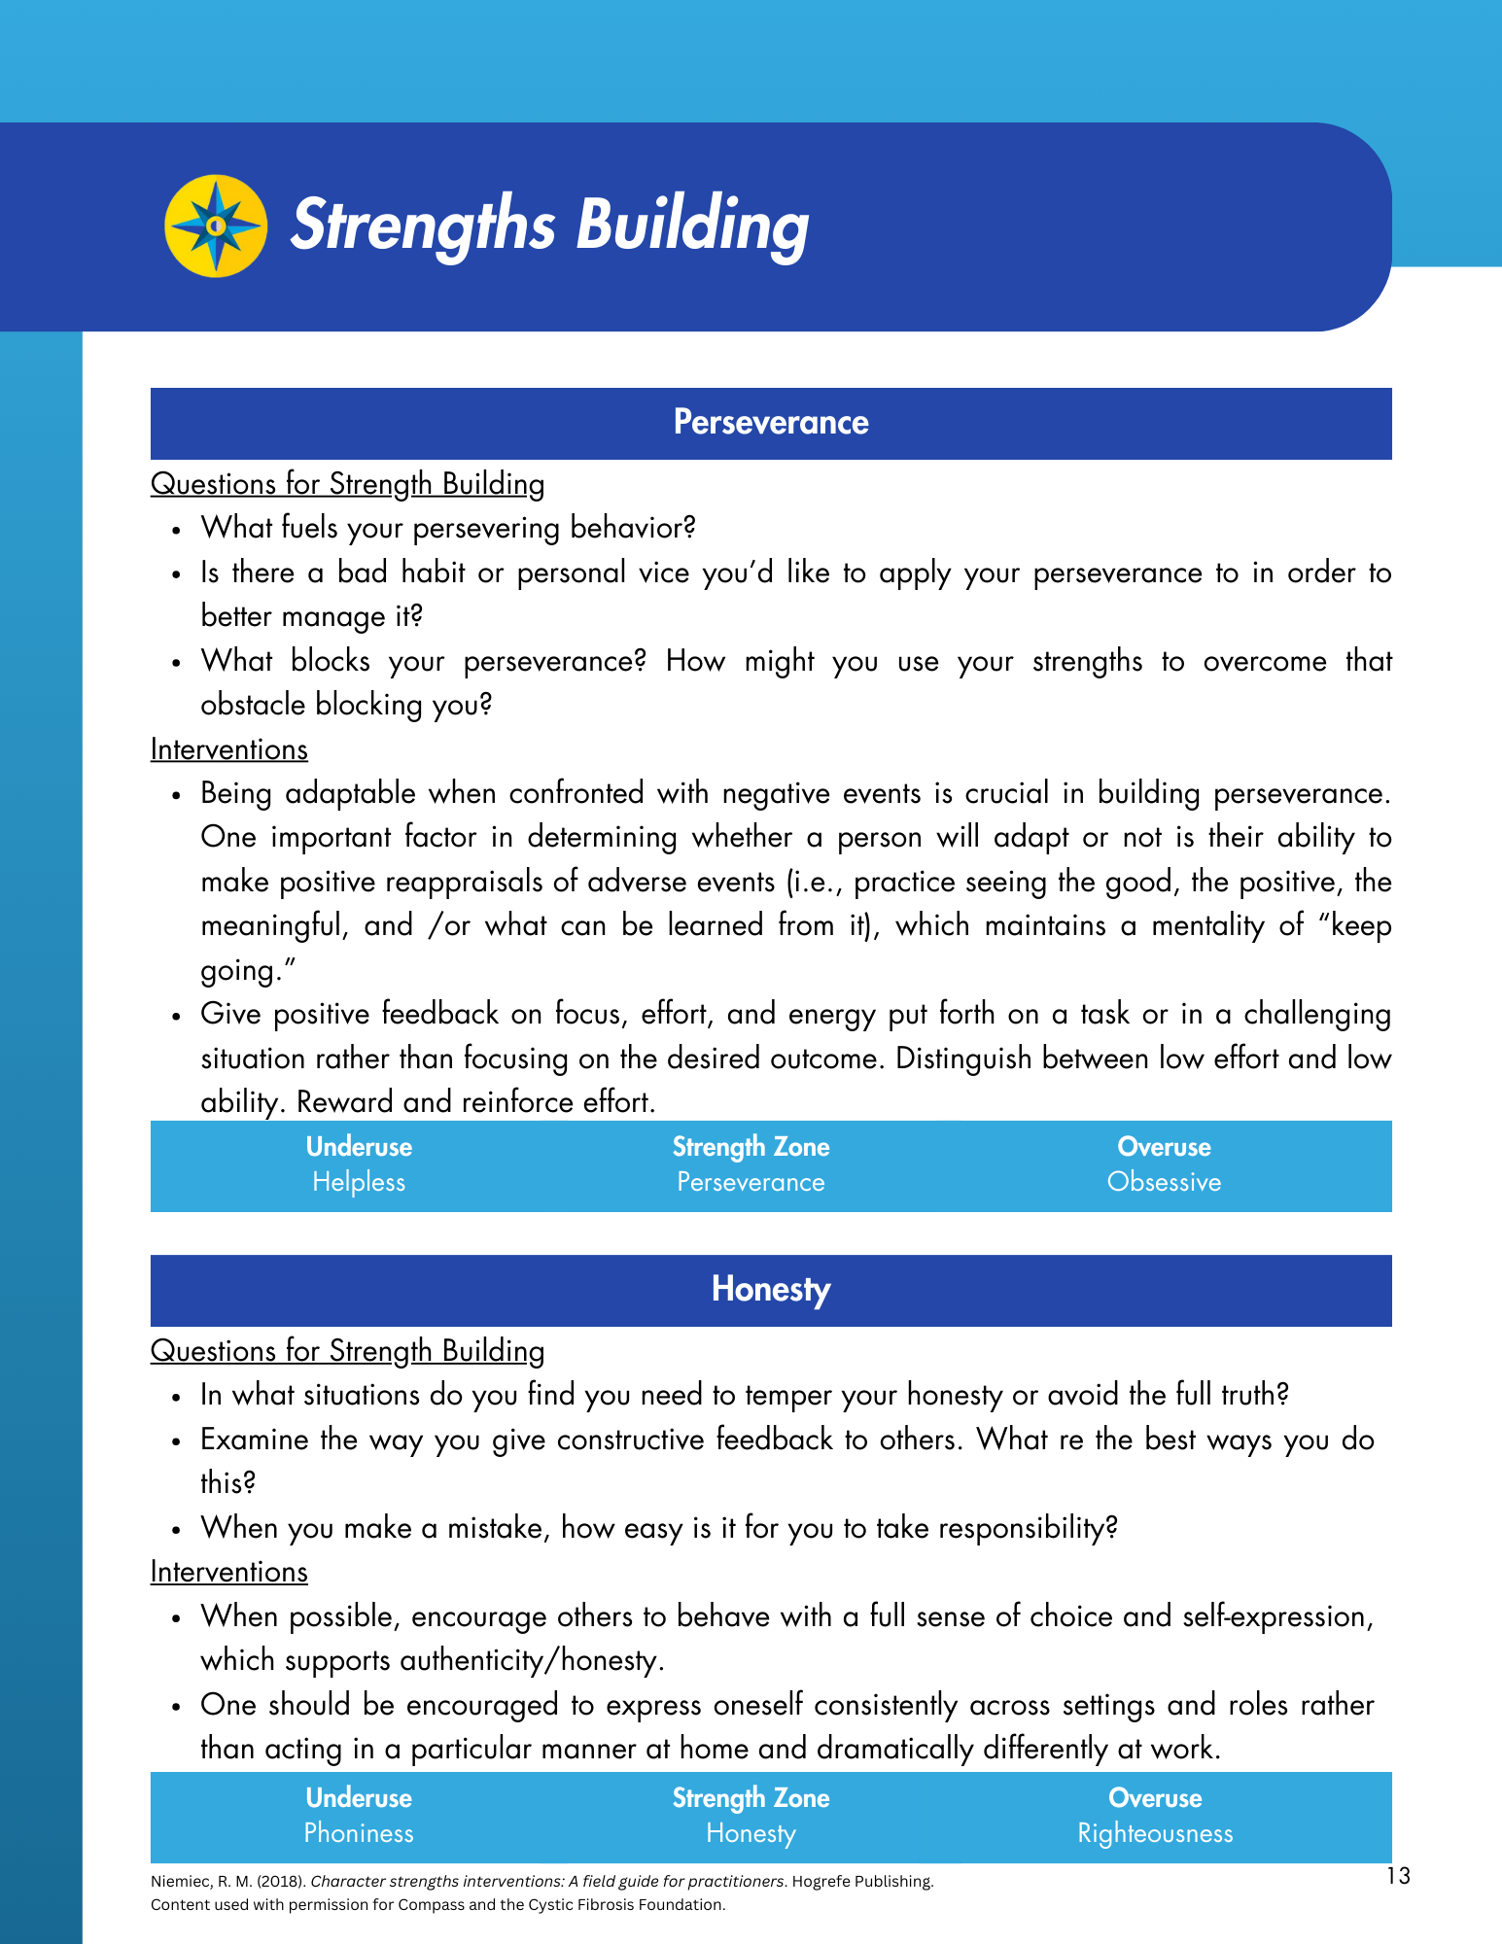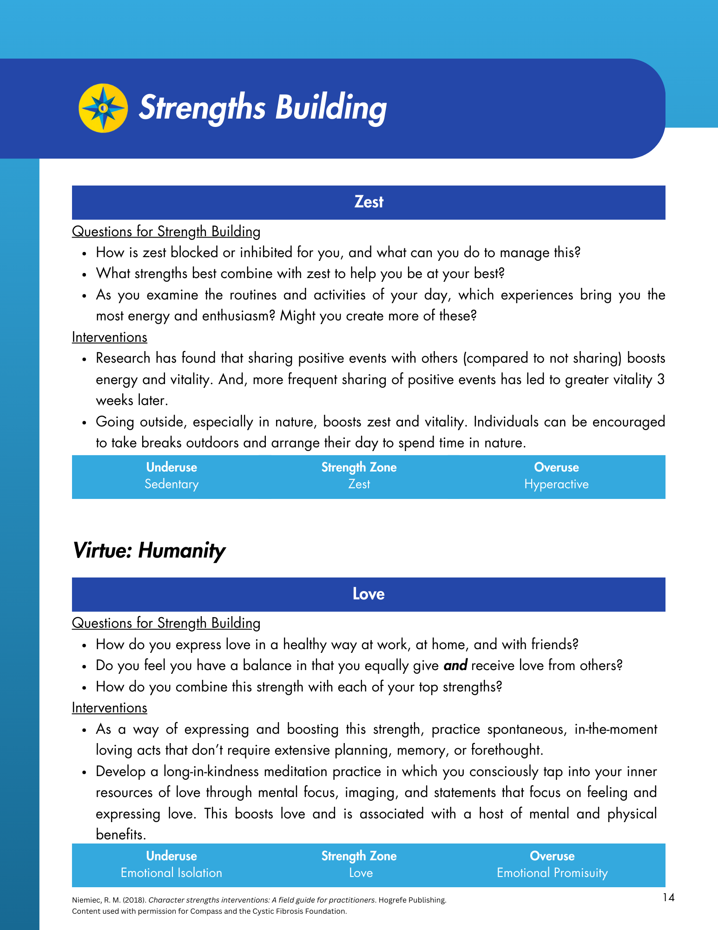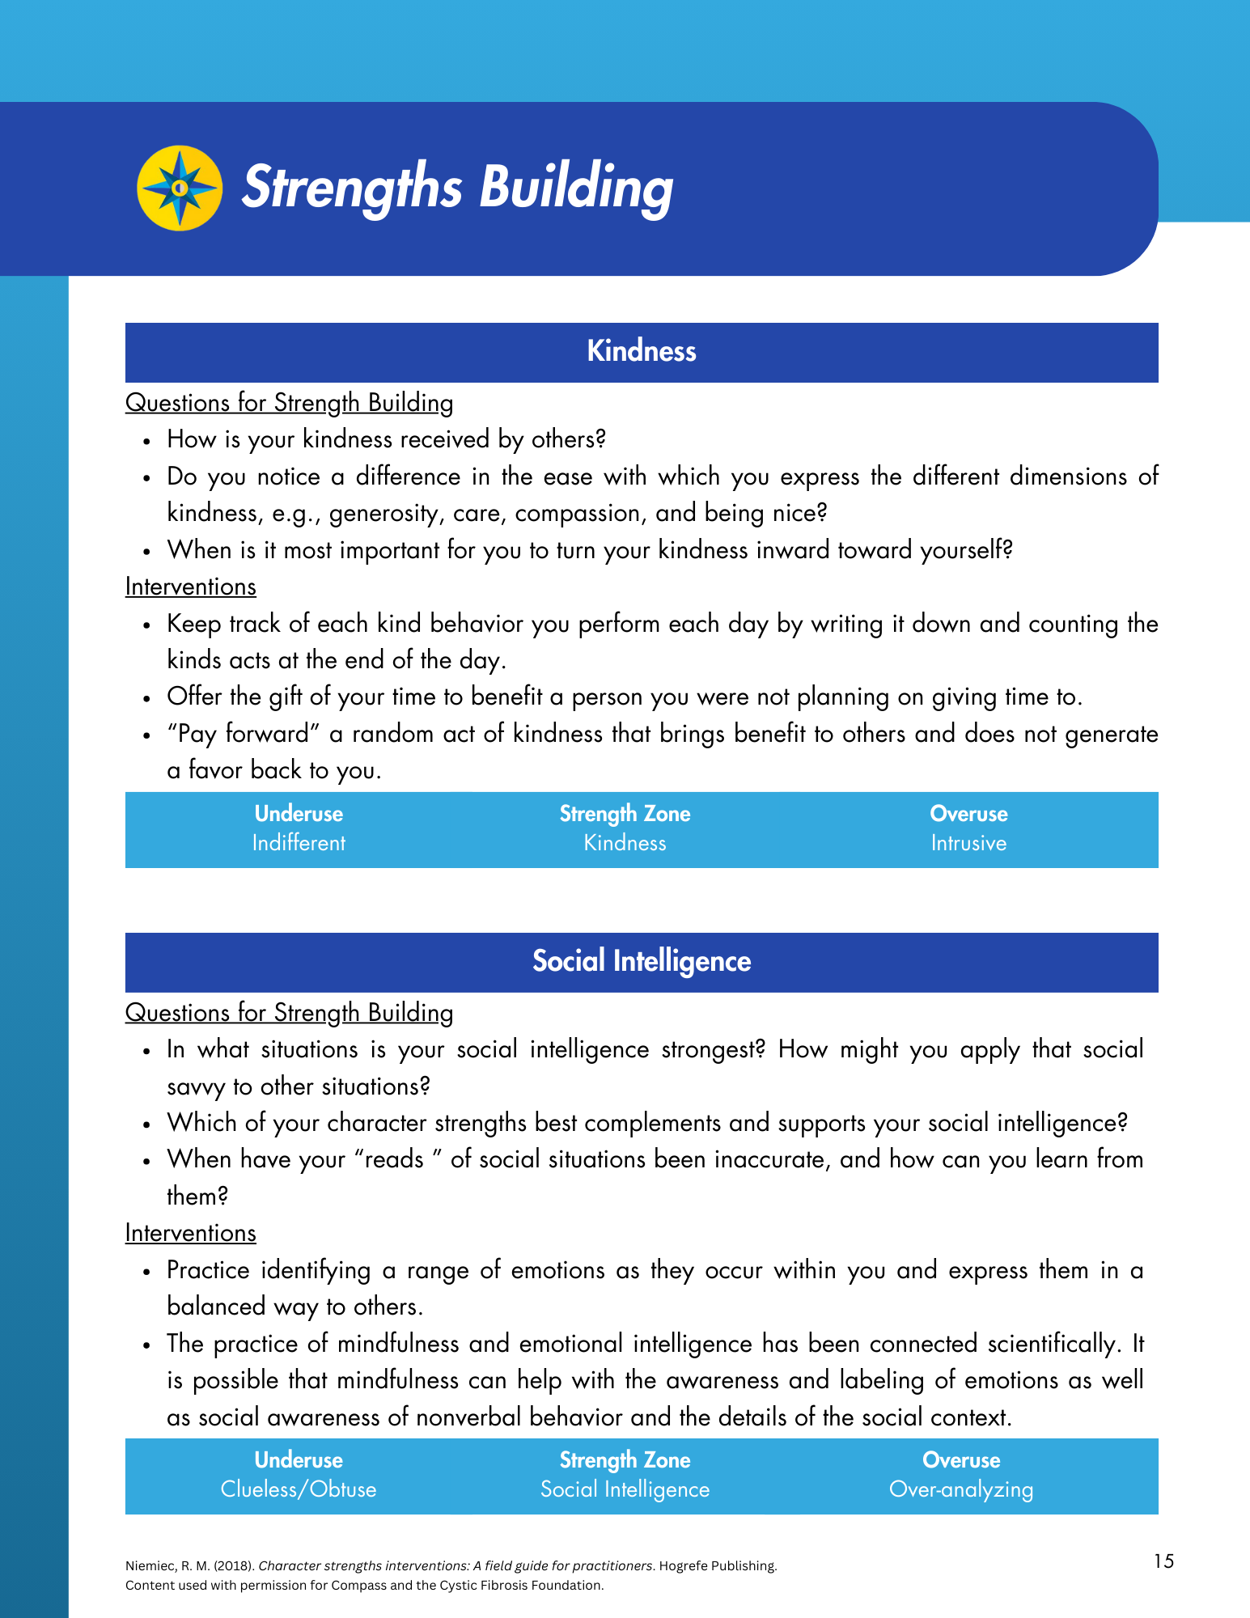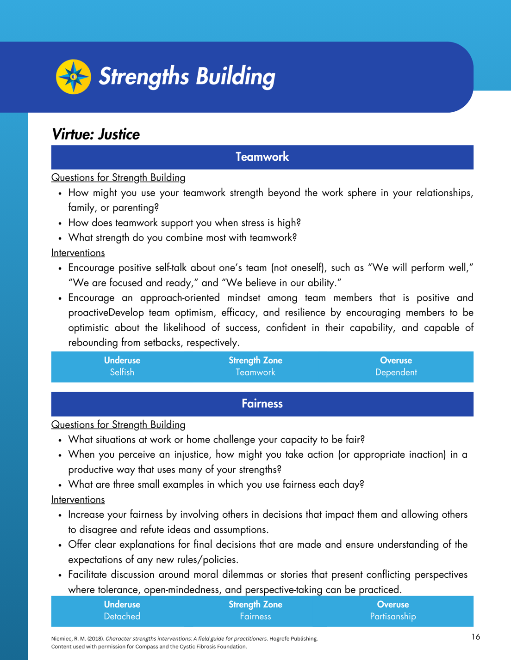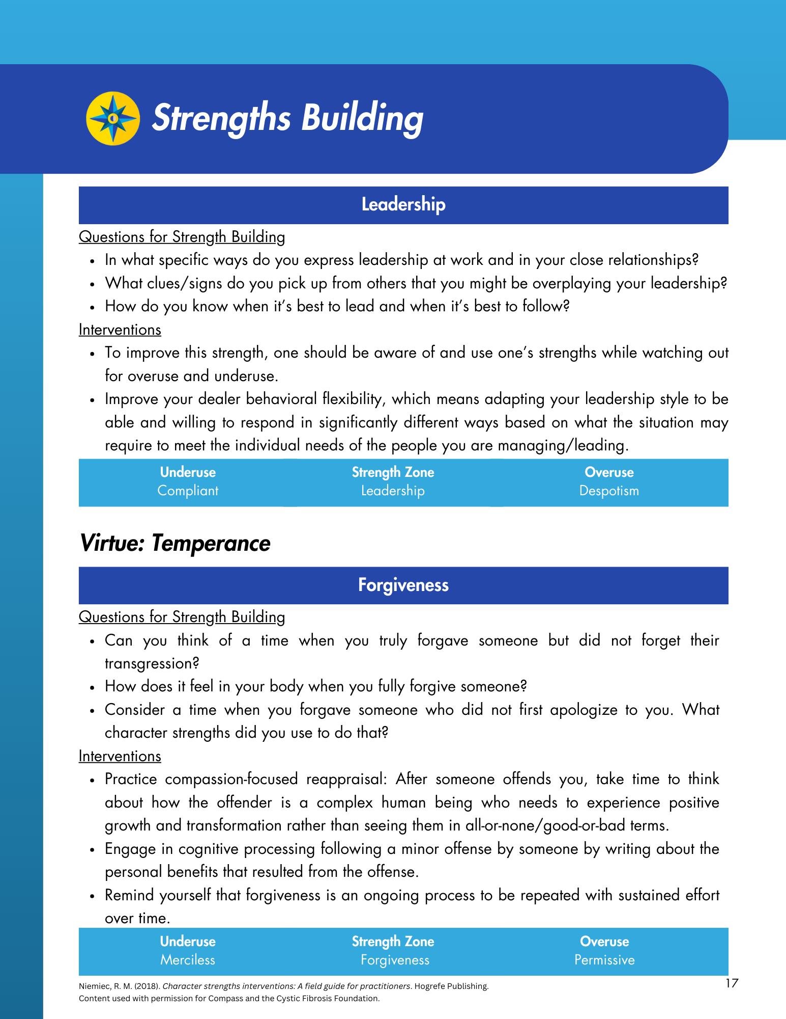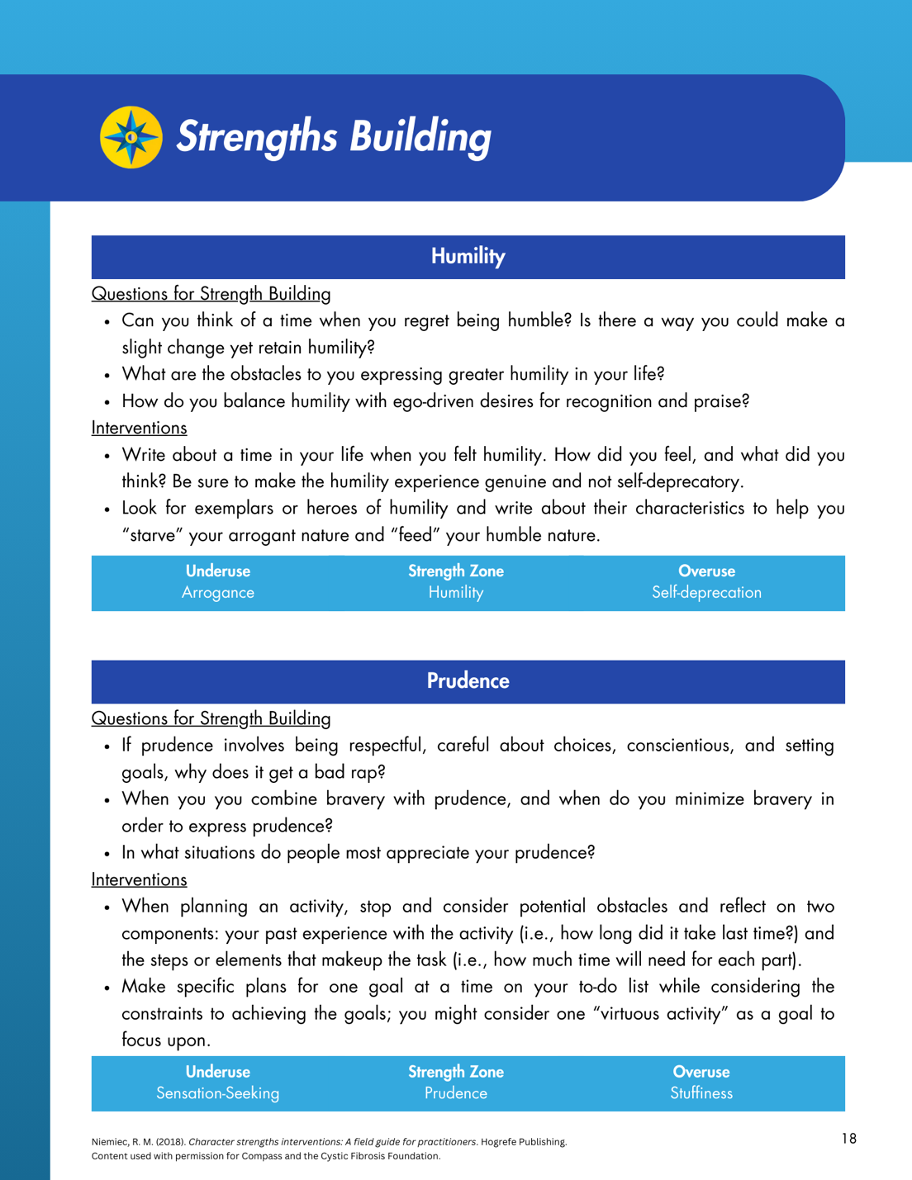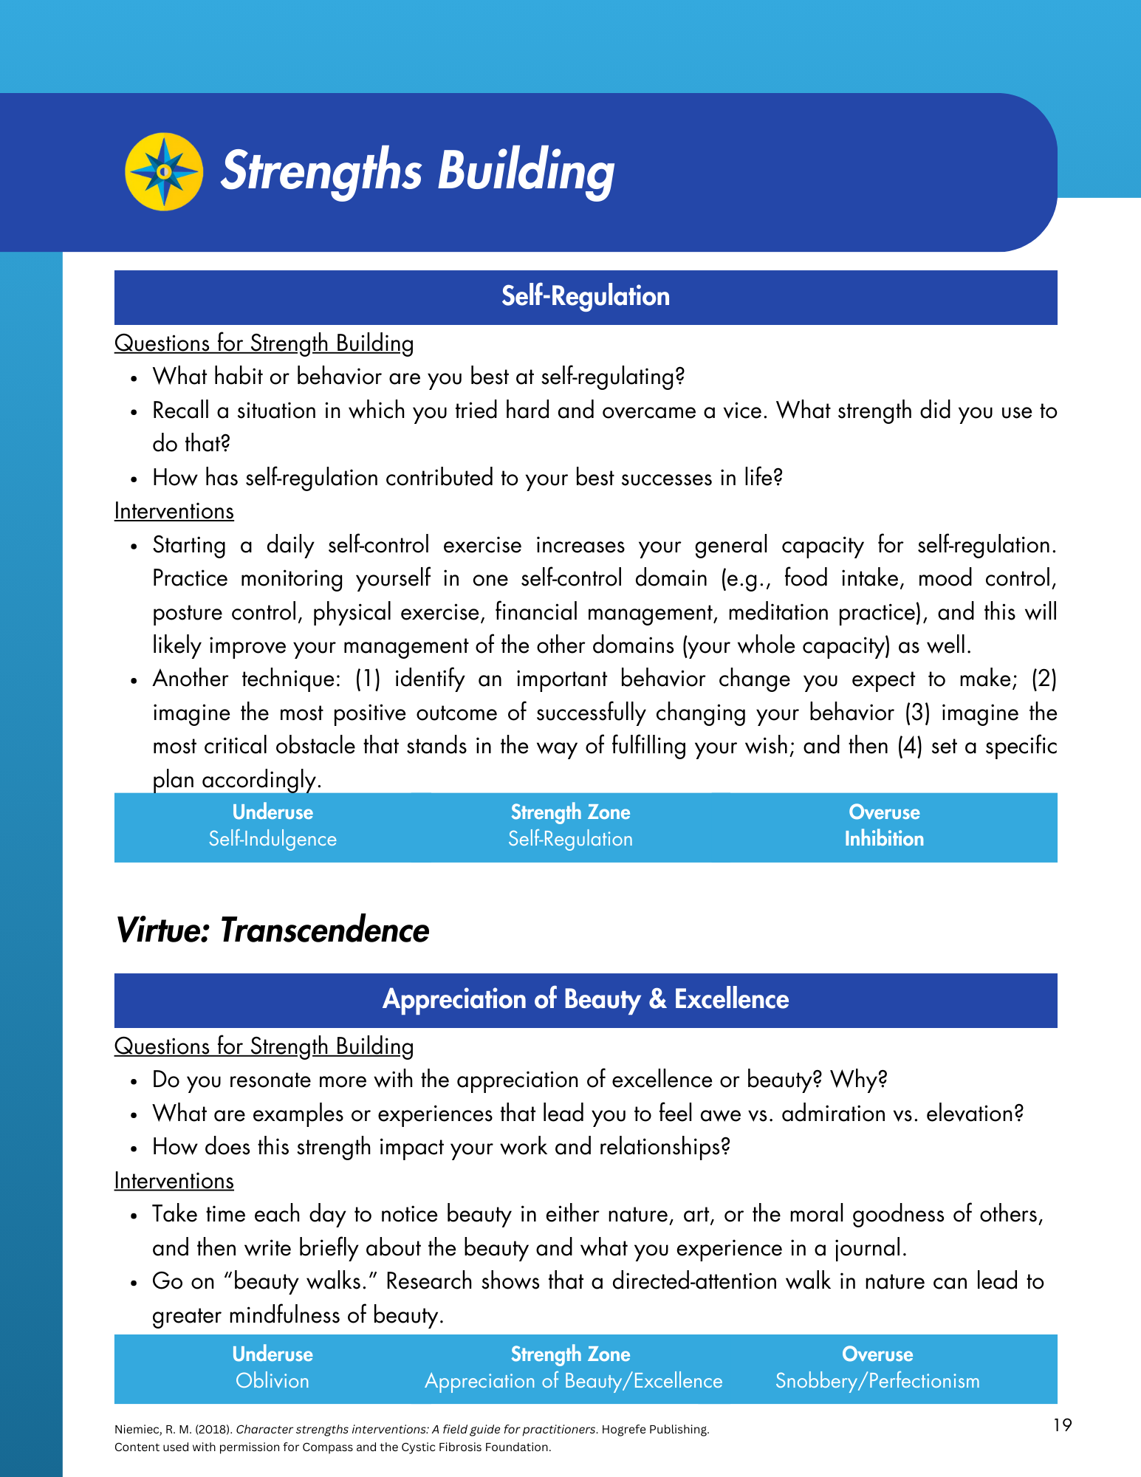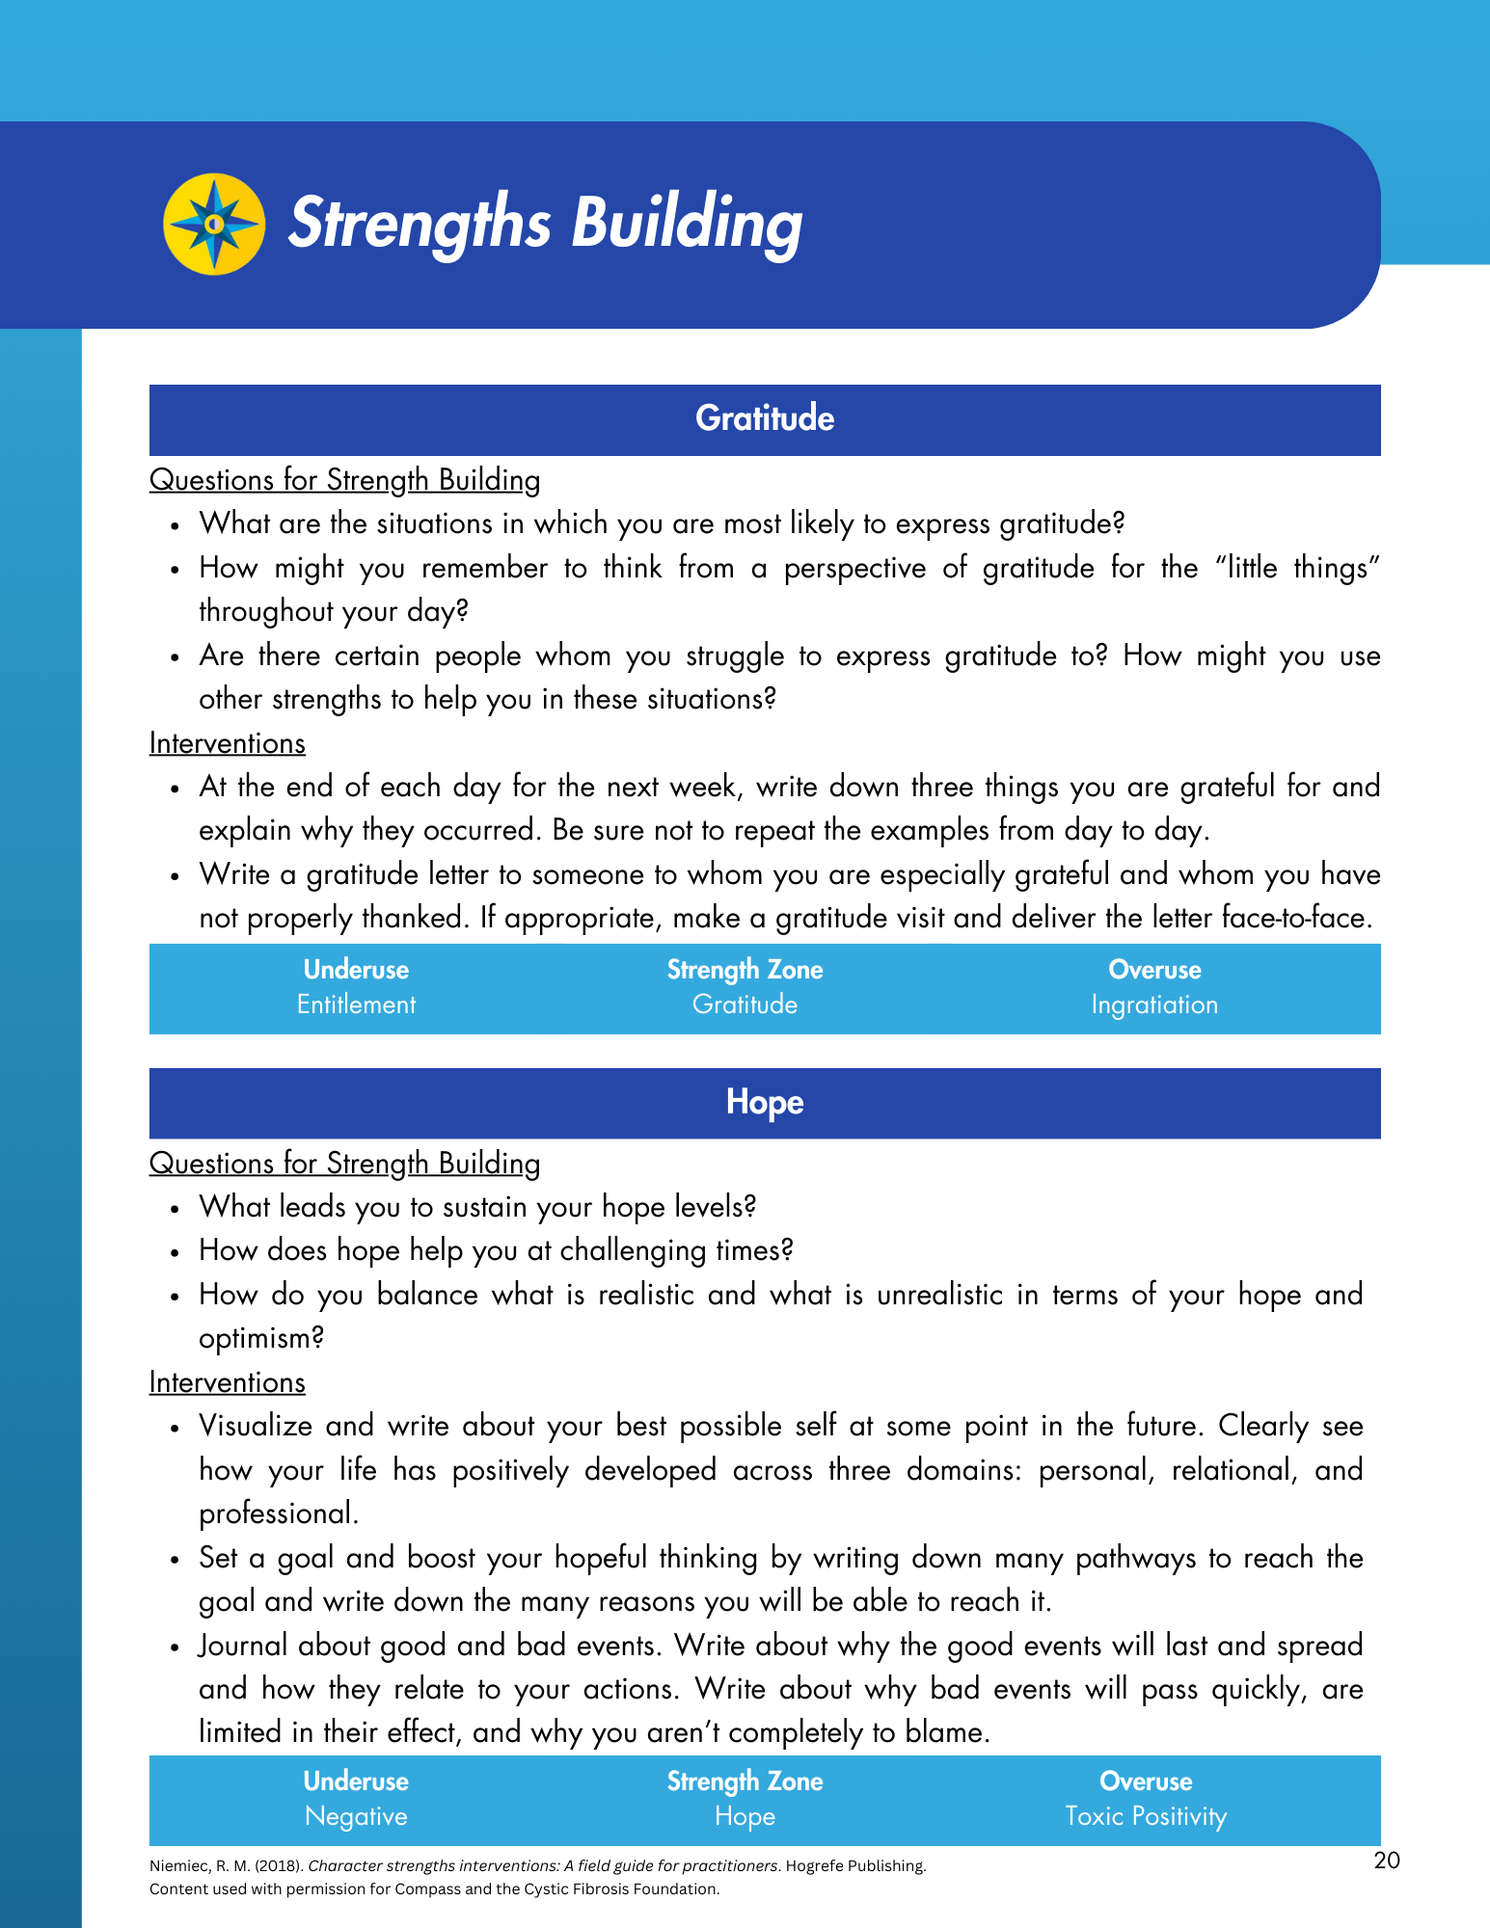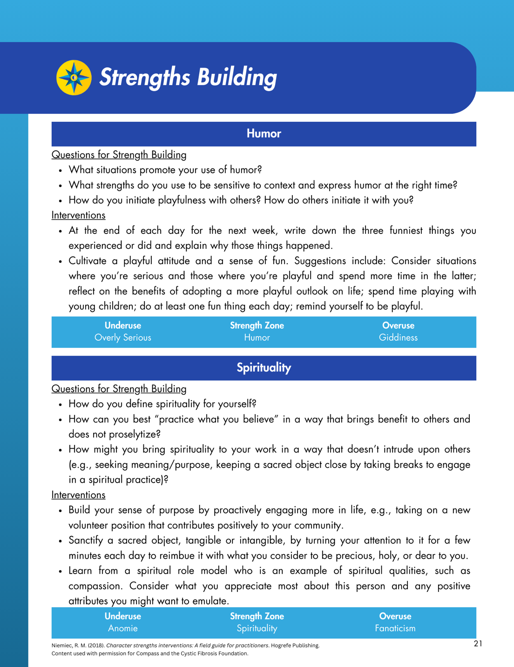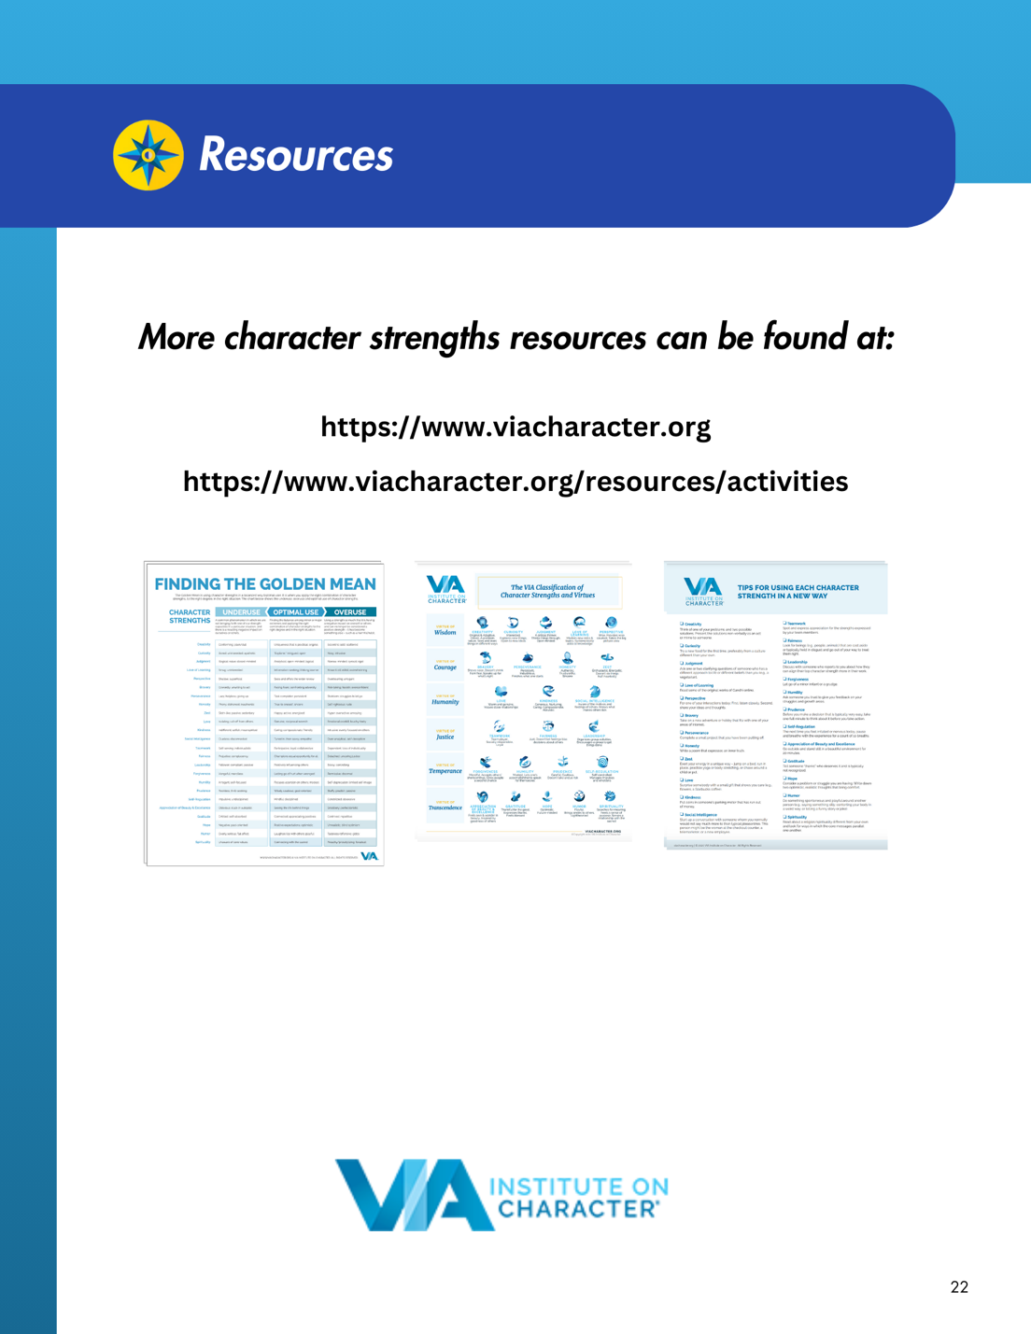

Appendix G
Team Leader Facilitation Guide – Team Culture + Character Strengths Activities
