

Evaluation of peri-implant bone level remodeling after immediate implant placement – Retrospective Study
Nasser Malek Mohammad, DDS
A Thesis
University of Pennsylvania, School of Dental Medicine
Presented to the faculties of the University of Pennsylvania inn Partial Fulfillment of the Requirements for the Degree of Master of Science in Oral Biology
2025
Advisor:
Dr. Joseph P. Fiorillini, DMD, DMSs _____________________________________
Thesis Committee
Dr. Jonathan Korostoff, DMD, PhD _____________________________________
Dr. Yu-Cheng Chang, DDS, MS, DMD. _____________________________________
Dr. Mohammad Qali, D.D.S, MS. _____________________________________
Dedication

I dedicate my dissertation work to my family who went through a lot during the time in residency. A special gratitude and appreciation for my better half my wife Fatmah for the all the support and help for the past four years. My sunshine, and positive energy source my daughters Zainab and Mariam and for the newcomer Yaseen. I apologize for the nights that you all went to bed, and I was not there and the days you woke up and I have already left, I promise I will make it up for you all. Finally, my family across the ocean their support and prayers were the blessing to get to this point.

Acknowledgments

To my mentor Dr. Fiorellini and faculty Dr. Korostoff, Dr. Chang, and Dr. Qali, whose guidance and support have been invaluable. Your wisdom, encouragement, and unwavering belief in my potential have inspired me throughout this journey. Thank you for challenging me to think critically, for nurturing my curiosity. This work is a testament to your dedication to education and to the countless students you have empowered. I also greatly grateful for all faculty at the Department of Periodontics and my co-residents and friends.

Abstract
Background: The use of dental implants has become the standard of care for the replacement of missing teeth. Due to the wound healing events that follow extraction of teeth it is well-documented that there can be significant remodeling/resorption of the alveolar bone. One approach that can be used to mitigate these processes is to place an implant directly into a fresh extraction socket. Thus, this retrospective study was conducted to evaluate the peri-implant bone remodeling taking place after immediate implant placement and will further evaluate the continuation of the remodeling after the insertion of the restorations.
Methods: Examination was completed in a retrospective fashion (n=155) by examining records for teeth that required extraction and were candidates for immediate implant placement. Evaluation of periapical radiographs (PA) was performed to measure changes in the position of the crestal bone relative to the implant platform over time (implant insertion, 3-month follow-up visit, impression visit, delivery of the final prosthesis and the follow-up of the final prosthesis if applicable.
Results: We found that marginal bone loss (MBL) occurred from the time of implant placement through the final follow-up visit. The extent of MBL varied between subjects.
The Restorative angle was significant higher for molar implant in mesial and the distal sites. Correlation of MBL with restorative emergence angle yield that REA was not correlated with the amount of bone loss.
Conclusion: The extent of MBL following immediate implant placement differed between subjects. Factors associated with the variability included the implant, position, and location provided information in regards to the REA but that finding was not significant for MBL.
Table of Contents
Cover Page
Dedication
Acknowledgement
Abstract
Table of Content
Chapter I – THE REVIEW OF THE LITERATURE
Introduction
Immediate implant placement
Peri-implantitis
Prosthetic Angle
Protocol of the study
CHAPTER II – THE THESIS
Introduction
Material and Methods
Study Sample and Inclusion Criteria
Exclusion Criteria
Data Collection and Grouping
Peri-implant Marginal Bone Loss:
At implant placement
3 month follow up
Impression appointment
Final prosthesis delivery
Follow up period duration and evaluation of marginal bone level of the final prosthesis
Statistical Analysis

Results
After implant placement
3 month follow up period
Impression appointment
Final prosthesis delivery
Follow up period duration and evaluation of marginal bone level of the final prosthesis Discussion
Conclusion
Bibliography

Chapter I
Review of the literature

Review of the literature
Replacement of patients’ missing teeth to provide better masticatory function and restore facial aesthetics represents a major challenge to the dental profession. The dynamic and innovate introduction of dental implants (Brånemark et al., 1969) has dramatically improved the outcomes that can be achieved. Noteworthy, replacement of teeth with dental implants is complicated by the alterations in alveolar bone morphology following an extraction.
The dental implant development went through extensive research and evolution to reach a recipe where the stability and predicable outcomes could be achieved. Those aspects included dental material and surface chemistry which were described in the following articles (Abrahamsson et al., 2004; Buser et al., 1991, 2004; Carlsson et al., 1988).
(2017) Buser et al. published an article titled “Implant placement post extraction in esthetic single tooth sites: when immediate, when early, when late?” and provided detailed information for each situation and scenario.
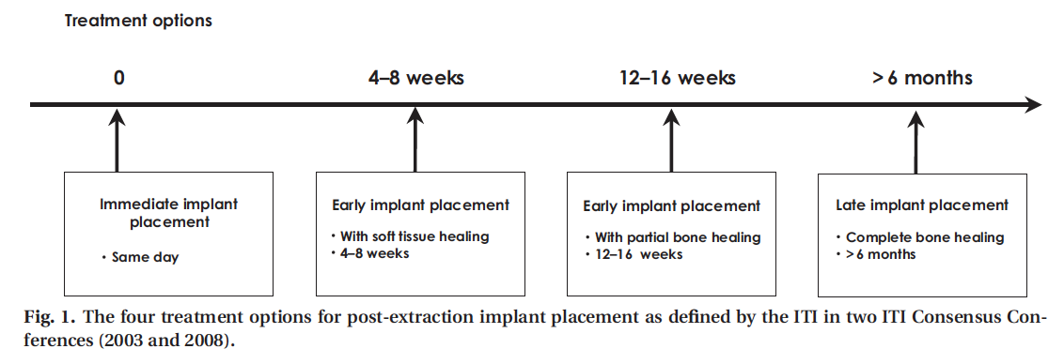
In the article Buser quoted the conclusions of an ITI consensus conference summarized in Fig. 1:
Where type I – would be the treatment of choice with flapless surgical procedure in site where ideal parameters exist such as think wall phenotype and thick gingival biotype.
Type II – Early implant placement with soft tissue healing – this would explain a site with a thin or damaged facial bone wall, but this site does allow correct implant position. This type would require raising full thick mucoperiosteal flap and will require contour augmentation to correct the deficiency.
Type III – Early implant placement with partial bone healing – This involves extended bone lesion with large periapical lesion which require partial bone healing prior to implant placement. At the stage where implant placement is applicable this type will require contour augmentation to correct the deficiency.
Type 4 – Late implant placement – (Buser et al., 2017) describe it as the least attractive treatment option for the patient due to the long treatment and possible multiple surgical intervention to reach the desirable outcome by restoring function and esthetics.
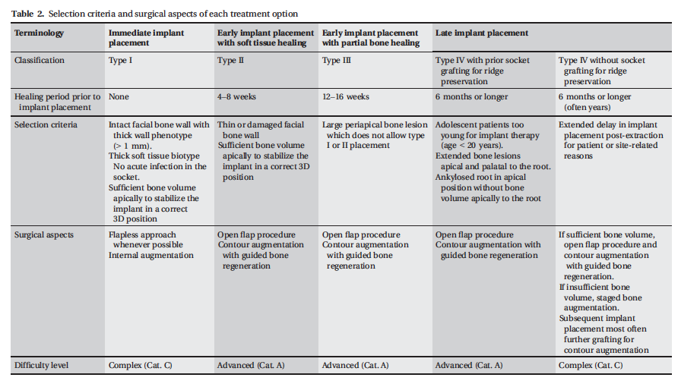
Immediate implant Placement:
(Schulte & Heimke, 1976) The concept of immediate placement of dental implant in fresh extraction socket was initially proposed by Germans in 1976, and this credit belong to Profs. Schulte and Heimke. This concept gained popularity due to the high aesthetics demand particularly in the anterior zone, significant reduction in the number of surgical interventions and a shorted treatment time.(Lazzara, 1989) Concluded that immediate implant placement helped preserve the integrity of the extraction socket in humans.
A systematic review conducted by (Lang et al., 2012) concluded the annual implant failure was 0.82% which in 2 year follow up the overall survival rate of 98.4%. Also, in the same article they concluded that about 20% of patients who received immediate dental implant with delay restoration suffered a suboptimal aesthetics outcome due to the buccal soft tissue recession.
(Cosyn et al., 2019) concluded it is that the success of immediately placed implants is case type-specific with multiple factors contributing to the likelihood of a favorable outcome. The authors suggested that < 10% of patients had sites amenable to immediate placement. Individuals with intact post-extraction buccal alveolar bone and a thick gingival biotype who underwent immediate implant placement and restoration crown experienced limited midfacial recession.
Peri-implantitis: (What is peri-implantitis)
(Berglundh et al., 2018) Referring to the consensus of the 2017 world workshop there are many terminologies that needs to be explained in detail to aid in having standard diagnosis and addressing conditions around dental implants.
Peri-implant health – and it was defined as site is characterized by absence of erythema, bleeding on probing, and the absence of swelling and suppuration.
Peri-implant mucositis – it was defined as the preserve of bleeding on gentle probing along with erythema, and/or suppuration may also be present.
Peri-implantitis – is defined as a plaque-associated pathological condition occurring in tissue surrounding dental implants and include all the clinical findings associated with peri-implant mucositis with the addition of subsequent loss of supporting bone around the dental implant.
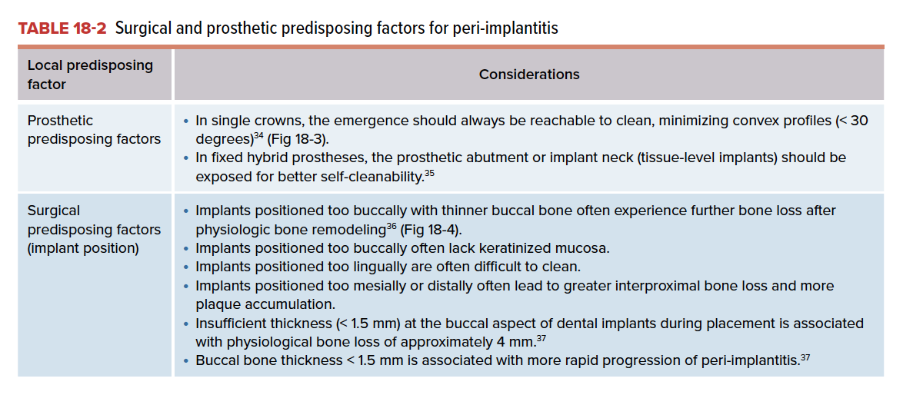
Prosthetic Angle:
In an era were peri-implantitis has been a growing issue and complication is dentistry. The prevalence of such issue been documented in the literature, and it ranges from 1%-47% (Derks & Tomasi, 2015). Patient having certain medical condition, history of periodontal disease, smoking, implant malposition have been linked to increase risk of peri-implantitis. Those studies focused of the biological/medical conditions in the prediction of the peri-implantitis, but those studies lacked the assessment of the restorative component which is the main goal and result of the implant placement in the first place.
(Yi et al., 2020) conducted a study with an aim to identify the influence of prosthetic features as a critical cofounder for peri-implantitis.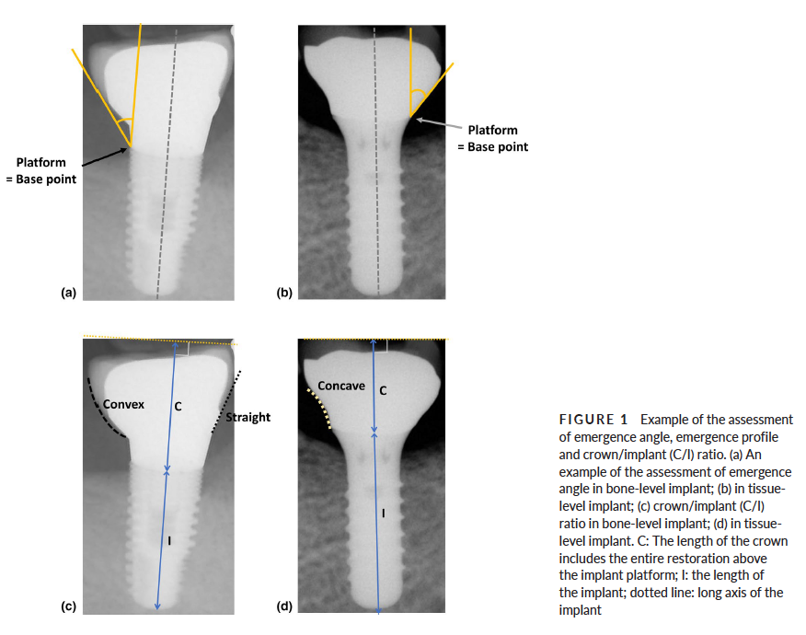
They concluded that over-contoured implant prosthesis is a critical local contributing factor for peri-implantitis, when the emergence angle is greater or equal to 30 degrees.
(Majzoub et al., 2021) Also investigated in a retrospective study the influence of restoration design on the progression of peri-implantitis.
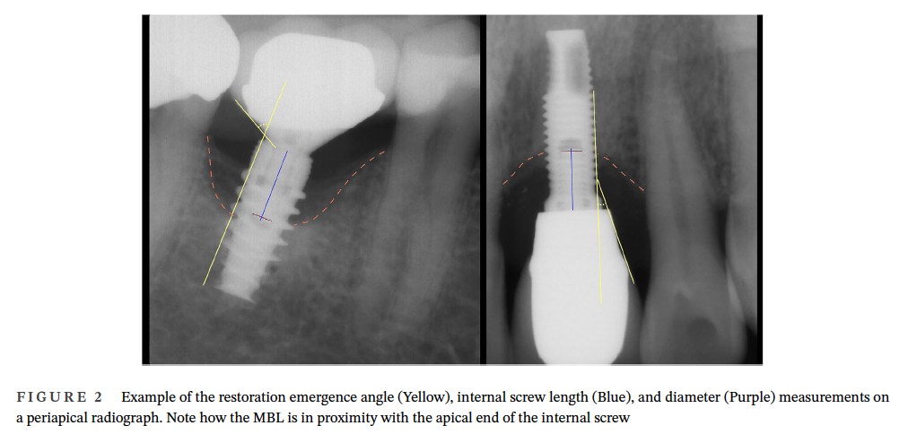
They concluded and confirmed the proposal from (Yi et al., 2020) that the restoration emergence angle of greater than 30 degrees were found to be significantly associated with early stage of peri-implantitis.
Protocol of the study:
In this retrospective study, evaluation of the peri-implant bone level remodeling will be assessed based on 2D evaluation from Peri-apical radiographs for immediate implant placement. The evaluation will conduct for cases were extraction and immediate implant placed occurred simultaneously. The data collection will be obtained from Axium software from the period of 2019-2024. Patient/Chart will be reviewed and categorized based on age, sex, medical condition, implant brand and length, and the follow up x-rays evaluation for the immediate implant placement, 3 months, 6 months, 1 year and finally two years follow up. During the evaluation bone remodeling will be measured through Image “J” for PA radiographs and emergence angle will be calculated for the final prosthesis and will evaluate if that have any implant on the peri-implant bone level.

Chapter II
Thesis

Introduction:
Replacing missing teeth to provide patients with better masticatory function and aesthetics is a major component of daily clinical practice. The dynamic and innovative introduction of endosseous dental implants by Brånemark and colleagues represented a major technological advancement in modern day dentistry. Noteworthy, the success of replacing teeth with implant-supported restorations dental implant can be complicated by morphologic changes in the alveolar bone that occur following extraction of teeth.
The concept of immediate placement of dental implant in fresh extraction sockets was initially proposed by Germans in 1976, and credit belongs to Profs. Schulte and Heimke (Schulte & Heimke, 1976). This concept gained popularity because it addresses the high aesthetic demands of patients particularly when replacing teeth in the anterior maxilla and significantly reduces the number of surgical interventions resulting in a shorted overall treatment time. Furthermore, Lazarra concluded that immediate implant placement helped preserve the integrity of the alveolar bone.
Long term success of dental implant requires stability of the peri-implant crestal bone level. It is relatively common that a degree of bone remodeling will occur following implant placement. One explanation for this is the body’s attempt to create sufficient space for reestablishment of the biologic width following exposure of the implant platform to the oral cavity (Albrektsson et al., 2017). This remodeling process needs to be distinguished from pathological bone loss, or peri-implantitis (Berglundh et al., 2018). Despite the initial peri-implant crestal bone remodeling that is recognized as part of the normal healing process, one needs to consider this with caution because the amount and the rate of the bone remodeling has a great impact on implant success and potential susceptibility to peri-implantitis (Galindo-Moreno et al., 2015).
Recently, investigators sought to evaluate the impact of two restorative factors on crestal bone remodeling following delayed implant placement: the transmucosal abutment height and the emergence angle (REA) of implant-supported crowns. The authors concluded that a transmucosal abutment height being of > 2 mm from the fixture level and REA of ≤ 30º will reduce the risk of peri-implantitis (PI) and marginal bone loss (MBL) (Misch et al., 2025).
This retrospective evaluation aims to evaluate the peri-implant bone level remodeling after immediate implant placement, during the 3 months follow up, during the impression visit, delivery of the final process and evaluation the peri-implant bone level changes after following up period after the fixture being loaded. The secondary goal is to determine whether the restorative emergence angle values (REA) and affects the extent of crestal bone remodeling.

Material and Methods:
Overview:
This retrospective evaluation was conducted in alignment with all ethical standards and proper protocols were followed. Also, this retrospective evaluation utilized data from Axium data base at the University of Pennsylvania School of Dental Medicine and data was anonymized and handled with compliance to all regulation which ensure confidentiality, and the privacy of human subjects included. This retrospective evaluation was approved by the University of Pennsylvania School of Dental Medicine, institutional Review Board for Human Studies (IRB Protocol #857448) which approve that procedures completed and conducted were in accordance with ethical protocols and standards.
Identification of subjects
In this retrospective evaluation, the data analysis conducted for patient seen at University of Pennsylvania School of Dental Medicine and underwent dental implant surgery (Bone level or Tissue Level Implants) and those implants were restored at the Periodontics, Oral Surgery, Prosthodontics and Faculty Practice clinics between Jan 2019 till December 2024.
Inclusion Criteria:
- Patient requiring single tooth extraction of primary or permanent dentition.
- Patient will receiving simultaneous implant placement after the extraction immediately.
- Patient included in this evaluation are 18 and older.
- Presence of periapical / bitewings radiographs for evaluation during the proposed phases.
- Implant information from manufacture, width, and length are available (For radiographic measurement calibration)
- Presence of adjacent dentition.
- Bone, and tissue level implants.
Exclusion Criteria:
- Full arch restoration.
- Multiple adjacent implants.
- Poor documentation (Crown/Implant junction is not visible).
- Lack of follow up x-rays/Impression or final delivery.
- Implant that underwent peri-implantitis treatment.
- Sites were previously treated due implant failures.
Data Collection
Axium data was filtered and extracted for patient underwent extraction/surgical extraction and immediate implant placement in the same visit. Data was extracted using these codes D7210 surgical removal or D7140 extraction and D6010 for the implant placement. Then each chart was reviewed and filtered based on the inclusion criteria. Relevant patient information was collected, which include patient age, gender, site require extraction, implant brand, implant length, implant diameter and loading status at the implant placement stage (Cover screw, healing abutment, custom healing abutment, or temporary crown). Then data was evaluated in details and x-rays was reviewed to calculate the peri-implant bone level at the implant placement (T0), 3 months follow up (T1), at the impression appointment (T2), after the delivery of the prosthesis (T3) and follow of the prosthesis if applicable (T4). Implant failure was identified as the removal, loss of the implant due to loss of osteointegration (n=16) (Albrektsson 2014)
Measurement of crestal bone levels
The measurements were completed utilizing Image J – Free software to measure the peri-implant bone level during the periods mentioned above. Implant length, or diameter was utilized to calibrate the measurements. Peri-implant bone level measured at T0, T1, T2, T3, T4 at the mesial and the distal aspect of the implant from the fixture level to the bone level surrounding the implant. In this review there is not clinical input from the status of the implant or other factors such as the shape of the final prosthesis in 3D format or the soft tissue thickness/quality around the implant.
Determination of restorative angle
The measurements were completed on both Mesial and distal aspect of the final prosthesis emergence angle utilizing Image J – Free software. REA was measured utilizing the implant platform as base point (Misch et al., 2025). Those finding grouped into two main categories based on the REA value which being greater than 30 degrees or less than 30 degrees.
Statistical analysis:
The primary objective of this retrospective review is to evaluate the peri-implant level changes during different period time frames (T0, T1, T2, T3, and T4). The secondary goal is to calculate the REA and investigate the impact this value has on the peri-implant bone level around dental implants.

Results:
Demographics:
The initial data included 218 charts to review (Pertaining to 205 patients, 99 males (45.4%) and 119 females (54.5%) average age for population included 59 year of age. After the evaluation of each chart and obtaining the x-rays records the remaining total of the population was 155 charts that was reviewed. A spreadsheet was created to include chart number, gender, age, medical history, tooth type (A: Anterior, PM: Premolar, M: Molar), implant brand, implant diameter and implant length, loading status (Cover screw, healing abutment, custom healing abutment or temporary crown), then peri-implant bone level values at (T0, T1, T2, T3, T4) and finally the restoration emergency angle.

Statistical analysis:
Data were initially managed and arranged in an Excel sheet (Excel Microsoft Software) and then imported to Stata version 16.1 software (StataCorp, CollegeStation, TX, USA) for analysis. The imported data were assessed for normal distribution using the Shapiro-Wilk test. The measurement data were expressed as mean ± sd (“sd" was standing for “standard deviation of the sample mean”) if they are normally distributed, the measurement data were expressed as the median and range or interquartile range (IQR) if they are not normally distributed. Baseline (T0) and marginal bone loss difference for (T0-T3) for mesial side were not normally distributed (P < 0.05). Wilcocxon signed rank test was used used to examine the differences between the initial (T0) and follow-up phases of marginal bone loss (T1,T2,T3,T4). Addtionally, to evaluate changes in bone level from baseline (T0) to the time of restoration delivery (T3), stratified by restorative emergence angle groups (>30° vs. ≤30°), Wilcoxon signed-rank tests were performed separately for mesial and distal sites.
To evaluate difference in MBL between REA groups (>30° vs. ≤30°) within each specific tooth type and site, an independent t-test was used. One-way ANOVA was used for comparison between multiple groups including REA, teeth positions and each site individually, and if homogeneity of variance was found, the Bonferroni test was used for post hoc multiple comparisons. Finally, Spearman rank correlation analysis was used for correlation analysis. P < 0.05 was considered to be a statistically significant difference.

Crestal bone changes
The comparison between the MBL measurements between baseline (T0) and subsequent time points (T1–T4) was carried out using wilcoxon signed-rank test as non-parametric test for all teeth together in Table 1.. Paired comparisons of bone levels between baseline (T0) and subsequent follow-up timepoints (T1–T4) revealed a consistent trend of MBL following immediate implant placement. The median MBL from T0 to T1 was 1.00 mm (IQR: 1.75 mm), increasing to 1.50 mm (IQR: 1.00 mm) at T2. At the time of restoration delivery (T3), the median MBL reached 2.00 mm (IQR: 1.50 mm). This value remained stable at the final follow-up (T4) with a median of 2.00 mm and a slightly wider IQR of 2.00 mm, indicating increased variability among participants. These results confirm that the observed MBL at each phase was statistically significant compared to baseline.
Table 1: Marginal Bone Level Changes Over Time
Parameter | MBL mm  Median (Range) | p-value
Difference T0–T1 | 1.00 (2.00 − 0.25) | < 0.001
Difference T0–T2 | 1.50 (2.00 − 1.00) | < 0.001
Difference T0–T3 | 2.00 (2.50 − 1.00) | < 0.001
Difference T0–T4 | 2.00 (3.00 − 1.00) | < 0.001
Comparison made using non-parametric Wilcoxon signed-rank test. Signficnat level at p<0.05

T0–T3 MBL Differences Stratified by Restorative Emergence Angle:
The assessment of the difference between bone level from baseline (T0) to the time of restoration delivery (T3), stratified by REA groups (>30° vs ≤30°), using Wilcoxon signed-rank tests were performed separately for mesial and distal sites Table 2. The median marginal bone level (MBL) change from baseline (T0) to restoration delivery (T3) was 2.0 mm across all REA groups (>30° and ≤30°) and both mesial and distal sites. Interquartile ranges (IQRs) were similar, ranging from 1.0 to 3.0 mm for REA >30°, and 1.0 to 2.0 mm for REA ≤ 30°. Despite the similar magnitude of bone loss, Wilcoxon signed-rank tests indicated statistically significant changes within all groups (p < 0.001), confirming consistent MBL reductions over time.
Table 2. T0–T3 MBL Differences Stratified by Restorative Emergence Angle
Parameter | Restorative Emergence Angle | MBL mm Median (Range) | p-value
Difference T0–T3 Mesial | >30 | 2.0 (1.0–3.0) | < 0.001
Difference T0–T3 Distal | >30 | 2.0 (1.0–2.0) | < 0.001
Difference T0–T3 Mesial | ≤30 | 2.0 (1.0–2.0) | < 0.001
Difference T0–T3 Distal | ≤30 | 2.0 (1.0–2.0) | < 0.001
Comparison made using non-parametric Wilcoxon signed-rank test. Signficnat level at p<0.05

Comparison of MBL in different implant sites for REA > 30° and ≤ 30°:
The Independent t-test revealed that the differences were not statistically significant when comparing the amount of MBL for REA >30° and ≤30° for anterior, premolar and molar implant position and sites. (P > 0.05) Table 3. The mean MBL values were comparable between groups across all positions and sites, suggesting that emergence angle alone did not significantly impact the extent of bone remodeling following implant placement.

Table 3. Comparison of MBL for Restorative Emergence Angle >30° and ≤30°.
Position | Restorative Emergence Angle | MBL mm  Mean ± sd | p-value
Anterior Mesial | >30 | 1.96 ± 1.19 | 0.76
Anterior Distal | >30 | 1.87 ± 0.99 | 0.63
Premolar Mesial | >30 | 1.65 ± 1.42 | 0.90
Premolar Distal | >30 | 1.22 ± 1.09 | 0.77
Molar Mesial | >30 | 1.22 ± 1.09 | 0.40
Molar Distal | >30 | 1.68 ± 1.26 | 0.88
Anterior Mesial | ≤30 | 2.07 ± 1.10 | 0.76
Anterior Distal | ≤30 | 1.71 ± 1.13 | 0.63
Premolar Mesial | ≤30 | 1.60 ± 1.47 | 0.90
Premolar Distal | ≤30 | 1.57 ± 1.14 | 0.77
Molar Mesial | ≤30 | 1.60 ± 1.10 | 0.40
Molar Distal | ≤30 | 1.75 ± 1.04 | 0.88
Comparison made using parametric Independet t-test. Signficnat level at p<0.05

Comparison of REA in different implant sites

Mesial Restorative Emergence Angle
One-way ANOVA showed that the differences between the three implant sites were statistically significant in the comparison of the mesial emergence angle (F = 10.59, p < 0.001). Bartlett’s test indicated that the assumption of homogeneity of variance was satisfied (p = 0.500). Post hoc Bonferroni comparisons indicated that the mesial emergence angle was significantly higher in molars compared to premolars (p = 0.007) and anteriors (p < 0.001), with no significant difference between premolars and anteriors (p = 0.241) Table 4.
Table 4. Post Hoc Bonferroni Comparison Table – Mesial REA:
Comparison | Mean Difference | p-value
Molar vs Premolar | 0.321 | 0.007
Molar vs Anterior | 0.466 | <0.001
Premolar vs Anterior | 0.145 | 0.241
Signficnat level at p<0.05

Distal Restorative Emergence Angle
One-way ANOVA demonstrated a statistically significant difference in distal REA across implant sites (F = 12.54, p < 0.001). Bartlett’s test confirmed equal variances across groups (p = 0.568). Bonferroni post hoc analysis revealed that molars had significantly greater distal emergence angles than both premolars (p = 0.001) and anteriors (p < 0.001), while no significant difference was observed between premolars and anteriors (p = 0.359) Table 5.
Table 5. Post Hoc Bonferroni Comparison Table – Distal REA:
Comparison | Mean Difference | p-value
Molar vs Premolar | -0.373 | 0.001
Molar vs Anterior | -0.500 | <0.001
Premolar vs Anterior | -0.127 | 0.359
Signficnat level at p<0.05
Molar implants exhibited significantly greater mesial REA compared to anterior and premolar implants (p < 0.01), while their distal REA were significantly lower than those of anterior and premolar implants (p < 0.01). No significant differences were found between anterior and premolar sites for either mesial or distal REA.
Correlation of marginal bone loss with restorative emergence angle
The MBL and the REA for implants were analyzed separately in the anterior, premolar, and molar regions. Spearman's rank correlation analysis revealed no correlation between the emergence angle and MBL (P > 0.05). Table 6. These results suggest that the emergence angle was not correlated with the amount of bone loss observed at the restoration phase (T3).
Table 6. Correlation Between REA and MBL after the delivery of the prosthesis (T3)
Position | MBL | p-value
Position | Correlation (r_{s}) | p-value
Molar Mesial | -0.163 | 0.398
Premolar Mesial | 0.051 | 0.711
Anterior Mesial | -0.038 | 0.760
Molar Distal | -0.014 | 0.941
Premolar Distal | 0.019 | 0.891
Anterior Distal | 0.060 | 0.632
Significant level at p<0.05
The MBL and the REA were evaluated independently across anterior, premolar, and molar regions at the follow-up phase (T4). Spearman's rank correlation analysis revealed no statistically significant correlation between REA and MBL at mesial or distal implant sites (P > 0.05) (Table 7). These findings suggest that at the final follow-up, the emergence angle did not appear to influence the amount of bone remodeling observed around the implants.
Table 7. Correlation Between REA and MBL at follow-up (T4)
Position | MBL Correlation (rₛ) | p-value
Molar Mesial | -0.2128 | 0.50
Premolar Mesial | -0.0106 | 0.96
Anterior Mesial | 0.1082 | 0.61
Molar Distal | 0.3315 | 0.29
Premolar Distal | 0.3813 | 0.10
Anterior Distal | -0.1526 | 0.4764
Signficnat level at p<0.05

Linear regression models were conducted to assess the association between REA and MBL at the time of restoration delivery (T3) for anterior implants, stratified by mesial and distal sites (Table 8):
- Mesial Site:
Restorative emergence angle was not significantly associated with mesial MBL.
(β = −0.11, 95% CI: −0.79 to 0.58, p = 0.76). Implants with emergence angle >30° had, on average, 0.105 mm less MBL compared to those with REA ≤30°. However, the effect is not statistically significant (P > 0.05), so this difference could be due to random variation.
- Distal Site:
Similarly, no significant association was found between REA and distal MBL.
(β = 0.16, 95% CI: −0.49 to 0.80, p = 0.63). Implants with EA >30° had, on average, 0.155 mm more MBL than those with REA ≤30°, again not statistically significant
These results indicate that REA (>30° vs. ≤30°) did not significantly influence MBL in the anterior region at the restoration phase.
Table 8. Linear Regression of MBL at T3 by Emergence Angle (Anterior Teeth Only)
 | β (Coef.) | 95% CI | p-value
Mesial | -0.105 | -0.79 - 0.58 | 0.76
Distal | 0.155 | -0.49 - 0.80 | 0.63
Signficnat level at p<0.05

Discussion:
This retrospective study evaluated in 2D fashion extraction of non-restorable tooth and immediate implant placement in the same visit. The analysis was completed by evaluating provided x-rays for the implant site though different time periods and follow up time frame. This analysis investigates the peri-implant bone remodeling around immediately placed dental implant and the second aim of this analysis is to evaluate the effect of the restorative emergence angle has on peri-implant marginal bone level. The result of this retrospective analysis deemed the observed MBL at each phase was statistically significant compared to baseline and the analysis suggest that the emergence angle was not correlated with the amount of bone loss observed at the restoration phase
Total initial included chart and implants were 218 and there was 16 implant failure in the included data. After further evaluation through the record the final total number of implants were included in this analysis were 153. The evaluation rendered and completed through utilizing Image J to measure the peri-implant bone level by given value either the implant length, or diameter as the refence point. Total anterior site included in this analysis 67 sites, premolars were 57 and molar site included were 29 in total. A spreadsheet was created to include chart number, gender, age, medical history, tooth type (A: Anterior, PM: Premolar, M: Molar), implant brand, implant diameter and implant length, loading status (Cover screw, healing abutment, custom healing abutment or temporary crown), then peri-implant bone level values at (T0, T1, T2, T3, T4) and finally the restoration emergency angle REA >30° and ≤30°.
(Majzoub et al., 2021), (Strauss et al., 2024) and (Misch et al., 2025) suggest the effect REA has on MBL where they found significant effect when implant having > 30° REA. In (Misch et al., 2025) the angle of 30° was not significant if the abutment height that was used in the final prosthesis is 2mm or higher. The main difference in studies mentioned the evaluation was completed in healed ridge and implant placement and was not immediate implant cases. In this retrospective analysis the percentage of implant included in the anterior sites and premolar sites had REA of ≤30°. Further research needed to investigate the importance of the REA, restorative/prosthesis design and clinical parameter effect of the peri-implant marginal bone level.
Conclusion:
With the limitation of this retrospective evaluation, we observed significant variations in emergence angles which were observed across different implant sites. However, when accounting for variables such as implant location and site, no correlation was found between emergence angle and marginal bone loss (MBL).

References:
- Abrahamsson, I., Berglundh, T., Linder, E., Lang, N. P., & Lindhe, J. (2004). Early bone formation adjacent to rough and turned endosseous implant surfaces. An experimental study in the dog. Clinical Oral Implants Research, 15(4), 381–392. https://doi.org/10.1111/j.1600-0501.2004.01082.x
- Albrektsson, T., Chrcanovic, B., Östman, P.-O., & Sennerby, L. (2017). Initial and long-term crestal bone responses to modern dental implants. Periodontology 2000, 73(1), 41–50. https://doi.org/10.1111/prd.12176
- Berglundh, T., Armitage, G., Araujo, M. G., Avila-Ortiz, G., Blanco, J., Camargo, P. M., Chen, S., Cochran, D., Derks, J., Figuero, E., Hämmerle, C. H. F., Heitz-Mayfield, L. J. A., Huynh-Ba, G., Iacono, V., Koo, K.-T., Lambert, F., McCauley, L., Quirynen, M., Renvert, S., … Zitzmann, N. (2018). Peri-implant diseases and conditions: Consensus report of workgroup 4 of the 2017 World Workshop on the Classification of Periodontal and Peri-Implant Diseases and Conditions. Journal of Periodontology, 89(S1), S313–S318. https://doi.org/10.1002/JPER.17-0739
- Brånemark, P. I., Adell, R., Breine, U., Hansson, B. O., Lindström, J., & Ohlsson, A. (1969). Intra-osseous anchorage of dental prostheses. I. Experimental studies. Scandinavian Journal of Plastic and Reconstructive Surgery, 3(2), 81–100. https://doi.org/10.3109/02844316909036699
- Buser, D., Broggini, N., Wieland, M., Schenk, R. K., Denzer, A. J., Cochran, D. L., Hoffmann, B., Lussi, A., & Steinemann, S. G. (2004). Enhanced bone apposition to a chemically modified SLA titanium surface. Journal of Dental Research, 83(7), 529–533. https://doi.org/10.1177/154405910408300704
- Buser, D., Chappuis, V., Belser, U. C., & Chen, S. (2017). Implant placement post extraction in esthetic single tooth sites: When immediate, when early, when late? Periodontology 2000, 73(1), 84–102. https://doi.org/10.1111/prd.12170
- Buser, D., Schenk, R. K., Steinemann, S., Fiorellini, J. P., Fox, C. H., & Stich, H. (1991). Influence of surface characteristics on bone integration of titanium implants. A histomorphometric study in miniature pigs. Journal of Biomedical Materials Research, 25(7), 889–902. https://doi.org/10.1002/jbm.820250708
- Carlsson, L., Röstlund, T., Albrektsson, B., & Albrektsson, T. (1988). Removal torques for polished and rough titanium implants. The International Journal of Oral & Maxillofacial Implants, 3(1), 21–24.
- Cosyn, J., De Lat, L., Seyssens, L., Doornewaard, R., Deschepper, E., & Vervaeke, S. (2019). The effectiveness of immediate implant placement for single tooth replacement compared to delayed implant placement: A systematic review and meta-analysis. Journal of Clinical Periodontology, 46 Suppl 21, 224–241. https://doi.org/10.1111/jcpe.13054
- Derks, J., & Tomasi, C. (2015). Peri-implant health and disease. A systematic review of current epidemiology. Journal of Clinical Periodontology, 42 Suppl 16, S158-171. https://doi.org/10.1111/jcpe.12334
- Galindo-Moreno, P., León-Cano, A., Ortega-Oller, I., Monje, A., O Valle, F., & Catena, A. (2015). Marginal bone loss as success criterion in implant dentistry: Beyond 2 mm. Clinical Oral Implants Research, 26(4), e28–e34. https://doi.org/10.1111/clr.12324
- Lang, N. P., Pun, L., Lau, K. Y., Li, K. Y., & Wong, M. C. M. (2012). A systematic review on survival and success rates of implants placed immediately into fresh extraction sockets after at least 1 year. Clinical Oral Implants Research, 23 Suppl 5, 39–66. https://doi.org/10.1111/j.1600-0501.2011.02372.x
- Lazzara, R. J. (1989). Immediate implant placement into extraction sites: Surgical and restorative advantages. The International Journal of Periodontics & Restorative Dentistry, 9(5), 332–343.
- Majzoub, J., Chen, Z., Saleh, I., Askar, H., & Wang, H.-L. (2021). Influence of restorative design on the progression of peri-implant bone loss: A retrospective study. Journal of Periodontology, 92(4), 536–546. https://doi.org/10.1002/JPER.20-0327
- Misch, J., Abu-Reyal, S., Lohana, D., Mandil, O., Saleh, M. H. A., Li, J., Wang, H.-L., & Ravidà, A. (2025). Combined Effect of Abutment Height and Restoration Emergence Angle on Peri-Implant Bone Loss Progression: A Retrospective Analysis. Clinical Oral Implants Research, 36(5), 600–612. https://doi.org/10.1111/clr.14408
- Schulte, W., & Heimke, G. (1976). [The Tübinger immediate implant]. Die Quintessenz, 27(6), 17–23.
- Strauss, F. J., Park, J.-Y., Lee, J.-S., Schiavon, L., Smirani, R., Hitz, S., Chantler, J. G. M., Mattheos, N., Jung, R., Bosshardt, D., Cha, J.-K., & Thoma, D. (2024). Wide Restorative Emergence Angle Increases Marginal Bone Loss and Impairs Integrity of the Junctional Epithelium of the Implant Supracrestal Complex: A Preclinical Study. Journal of Clinical Periodontology, 51(12), 1677–1687. https://doi.org/10.1111/jcpe.14070
- Vacek, J. S., Gher, M. E., Assad, D. A., Richardson, A. C., & Giambarresi, L. I. (1994). The dimensions of the human dentogingival junction. The International Journal of Periodontics & Restorative Dentistry, 14(2), 154–165.
- Yi, Y., Koo, K.-T., Schwarz, F., Ben Amara, H., & Heo, S.-J. (2020). Association of prosthetic features and peri-implantitis: A cross-sectional study. Journal of Clinical Periodontology, 47(3), 392–403. https://doi.org/10.1111/jcpe.13251

