THE IMPACT OF ALTERED DIET PRESENTATION ON TIME BUDGET OF RESEARCH HOUSED RHESUS MACAQUES (MACACA MULATTA)

Kelsey Renae Neeb Lambert
Master of Science in Animal Welfare and Behavior Program, University of Pennsylvania
VCSN 653: Capstone Project
Advisor: Thomas D. Parsons, VMD, PhD
Advisor: Jennifer A. Punt, VMD, PhD
On-site Mentor: Erin L. Mitchell, DVM, DACLAM
Date: 15 July 2023

Dedication
This thesis project is dedicated to my husband, Shea, and in loving memory of my father-in-law, Mark. Shea and my mother-in-law, Yvonne, provided tremendous support throughout the program helping to fill in the gaps when my energy for tasks outside of the program was waning. My friends and classmates were unwavering in their willingness to share their knowledge, experiences, and support. My children, Dane, Oliver, Markus, and Kynabeth, are a constant source of inspiration pushing me to seek out opportunities to refine the world they will inherit. This is also dedicated to my human and non-human coworkers for striving for greatness and improving our collective welfare through mutually beneficial changes to captive animal care.
“Our quality of work is their quality of life.” ~ Merle Nelson

Acknowledgements
This project would not have been possible without the Animal Resources Program at Wake Forest School of Medicine, in particular the Animal Welfare team and husbandry staff with all of their efforts in providing excellent care and observations of the primates in our care. I would also like to thank Dr. Erin Mitchell, my supervisor and mentor, for her efforts in coordination, facilitation, and oversight. Thank you to the labs of Drs. Mark Cline and Robert Hampson, who provided access to their animals and additional support throughout this project. A special thank you to my mentors and colleagues in the Animal Welfare and Behavior Master’s Program at Penn Vet for all of their guidance and confidence in helping adapt and refine this project from start to finish, including Dr. Cade Torcivia for their boost of confidence and last-minute guidance. Last but not least, thank you to the monkeys.

Abstract
Rhesus macaques in the wild are known to adapt to a changing environment spanning different types of geography in order to find and process a wide variety of dietary resources. Captive rhesus are not faced with the same challenges when it comes to accessing dietary resources to meet their daily caloric need. Standard diet presentation for research-housed rhesus macaques involves placement of the nutritionally complete diet in an open feeder hung on the front portion of the enclosure. The goal of this project was to place a modified diet feeder on the top of the enclosure of thirteen rack-housed rhesus to increase the effort and time required to obtain the daily ration. The data demonstrated a statistically significant increase in upright posture (p<0.05) and appetitive behaviors (p<0.001) indicating an increase in time and effort to obtain daily ration. However, no significant impact on performance of maladaptive behavior was observed. Future evaluation with larger cohorts of primates is warranted in order to determine the impact of covariates (such as age, sex, social housing, and study type), and incorporate additional measures of welfare to better predict impact on individual primate welfare.

Introduction
Rhesus macaques (Macaca mulatta) are a highly adaptable species with home ranges covering a variety of habitats over multiple Asiatic countries (Gogoi & Das, 2018; Goldstein & Richard, 1989; Makwana, 1978; Richard et al., 1989; Sengupta et al., 2014; Wenyuan et al., 1993; Wolfe, 1992). In the wild rhesus macaques spend anywhere from 11-48% of their time engaged in foraging activities (Gottlieb et al., 2011) depending on seasonal access to resources, presumed energy density in the diets, and proximity to humans (Gogoi & Das, 2018 and Wolfe, 1992). Captive environments tend to lack many of the challenging aspects of the wild, to which rhesus macaques are well adapted.
In a research environment, rhesus macaques are presented with a nutritionally complete diet (or “chow”), in the form of a dry biscuit or pellet, provided in easy-to-access-and-empty feeders at least once to twice daily. Ingredients used to make the commercially available diets for research-housed rhesus macaques are different than what is found in the wild and are consumed at a reduced energetic cost (Morgan & Tromborg, 2007; Schapiro et al., 1996). Provision of supplemental dietary items, such as produce or dry goods (such as, cereal, dried fruit, seeds, nuts, pasta, etc.), vary based on research facility program and are not typically considered part of the daily ration. Supplemental dietary provision is usually referred to as “forage” in most program descriptions. Appetitive behaviors for research-housed macaques outside of their breeding colonies typically include picking up the food and consuming food by mastication, with or without the use of their cheek pouches, and with or without the use of water to ease mastication. While nutritional needs are met with chow, insufficient outlets for the monkeys’ adaptive strategies related to diet consumption could lead to a behavioral frustration because the primate is unable to satisfactorily complete the behaviors driven by their appetite (Morgan & Tromborg, 2007). This frustration could lead to the development of locomotor stereotypies or maladaptive behaviors, as a strategy to alleviate that frustration and provide an energetic outlet (Mason & Turner, 1993). The development of stereotypies and/or maladaptive behaviors can impact the time budget, through the restriction of an individual’s behavioral repertoire or the creation of abnormal behavioral patterns, both of which are believed to be a sign of poor welfare (Broom, 1991; Honess & Marin, 2006; Novak, 2003; Wickins- Dražilová, 2006). Over the last four decades, specialists in primate behavior and welfare have been dedicated to looking at new ways to address negative welfare states and enhance positive welfare states through various strategies for research-housed primates (Coleman & Novak, 2017; Lutz & Novak, 2005).
Much of the focus in the research environment has been to encourage interaction with devices, extension of feeding intervals, and increasing foraging opportunities through the use of supplemental treats or foods outside of the daily chow ration. Foraging efforts in the literature are predominantly focused on providing supplemental food items (such as fruits, vegetables, hay, and other treats) in devices that are intended to elongate the time spent working for the food reward (Baker, 2016; Bayne et al., 1991; Bennett et al., 2014; Bertrand et al., 1999; Gottleib et al., 2011; Novak et al., 1998; Schapiro & Bloomsmith, 1994; Schapiro et al., 1996; Vick et al., 2000). These types of foraging opportunities can be designed to increase foraging behavior to frequencies similar to those observed in the wild; however, the impact on behavior can be variable and, at times, short lasting (Bayne et al., 1991; Bennett et al., 2014; Gottlieb et al., 2011; Novak et al., 1998; Schapiro & Bloomsmith, 1994; Schapiro et al., 1996). Fewer articles are dedicated to changing the presentation of the standard diet ration to introduce challenge and elongation of time spent feeding standard chow (Bertrand et al, 1999; Inglis, 1997; Reinhardt, 1993a, 1993b, 1994). Increasing the effort required to obtain food could increase cognitive stimulation and provide a useful outlet to support species-typical drives and motivations for the completion of behaviors (Bennett et al., 2016; Hayden & Zimmerman, 2019; Prescott et al., 2010). Prescott et al. (2010) argue that regulated feeding and water periods better mimic the naturally occurring periods that challenge many wild macaque populations, and caution that free-feeding conditions are likely to cause obesity in captive primates. Bertrand et al. (1999) found that using the primate’s full ration of chow to forage with could lead to less waste and longer feeding times with no negative impact on body weight.
As highly adaptable omnivores, rhesus macaques are well-suited for conditions where access to resources may require challenge and cognitive stimulation (Morgan & Tromborg, 2007). The use of the full ration of diet in foraging opportunities could better support the monkeys’ behavioral drives and provide an outlet for at least one frustration inherent in captive housing. The goal of this project is to place a modified diet feeder on the top of the enclosure to increase the effort and time require to obtain the daily ration. We predict that this refinement will increase upright postural adjustments in a rack-housed environment, as well as lengthen the time spent acquiring the daily ration and engaging in appetitive behaviors. Additionally, we hypothesize that the change will decrease the time macaques spend engaging in maladaptive behaviors.
Materials and Methods
This study was performed in an AAALAC International-accredited facility and approved by the Wake Forest University School of Medicine Institutional Animal Care and Use Committee. Thirteen rack-housed rhesus macaques were selected for this study (Table 1). The subjects included: seven singly-housed males (age range 9-19yo), two singly-housed females (age range 17-24), and four pair-housed males (age 5yo).
Table 1: Subject list outlining sex, origin, age (years), starting body weight (kg), social status, and assigned group number.

All primates were housed in a standard stainless steel two-over-two rack (Figure 1). All primates had access to a top and bottom enclosure, with one single primate and the two pairs of primates having access to the whole rack. Paired primates were not separated at the time of diet provision but may have been separated for the provision of dietary enrichment or supplements, particularly as part of a training regime. All primates had access to water from an automatic water delivery system or water bottle.
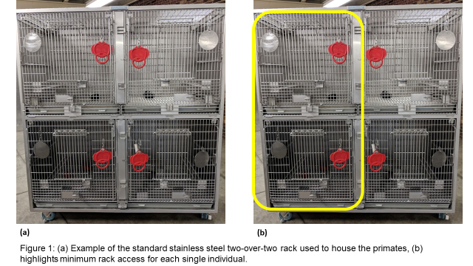
All subjects were fed twice a day. Eight of the primates (Group 1) were housed on a neuroscience protocol and fed the “maintenance diet” split equally between the two feedings. Two of these primates were actively chaired and working at the time of the project. Five of the primates were housed on a non-neuroscience protocol (Group 2) and fed the “typical American diet” with 1/3 of the diet provided in the morning and 2/3 of the diet provided in the afternoon. Due to the difference in diet size and weight, Timothy hay was added to feedings in the raised feeder for all subjects. This decision was made after the baseline data had been collected and increased wastage was noted due to the small size of the “standard American diet” (diet size comparison, Figure 2). Both diets were made commercially by LabDiet®. As part of the standard enrichment program, all primates receive dietary enrichment at least once a day, five days a week. The dietary enrichment items were provided in the afternoons.
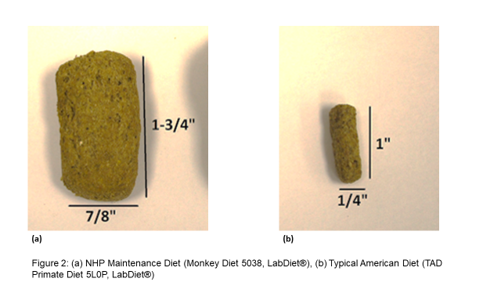
All subjects received three weeks of acclimation and training to the raised feeder (Figure 3). For the first week, only dietary supplements were offered in the raised feeder. For the next two weeks, half of the diet was provided in the raised feeder and half in the standard feeder at the front of the enclosure.
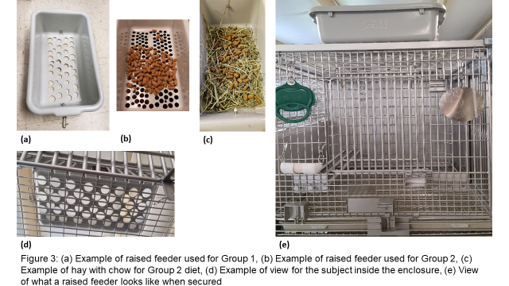
Video of each subject was taken once in the two weeks prior to training for the raised feeder, and once during the first two weeks of full diet provision in the raised feeder. Each video length was between 8 to 11 hours. BORIS software (v.8.9; Friard & Gamba, 2016) was used to code the entire length of video by instantaneous sampling at one minute intervals using an ethogram specifically tailored to this project (Table 2). Each behavior was treated as mutually exclusive. For the purposes of statistical analysis, some behavioral codes were grouped together. Upright posture was indicated using the behavioral codes: CHW, EwE Posture Up, and NAR Arms Raised. Appetitive behaviors included the following behavioral codes: NAR Chewing, CHW, FRG, and FDR. Maladaptive behaviors in this project were defined using the following behavioral codes: STY (any) and SDB.
Table 2: Ethogram used to code behavioral video

Diet counts were taken during the baseline week, the final two weeks of training, and the first full week of diet provision. Diet counts were collected each weekday morning prior to morning feeding. Leftover diet, or diet waste, was collected and weighed from each subject’s feeder (standard and/or raised as appropriate), pans or inside the enclosure, and items from the floor (tallied and attributed to total room waste). A percentage of waste in pan and waste in feeder was obtained by dividing the amounts retrieved by the amounts provided, and an average was taken from all 5 days of each diet count. Body weights were tracked for the primates on the neuroscience protocols and two of the non-neuroscience primates during regularly scheduled data collection for the subjects’ original protocols.
Statistics
Due to the varying lengths of video data captured for each individual at each time point, it was determined that each individual had at least 207 one-minute intervals following each feeding. The morning and afternoon feeding data were combined to give each primate 414 intervals (Table 3). The percentage of intervals was determined by dividing the number of intervals where the behaviors were observed by the total number of intervals (Table 4). Paired t-test data was performed using Microsoft Excel (Microsoft Corporation, 2018).
Table 3: Number of intervals for each primate in each condition for Upright Posture, Appetitive Behavior, and Maladaptive Behavior. Group 2 is shaded gray.
Table 4: Percentage of intervals for each primate in each condition for Upright Posture, Appetitive Behavior, and Maladaptive Behavior. Group 2 is shaded gray.

Results
Upright Posture
Upright posture grouped together the behavioral codes: CHW, EwE Posture Up, and NAR Arms Raised. Comparisons of upright posture between standard and raised feeding conditions are visually represented in Table 5(a) and Figure 4. The impact of diet provision in a standard feeder versus the raised feeder on upright posture was significant (p≤0.001, Table 5(b)). The number of intervals where primates were observed in an upright posture increased with the provision of diet in the raised feeder for all but one primate, Davy. All of Group 2, excluding Tyrion, appeared to exhibit more of an increase in upright behavior when compared to Group 1. A two-sample t-test found the difference between the two groups to be significant (p<0.05).
Table 5: Upright Posture (a) percentage of intervals engaged in upright posture for each individual in each condition with Group 2 shaded gray, (b) paired t-test results indicating significance between the two conditions (p<= 0.001).
(a)
(b)
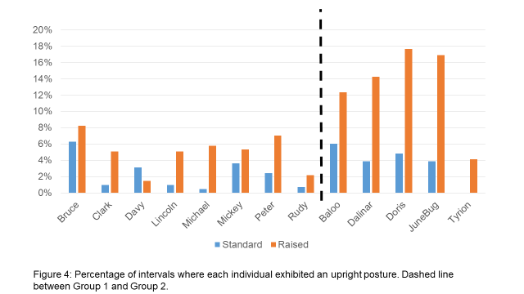

Appetitive Behavior
Appetitive behaviors included the following behavioral codes: NAR Chewing, CHW, FRG, and FDR. Comparisons of appetitive behavior between standard and raised feeding conditions are visually represented in Table 6(a) and Figure 5. The impact of diet provision in a standard feeder versus the raised on appetitive behavior was significant (p<0.001, Table 6(b)). All primates were observed engaging in more appetitive behaviors when diet was provided in a raised feeder. Differences in appetitive behavior were not found to be significant between the two groups.
Table 6: Appetitive Behavior (a) percentage of intervals engaged in appetitive behavior for each individual in each condition with Group 2 shaded gray, (b) paired t-test results indicating significance between the two conditions (p< 0.001).
(a)
(b)

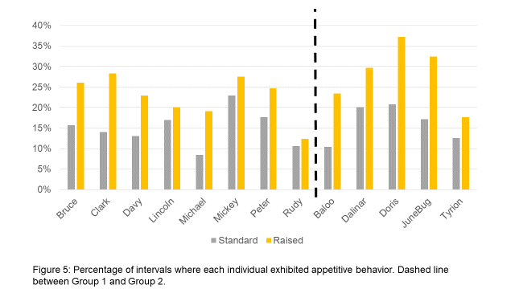
Maladaptive Behavior
Maladaptive behaviors in this project were defined using the following behavioral codes: STY (any) and SDB. Comparisons of maladaptive behavior between standard and raised feeding conditions are visually represented in Table 7(a) and Figure 6. The impact of diet provision in a standard feeder versus the raised feeder on maladaptive behavior was not significant (p>0.05, Table 7(b)). Four of 13 primates exhibited an increase in maladaptive behavior during the period that diet was provided in a raised feeder. The groups were evaluated separately, and a paired t-test found significance in group 2 (p<0.05). One primate, Michael, was noted with a higher percentage of intervals engaged in maladaptive behavior in both conditions. Removal of his data, as an outlier, did not demonstrate significance between the two groups in either condition.
Table 7: Maladaptive Behavior (a) percentage of intervals engaged in maladaptive behavior for each individual in each condition with Group 2 shaded gray, (b) paired t-test results did not indicate significance.
(a)
(b)

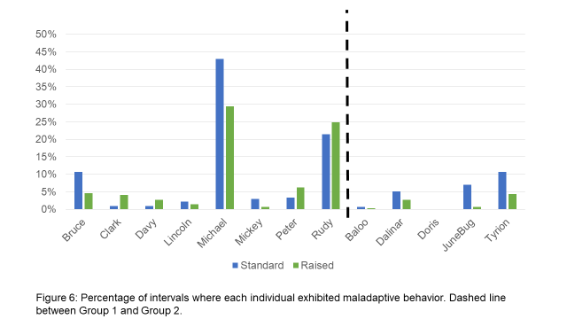
Diet Count and Body Weights
The average percentage of diet waste was calculated for each individual for a week during diet provision in a standard feeder and a week during the diet provision in a raised feeder (Figure 7). Group 1 primates did not exhibit much waste, if any, during the course of the study. While Group 2 demonstrated higher percentages of diet waste in both conditions, a paired t-test found that the difference between standard and raised feeding for Group 2 did not demonstrate a significant difference for diet left in pan or feeder (p>0.1). 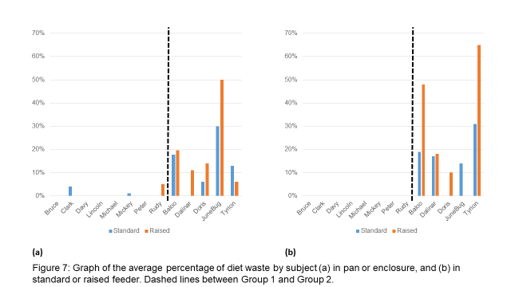
No significant body weight loss was observed during the course of the study (Table 11). All primates were able to access the majority of their diet throughout this project and did not exhibit any significant changes to weight.
Table 8: Body Weights (kg) for primates at the time of the baseline video collection with standard feeding compared to body weights taken following 100% diet provision in the raised feeder. All body weights were taken within the same month of the feeding condition.

Discussion
The results of this study suggest that provision of diet in a raised feeder with hay increases upright postural adjustment and time spent engaging in appetitive behaviors, as anticipated. While eight of the primates exhibited a decrease of maladaptive behavior during the observation periods, this was not found to be significant as four primates exhibited an increase. While this does not support the hypothesis, it does suggest that the development of maladaptive behaviors, such as self-directed or locomotor stereotypical behaviors, should not be grouped together in their etiology (Lutz et al., 2022; Pomerantz et al., 2012), and appetitive frustration is not the only factor to consider in the development of maladaptive behaviors in captive rhesus. The maladaptive behaviors selected for the ethogram in this study were done so because they tend to be easier to observe; however, whole body locomotor behaviors like pacing are not always reliable indicators of poor welfare (Poirier & Bateson, 2017).
Limitations
In addition to the challenges with the grouping and assumptions for maladaptive behaviors, the sample size for the study cohort was small and there may have been covariates influencing the data. The sample size was not large enough to allow in-depth evaluation of the covariates, so future research is needed to determine what, if any, impact these covariates could have had on the results. Of the 13 primates, only two of them were females, and both of the females were the more senior members of the cohort. Enrolling a greater number of females in a future study would allow a deeper look into whether or not sex differences exist in appetitive behaviors, or if the increase noted for the two females in this study was a result of individual variance. A greater age distribution across a larger female cohort may also be enlightening.
Group 2 was comprised of older adult macaques of primarily Indian origin. A significant difference in increasing upright posture was noted when comparing Group 1 and Group 2. All four primates contributing to the higher values were of Indian origin, with Tyrion being the only Chinese origin primate in Group 2. Some literature has found that there are behavioral and physiological differences between Chinese origin and Indian origin macaques (Champoux et al., 1994 and 1997; Gottlieb et al., 2015). Gottlieb et al. (2015) found evidence that Chinese-origin rhesus were more likely to exhibit motor stereotypical behaviors than Indian-origin; however, this data failed to support that theory. Michael, a rhesus of Indian-origin, appeared to have unusually high levels of maladaptive behavior compared to the other primates in this study cohort. Though removing him from the data set did not demonstrate a significant difference between the Chinese-origin and Indian-origin rhesus in regards to maladaptive behavior, perhaps due to the small number of rhesus on this study.
The cohort also only had two pairs of primates represented. Both pairs of primates represented the youngest rhesus in the study and all four primates were in Group 1. The number of socially housed primates in this study were not high enough to determine if social housing could be considered a covariate for appetitive behavior or frustration.
Group 1 primates were enrolled on a neuroscience protocol and came into quarantine in two sets, with each set of four age-matched at the time of arrival. Both sets arrived around 2-3 years of age. All 8 primates in Group 1 were chair trained and pulled from their enclosure at least once per week, up to 5 times for the two actively working primates. Group 2 primates were enrolled on a non-neuroscience protocol and arrived into quarantine in different sets at various ages. The protocol for these primates did not involve voluntary training for cooperative behaviors, such as chair training. Interactions with study staff occur primarily while sedated and are typically months apart, in contrast to Group 1. The differences in staff and study interaction between the two groups could account for variation in response to stressors within the environment; however, more evaluation is needed.
Due to the differences in study parameters, each group was on a different diet with a different dietary composition. While the diet amounts allotted each individual took into account the caloric density of the diets, the composition and size of the diet could have an impact on primate behavior based on satiation. A recent study suggests a relationship between primates that engage in locomotor stereotypic behaviors and gut microbiota levels (Pan et al., 2021). As research in the gut microbiome continues, additional refinements could be indicated regarding diet composition and presentation to help alleviate or identify primates who might be more likely to perform maladaptive behaviors.
Use of Hay in the Feeders
While significant increases in upright posture and appetitive behaviors were observed in both Groups, these differences could be a result of the addition of hay in the raised feeder. Much of the time spent processing, handling, and chewing could be attributed to the long fibrous nature of the hay and the primates’ motivation to engage with such items as it may closely mimic some dietary options in their native habitats. The use of Timothy hay was selected as it is low in calorie, easier to clean out of a rack than if paper was used (as wet crinkle paper can clump together and prove difficult to clean), and was readily available. Hay was not anticipated by the institutional veterinarians to be ingested in large quantities by macaques and was considered low value.
For the provision of hay, all raised feeders received a handful of hay first, then each primate was fed their allotted ration of chow. During the gap period between the provision of hay and the provision of chow, it was noticed that most of the primates would start engaging with the raised feeder immediately upon placement of the hay. This was not captured during the data collection, as data collection started as soon as dietary ration was placed in the feeders.
Unfortunately, the provision of hay in standard feeders to compare with hay provision in modified feeders was not performed due to timing of the study. Future studies are in discussion to look at the benefits of hay alone or provision of hay in standard feeder in rack-housed macaques.
Additional Measures for Welfare
The original idea for this study started with the goal of creating an outlet to slow diet intake and introduce an opportunity for a form of physical therapy for two obese paired neuroscience macaques. In this case, the use of the raised diet feeder for these two primates did not appear to impact body weight; however, it did increase the time for diet consumption from 5-10 minutes to 25-30 minutes (personal observation, 2019) and the research staff reported an increase in comfort and mobility within the rack and when chaired for task performance. Future studies may include range of motion or the impact on housing-related acceleration of joint or muscle degeneration.
Body condition scoring was originally going to be used over body weight to determine a positive impact on welfare, as weight by itself is not a reliable measure without also taking into consideration the size, length, sex, and age of the primate. Body condition scoring was deemed inappropriate for this study as it required a sedation event and was not something that could be done reliably cage side or that the primates could be trained to do voluntarily. In future studies involving diet presentation, composition, and hay use, body condition scoring will likely be added as a measure of welfare.
Neither of the pilot primates were observed engaging in maladaptive behaviors in either feeding condition; however, it was interpreted by research staff to improve the welfare of these primates strongly enough that all of their primates were transitioned to the raised feeders. Over the course of this project, staff perception was captured via in-person communication and additional potential measures of welfare were identified for future evaluation. It was suggested that primate welfare had improved based on:
- Alopecia – An improvement in alopecia scores was noted in Group 2 during the course of diet provision in the raised feeder. These primates are believed to have behaviorally-driven alopecia based on veterinary and behavior staff evaluation.
- Approachability – husbandry staff reported that Group 1 primates were less aggressive and engaged in less rack-shaking and dominance behaviors when staff entered to feed them their dietary ration while fed in the raised feeder.
- Task performance – though the data collected in this project for Rudy demonstrated an increase in maladaptive behavior in the housing location, research staff reported an increase in task performance, comfort in moving to chair, and ability to stay focused throughout the duration of the diet being fed in the raised feeder.
Call for Distinct Definitions
Feeding ecology in the literature is defined primarily based on the breakdown of the types of items consumed by the macaques, using the terms “foraging” and “feeding” interchangeably. In literature the primary difference between feeding and foraging is related to whether the primate is consuming something that is directly related to their nutritional needs (the ration of chow) versus whether it is considered supplemental or “extra” (the dietary treats provided). For example, Iredale et al. (2010) defined feeding behavior in their ethogram as “[P]hysically putting food into the mouth or chewing food”, while Gottlieb et al. (2011) defined forage in their ethogram as “picking up and placing a food item in the monkey’s mouth (not including monkey chow in the cage)”. Creating distinct definitions based on the behaviors involved in or motivated by appetitive drive, could create a better understanding of macaque feeding ecology and how to best meet the needs of these primates in captivity. Perhaps it would be important to note what behaviors are deemed important to satiating the appetitive drive. Such questions may include: is cheek pouch use innately driven or learned based on environment; how frequent should a captive primate’s meals be during the day and what is the impact on behavior; what diet composition or presentation is required to encourage a feeling of satiation and cessation of appetite driven behavior.
Conclusion
Provision of diet in a raised feeder as a refinement strategy had an overall positive impact on primate welfare based on the increase in upright posture and time spent engaging in appetitive behaviors. While the impact to maladaptive behaviors did not suggest a positive impact, eight out of 13 primates did demonstrate varying degrees of a reduction in maladaptive behavior. While this study looked at 100% diet presentation, additional studies might indicate more positive association with less than 100% provision or rotating diet presentation to encourage more exploratory behaviors. At the conclusion of this project, it was determined that a feeder may not be required if the diet size was large enough to prevent the diet from falling through. This could decrease the impact on labor during the provision of diet. Future studies should also look at the provision of hay by itself as a potential dietary supplement and its impact alone on primate behavior. While additional evaluation is required, refinements in how and what is provided captive macaques could have a positive influence on their welfare.
References
Bayne, K., Mainzer, H., Dexter, S., Campbell, G., Yamada, F., & Suomi, S. (1991). The reduction of abnormal behaviors in individually housed rhesus monkeys (Macaca mulatta) with a foraging/grooming board. American Journal of Primatology, 23(1), 23-35.
Bennett, A. J., Perkins, C. M., Harty, N. M., Niu, M., Buelo, A. K., Luck, M. L., & Pierre, P. J. (2014). Assessment of foraging devices as a model for decision-making in nonhuman primate environmental enrichment. Journal of the American Association for Laboratory Animal Science, 53(5), 452-463.
Bennett, A. J., Perkins, C. M., Tenpas, P. D., Reinebach, A. L., & Pierre, P. J. (2016). Moving evidence into practice: cost analysis and assessment of macaques’ sustained behavioral engagement with videogames and foraging devices. American Journal of Primatology, 78(12), 1250-1264.
Bertrand, F., Seguin, Y., Chauvier, F., & Blanquié, J. P. (1999). Influence of two different kinds of foraging device on feeding behaviour of rhesus macaques (Macaca mulatta). Folia Primatologica, 70(4), 207.
Broom, D. M. (1991). Animal welfare: concepts and measurement. Journal of animal science, 69(10), 4167-4175.
Champoux, M., Suomi, S. J., & Schneider, M. L. (1994). Temperament differences between captive Indian and Chinese-Indian hybrid rhesus macaque neonates. Laboratory animal science, 44(4), 351-357.
Champoux, M., Higley, J. D., & Suomi, S. J. (1997). Behavioral and physiological characteristics of Indian and Chinese‐Indian hybrid rhesus macaque infants. Developmental Psychobiology: The Journal of the International Society for Developmental Psychobiology, 31(1), 49-63.
Coleman, K., & Novak, M. A. (2017). Environmental enrichment in the 21st century. ILAR journal, 58(2), 295-307.
Friard, O., & Gamba, M. (2016). BORIS: a free, versatile open-source event-logging software for video/audio coding and live observations. Methods in Ecology and Evolution, 7(11), 1325–1330.
Gogoi, S., & Das, A. N. (2018). Diet and Feeding behaviour of Rhesus macaque at Navagraha temple, kamrup district of Assam. Periodic Research, 7(2), 93-98.
Goldstein, S. J., & Richard, A. F. (1989). Ecology of rhesus macaques (Macaca mulatta) in northwest Pakistan. International Journal of Primatology, 10(6), 531-567.
Gottlieb, D. H., Ghirardo, S., Minier, D. E., Sharpe, N., Tatum, L., & McCowan, B. (2011). Efficacy of 3 types of foraging enrichment for rhesus macaques (Macaca mulatta). Journal of the American Association for Laboratory Animal Science, 50(6), 888-894.
Gottlieb, D. H., Maier, A., & Coleman, K. (2015). Evaluation of environmental and intrinsic factors that contribute to stereotypic behavior in captive rhesus macaques (Macaca mulatta). Applied Animal Behaviour Science, 171, 184-191.
Hayden, B. Y., & Zimmermann, J. (2019). Macaques are risk-averse in a freely moving foraging task. Scientific reports, 9(1), 1-12.
Honess PE and Marin CM (2006). Behavioural and physiological aspects of stress and aggression in nonhuman primates. Neuroscience & Biobehavioral Reviews 30(3): 390-412.
Inglis, I. R., Forkman, B., & Lazarus, J. (1997). Free food or earned food? A review and fuzzy model of contrafreeloading. Animal behaviour, 53(6), 1171-1191.
Iredale, S. K., Nevill, C. H., & Lutz, C. K. (2010). The influence of observer presence on baboon (Papio spp.) and rhesus macaque (Macaca mulatta) behavior. Applied animal behaviour science, 122(1), 53-57.
Lutz, C. K., Coleman, K., Hopper, L. M., Novak, M. A., Perlman, J. E., & Pomerantz, O. (2022). Nonhuman primate abnormal behavior: Etiology, assessment, and treatment. American journal of primatology, 84(6), e23380.
Lutz, C. K., & Novak, M. A. (2005). Environmental enrichment for nonhuman primates: theory and application. Ilar Journal, 46(2), 178-191.
Makwana, S. C. (1978). Field ecology and behaviour of the rhesus macaque (Macaca mulatta): I. Group composition, home range, roosting sites, and foraging routes in the Asarori Forest. Primates, 19(3), 483-492.
Mason, G. J., & Turner, M. A. (1993). Mechanisms involved in the development and control of stereotypies. Perspectives in Ethology.
Microsoft Corporation. (2018). Microsoft Excel. Retrieved from https://office.microsoft.com/excel
Morgan, K. N., & Tromborg, C. T. (2007). Sources of stress in captivity. Applied animal behaviour science, 102(3-4), 262-302.
Novak MA (2003). Self-injurious behavior in rhesus monkeys: New insights into its etiology, physiology, and treatment. American Journal of Primatology 59(1): 3-19.
Novak, M. A., Kinsey, J. H., Jorgensen, M. J., & Hazen, T. J. (1998). Effects of puzzle feeders on pathological behavior in individually housed rhesus monkeys. American Journal of Primatology, 46(3), 213-227.
Pan, X., Liu, F., Song, Y., Wang, H., Wang, L., Qiu, H., ... & Li, J. (2021). Motor stereotypic behavior was associated with immune response in macaques: insight from transcriptome and gut microbiota analysis. Frontiers in Microbiology, 12, 644540.
Poirier, C., & Bateson, M. (2017). Pacing stereotypies in laboratory rhesus macaques: Implications for animal welfare and the validity of neuroscientific findings. Neuroscience & Biobehavioral Reviews, 83, 508-515.
Pomerantz, O., Paukner, A., & Terkel, J. (2012). Some stereotypic behaviors in rhesus macaques (Macaca mulatta) are correlated with both perseveration and the ability to cope with acute stressors. Behavioural brain research, 230(1), 274-280.
Prescott, M. J., Brown, V. J., Flecknell, P. A., Gaffan, D., Garrod, K., Lemon, R. N., Parker, A.J., Ryder, K., Schultz, W., Scott, L., Watson, J. & Whitfield, L. (2010). Refinement of the use of food and fluid control as motivational tools for macaques used in behavioural neuroscience research: report of a Working Group of the NC3Rs. Journal of neuroscience methods, 193(2), 167-188.
Reinhardt, V. (1993a). Enticing nonhuman primates to forage for their standard biscuit ration. Zoo Biology, 12(3), 307-312.
Reinhardt, V. (1993b). Using the mesh ceiling as a food puzzle to encourage foraging behaviour in caged rhesus macaques (Macaca mulatta). Animal Welfare, 2(2), 165-172.
Reinhardt, V. (1994). Caged rhesus macaques voluntarily work for ordinary food. Primates, 35(1), 95-98.
Richard, A. F., Goldstein, S. J., & Dewar, R. E. (1989). Weed macaques: the evolutionary implications of macaque feeding ecology. International Journal of Primatology, 10(6), 569-594.
Sarker, G. C., Kabir, M. M., Feeroz, M. M., & Hasan, M. K. (2008). Food and feeding behaviour of rhesus macaque (Macaca mulatta) at Barmi, Gazipur, Bangladesh. Bangladesh J. Life Sci, 20(2), 1-8.
Schapiro, S. J., & Bloomsmith, M. A. (1994). Behavioral effects of enrichment on pair‐housed juvenile rhesus monkeys. American Journal of Primatology, 32(3), 159-170.
Schapiro, S. J., Suarez, S. A., Porter, L. M., & Bloomsmith, M. A. (1996). The effects of different types of feeding enhancements on the behaviour of single-caged, yearling rhesus macaques. Animal Welfare, 5(2), 129-138.
Sengupta, A., McConkey, K. R., & Radhakrishna, S. (2014). Seed dispersal by rhesus macaques Macaca mulatta in northern India. American Journal of Primatology, 76(12), 1175-1184.
Wenyuan, Q., Yongzu, Z., Manry, D., & Southwick, C. H. (1993). Rhesus monkeys (Macaca mulatta) in the Taihang mountains, Jiyuan county, Henan, China. International Journal of Primatology, 14(4), 607-621.
Wickins-Dražilová, D. (2006). Zoo animal welfare. Journal of agricultural and environmental ethics, 19, 27-36.
Wolfe, L. D. (1992). Feeding habits of the Rhesus monkeys (Macaca mulatta) of Jaipur and Galta, India. Human evolution, 7(1), 43-54.
Zhang, K., Karim, F., Jin, Z., Xiao, H., Yao, Y., Ni, Q., ... & Xu, H. (2022). Diet and feeding behavior of a group of high-altitude rhesus macaques: high adaptation to food shortages and seasonal fluctuations. Current Zoology.

