Empowering African American Well-being:
An Analysis of Positive Psychology Based “Conscious Nourishment”

Mariah DuBose
Master of Applied Positive Psychology Program, University of Pennsylvania
MAPP 800: Capstone Project
Advisor: Dr. Elaine O’Brien
July 15, 2023

Abstract
This paper introduces the term conscious nourishment to explore the relevance and importance of empowering African American well-being through positive psychology-based approaches to nutrition and physical activity. It addresses the unique cultural, social, and historical factors contributing to this population's health challenges. This review highlights character strengths, self-efficacy, and social considerations as vital factors for improving individual well-being. Through an exploration of the practical implementation of positive psychology within the realm of African American health, this paper not only extends the examination of existing evaluations of positive psychology for this community but also provides valuable insights for institutions, practitioners, and scholars. These insights can guide the development of comprehensive, culturally sensitive strategies aimed at enhancing health outcomes and the overall well-being of African Americans. Finally, I propose a holistic framework called WHEALTHY
Keywords: Preventative Care, Conscious, Self-efficacy, Health Disparities, Nutrition, Physical Exercise, Positive Psychology for African Americans

Acknowledgments
To my mother, Yvonne DuBose – Your warmth, laughter, and love are invaluable. I am immensely grateful for your unwavering determination to provide your children with greater opportunities than you had, which has fueled my motivation and courage. Witnessing your tenacity and faith in God as you raised four children has inspired me to persevere through challenges. Thank you for your optimism, sense of humor, boldness, and commitment to justice. Your dedication to your family and service to others, particularly those who are underrepresented, has ignited a flame within me to do the same. You have shown me the true essence of love, inner beauty, and being human, all of which I am eternally thankful for.

To my siblings, Veronica DuBose, Ashley DuBose, and Jeffery DuBose – thank you for being supportive and incredible role models. It was seeing your journey through college and pursuing meaningful careers that gave me the motivation and determination that I could do the same.

To Benjamin Aguilar, Khadyon Reid, and Ari Kushner – Seeing you trailblaze through your careers with passion, persistence, and love has given me a clear example of what dedication and consistency produce. Thank you for being colleagues and friends who encourage me to pursue my passions and purpose in the health and well-being space.

To MAPP faculty, staff, AIs, and classmates – Dr. Martin Seligman: Thank you for founding Positive Psychology as a field and for personally encouraging me to address the gaps in positive psychology practices for African Americans with humility and enthusiasm.
Leona Brandwene and James Pawelski: Your compassion, guidance, and unwavering support throughout this challenging year have meant the world to me. Thank you for your humor and for creating a space for genuine and intellectually stimulating dialogue. Your presence has been a source of inspiration and encouragement.
Journal reader - Joseph Glaser-Reich and AIs - such as Abimbola O. Tschetter, Frank Jackson, Shondrea McCargo, Elizabeth Sutton, Devon Still, and Julia Pool, thank you for your dedication to the research and practice of well-being and for cheering me on along the way.
To my classmates – Thank you for your commitment and passion to help others, and for reminding me of the power of collective support.

To my Advisor, Dr. Elaine O ‘Brien – From the moment I heard you speak about the transformative power of movement at the MAPP Summit, where you had over 250 of us on our feet dancing, I sensed there was something truly special about you. Little did I know just how extraordinary you truly are. Your zest and joy are contagious. When I approached you with my ideas, you immediately embraced them with unwavering dedication and a genuine willingness to help bring them to life. Your kindness and support have been immeasurable, going above and beyond by providing valuable resources and regularly checking in on my well-being. Thank you for your relentless support in helping me to get this across the finish line.

A special thank you to Isaac Prilleltensky, Jaqueline Mattis, and John Ratey, whose work demonstrating “other people matter”, the value of striving for equity for African Americans, and the importance of physical activity in well-being respectively, has inspired me to continue working towards the empowerment of others especially those who are underserved.

Table of Contents
Preface 6
Empowering African American Well-being: An Analysis of Positive Psychology Based “Conscious Nourishment” 7
Outline of the Paper 7
I. Introduction 9
A. Background and Significance 9
II. African American Well-being & Challenges to Physical Exercise and Nutrition 13
A. Prevalence of Health Disparities 13
B. Socioeconomic and Cultural Factors 16
III. Positive Psychology 20
A. Definition and Origins 20
B. Positive Emotions and Well-being 23
C. Character Strengths 23
D. Self-Efficacy and Motivation 24
IV. Positive Psychology Based “Conscious Nourishment” for African Americans 29
A. Conscious Nourishment 29
V. African Americans & Positive Psychology Research 36
A. Historical Context on Disparities in Science Research 36
B. Underrepresentation in Positive Psychology 37
C. Implications of Research Gap in Positive Psychology 38
VI. Future Considerations 39
A. Increase Diversity in Positive Psychology 39
B. Apply a New Positive Psychology Framework: WHEALTHY 41
C. Build Supportive Networks 42
D. Focus on African American Youth 44
Conclusion 45
References 46
Appendix A: Social Determinants of Health, Health Disparities and Prevention 63
Appendix B: Positive Psychology 67
Appendix C: Future Considerations 70
Appendix A-C References 72

Preface
In an era where the pursuit of well-being takes center stage and is indisputably universal, it is imperative that we shine a spotlight on the diverse and unique challenges faced by African Americans. This research is a testament to the importance of this endeavor.

Well-being is not a one-size-fits-all concept; it is a deeply nuanced and multifaceted aspect of human existence. Yet, for far too long, the discourse surrounding well-being has lacked the depth and breadth needed to address the specific concerns of African Americans. This paper seeks to bridge that gap.

I invite you along this journey where I explore the intersection of positive psychology and conscious nourishment practices in the context of African American well-being. I dive into the foundations of positive psychology, which emphasizes the cultivation of positive emotions, personal strengths, and the pursuit of a fulfilling life. Simultaneously, I emphasize the importance of health practices that I have coined “conscious nourishment”, which advocates for intentional, personalized practices to promote healthy lifestyle choices.

As an African American who has experienced and or witnessed the ravaging effects of systemic injustice, this paper is a marker of my commitment to address the unique challenges faced by African Americans, including disparities in healthcare, education, and socioeconomic conditions. It is a call to action, a plea for change, and an exploration of how conscious nourishment practices, coupled with the principles of positive psychology, can empower individuals to not only survive but thrive despite adversity.

Along this journey I will take you through the existing literature, highlighting the gaps and opportunities for improvement in current positive psychology approaches. Together, we will explore the practical strategies and interventions that can be harnessed to foster resilience, enhance life satisfaction, and promote holistic well-being within African American communities.

Collectively, let us work towards a more equitable and inclusive approach to well-being, one that truly empowers every individual to flourish, irrespective of their background. While this may be a difficult topic to approach, discomfort is often a sign of an opportunity to grow. Let us get uncomfortable together and be the change we hope to see in the world.

I extend my gratitude to those who have contributed to this body of work and those who continue to champion the cause of African American well-being. Your dedication and commitment are an inspiration to me, as well as to many others.

With unwavering optimism and a shared vision for a brighter future,

Mariah D. DuBose
15 July 2023

Empowering African American Well-being: An Analysis of Positive Psychology Based “Conscious Nourishment”

Outline of the Paper
This paper makes a case for an increase in positive psychology-based conscious nourishment practices to improve the health and well-being of African Americans. It 1) builds an understanding of the health disparities and physical activity challenges among African Americans 2) provides an overview of positive psychology and applicable theories 3) shares a new concept of conscious nourishment (focused on nutrition and physical exercise), and highlights cultural considerations 4) then dives into a literature review and commentary on the gaps in positive psychology research for African Americans 5) concludes with recommendations for future considerations including a proposal for a new positive psychology framework, called WHEALTHY.

Scope and Key Themes
Greater well-being is associated with various positive outcomes in terms of physical health and longevity (Diener et al., 2017). The cultivation of well-being takes place through different types of nourishment albeit spending time with loved ones, eating a nutritious meal, or getting physical exercise. While over the past decade, the field of positive psychology has made significant advances to provide theories and interventions to promote well-being, there is a notable gap in its application to address the unique challenges faced by individuals from Low Income and Economically Marginalized (LIEM) populations, particularly African Americans (Mattis et al., 2016). The core themes of this paper include addressing systemic inequities that affect African American health and well-being, highlighting the opportunity to evolve positive psychology research to develop tailored interventions that bolster African American well-being, and advancing the hypothesis that adopting positive conscious nourishment practices rooted in positive psychology will improve African American well-being.

Definitions of Key Terms
Throughout this paper, the following terms will be used:
- Well-being – a multifaceted term that encompasses an individual’s subjective perception of their overall quality of life, sense of happiness, health, and prosperity. It involves experiencing positive emotions like contentment, while also nurturing one's potential, asserting a degree of control over life, fostering a sense of purpose, and cultivating positive relationships. Well-being refers to optimal physical, mental, and emotional health (Diener & Chan, 2011; Huppert, 2009; Keyes, 2005).

- Positive Psychology – a scientific study of what makes life most worth living. It focuses on the evaluation and promotion of positive aspects that contribute to human well-being, happiness, and the enhancement of the overall quality of life (Seligman, 2012).

- Consciousness – is a complex and multifaceted concept that can be defined in various ways. In this paper, it refers to the state of being aware of and having subjective experiences encompassing both external awareness of the environment and internal awareness of one’s thoughts, desires, emotions, and bodily sensations.

- Nourishment – an overarching term used to describe well-being practices in action, such as getting adequate sleep, resting, engaging in physical activity and movement, eating, etc. The active

- Conscious Nourishment – a term presented to encompass intentional practices such as sleep, exercise, and nutrition that are done in alignment with one’s needs/desires (i.e., participating in balanced nutrient-dense meals) to help improve well-being.

- Lower Income Economically Marginalized (LIEM) – A term created by the American Psychological Association (APA) Guideline for Professional Practice for individuals from disadvantaged backgrounds, including class privilege, income inequality, social capital, educational attainment, and poverty (American Psychological Association, 2019).

- African American / Black People / Black Community – used interchangeably to describe people of African descent; particularly those whose ancestors were brought to the Americas through the transatlantic slave trade (Berlin, 2010).

- Positive Psychology Intervention (PPI) – Intentional activities aimed at increasing hedonic (striving for what brings pleasure/happiness) or eudaimonic (striving to do what is meaningful) well-being in individuals or communities (Pawelski, 2020).

Introduction

Background and Significance

“Health is Wealth”
An individual could argue that the goal in life is to be happy (Sin & Lyubomirsky, 2009) while another might say that the ultimate goal is to be rich. Philosopher Jean Jaques Rousseau is credited for the popular phrase “money can’t buy happiness”. However, one’s income is often a predictor of the level of access they have to proper health resources (Feinglass et al., 2007). The enduring socioeconomic repercussions stemming from historical structural racism and the legacy of slavery have played a significant role in the lower income and wealth levels of African American households (Mineo, 2021; Saunders & LMSW, 2020). According to psychology professor Hector F. Myers, racism increases the vulnerability of individuals who are already grappling with low socioeconomic status (SES)(Clay, 2001). Wealth improves health (Geesler, 2022). Yet, in various circumstances, lower SES is associated with lower wealth, reduced access to care, poorer health outcomes, and increased mortality and chronic diseases as individuals get older (McMaughan et al., 2020; South et al., 2022). So, one can see that money does, in fact, contribute to one’s happiness as money grants access to vital services that contribute to greater well-being (Clay, 2001).
Well-being has been defined as a multifaceted concept encompassing the experience of positive emotions like happiness and contentment as well as the development of one's potential, a sense of personal control, a meaningful sense of purpose, and positive relationships; it represents a holistic blend of feeling good and functioning effectively in various aspects of life (Huppert, 2009). So perhaps the purpose of life transcends the pursuit of happiness and wealth to encompass how people live and their shared experiences. While the Oxford Dictionary defines wealth as “an abundance of valuable possessions or money”, the term wealth can also pertain to an abundance of good health and well-being. Jean Jacques Rousseau goes on to state that being wealthy is what an individual wants in relation to what they desire. Most individuals desire to be healthy (Howell et al., 2007). Studies indicate that when people have their health and well-being, the likelihood of experiencing greater life satisfaction is exponentially higher (Howell et al., 2007). Put simply, “health is wealth” – a phrase highlighting the interconnection of these two vital components of a fulfilling life.

Determinants of Health
According to the World Health Organization, health is “a state of complete physical, mental, and social well-being and not merely the absence of disease or infirmity” (Constitution, 1946; World Health Organization, 2004). Determinants of health include income, education, neighborhood/environment, access to healthcare, etc., (Javed et al., 2022; see Appendix A: Graphic 1). These factors contribute to an individual’s whole health. “Whole health” refers to a holistic and comprehensive approach to well-being that encompasses multiple dimensions of an individual's life, such as physical, mental, emotional, social, cognitive, spiritual, environmental, and occupational well-being (Stoewen, 2017). Both genetic and environmental factors, including diet and lifestyle, contribute to cardiovascular disease, cancers, and other leading causes of mortality. However, multiple lines of evidence suggest that environmental factors play a more significant role (Willett, 2002). African Americans, especially those from Low-Income Economically Marginalized (LIEM) backgrounds, continue to face substantial disadvantages in social determinants of health (Javed et al., 2022; Williams et al., 2010). Systemic inequities in education, healthcare access, geographical location, and SES collectively undermine African American well-being, posing significant obstacles to their whole health.

African American Health Disparities
Whole health challenges persist for African Americans who, for centuries, have faced differences in health outcomes relative to other ethnic groups (Javed et al., 2022; Smedley et al., 2003). Health disparities in the African American community include a disproportionate prevalence of obesity, hypertension, and diabetes, all of which are highly preventable (Bahram et al., 2008; Jamison et al., 2006; Nadeem, 2023). Recently, these disparities were pronounced by the disproportionate COVID-19-related mortality rates among African Americans compared to other ethnic groups (Nadeem, 2023; Weir, 2021). Additionally, during the pandemic, many African Americans were more likely to be front-line workers (Rioja & Thomas, 2021). These health disparities stem from a complex interplay of historical and current social and socioeconomic factors such as racism and access to healthcare (Ford CL & Airhihenbuwa CO, 2010). Income inequality is associated with well-being and psychological disorders (Pickett et al., 2006).
The lower an individual's socioeconomic status is, the higher their risk is for physical and psychological health problems (Clay, 2001). Ninety-five years ago, in 1928, statistician Louis Israel Dublin expressed the profound impact that improving the health of the African American community could have on various aspects of their lives, stating:
An improvement in Negro health, to the point where it would compare favorably with that of the White race, would at one stroke wipe out many disabilities from which the race suffers, improve its economic status, and stimulate its native abilities as would no other single improvement (Dublin, 1928, p. 77).
This assertion highlights how eradicating African American health disparities would significantly enhance their economic status and support their innate abilities. It emphasizes that improved Black health would bring about transformative social and health progress (Dublin, 1928). The present-day health disparities African Americans face demonstrate the necessity of focusing on solutions to enhance the well-being of African Americans. The field of positive psychology presents promising avenues to address these health inequities and offer application strategies to encourage optimal well-being (Seligman & Csikszentmihalyi, 2000).

Innate Strengths of African Americans
Today, despite health disparities faced in the United States, African Americans demonstrate significant strengths that can continue to shift the trajectory of African American well-being. One example of this is the community’s rich history of resilience and strength in the face of adversity (Smedley & Syme, 2001). Akin to positive psychology is Black Psychology, a scientific field that focuses on how people of African descent know and experience the world. which highlights seven psychological strengths of African Americans (White & Parham, 1990). Proposed approaches to empower African American well-being must address systemic and cultural challenges while leveraging these innate strengths.

Positive Psychology for African Americans
For years, health services have focused on treating illnesses; however, evidence-based research from the discipline of positive psychology focuses on well-being (Slade, 2010). Positive psychology is an umbrella term for the study of various contributors to health and human flourishing, i.e., character strengths, positive emotions, life meaning, close relationships, etc. (Peterson, 2006; Seligman, 2012). Researchers and practitioners have started developing intervention strategies based on positive psychology to enhance positive psychological assets, like positive emotions and life satisfaction, to support physical health (Park et al., 2014). Over the years, positive psychology has contributed significantly to improving human flourishing. However, there is a lack of representation of African Americans and other diverse populations from LIEM backgrounds in positive psychology literature (Mattis et al., 2016). By merging innate African American strengths with positive psychology principles, scholars and practitioners can help bridge health equity gaps through culturally relevant, preventive, and restorative approaches. Together, these practices leverage the power of consciousness.

The Power of Consciousness
This paper introduces the term conscious nourishment (described in greater detail in the conscious nourishment section) to highlight intentional practices tailored to meet one’s desired outcome – for example, an individual attending a dance class to incorporate an enjoyable physical exercise into their routine. As these practices are applied in the context of African Americans, they may be modified to consider cultural or socioeconomic factors. In the pursuit of optimal well-being, it is important for institutions, scholars, and practitioners to consciously develop strategies tailored to the intended audience and help individuals increase their awareness of their thoughts, actions, and desires (Schueller, 2014). Positive psychology's foundation lies in conscientious efforts to develop intentional lifestyle habits that foster healthy living. Focusing on lifestyle habits that improve nutrition and physical activity is key to addressing the higher rates of obesity, high blood pressure, and cardiovascular disease found in African American Populations (Gaillard et al., 2009; National Healthcare Quality and Disparities Report, 2022; see Appendix A: Graphic 2 for additional lifestyle factors that improve health).

African American Well-being & Challenges to Physical Activity and Nutrition

Prevalence of Health Disparities
The disproportionate health disparities faced by the African American population in the United States are not coincidental. The historical context is rooted in the enslavement of African Americans, beginning with their forced transportation from Africa to the New World (Noonan et al., 2016b). The individuals who survived the traumatic middle passage, where death rates were estimated to range from 9% to 35% (Noonan et al., 2016) and potentially higher, exemplify remarkable resilience. However, it is important to recognize that the history of slavery and the current persistent racial discrimination faced by this group contribute to the overall poor health status experienced by African Americans today.
Over recent decades, health disparities have been most pronounced for conditions or diseases for which deaths can be prevented, such as diabetes, stroke, infectious and respiratory diseases, preventable cancers, and circulatory diseases like hypertension (Noonan et al., 2016; Smedley et al., 2003). Cardiovascular diseases (CVDs) are a group of disorders of the heart and blood, and are the leading cause of death globally (World Health Organization, 2021). Over 45% of African Americans older than 19 suffer from cardiovascular disease. According to the Centers for Disease Control and Prevention (CDC), the leading risk factors for heart disease and stroke are obesity, high blood pressure, hypertension, and unhealthy blood cholesterol levels.
Black Americans are nearly 2.5 times more prone than their White counterparts to reside in neighborhoods characterized by restricted access to healthcare services (Stewart III et al., 2021). These neighborhoods are typically classified as either medically underserved or suffering from an insufficient number of healthcare providers relative to the population. Medical misconduct has also led African Americans to be less likely to partake in preventative care (Rioja & Thomas, 2021). Additionally, dental health, which is typically lower for African Americans, if untreated, can cause pain that can interfere with eating, lead to poor nutrition, and exacerbate chronic health conditions (Como et al., 2019). In the last ten years, outcomes have improved for children coming from LIEM backgrounds, and measures indicate a narrowing of this prominent health disparity. Overall, healthcare delivery and outcomes have worsened, including maternal care and hospitalizations for diabetes-related complications, which have increased by 66.2% between 2016 and 2019 (Como et al., 2019).
Here is a list of several health disparities for African Americans (Breathett et al., 2020; Cleveland. C. medical, 2022; Ogunniyi et al., 2021):
Black Adults
- Black adults have the highest prevalence of severe obesity (a BMI of at least 40)
- 47% of Black adults have been diagnosed with CVD compared to 36% of White adults.
- Black adults are more likely to have a stroke compared with other racial and ethnic groups. They’re also likely to be younger.
- Black adults are more than twice as likely as white adults to be hospitalized for heart failure. They also spend longer in the hospital and are more likely to be admitted again within 90 days.
Black Women
- Black women are twice as likely as white women to develop chronic hypertension during pregnancy. This condition raises a person’s risk for cardiovascular disease down the road.
- Black women have a 50% higher risk of heart failure compared with white women.
- Black women are more likely than white women to have a heart attack.
Black Men
- Black men have a 70% higher risk of heart failure compared with white men.
In addition to these disparities, African Americans as a whole report higher levels of chronic physiological stress in comparison to non-Hispanic Whites (Brewer LC et al., 2018). These psychological stressors have the potential to manifest into the risk factors and morbidities mentioned above, such as physical inactivity, stress, heart attacks, obesity, and hypertension (Clay, 2001; Schulz et al., 2008).
Health disparities resulting in poverty and restricted access to healthcare play significant roles in the prevalence of health conditions among African Americans, including heart disease, stroke, asthma, diabetes, and cancer (Der Ananian et al., 2018; see Appendix A: Graphic 3 for asthma percentage by race). These ailments result from a combination of systemic risk factors that contribute to an unhealthy diet and inactivity (See Fig. 1 below). Hence, scholars and practitioners aiming to develop positive psychology-infused conscious nourishment practices for enhancing the well-being of African Americans should prioritize efforts to enhance healthcare access, financial stability, nutrition, and physical activity within this community.
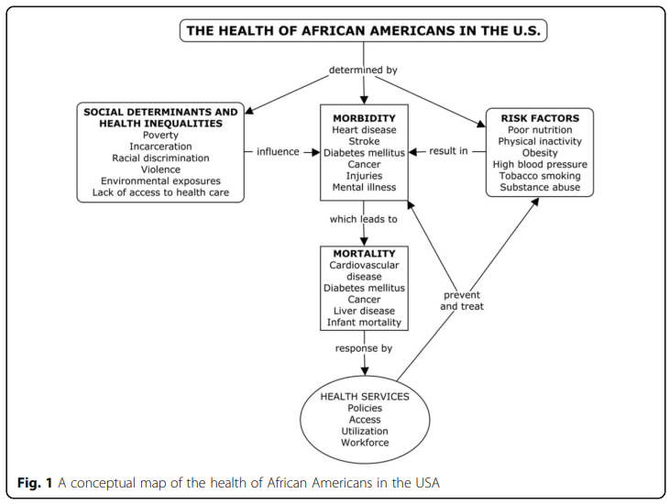
Fig. 1: A Conceptual Map of Health of African Americans in the USA

Note: The Health of African Americans in the U.S. (determinants and risk factors impacting African American well-being). Reprinted from “Improving the Health of African Americans in the USA: An overdue opportunity for social justice” by A. S. Noonan, 2016, Public Health Reviews 37 (12). Copyright 2016 by Creative Commons. Reprinted with permission.

Socioeconomic and Cultural Factors

Socioeconomic Factors
Various social factors significantly influence an individual's health, including financial resources, education, healthcare quality, living conditions, nutrition, and supportive relationships free of discrimination and violence (Javed et al., 2022). Developing positive psychology practices for the Black community requires careful attention to these common socioeconomic and environmental factors. Unhealthy and or unsafe physical environments increase the risk of negative cardiovascular health (Javed et al., 2022; Williams et al., 2010). Many African Americans live in neighborhoods with limited access to affordable, healthy food and safe spaces for physical activity (Javed et al., 2022; Stewart III et al., 2021). Approximately 20% of Black households reside in areas known as food deserts, where access to grocery stores, restaurants, and farmers’ markets is limited (Stewart III et al., 2021). These environmental conditions present barriers to healthy diets (Hill JO & Peters JC, 1998). Additionally, African Americans experience high racial discrimination/systemic social injustice-related stress and trauma (Prilleltensky & Prilleltensky, 2021).
Additional research shows that negative stigmas associated with African Americans, beyond socioeconomic factors like racial discrimination, affect their well-being. For instance, African American men are often stigmatized as problematic and dangerous, hampering their upward mobility (Hammond & Mattis, 2005). In contrast, African American women are subject to the "Strong Black Woman" (SBW) stereotype, expected to display unwavering resilience and tenacity, dating back to the era of slavery (Abrams et al., 2019; Morris & Caile, 2011). In Remembering Slavery by Ira Berlin, a collection of oral histories featuring accounts from former slaves, one former slave, George Fleming says “Women worked in de field same as de men. Some of dem plowed jes’ like de men and boys. Couldn’t tell ‘em apart in de field, as dey wore pantalets or breeches…” (Berlin, 1998, p. 126). This societal portrayal of strong Black women perpetuates the expectation for them to remain poised and resilient in all circumstances (Thomas et al., 2004).

Cultural Factors
It is crucial to have a cultural context in positive psychology and PPIs that incorporates the intersectionality of an individual. The entire person, i.e., sexual orientation, gender, disability, and social class, provides the necessary cultural humility to develop practices that are culturally informed (Pedrotti & Edwards, 2017). The field of positive psychology continues to evolve to serve diverse populations. However, the historical and research-based exploration of the cultural context within positive psychology offers valuable opportunities for growth (Pedrotti & Edwards, 2017). Cultural factors that impact African American health include common beliefs about illness causation, healthcare system distrust, and the significance of spirituality in health (Mattis et al., 2016). Further factors beyond socioeconomic conditions that impact African American physical health include traditional cuisine and perceptions of being healthy.
Cultural food that is high in sodium and saturated fat, as well as negative attitudes toward movement, impact African American well-being (Biggers et al., 2020). One study on diet and physical health activity among urban African Americans suffering from mental illness found that the most common barriers to healthy living include traditions that affect health, poverty, lack of money, lack of time, and the notion that exercise is boring (Sayer et al., 2019). The same study stated healthy habits such as growing fresh vegetables in a garden given the exposure to having a garden with fruits and vegetables growing up as cultural norms. However, most participants in this study stated culture in relation to eating high-fat foods, noting them as a staple in the African American upbringing, with many high-fat foods passed down from generation to generation. One participant stated:
“What we’re used to is how our mothers and grandmothers cook. They cook with a pound of butter and sugar and lard. And they teach us to eat unhealthy. We’re still doing it. I’ll cook what my grandma used to cook” (Sayer et al., 2019).
Another individual echoed a similar sentiment:
“The meals that our ancestors prepared from the south used a lot of fat, pork, and salt … I was raised on southern fried chicken, fat-back, collard greens, chitlins. So, I bring that into my lifestyle. When I learned how to cook that, I brought it and fed it to my children.” (Sayer et al., 2019).
Traditional Southern cuisine, known for its heavy use of pork due to its affordability (Sayar et al., 2019), represents another important cultural element to consider.
Exploring African Americans' mainstream and ethnic cultures is crucial for comprehending how these factors either enable or impede healthy food intake and physical activity. However, it is equally vital to scrutinize additional factors that directly shape how culture impacts individuals' health. In essence, culture's influence on health is contingent on practical considerations that extend beyond cultural aspects alone (Swierad, et al., 2017). In addition to cultural norms around what African Americans eat, some participants in the study stated that healthy eating was not a part of their culture and that in some cases it was a source of humiliation that could cause embarrassment. Nevertheless, within the context of these cultural challenges that affect African American well-being, it is crucial to recognize the positive cultural traits that can contribute to reshaping the narrative surrounding African American health.
African Americans have a lot of positive characteristics that can support their health including determination, endurance, and self-motivation (Sayer et al., 2019). Changes in physical activity and diet and investments in education, food policies, and urban physical infrastructure are needed to improve African American well-being (Jamison et al., 2006). It is important that these barriers are solved on a community and individual level (Sayer et al., 2019). Health and well-being interventions designed for African Americans should attend to multiple individual, cultural, and contextual needs (Sayer et al., 2019).

Positive Psychology

Definition and Origins
For years, Psychologists focused primarily on treating people with mental health problems and psychopathological issues (Bolier et al., 2013). Psychologist Martin Seligman began to see this as a major concern and decided that focusing on the alleviation of individual and communal problems with scant attention to what goes right in life was no longer acceptable (Seligman, 2012). Dr. Seligman and other prominent positive psychology leaders, such as Mihaly Csikszentmihalyi highlighted the detrimental impact of excessive attention on what is going wrong in individuals' lives. Their insights underscored the tendency for health practitioners and individuals to overlook what is going well when they become overly fixated on negative aspects (Peterson, 2006). In 1998, under the leadership of Dr. Seligman, who was then serving as the president of the American Psychological Association, the field of study was formally designated as "Positive Psychology" (Alex Linley et al., 2006).
Positive psychology is a specific focus within psychology that studies what goes right in life (Peterson, 2006). The goal is to use scientific methods to analyze various factors related to positive mental health, such as well-being, strengths, flow, wisdom, and creativity to promote optimal functioning (Boniwell, 2012). It focuses on other positive aspects of human experience, such as happiness, positive emotions, resilience, and the cultivation of positive subjective experiences and meaningful lives (Peterson & Seligman, 2004). The three pillars of positive psychology were initially summarized as (Peterson, 2006):
- Positive subjective experiences (happiness, pleasure, gratification, fulfillment)
- Positive individual traits (strengths of character, talents, interests, values) and
- Positive institutions (families, schools, businesses, communities, societies)

Using these three pillars (see Appendix B: Table 1) and science-backed methodology, field scholars and practitioners strive to improve human well-being.
The field of positive psychology recognizes that there were various psychological research studies, philosophers, and religious figures before it, which can be viewed as a foundation for positive psychology (Peterson, 2006). Philosophers and religious figures such as Jesus and Buddha posed deep questions about meaning and purpose. Other notable figures included Maslow (1970) and Rogers (1951), who popularized humanistic psychology (Peterson, 2006). One less noted forerunner is Black Psychology, which is defined as the psychology of Black people (White & Parham, 1990). Dr. Joseph White, a prominent leader in Black Psychology, established the seven psychological strengths of African Americans (See Appendix B: Table 2), which have similarities to the core virtues of positive psychology, such as community, resilience, and spirituality (Bethea & Aaron, 2020). Collectively, these figures have created the foundation on which positive psychology continues to expand theories and practices for human thriving.
Although the field's origins were in studying individuals who were already thriving and aiming for greater success, a point that has faced criticism, Dr. Seligman underscores that this research can also aid individuals in navigating challenges (Peterson, 2006). The field offers positive psychology interventions (PPI) that advocate equal attention to strengths and weaknesses, equal emphasis on constructing the finest aspects of life as well as rectifying the worst, and equal dedication to enhancing the lives of healthy individuals as to tending to the struggles of the distressed (Peterson, 2006). To gain insight into the practical applications of positive psychology for African Americans, it is crucial to be well-acquainted with prevalent theories and models in the field.
Before proceeding, it is essential to pinpoint fundamental positive psychology models and techniques that can be incorporated into the creation of impactful interventions for individuals within the Black community. Dr. Seligman (2012) developed the PERMA theory to help define and quantify what creates well-being. The PERMA model consists of five essential elements for well-being, which people pursue for their own sake and are measured independently of others. These five areas include:
P-positivity extends beyond merely “happiness”, and positive emotions and includes hope, interests, joy, love, compassion, pride, amusement, and gratitude. Positive emotions are essential for flourishing, and they can be fostered and learned to increase well-being (Fredrickson, 2001).
E-engagement is “being one with the music” (Seligman, 2012), being present and engaging with what is at hand.
R-relationships encompass all the various interactions individuals have with those in their community i.e., partners, friends, family members, etc.
M-meaning is belonging and/or serving something greater than oneself.
A-accomplishments/achievements is an accomplishment resulting from working hard toward and reaching goals, mastering an endeavor, and having self-motivation to finish what one set out to do.
Focusing on the “P” in PERMA, Fredrickson further points out that positive emotions can help resolve negative emotions and promote resilience (Fredrickson, 2013)

Positive Emotions and Well-being
Positive psychology focuses on cultivating positive emotions (Fredrickson, 2001) and well-being. Engaging in activities that generate positive emotions, such as practicing gratitude, acts of kindness, or savoring positive experiences, can broaden an individual's awareness and perspective (Fredrickson, 2001). Fredrickson's broaden-and-build theory (2001) suggests that positive emotions broaden one's cognitive and behavioral collection, expanding consciousness and enhancing well-being. Numerous studies have shown that experiencing positive emotions contributes to better mental health, improved physical health, and increased resilience (Fredrickson, 2013). By intentionally focusing on positive aspects of life, individuals can expand their consciousness beyond negative biases and limitations. One way an individual might do this is by identifying and focusing on their strengths.

Character Strengths
An early initiative of positive psychology was the development of the scientific classification of character strengths and virtues. Peterson and Seligman (2004) advanced character strengths and virtues to replace the negative diagnostic criteria of pathology with characteristics of human flourishing (Alex Linley et al., 2006). This led to strengths and virtues being a hallmark of positive psychology (Niemiec et al., 2012) and coaching (Linley & Harrington, 2006). The 24-character strengths (Appendix B: Table 3), derived from the six virtues in positive psychology, are considered universal. They were identified through comprehensive literature searches, historical lists of strengths and virtues, discussions with field experts, and conversations with conference participants (Peterson & Seligman, 2004). People who identify and use their character strengths and virtues experience greater well-being. Research has shown that leveraging and developing personal strengths contributes to higher levels of consciousness, self-actualization, and positive functioning (Park et al., 2004; Peterson & Seligman, 2004). This strengths-based approach fosters consciousness of one's capabilities and encourages individuals to align their actions with their strengths, leading to greater fulfillment and success.

Self-Efficacy and Motivation
When exploring consciousness, it becomes crucial to understand the concept of "self-efficacy." Self-efficacy refers to the belief in one's ability to achieve desired outcomes through personal actions (i.e., the conviction that an individual will be successful in changing to a healthier lifestyle) (Myers et al., 2017). It is the belief that a person can accomplish what they set out to achieve and is often regarded as a fundamental factor for success. Acknowledging and embracing one's inherent power and cultivating self-assurance in one's abilities play a pivotal role in shaping and elevating an individual's level of consciousness (Maddux & Kleiman, 2021). Self-efficacy and self-determination contribute significantly to helping individuals align consciously with their desired outcomes.
Through the Self-Determination Theory (SDT), Brown and Ryan (2015) argue that intrinsic and extrinsic motivators influence a person’s behaviors and help them to understand what they want and why. Some individuals are motivated to eat better and be physically active given motivators like spirituality (transitioning from one faith to another), health factors (i.e., being at risk for diabetes), the desire for better metabolism, the possibility of reducing medication, and the desire to live longer (Sayer et al., 2019). Improving one’s well-being requires intrinsic and or extrinsic motivation. Some individuals have self-motivation, while others get motivation from family, friends, or a coach (Sayer et al., 2019). The SDT highlights the importance of these motivational orientations that direct individual actions and have significant effects on healthy behavioral regulation and psychological well-being (Brown & Ryan, 2015). While a person’s self-determination and motivation are important, it is also critical to consider the community support involved.
Isaac Prilleltensky presents the ICOPPE framework to help support well-being individually and collectively, advocating for policies that promote social justice and equity. The ICOPPE model is an acronym that stands for:
I - Individual: Focus on individual well-being and personal agency.
C - Community: Emphasize the importance of supportive and inclusive communities.
O - Organization: Highlight the role of organizations in creating positive environments.
P - Physical: Engage in health factors, such as exercise, nutrition, and sleep.
P - Psychological: Emphasizing the importance of emotional and mental health.
E - Evaluation: Incorporate regular assessments of well-being and social progress.
Overall, the Interpersonal, Community, Occupational, Physical, Physiological, or Economic model promotes a holistic approach to well-being that considers individual, community, and sociopolitical factors as interconnected and essential for fostering positive change. People experience greater individual and social well-being when there is a heightened sense of awareness on an individual level and within the broader social context. When individuals feel genuinely valued, can contribute meaningfully, experience happiness, and witness fairness, their overall well-being is significantly enhanced (Prilleltensky & Prilleltensky, 2021).
While individuals coexist within a collective society, it is important to acknowledge that society often exhibits individualistic tendencies that can lead to oppressive outcomes. To address this, Prilleltensky shares the SPEC (Strengths-based, Positive, Empowering, Community) framework which promotes a paradigm shift in promoting wellness, fairness, and worthiness (Prilleltensky, 2005). People may be able to use their strengths while changing the system.
Prilleltensky describes DRAIN (Deficits, Reactive, Arrogance, Individual), as a system rooted in blame. He believes instead individuals and institutions should focus on Strength Prevention, Empowerment, Community (SPEC) which is rooted in change for greater collective well-being. Prilleltensky also presents a short and memorable list of strategies called the BET I CAN method which stands for Behaviors, Emotions, Thoughts, Interactions, Context,
Awareness, and Next steps to help improve ICOPPE well-being aspects (Prilleltensky & Prilleltensky, 2021):
Behaviors | - Set a Goal, Create a Positive Habit
Emotions | - Cultivate Positive Emotions, Manage Negative Emotions
Thoughts | - Challenge Negative Assumptions, Write a New Story
Interactions | - Connect, Communicate
Context | - Read the Cues, Change the Cues
Awareness | - Know Yourself, Change the Cues
Next Steps | - Make a Plan, Make it Stick

Prilleltensky and his research team applied the BET I CAN model to a cohort of 1146 participants, which led to the model's development. The study reveals that one’s belief in their ability to achieve desirable goals is crucial for improving their behaviors, emotions, or thoughts to improve their self-efficacy. As one might anticipate, merely directing individuals to utilize their "behaviors, emotions, or thoughts to enhance their self-efficacy" is insufficient. Considering this, Prilleltensky equipped the participants with the two specific skills outlined in the table above. These skills were intended to empower them to enhance their self-worth by cultivating positive habits, such as regular exercise. When individuals engage in warm and positive communication with others, they can create a sense of value, and by simultaneously adjusting negative cues like removing access to unhealthy snacks, they can enhance their ability to achieve a specific goal, such as adopting a healthier eating pattern. Overall, the study demonstrated the effective utilization of the BET I CAN skills in improving an individual's overall well-being and self-efficacy.

The Importance of Consciousness
Consciousness, a multifaceted concept, can be understood as the state of being aware, encompassing self-reflection, introspection, and the processing of sensory information (Thorp, 2013). It not only pertains to the awareness itself but also the capacity for self-awareness. Positive emotions, character strengths areas above all require consciousness. Consciousness plays a pivotal role in shaping an individual's experiences, thoughts, emotions, behaviors, and ultimately, their overall well-being (Vieten et al., 2018). By evaluating and expanding consciousness, individuals can uncover practices that enhance sensory awareness and deepen their understanding of themselves (Vieten et al., 2018).
Self-awareness includes recognizing one’s own thoughts, emotions, strengths, and weaknesses. It plays a significant role in personal growth, self-acceptance, and cultivating well-being (Maddux & Kleiman, 2021). Often individuals derive their desires from external places such as family or social media. However, as an individual identifies what they intrinsically want and why, they can pursue their goals with greater persistence and performance in comparison to behaviors driven by extrinsic motivation (Brown & Ryan, 2015). Consciousness is also closely tied to mindfulness which is a key element of positive psychology. Mindfulness involves paying attention to the present moment with non-judgmental awareness (Brown & Ryan, 2015).
There are several ways positive psychology encourages practices that increase consciousness. These practices can help individuals to gain insights into their values, strengths, and areas for growth
These practices include:
- Journaling: Engagement in self-reflection which increases awareness of desires. This self-awareness promotes a higher level of consciousness about one's thoughts, emotions, and behaviors (Pennebaker et al., 1990).
- Breath Work / Mindfulness Exercises: Paying attention to the present moment without judgment (Niemiec et al., 2012) helps individuals cultivate awareness of their thoughts, sensations, and experiences. Research indicates that establishing a mindfulness practice reduces anxiety, diminishes stress reactivity, enhances coping, benefits attention, increases compassion (and self-compassion), and strengthens emotion regulation (Biggers et al., 2020). Katara McCartney, a Black female app developer, has founded the Exhale App, a first-of-its-kind Exhale breathwork and meditation app specifically tailored for Black women. Getting its start after a string of high-profile unarmed Black deaths, a part of the mission is to reduce the stress caused by ongoing racism (Wicker, 2023).
- Growth Mindset and Personal Development: Positive psychology promotes a growth mindset, which is the belief that personal qualities and abilities can be developed through dedication and effort. Adopting a growth mindset fosters a sense of curiosity, open-mindedness, and a willingness to learn. By embracing challenges, seeking feedback, and pursuing personal development, individuals can expand their consciousness and unlock new possibilities (Niemiec et al., 2012).
- Meaning and Purpose: Exploring and aligning with personal values and finding meaning and purpose in life are integral to positive psychology. Engaging in activities that align with one's values and contribute to a greater sense of purpose can deepen an individual's consciousness and connection to something larger than oneself. Prilleltensky and Gonick (1996) recommend the establishment of comprehensive critical consciousness programs across all educational levels, aiming to empower individuals and provide them with enhanced self-awareness, a deeper understanding of their surroundings, and the ability to catalyze meaningful change and transformation.
One of the wealthiest Black men in the world, entrepreneur and first Black philanthropist, Robert F. Smith (Wong, 2023) mirrors foundational strength-based tenets of positive psychology, encouraging individuals to find their talents and gifts. He further inspires individuals to know their purpose, highlighting the importance of consciousness through being thoughtful and conscious of what one’s highest and best use is (Wong, 2023). Awareness of one’s desires in the pursuit of optimal well-being is critical. At the core of positive psychology is consciousness that contributes to intentional lifestyle habits that cultivate health and well-being.

Positive Psychology Based “Conscious Nourishment” for African Americans

Conscious Nourishment

Overview
The conscious nourishment framework integrates positive psychology principles into culturally sensitive approaches to well-being areas such as nutrition and physical activity. Well-being is cultivated using self-regulatory processes such as awareness and purpose (Dahl et al, 2020). This is a holistic approach that considers historical trauma, cultural values, character strengths, and self-efficacy. Conscious nourishment is a term that can be used to describe activities that allow people to apply a sense of awareness and intentionality around the choices they make to take care of themselves or the people around them. These choices impact individuals in various physiological ways, including mentally, physically, and or spiritually. Examples of conscious nourishment may include having a sleep schedule that ensures eight hours of rest, having a spiritual practice such as daily devotionals, budgeting personal finances, spending time exercising, or taking the time to select nutritious meals. Conscious nourishment allows people to make choices that best align with what it is that they want. Implementing this framework within the context of African American well-being enables scholars and practitioners to intentionally target essential health areas for this community.
Nutrition and exercise are two critical areas that greatly impact African Americans’ health and well-being (Jamison et al., 2006). Dietary and lifestyle factors, such as nutrition and exercise, have the potential to prevent and reduce the risk of common chronic diseases faced by African Americans, including coronary artery disease, stroke, and diabetes, among others, without the need for medication (Jamison et al., 2006). Preventing these diseases will require investments in education, food policies, and urban physical infrastructure as well as changes in behaviors related to smoking, physical activity, and diet (Jamison et al., 2006).
Physically, conscious nourishment can involve paying attention to the quality and types of food one consumes. In practice, this may include being mindful of food portion sizes, making healthy food choices, and listening to one’s body's cues of hunger and fullness. This approach emphasizes the importance of making decisions that involve intentionality and awareness to support healthy eating and overall improved well-being. Practitioners and scholars can apply the conscious nourishment framework by developing community-based programs that promote positive psychology-informed approaches to nutrition and physical activity. One study focused on chronic disease prevention argues that interventions targeting dietary and lifestyle changes must encompass educational efforts, environmental alterations, food supply adjustments, community initiatives, and the implementation of economic policies (Jamison et al., 2006).
Stress, which is prevalent in the African American community, can lead individuals to both overeat and undereat (Adam & Epel, 2007). These programs should be rooted in cultural competence and tailored to the specific needs of African Americans. One need that is not considered as often is the importance of practices to be engaging, versatile, and incorporate play.

The Power of Play
Play is a crucial component in shaping an individual's brain, enabling the development of cognitive and emotional functions necessary for becoming a well-functioning adult (Lukianoff & Haidt, 2018). In the recently published book, The Power of Play, Dr. Elaine O’Brien, and Andrea Seydel highlight the importance and transformative force of play. In it they draw upon the scientific studies that demonstrate how play can be a transformative force that brings joy, fulfillment, and vibrant experiences to everyday life (O’Brien & Seydel, 2022). Evidence-based practices and activities support the benefits of play, including improved mental health, well-being, concentration, motivation, and social connections. While making behavioral changes can be challenging, studies have shown that when play and fun are incorporated as key elements, people find greater pleasure in the process and thus experience greater life satisfaction.
Play can be incorporated into conscious nourishment practices and can function as a protective factor in handling life's stresses, preventing burnout, and promoting resilience (O’Brien & Seydel, 2022). Play has the power to positively impact various aspects of well-being, including positive emotions, engagement, relationships, meaning, and accomplishment. Fun can be seen as the facilitator of participation in physical activity (1999). By reflecting and becoming more self-aware and conscious, individuals can enhance their joy potential and increase their physical activity. Positive emotions broaden attention and thinking, leading to an upward spiral of goodness and contributing to a more joyful life (O’Brien & Seydel, 2022).
“The desire to express ourselves through music and movement is built into our human experience” (O’Brien & Seydel, 2022). African Americans culturally have a rich history of incorporating play into their lives through music and dance which dates back to slavery has been a form of promoting well-being. Here are a few additional ways that African Americans may consider incorporating play in a consciously nourishing way.
- Embrace cultural expression through play
- Explore recreational activities
- Seek culturally competent therapy
- Celebrate achievements and milestones

Conscious Nourishment: Nutrition
Maintaining a healthy weight and ensuring proper nutrition are crucial to overall health (Sayer et al., 2019). Conscious nourishment allows individuals to focus on what they are consuming and how it contributes to their overall well-being. Practitioners and scholars can consider how to combine information on nutrition challenges with an awareness of nutritional needs for a community or individual. In establishing conscious eating practices, one could evaluate nutritional needs, such as access to foods and education on how much vitamins, protein, and carbohydrates should be consumed. Conscious eating may also involve intentionally becoming aware of what is in food. Reading nutrition labels and knowing which ingredients lead to negative health, such as (i.e., high fructose corn syrup, artificial sweeteners, artificial food colorings, etc.), and not eating them is another example of conscious nourishment involving nutrition.

Example: Incorporating Smoothies
Smoothies offer a nourishing solution to individuals seeking to enhance their nutritional intake (McCartney et al., 2018). Packed with nutrient-rich ingredients like fruits, vegetables, nuts, seeds, and superfoods, they provide a valuable source of essential vitamins, minerals, antioxidants, and fiber, promoting overall health and well-being. Smoothies appear to play a positive role in the diet of some individuals, promoting increased consumption of core foods (i.e., fruit, vegetables, and dairy products). Smoothies have a beneficial impact on some individuals' diets by encouraging a higher intake of essential foods like fruits and vegetables (McCartney et al., 2018). Smoothies offer the advantage of simplicity and convenience, as they can be easily prepared in advance or while on the move. This can make them an ideal choice for a nutritious breakfast or post-workout replenishment.

Conscious Nourishment: Physical Exercise
Engaging in regular physical activity is one of the most effective actions that individuals of all ages in the United States can take to foster and sustain optimal health (Williams et al., 2018). Conscious nourishment through mindful movement encompasses the conscious awareness of one's physiological state, both during physical activities and moments of rest. It involves attentively tuning into one's actions and being mindful of factors such as breathing, posture, and bodily sensations (Biggers et al., 2020). As an individual focuses on their body and begins to attribute positive emotions such as optimism, they may experience greater motivation for movement. Those with chronic diseases have described many specific positive psychological constructs that both promote and result from physical activity (Millstein et al., 202). Research has demonstrated that there are significant positive associations between the PERMA (Positive Emotions, Engagement, Relationships, Meaning, and Accomplishments) and physical health (Kern et al., 2015). To maintain healthy lifestyle choices, individuals need to discover physical activities that align with their health goals and bring them a sense of enjoyment.
Positive psychology has the potential to enhance well-being by advocating for conscious nourishment activities such as mindful movement, which embraces an intentional approach to physical activity. By incorporating practices that cultivate consciousness, such as mindfulness, individuals can foster a deepened mind-body connection through the act of being fully present and attentive during their physical movements (Ratey, 2013). Engaging in conscious movement entails purposefully attending to bodily sensations, posture, breathing, and the overall experience of the activity. Nurturing this heightened mind-body connection can magnify the joy derived from movement and contribute to holistic well-being.
Regular physical activity is associated with a multitude of positive outcomes, including a heightened sense of purpose, increased feelings of gratitude, love, and hope (Ratey, 2013). Furthermore, individuals who engage in regular physical activity tend to experience a greater sense of connection to their communities, reducing the likelihood of loneliness and depression. Remarkably, these benefits transcend age and socioeconomic status, demonstrating their universal applicability across cultures. Notably, the psychological and social advantages derived from physical activity are not contingent upon specific physical abilities or health conditions (Ratey, 2013). Individuals facing challenges such as chronic pain, physical disabilities, serious mental or physical illnesses, and those receiving hospice care have demonstrated these remarkable benefits.

Example: Dance-Based Movement
Traditional African dances, such as the West African Djembe drumming or the Congolese Soukous dance, are not only enjoyable but also serve as a means of self-expression, celebration, and community connection. In addition, African Americans have influenced and pioneered various music genres like jazz, blues, hip-hop, and R&B, which provide avenues for artistic expression and enjoyment (Mattis et al., 2016). Dance has proven to have a positive impact on both physical and mental well-being, enhancing our strength and fitness while uplifting our mood and alleviating anxiety (O’Brien & Seydel, 2022). Conscious nourishment through dancing allows people to embrace physical exercise beyond the need to go to the gym or be athletically fit. Incorporating fun and play into movement allows individuals to get past the barrier of an intimidating weight rack. Whether it is rock climbing, biking, swimming, or even dancing, finding movement that aligns with what the individual enjoys doing will prove to have a lasting impact (Ratey, 2013).
Applying Positive Psychology
Family, wisdom, and spirituality are common core values for African Americans (Bethea & Aaron, 2020). To enhance conscious nourishment through the application of positive psychology principles, it is advisable to leverage these inherent strengths. Isaac Prilleltensky’s theory on collectivism demonstrates the importance of community and how as Dr. Christopher Peterson was known to say, “other people matter(OPM)” (Prilleltensky & Prilleltensky, 2021). OPM methodology emphasizes the importance of social justice, well-being, and collective action. OPM helps people foster a sense of responsibility to care for their health and well-being, not only for themselves but also for the betterment of their family and others in the community (Prilleltensky & Prilleltensky, 2021). Applying this methodology in the Black community may help promote empowerment, address systemic inequalities, and foster community well-being. Emphasizing collective well-being can serve as a driving force for institutions, scholars, and practitioners to empower African American well-being.

African Americans & Positive Psychology Research

Historical Context on Disparities in Science Research
The underrepresentation of Black individuals in scientific studies has been a long-standing public health and social justice issue with multiple contributing factors, such as historical and systemic racism, limited access to healthcare and research opportunities as well as a lack of diversity in the researcher population (Saunders & LMSW, 2020). Historical and systemic factors, such as discriminatory practices and unequal access to healthcare and research opportunities (Williams & Collins, 2001), have contributed to a lack of representation of Black individuals in scientific studies. These factors include unethical research practices in the past, such as the exploitation of Black individuals in medical experiments, which could have led to mistrust and reluctance to participate in research (Wendler et al., 2006).
The disparities in access to healthcare and research opportunities include a lack of health insurance, limited availability of participation by research institutions in certain communities, and socioeconomic barriers, which have limited the participation of Black individuals in scientific studies (Smedley et al., 2003). Clinical trials, which are critical for evaluating interventions, lack diversity in their participant pool. This underrepresentation can limit the generalizability of study findings and the understanding of health outcomes within diverse populations, including the Black community.

Underrepresentation in Positive Psychology
Researchers, psychologists, and educators are beginning to integrate findings about culture and positive psychology and see how worldviews, cultural frameworks, and constructs come together (Chang et al., 2016; Magyar-Moe, 2014). The field of positive psychology has historically lacked diversity and representation, including a limited number of Black scholars, researchers, and practitioners (Lopez et al., 2018). There is a scarcity of research specifically examining positive psychology interventions (PPIs) and their effectiveness within the Black community. This gap hampers the ability to tailor interventions to address the unique challenges and strengths of this population (Jones et al., 2016).

Review of Literature
Below are a few Positive Psychology-based studies including African Americans:
- Cultural considerations in positive psychology and the psychology of religion and spirituality (Mattis, 2022): Explores the link between culture, religiosity, spirituality, and positive psychological development. Argues that extant approaches to the study of culture, religiosity/spirituality, and positive development are limited in that they do not sufficiently account for structural and sociopolitical contributors to these relationships.
- Positive Psychology in African Americans (Mattis et al., 2016): An overview of scholarship on positive outcomes among African Americans, combining perspectives from cultural studies, gender studies, sociology, anthropology, and political science
- Positive Psychology Practice with African Americans: Mental Health Challenges and Treatments (Eshun & Packer, 2016): Considers mental illness among African Americans in the light of past and current discrimination and other negative experiences as well as the impact of personally mediated, internalized, and institutionalized racism.
- Promoting Positive Youth Development: Lessons from the 4-H Study (Advancing Responsible Adolescent Development) (Bowers et al., 2015): Explores how young people can develop self-regulation and leverage contextual resources (like strong relationships with parents, peers, and the community) to improve their overall functioning. Each chapter examines aspects of youth thriving, offering insights into the impact of positive development on various outcomes, from reduced emotional problems to increased community involvement. Introduces a modern model of positive development for diverse youth, showcases effective youth development programs, and suggests ways to inform future policies and practices.
- African American Psychology, Chapter 1: Introduction to African American Psychology and Positive Psychology (DeFreitas, 2020): Defines African American psychology and traces its historical development. Identifies and emphasizes key constructs within positive psychology. Articulates the necessity of adopting a positive psychology perspective within the context of African American psychology. Explore resilience and various resilience models applicable to African Americans."
This literature, in addition to others not listed, constitutes the foundation. Further research is needed to explore the cultural nuances, values, and strengths of the Black community to develop more culturally sensitive positive psychology approaches.

Implications of Research Gap in Positive Psychology
Across the academic and research community, there is an underrepresentation of Black researchers and scientists (Willis et al., 2021). One of the greatest barriers to positive psychology in the Black community is the lack of cultural relevance and representation in research and scholarly literature (Mattis et al., 2016). The limited representation contributes to a lack of understanding of the specific needs and perspectives of Black individuals (Willis et al., 2021). Positive psychology interventions (PPIs) developed within a predominantly White, Western context may not always align with the experiences, values, and cultural norms of the Black community (Chatters, 2019). The emphasis on individualistic perspectives and ideals of happiness in mainstream positive psychology may overlook the collective, community-oriented values often emphasized in Black culture (Hill, 2014). Promoting inclusivity, cultural relevance, and community engagement in positive psychology research and practice may help overcome these barriers (Prilleltensky & Prilleltensky, 2021). This may involve partnering with community organizations, involving Black scholars and practitioners in the development and evaluation of interventions, and conducting research that explicitly focuses on the Black community's strengths and needs.
As the late Dr. Toy Caldwell-Colbert shares “From their African roots, traditional African American culture is filled with messages of encouragement, optimism, community support, and resilience: That is the more reason why positive psychology [in practice] is ripe and needs to be embraced with a passion” (Caldwell-Colbert et al., 2009). Together, given these reasons, further research is pertinent to continue to expand upon the preexisting positive psychology literature to incorporate the evolving values, strengths, and cultural nuances of the African American community.

Future Considerations

Increase Diversity in Positive Psychology
While in theory, the idea of implementing conscious nourishment practices based on Positive Psychology is ideal, scholars and practitioners must consider the historical and current systemic barriers that may arise. Considering these barriers, here are four areas to consider when looking to increase the diversity of African Americans in the participation and facilitation of research studies. The 1) first area is having cultural sensitivity in the research approach by understanding the unique experiences and recognizing and respecting the cultural differences in positive psychology research and practice. 2) Another area is actively seeking greater representation in positive psychology research by providing opportunities for their voice and perspectives to be heard. 3) The next area is collaborating with researchers, practitioners, and organizations, such as Historically Black Colleges and Universities that have expertise in working with diverse populations to recruit and co-create research projects or implement health strategies (see Appendix C: Graphic 4 for an example of a health campaign). Barbershops and beauty salons are also promising settings for reaching populations most at risk for health disparities (Linnan et al., 2014; Weir, 2021). 4) The final area is allocating funding, such as grants and fellowships, that target underrepresented recipients or researchers focused on initiatives that focus on diversity and inclusion in positive psychology. Besides mitigating the risk factors of common diseases and promoting good nutrition and physical exercise, it is essential to invest in education, food policies, and urban physical infrastructure to support and encourage these positive changes (Jamison et al., 2006).
At the core of these considerations is the need for trust and intentional collaboration with and within the Black community. Historical mistrust of research and healthcare systems is rooted in experiences of exploitation and racism and may create skepticism and resistance to engaging with positive psychology (LaVeist et al., 2009). Addressing this hurdle requires building trust through community engagement, which includes involving community members in the process of research and intervention development. Moreover, it is crucial to consider the importance of assisting African Americans in promoting healthy behaviors among their family members and friends.
It is important to acknowledge that the categorization of "Black/African American" as a single identifier in empirical research can obscure the vast array of differences within this group (Mattis et al., 2016). Factors such as class backgrounds, cultural practices, and ideological diversity exist within the African American community, necessitating a more nuanced approach in research and analysis. By recognizing and accounting for these variations, scholars and practitioners can better understand the complexity and diversity within the African American population, leading to more accurate and inclusive findings (Mattis et al., 2016).
It is vital to recognize that promoting diversity in research samples and amplifying the voices and experiences of Black individuals are essential for fostering a more comprehensive and equitable understanding of positive psychology. By actively striving for inclusivity and valuing diverse perspectives, researchers can gain deeper insights into the unique factors that contribute to well-being within the Black community. These efforts not only enrich the field of positive psychology but also address historical disparities and promote social justice (Caldwell-Colbert et al., 2009).

Apply a New Positive Psychology Framework: WHEALTHY
Considering well-documented obstacles, African Americans have cultivated notable strengths that align with Afrocentric values and have the potential to be applied to the fundamental tenets of positive psychology (Caldwell-Colbert, 2009). Hence, there is a promising horizon for the future of positive psychology to establish a fresh framework that embraces and highlights the virtues and strengths that are integral to the African American community. With this pretense, I propose a new whole health model called “WHEALTHY.” WHEALTHY is well-being, characterized by hedonic and eudemonic attributes. Hedonic well-being consists of pleasures and happiness (Huta, 2016), while eudemonic well-being goes beyond happiness and involves the actualization of human potential (Ryan & Deci, 2001). Both hedonic and eudaemonia attributes contribute to the experience of a WHEALTHY life. The key dimensions of well-being experienced through WHEALTHY are Wonder, Healing, Emotion, Autonomy, Leadership, Togetherness, Hope, and Yahweh (God) (see Appendix C: Graphic 5). WHEALTHY is a relational well-being construct that incorporates creativity, restoration, self-determination, adding value, belonging, optimism, and spirituality. Connecting to attributes that are paramount to the African American community.
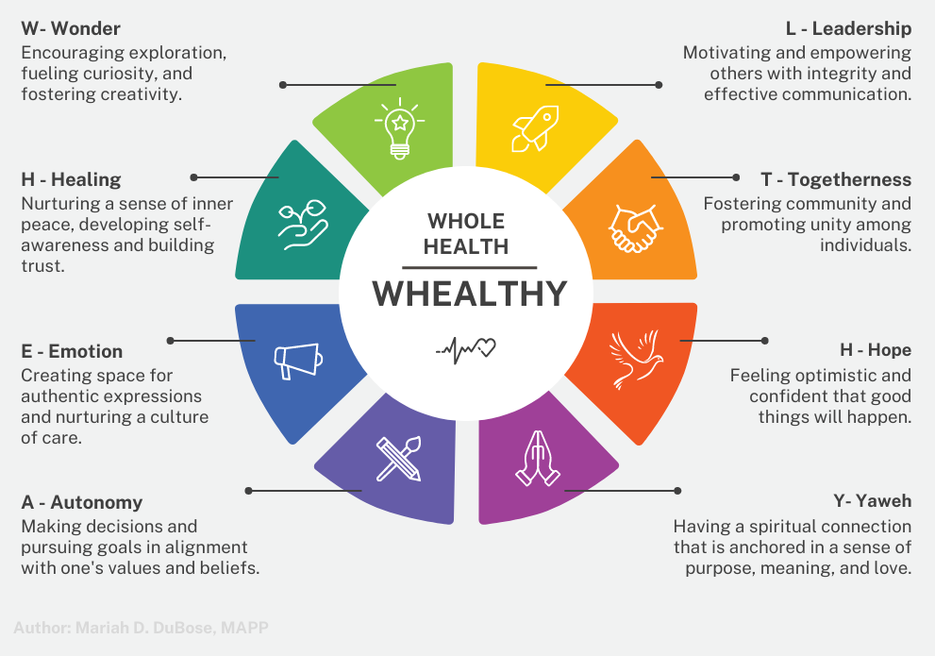
More broadly, these eight elements are key dimensions within several core psychological well-being and corresponding constructs from positive psychology theories, existing measures of psychological well-being, and new measures of thriving (Su et al., 2014). Hope, which is a form of positivity (Frederickson, 2013), is a key element in this construct, along with interest. It is suggested that interest provides a sense of mystery, letting one feel open and alive, while hope allows one to fear the worst but expect better, which inspires planning (Frederickson, 2013). Understanding this, allows individuals to lean into hope, which provides a greater likelihood of success and well-being. When evaluating aspects that contribute to one’s health and well-being, the entire person must be considered (mind-body-soul). A holistic approach of this nature increases the effectiveness of practices.

Build Supportive Networks
Incorporating positive psychology [health-conscious] practices into daily life requires commitment, practice, and a willingness to explore and embrace personal growth (Seligman & Csikszentmihalyi, 2000). In the PERMA model, the "R" which stands for relationships, underscores the essential role of community and social connections in promoting well-being. The emphasis on personal growth holds immense potential for positively impacting collective well-being by empowering individuals to take care of themselves and contribute to the support of others. When people cultivate their own well-being and personal development, they are better equipped to nurture positive relationships, contribute to their communities, and create a ripple effect of well-being that extends beyond themselves (Seligman, 2012). This interconnectedness of personal growth and collective well-being highlights the transformative power of individual efforts in fostering a healthier and more harmonious society. By consciously nurturing themselves through awareness and finding meaning, individuals can prioritize their own well-being first, akin to putting on their own oxygen mask before assisting others.
A foundation of self-love motivates individuals to adopt healthy lifestyles (Mann et al., 2004) and changes rooted in self-care and well-being rather than solely focusing on achieving societal beauty standards. The African American community has several notable and inspiring role models and influencers across various domains, including health and wellness. These public figures can provide relatable examples of individuals who have achieved success in adopting healthy lifestyles, promoting physical activity, and making positive nutrition choices. Role models and influencers can serve as sources of inspiration and guidance for those seeking to make similar changes (Hackett & Byars, 1996). While these attributes can contribute to receptiveness to healthy lifestyle changes, individual preferences and experiences can still vary within the African American community. Recognizing and building upon these positive attributes can help create culturally sensitive interventions that resonate with individuals in the Black community and foster sustainable health and well-being.
Given the shared and distinct experiences of injustice faced by African American men and women, it is crucial to offer outreach initiatives that are specifically tailored to address their unique needs. Conscious nourishment practices such as mindfulness and meditation can allow African Americans to prioritize their emotional well-being. An important consideration is the potential resistance to mindfulness programs that emphasize their association with Eastern Buddhist traditions, which may not align with the strong Christian affiliation prevalent within the African American community (Wormald, 2015). Now, more than ever, Black women [and men] must learn to exhale (Wicker, 2023) and simply be. Providing spaces and learning opportunities for African Americans to do this will provide greater opportunities to increase their overall well-being.
As scholars and practitioners endeavor to research and craft effective conscious nourishment practices for African Americans, it is imperative to acknowledge the hurdles, including income disparities, access to nutritious food, and educational barriers, that can impact the adoption of a healthier lifestyle (Swierad et al., 2017). Socioeconomic and cultural factors can have mixed effects on health. However, these observations highlight the potential for health interventions to emphasize and promote existing health-enhancing behaviors within individuals' cultures, rather than solely focusing on eliminating health-compromising behaviors. Transitioning from a deficit model to a strength-based model empowers African Americans, validating their experiences without pathologizing their health practices (Swierad et al., 2017). The late Dr. Joseph White, known as the Godfather of Black Psychology, reiterated this as he highlighted the importance of African Americans focusing on their strengths.

Focus on African American Youth
At a Black History Month event in Minneapolis, Minnesota, Dr. White, spoke to a group of nearly 150 people, expressing the importance of focusing on the youth. “We need to help our young people draw on the strength and the wisdom of the past,” he shares. Then he goes on to say that young people “need to learn” the seven psychological strengths of Blacks “and internalize them,” (White & Hallman, 2013). He then doubles down on the importance of African Americans tapping into their resilience by saying,
“If you are Black in America, you got to be able to come back from a setback, bounce back from setbacks, and become stronger in the broken places. You are not going to get through 80 years of life without getting knocked upside your head.”
Following in the enormous strides of Dr. Joseph White, a concerted effort ought to be placed on supporting African American youth to help them work through adversities, know their innate strengths, and see that they “have a future of unknown opportunities” (White & Hallman, 2013).

Conclusion
It is timely for the field of positive psychology to expand upon its understanding of the specific factors needed to facilitate the flourishing of African Americans. Scholars and practitioners must continue to bridge the field’s gaps in the literature to ensure positive psychology includes, reaches, and resonates with African Americans. Incorporating the participation of African Americans in research is essential for tailoring theories and practices to maximize the likelihood of success. The Black community faces a multitude of systemic challenges that negatively impact their well-being, including higher rates of chronic health conditions, limited access to quality healthcare, and disparities in education and income. These challenges underscore the need for a holistic approach encompassing communal, physical, mental, and emotional well-being. Conscious nourishment practices, emphasizing intentional practices that align with one’s desires, offer a promising avenue for addressing these challenges.
Merely focusing on health challenges to improve African American well-being is insufficient. Instead, this paper suggests that the additional consideration of positive psychology tenets, such as character strengths, self-efficacy, and Prilleltensky’s ICOPPE model, is essential to support this community. A strengths-based model emboldens many of the innate strengths of African Americans. Practices such as conscious movement and eating may be considered as ways to improve physical health and prevent risk factors such as obesity and hypertension. Although further research is needed, implementing conscious nourishment practices rooted in positive psychology holds great promise for empowering African American well-being.

References
Abrams, J. A., Hill, A., & Maxwell, M. (2019). Underneath the mask of the strong Black woman
schema: Disentangling influences of strength and self-silencing on depressive symptoms among U.S. Black women. Sex Roles: A Journal of Research, 80(9-10), 517
526. https://doi.org/10.1007/s11199-018-0956-y
Adam, T. C., & Epel, E. S. (2007). Stress, eating, and the reward system. Physiology &
Behavior, 91(4), 449–458. https://doi.org/10.1016/j.physbeh.2007.04.011
Alex Linley, P., Joseph, S., Harrington, S., & Wood, A. M. (2006). Positive psychology: Past, present, and (possible) future. The Journal of Positive Psychology, 1(1), 3–16. https://doi.org/10.1080/17439760500372796
American Psychological Association (2019). Guidelines for Psychological Practice for People with Low-Income and Economic Marginalization.
Bahram, H., Kronmal, R., Bluemke, D. A., Olson, J., Shea, S., Liu, K., Burke, G. L., & Lima, J.
A. (2008). Differences in the incidence of congestive heart failure by ethnicity. Archives of Internal Medicine, 168(19), 2138. https://doi.org/10.1001/archinte.168.19.2138
Berlin, I. (2010). The changing definition of African American. Smithsonian Magazine.
Chicago. https://www.smithsonianmag.com/history/the-changing-definition-of-african
american-4905887/
Berlin, I. (1998). Remembering slavery: African Americans talk about their personal
experiences of slavery and emancipation. New Press.
Bethea, Aaron (2020). "Black Psychology: A Forerunner of Positive Psychology," Psychology
from the Margins: Vol. 2, Article 5.
Biggers, A., Spears, C. A., Sanders, K., Ong, J., Sharp, L. K., & Gerber, B. S. (2020). Promoting mindfulness in African American communities. Mindfulness, 11(10), 2274–2282. https://doi.org/10.1007/s12671-020-01480-w
Bolier, L., Haverman, M., Westerhof, G. J., Riper, H., Smit, F., & Bohlmeijer, E. T. (2013). Positive psychology interventions: A meta-analysis of randomized controlled studies. BMC Public Health, 13(1). https://doi.org/10.1186/1471-2458-13-119
Boniwell, I. (2012). Positive psychology in a nutshell. (Third Edition). Two Penn Plaza, New York: Open University Press.
Bowers, E. P., Geldhof, G. J., Johnson, S. K., Hilliard, L. J., Hershberg, R. M., Lerner, J. V., & Lerner, R. M. (2015). Promoting positive youth development lessons from the 4-H study. Springer International Publishing.
Breathett, K., Sims, M., Gross, M., Jackson, E. A., Jones, E. J., Navas-Acien, A., Taylor, H., Thomas, K. L., Howard, B. V., & American Heart Association Council on Epidemiology and Prevention; Council on Quality of Care and Outcomes Research; Council on Cardiovascular and Stroke Nursing; Council on Clinical Cardiology; and Council on Lifestyle and Cardiometabolic Health (2020). Cardiovascular Health in American Indians and Alaska Natives: A Scientific Statement From the American Heart Association. Circulation, 141(25), e948–e959. https://doi.org/10.1161/CIR.000000000000077
Brewer LC, Redmond N, Slusser JP, Scott CG, Chamberlain AM, Djousse L, Patten CA, Roger V & Sims M (2018). Stress and achievement of cardiovascular health metrics: The American Heart Association Life’s Simple 7 in Blacks of the Jackson Heart Study. Journal of the American Heart Association, 7(11). https://doi.org/10.1161/JAHA.118.008855
Brown, K. W., & Ryan, R. M. (2015). A self-determination theory perspective on fostering
healthy self-regulation from within and without. Positive psychology
in practice: Promoting human flourishing in work, health, education, and everyday life 2(1) 139–157. Wiley. https://doi.org/10.1002/9781118996874.ch9
Caldwell-Colbert, A. T., Parks, F. M., & Eshun, S. (2009). Positive psychology: African American strengths, resilience, and protective factors. In H. A. Neville, B. M. Tynes, & S. O. Utsey (Eds.), Handbook of African American Psychology (pp. 375–384). Sage Publications, Inc.
Chatters, L. M. (2019). Religion and health: A synthesis. In L. J. Francis (Ed.), Religion and Health: A Synthesis (pp. 347-368). Brill.
Chang, E. C., Downey, C. A., Hirsch, J. K., & Lin, N. J. (2016). Positive psychology in racial and ethnic groups: A second call to action! In E. C. Chang, C. A. Downey, J. K. Hirsch, & N. J. Lin (Eds.), Positive psychology in racial and ethnic groups: Theory, research, and practice (pp. 3–12). American Psychological Association. https://doi.org/10.1037/14799-001
Clay, R. A. (2001, October). Wealth secures health: psychologists’ research is probing why the more money you have, the better health you enjoy. Monitor on Psychology, 32(9), 78. https://www.apa.org/monitor/oct01/wealthhealth
Cleveland. C. medical. (2022, May 15). Heart disease risk: How race and ethnicity play a role. Cleveland Clinic. https://my.clevelandclinic.org/health/articles/23051-ethnicity-and-heart-disease
Como, D. H., Stein Duker, L. I., Polido, J. C., & Cermak, S. A. (2019). The Persistence of Oral Health Disparities for African American Children: A Scoping Review. International journal of environmental research and public health, 16(5), 710. https://doi.org/10.3390/ijerph16050710
Constitution. (1946). World Health Organization.
Dahl, C. J., Wilson-Mendenhall, C. D., & Davidson, R. J. (2020). The plasticity of well-being: A training-based framework for the cultivation of human flourishing. Proceedings of the National Academy of Sciences of the United States of America, 117(51), 32197–32206. https://doi.org/10.1073/pnas.2014859117
DeFreitas, S. C. (2020). African American psychology: A positive psychology perspective. Springer Publishing Company.
Der Ananian, C., Winham, D. M., Thompson, S. V., & Tisue, M. E. (2018). Perceptions of Heart-Healthy Behaviors among African American Adults: A Mixed Methods Study. International journal of environmental research and public health, 15(11), 2433. https://doi.org/10.3390/ijerph15112433
Diener, E., & Chan, M. Y. (2011). Happy people live longer: Subjective well-being contributes to health and longevity. Applied Psychology: Health and Well-Being, 3(1), 1-43. https://doi.org/10.1111/j.1758-0854.2010.01045.x
Diener, E., Pressman, S. D., Hunter, J., & Delgadillo-Chase, D. (2017). If, why, and when subjective well-being influences health, and future needed research. Applied Psychology: Health and Well-Being, 9(2), 133–167. https://doi.org/10.1111/aphw.12090
Dublin, L. I. (1928). The health of the negro. Annals of the American Academy of Political and Social Science, 140(1), 77–85. https://doi.org/10.1177/000271622814000111
Eshun, S., & Packer, E. M. (2016). Positive psychology practice with African Americans: Mental health challenges and treatment. In E. C. Chang, C. A. Downey, J. K. Hirsch, & N. J. Lin (Eds.), Positive psychology in racial and ethnic groups: Theory, research, and practice (pp. 259–279). American Psychological Association. https://doi.org/10.1037/14799-013
Feinglass, J., Lin, S., Thompson, J., Sudano, J., Dunlop, D., Song, J., & Baker, D. W. (2007). Baseline Health, socioeconomic status, and 10-year mortality among older middle-aged Americans: Findings from the Health and Retirement Study, 1992-2002. The Journals of Gerontology Series B: Psychological Sciences and Social Sciences, 62(4). https://doi.org/10.1093/geronb/62.4.s209
Ford CL, Airhihenbuwa CO. (2010). Critical Race Theory, Race Equity, and Public Health: Toward Antiracism Praxis. American journal of public health, 100 (1), S30–S35. https://doi.org/10.2105/AJPH.2009.171058
Fredrickson, B. L. (2013). Positive emotions broaden and build. In Advances in Experimental Social Psychology (pp. 1–53). Elsevier BV. https://doi.org/10.1016/B978-0-12-407236-7.00001-2
Fredrickson, B. L. (2001). The role of positive emotions in positive psychology: The broaden and-build theory of positive emotions. American Psychologist, 56(3), 218-226. https://doi.org/10.1037//0003-066x.56.3.218
Gaillard, T., Schuster, D., & Osei, K. (2009). Metabolic syndrome in Black people of the African diaspora: the paradox of current classification, definition, and criteria. Ethnicity & disease, 19(2), S2–7.
Geesler, K. (2022, August 31). How health systems can help build black wealth. Penn Medicine News. https://www.pennmedicine.org/news/news-releases/2022/august/how-health-systems-can-help-build-black-wealth
Hackett, G., & Byars, A. M. (1996). Social cognitive theory and the career development of
African American women. The Career Development Quarterly, 44(4), 322-340.
https://doi.org/10.1002/j.2161-0045.1996.tb00449.x
Hammond, W. P., & Mattis, J. S. (2005). Being a Man About It: Manhood Meaning Among
African American Men. Psychology of Men & Masculinity, 6(2), 114
126. https://doi.org/10.1037/1524-9220.6.2.114
Healthy People 2030, U.S. Department of Health and Human Services, Office of Disease
Prevention and Health Promotion. Retrieved June 2023, from
https://health.gov/healthypeople/objectives-and-data/social-determinants-health
Hill JO, & Peters JC (1998). Environmental contributions to the obesity
epidemic. Science, 280(5368), 1371–1374. https://doi.org/10.1126/science.280.5368.1371
Hill, P. C. (2014). The Black Church and Positive Psychology. In E. C. Chang, C. A. Downey, & J. D. Hirsch (Eds.), Positive Psychology in Racial and Ethnic Groups: Theory, Research, and Practice (pp. 221-239). American Psychological Association.
Howard, T., Shegog, M., McNair, D., & Lowery, M. (2019). Black health and wealth: understanding the intricate linkages between income, health, and wealth for African Americans. Center for Policy Analysis and Research, 1–24.
Howell, R. T., Kern, M. L., & Lyubomirsky, S. (2007). Health benefits: Meta-analytically determining the impact of well-being on objective health outcomes. Health Psychology Review, 1(1), 83–136. https://doi.org/10.1080/17437190701492486
Huta, V. (2016). Eudaimonic and Hedonic Orientations: theoretical considerations and research findings. In International handbooks of quality-of-life (pp. 215–231). Springer International Publishing. https://doi.org/10.1007/978-3-319-42445-3_15
Huppert, F. A. (2009). Psychological well-being: Evidence regarding its causes and
consequences. Applied Psychology: Health and Well-Being, 1(2), 137–164.
https://doi.org/10.1111/j.1758-0854.2009.01008.x
Javed, Z., Haisum Maqsood, M., Yahya, T., Amin, Z., Acquah, I., Valero-Elizondo, J., Andrieni, J., Dubey, P., Jackson, R. K., Daffin, M. A., Cainzos-Achirica, M., Hyder, A. A., & Nasir, K. (2022). Race, Racism, and Cardiovascular Health: Applying a Social Determinants of Health Framework to Racial/Ethnic Disparities in Cardiovascular Disease. Circulation. Cardiovascular quality and outcomes, 15(1), e007917. https://doi.org/10.1161/circoutcomes.121.007917
Jamison, D. T., Breman, J. G., Measham, A. R., Alleyne, G., Claeson, M., Evans, D. B., Jha, P., Mills, A., Musgrove, P., Willett, W. C., Koplan, J. P., Nugent, R., Dusenbury, C., Puska, P., Gaziano, T. A. (2006). Chapter 44. Prevention of Chronic Disease by Means of Diet and Lifestyle Changes. In World Bank Publications. World Bank Publications.
Jones, N., Kiely, J., Suraci, B., Collins, D. J., de Lorenzo, D., Pickering, C., & Grimaldi, K. A. (2016). A genetic-based algorithm for personalized resistance training. Biology of sport, 33(2), 117–126. https://doi.org/10.5604/20831862.1198210
Kern, M. L., Waters, L. E., Adler, A., & White, M. A. (2015). A multidimensional approach to measuring well-being in students: Application of the PERMA framework. The Journal of Positive Psychology, 10(3), 262–271. https://doi.org/10.1080/17439760.2014.936962
Keyes, C. L. (2005). Mental illness and/or mental health? Investigating axioms of the complete state model of health. Journal of Consulting and Clinical Psychology, 73(3), 539-548. https://doi.org/10.1037/0022-006X.73.3.539
LaVeist, T. A., Isaac, L. A., & Williams, K. P. (2009). Mistrust of health care organizations is associated with underutilization of health services. Health services research, 44(6), 2093–2105. https://doi.org/10.1111/j.1475-6773.2009.01017.x
Linnan, L. A., D'Angelo, H., & Harrington, C. B. (2014). A literature synthesis of health promotion research in salons and barbershops. American journal of preventive medicine, 47(1), 77–85. https://doi.org/10.1016/j.amepre.2014.02.007
Linley, P.A. & Harrington, S. (2006). Playing to your strengths. The Psychologist, 19(2), 86–89.
Lopez, R., Regier, J., Cole, M. B., Jordan, M. I., & Yosef, N. (2018). Deep generative modeling for single-cell transcriptomics. Nature methods, 15(12), 1053–1058. https://doi.org/10.1038/s41592-018-0229-2
Lukianoff, G., & Haidt, J. (2018). The coddling of the American mind: How Good Intentions and Bad Ideas Are Setting Up a Generation for Failure. Penguin.
Maddux, J. E., & Kleiman, E. M. (2021). Self-efficacy: The power of believing you can. In C. R. Snyder, S. J. Lopez, L. M. Edwards, & S. C. Marques (Eds.), The Oxford handbook of positive psychology (pp. 443–452). Oxford University Press.
Magyar-Moe, J. L. (2014). Applications of positive psychology to individual therapy. In A. C. Parks & S. M. Schueller (Eds.), The Wiley Blackwell handbook of positive psychological interventions (pp. 255–272). Wiley Blackwell. https://doi.org/10.1002/9781118315927.ch14
Mann, M., Hosman, C. M. H., Schaalma, H. P., & De Vries, N. K. (2004). Self-esteem in a broad-spectrum approach for mental health promotion. Health Education Research, 19(4), 357–372. https://doi.org/10.1093/her/cyg041
Maslow, A. H. (1970). Motivation and Personality (2nd ed.). New York: Harper & Row.
Mattis, J.S. (2022). Cultural Considerations in Positive Psychology and the Psychology of Religion and Spirituality. In: Davis, E.B., Worthington Jr., E.L., Schnitker, S.A. (eds) Handbook of Positive Psychology, Religion, and Spirituality. Springer, Cham. https://doi.org/10.1007/978-3-031-10274-5_9
Mattis, J. S., Simpson, N. G., Powell, W., Anderson, R. E., Kimbro, L. R., & Mattis, J. H. (2016). Positive psychology in African Americans. In E. C. Chang, C. A. Downey, J. K. Hirsch, & N. J. Lin (Eds.), Positive psychology in racial and ethnic groups: Theory, research, and practice (pp. 83–107). American Psychological Association. https://doi.org/10.1037/14799-005
McCartney, D. M., Rattray, M., Desbrow, B., Khalesi, S., & Irwin, C. (2018). Smoothies: Exploring the attitudes, beliefs and behaviours of consumers and Non-Consumers. Current Research in Nutrition and Food Science Journal, 6(2), 425–436. https://doi.org/10.12944/crnfsj.6.2.17
McMaughan, D. J., Oloruntoba, O., & Smith, M. L. (2020). Socioeconomic Status and Access to Healthcare: Interrelated Drivers for Healthy Aging. Frontiers in public health, 8, 231. https://doi.org/10.3389/fpubh.2020.00231
Millstein, R. A., Huffman, J. C., Thorndike, A. N., Freedman, M., Scheu, C., Kim, S., Amonoo, H. L., Barclay, M., & Park, E. R. (2020). How Do Positive Psychological Constructs Affect Physical Activity Engagement Among Individuals at High Risk for Chronic Health Conditions? A Qualitative Study, Journal of Physical Activity and Health, 17(10), 977–986. https://doi.org/10.1123/jpah.2019-0295
Mineo, L. (2021, June 3). Racial wealth gap may be key to other inequities - a look at how and why we got there and what we can do about it. The Harvard Gazette. Retrieved June 31, 2023, from https://news.harvard.edu/gazette/story/2021/06/racial-wealth-gap-may-be-a-key-to-other-inequities/.
Morris, Caile (2011). "Black Slave Gender Roles: How They Were Changed by Emancipation," Proceedings of GREAT Day: Vol. 2010, Article 17.
Myers, N. D., Prilleltensky, I., Prilleltensky, O., McMahon, A., Dietz, S., & Rubenstein, C. L. (2017). Efficacy of the Fun For Wellness Online Intervention to Promote Multidimensional Well-Being: a Randomized Controlled Trial. Prevention science : the official journal of the Society for Prevention Research, 18(8), 984–994. https://doi.org/10.1007/s11121-017-0779-z
Nadeem, R. (2023). Black Americans’ engagement with news and information on COVID-19 and other science-related topics. Pew Research Center Science & Society.
National Healthcare Quality and Disparities Report (2022). Rockville, MD: Agency for Healthcare Research and Quality; October 2022. AHRQ Pub. 22(23)-0030.
Niemiec, R., Rashid, T., & Spinella, M. (2012). Strong mindfulness: Integrating mindfulness and
character strengths. Journal of Mental Health Counseling, 34(3), 240–253.
https://doi.org/10.17744/mehc.34.3.34p6328x2v204v21
Noonan, A. S., Velasco-Mondragón, H. E., & Wagner, F. A. (2016). Improving the health of African Americans in the USA: an overdue opportunity for social justice. Public Health
Reviews, 37(1). https://doi.org/10.1186/s40985-016-0025-4
O’Brien, E., & Seydel, A. (2022). The Power of Play: Optimize Your Joy Potential. Live Life Happy Publishing.
Ogunniyi, M. O., Commodore-Mensah, Y., & Ferdinand, K. C. (2021). Race, ethnicity, hypertension, and heart disease: JACC Focus Seminar 1/9. Journal of the American College of Cardiology, 78(24), 2460–2470. https://doi.org/10.1016/j.jacc.2021.06.017
Park, N., Peterson, C., & Seligman, M. E. (2004). Strengths of character and well-being. Journal of Social and Clinical Psychology, 23(5), 603–619. https://doi.org/10.1521/jscp.23.5.603.50748
Park, N., Peterson, C., Szvarca, D., Vander Molen, R. J., Kim, E. S., & Collon, K. (2014). Positive Psychology and Physical Health: Research and Applications. American journal of lifestyle medicine, 10(3), 200–206. https://doi.org/10.1177/1559827614550277
Pawelski, J. O. (2020). The elements model: Toward a new generation of positive psychology interventions. The Journal of Positive Psychology, 15(5), 675–679. https://doi.org/10.1080/17439760.2020.1789710
Pedrotti, J. T., & Edwards, L. M. (2017). Cultural context in positive psychology; History, research, and opportunities for growth. In M. A. Warren (Ed.), Scientific Advances in Positive Psychology (pp. 257–287). essay, Praeger.
Peterson, C. (2006). In a primer in positive psychology. Oxford University Press.
Peterson, C. & Seligman, M.E.P. (2004). Character strengths and virtues: A handbook and
classification. Washington, DC: American Psychological Association.
Pennebaker, J. W., Colder, M., & Sharp, L. K. (1990). Accelerating the coping process. Journal
of Personality and Social Psychology, 58(3), 528–537.
https://doi.org/10.1037/0022-3514.58.3.528
Pickett, K.E., James, O.W., & Wilkinson, R.G. (2006). Income inequality and the prevalence of
mental illness: A preliminary international analysis. Journal of Epidemiology and
Community Health, 60, 646–647. https://doi.org/10.1136/jech.2006.046631
Prilleltensky, I., & Prilleltensky, O. (2021). How People Matter: Why it Affects Health,
Happiness, Love, Work, and Society. Cambridge University Press.
Prilleltensky, I. (2005). Promoting well-being: Time for a paradigm shift in health and human
services. Scandinavian Journal of Public Health, 33, 53-60.
https://doi.org/10.1080/14034950510033381
Prilleltensky, I., & Gonick, L. (1996). Polities change, oppression remains: On the psychology and politics of oppression. Political Psychology, 17(1), 127-147. https://doi.org/10.2307/3791946
Ratey, J. J. (2013). Spark. Little, Brown & Company.
Romero, R.E. (2000). The icon of the strong black woman: The paradox of strength. In L. C. Jackson & B. Greene (Eds.), Psychotherapy with African American women: Innovations in psychodynamic perspectives and practices (pp. 225-238). New York: Guilford Press.
Rogers, C. R. (1951). Client-centered therapy; its current practice, implications, and theory. Houghton Mifflin.
Rioja, E., Thomas, B. A. (2021). The COVID-19 pandemic, black mistrust, and a path
forward. EClinicalMedicine, 35, 100868. https://doi.org/10.1016/j.eclinm.2021.100868
Ruggeri, K., Garcia-Garzon, E., Maguire, Á., Matz, S., & Huppert, F. A. (2020). Well-being is
more than happiness and life satisfaction: A multidimensional analysis of 21 countries.
Health and Quality of Life Outcomes, 18(1). https://doi.org/10.1186/s12955-020-01423-y
Ryan, R. M., & Deci, E. L. (2001). On happiness and human potentials: A review of research on
hedonic and eudaimonic well-being. Annual Review of Psychology, 52, 141 166. https://doi.org/10.1146/annurev.psych.52.1.141
Saunders, M., & LMSW (2020). "Enough Is Enough." An Historical Perspective: Long Lasting
Health Disparities in the African American Population in the Midst of the COVID-19 and the George Floyd Incident. Delaware journal of public health, 6(5), 42–48. https://doi.org/10.32481/djph.2020.11.013
Sayer, J., Paniagua, D., Ballentine, S., Sheehan, L., Carson, M., Nieweglowski, K., MS, CRC,
LPC, Corrigan, P. (2019) Perspectives on diet and physical activity among urban African Americans with serious mental illness. Social work in health care, 58(5), 509–525. https://doi.org/10.1080/00981389.2019.1587662
Schueller, S. M. (2014). Person-activity fit in positive psychological interventions. In A.C. Parks & S. M. Schueller (Eds.), The Wiley Blackwell Handbook of Positive Psychological Interventions, 385–402. https://doi.org/10.1002/9781118315927.ch22
Schulz, A. J., House, J. S., Israel, B. A., Mentz, G., Dvonch, J. T., Miranda, P. Y., & Koch, M. (2008). Relational pathways between socioeconomic position and cardiovascular risk in a
multiethnic urban sample: complexities and their implications for improving health in
economically disadvantaged populations. Journal of Epidemiology & Community
Health, 62(7), 638-646. https://doi.org/10.1136/jech.2007.063222
Seligman, M. E. P. (2012). Flourish: A Visionary New Understanding of Happiness and
Wellbeing. Simon and Schuster.
Seligman, M. E. P., Csikszentmihalyi, M. (2000). Positive psychology: An introduction.
American Psychologist, 55(1), 5-14. https://doi.org/10.1037//0003-066x.55.1.5
Seligman, M. E. P. (2002). Authentic happiness. New York, NY: Free Press.
Sin, N. L., & Lyubomirsky, S. (2009). Enhancing well-being and alleviating depressive symptoms with positive psychology interventions: A practice-friendly meta-analysis. Journal of Clinical Psychology, 65(5), 467–487. https://doi.org/10.1002/jclp.20593
Slade, M. (2010). Mental illness and well-being: The central importance of positive psychology and Recovery Approaches. BMC Health Services Research, 10(1). https://doi.org/10.1186/1472-6963-10-26
Smedley, B. D., Stith, A. Y., Nelson, A. R. (2003). Institute of Medicine (US) Committee on Understanding and Eliminating Racial and Ethnic Disparities in Health Care. Unequal Treatment: Confronting Racial and Ethnic Disparities in Health Care. National Academies Press (US).
Smedley, B. D., Syme, S. L. (2001). Promoting Health: Intervention Strategies from Social and Behavioral Research. American Journal of Health Promotion, 15(3), 149–166. https://doi.org/10.4278/0890-1171-15.3.149
South, E., Venkataramani, A., & Dalembert, G. (2022). Building black wealth — the role of Health Systems in closing the gap. New England Journal of Medicine, 387(9), 844–849. https://doi.org/10.1056/nejmms2209521
Stewart III, S., Chui, M., Manyika, J., Julien, J., Hunt, D. V., Sternfels, B., & Woetzel, J. (2021). The economic state of Black America: What is and what could be. McKinsey Global Institute.
Stoewen, D. L. (2017). Dimensions of wellness: Change your habits, change your life. The Canadian veterinary journal = La revue veterinaire canadienne, 58(8), 861–862.
Swierad, E. M., Vartanian, L. R., & King, M. (2017). The Influence of Ethnic and Mainstream Cultures on African Americans' Health Behaviors: A Qualitative Study. Behavioral sciences (Basel, Switzerland), 7(3), 49. https://doi.org/10.3390/bs7030049
Taylor, W. C., Yancey, A. K., Leslie, J., Murray, N. G., Cummings, S. S., Sharkey, S. A., Wert, C., James, J., Miles, O., & McCarthy, W. J. (1999). Physical activity among African American and Latino middle school girls: consistent beliefs, expectations, and experiences across two sites. Women & health, 30(2), 67–82. https://doi.org/10.1300/j013v30n02_05
Thomas, A. J., Witherspoon, K. M., Karen, M., & Speight, S. L. (2004). Toward the
development of the Stereotypic Roles for Black Women Scale. Journal of Black Psychology, 30(3), 426-442. https://doi.org/10.1177/0095798404266061
Thorp, R. (2013). The concept of historical consciousness in Swedish history didactical research. Cultural and religious diversity and its implications for history education, 34, 207-224.
Vieten, C., Wahbeh, H., Cahn, B. R., MacLean, K., Estrada, M., Mills, P., Murphy, M., Shapiro, S., Radin, D., Josipovic, Z., Presti, D. E., Sapiro, M., Chozen Bays, J., Russell, P., Vago, D., Travis, F., Walsh, R., & Delorme, A. (2018). Future directions in meditation research: Recommendations for expanding the field of contemplative science. PloS one, 13(11), e0205740. https://doi.org/10.1371/journal.pone.0205740
Wendler, D., Kington, R., Madans, J., Van Wye, G., Christ-Schmidt, H., Pratt, L. A., Brawley, O. W., Gross, C. P., & Emanuel, E. (2006). Are racial and ethnic minorities less willing to participate in health research?. PLoS medicine, 3(2), e19. https://doi.org/10.1371/journal.pmed.0030019
Weir, K. (2021). There's a new push to reach underserved communities. Monitor on ` Psychology, 52(1).
White, J., & Hallman, C. (2013). Minneapolis Public Schools (MPS) Black History Month
Event. Godfather of Black psychology identifies Black strengths needed to counter harmful impact of mass media. Minneapolis; MPS Davis Center. Retrieved from https://spokesman-recorder.com/2013/03/06/godfather-of-black-psychology-identifies-black-strengths-needed-to-counter-harmful-impact-of-mass-media/#:~:text=These%20strengths%20include%20improvisation%2C%20resilience,I%20didn’t%20create%20them.
White, J. & Parham, T. A. (1990). The psychology of Blacks: An African American perspective (2nd ed.). Englewood Cliffs, NJ: Prentice Hall.
Wormald, B. (2015). America's Changing Religious Landscape, Pew Research Center's Religion & Public Life Project. United States of America.
Willett W. C. (2002). Balancing lifestyle and genomics research for disease prevention. Science (New York, N.Y.), 296(5568), 695–698. https://doi.org/10.1126/science.1071055
Williams, W. M., Yore, M. M., & Whitt-Glover, M. C. (2018). Estimating physical activity trends among blacks in the United States through examination of four national surveys. AIMS public health, 5(2), 144–157. https://doi.org/10.3934/publichealth.2018.2.144
Wicker, K. (2023, July). Black women waiting to exhale, there’s an app for that: Founded by Black female app developer Katara McCarty, the Exhale breathwork and meditation app prioritizes the Black experience. The grio. https://news.yahoo.com/black-women-waiting-exhale-app-202200012.html
Williams, D. R., & Collins, C. (2001). Racial residential segregation: a fundamental cause of racial disparities in health. Public health reports (Washington, D.C. : 1974), 116(5), 404–416. https://doi.org/10.1093/phr/116.5.404
Williams, D. R., Mohammed, S. A., Leavell, J., & Collins, C. (2010). Race, socioeconomic
status, and health: complexities, ongoing challenges, and research opportunities. Annals
of the New York Academy of Sciences, 1186, 69–101. https://doi.org/10.1111/j.1749
6632.2009.05339.x
Willis, A., Isaacs, T., & Khunti, K. (2021). Improving diversity in research and trial participation: the challenges of language. The Lancet. Public health, 6(7), e445–e446. https://doi.org/10.1016/S2468-2667(21)00100-6
World Health Organization. (2021, June 11). Cardiovascular diseases (cvds). World Health Organization. https://www.who.int/news-room/fact-sheets/detail/cardiovascular-diseases-(cvds)
World Health Organization. (2004). Promoting mental health: Concepts, emerging evidence, practice: Summary report. World Health Organization.
Wong, K. (2023, May 22). What did the richest Black billionaires’ study at uni?! Study International.

Appendix A: Social Determinants of Health, Health Disparities, and Prevention
Graphic 1: Social Determinants of Health
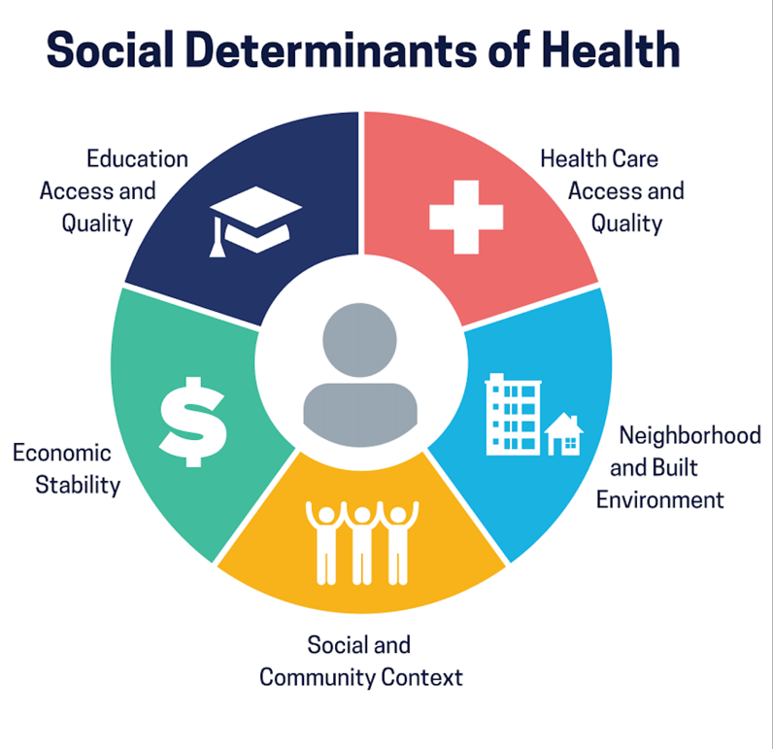

Note: Healthy People 2030, U.S. Department of Health and Human Services, Office of Disease Prevention and Health Promotion. Retrieved July 2023, from
https://health.gov/healthypeople/objectives-and-data/social-determinants-health

Graphic 2: Table of Lifestyle Factors and Chronic Diseases
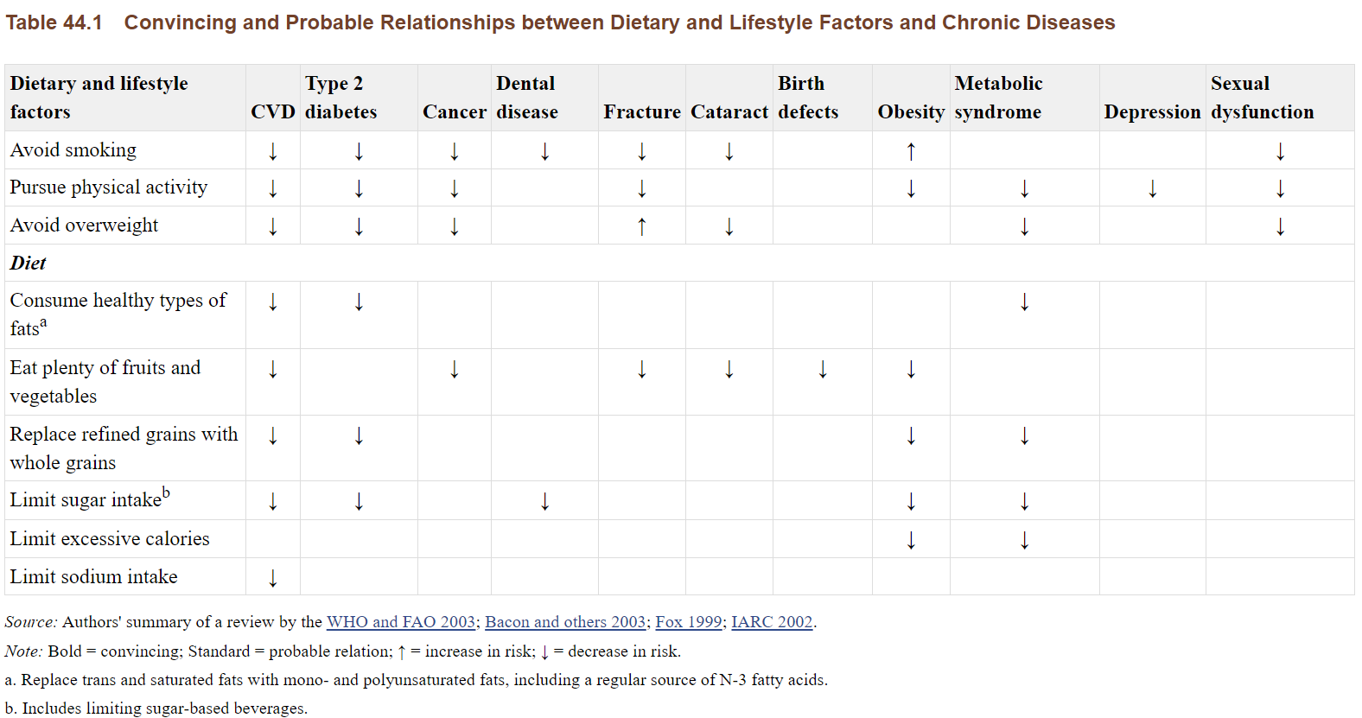
Note: Convincing Relationship Between Dietary Lifestyle Factors and Chronic Diseases Reprinted from “Chapter 44. Prevention of Chronic Disease by Means of Diet and Lifestyle Changes” by Jamison et al., 2006, In the World Bank. Copyright 2006 by University of Akron. Reprinted with permission.

Graphic 3: Asthma Percentage by Race from 2007 to 2017 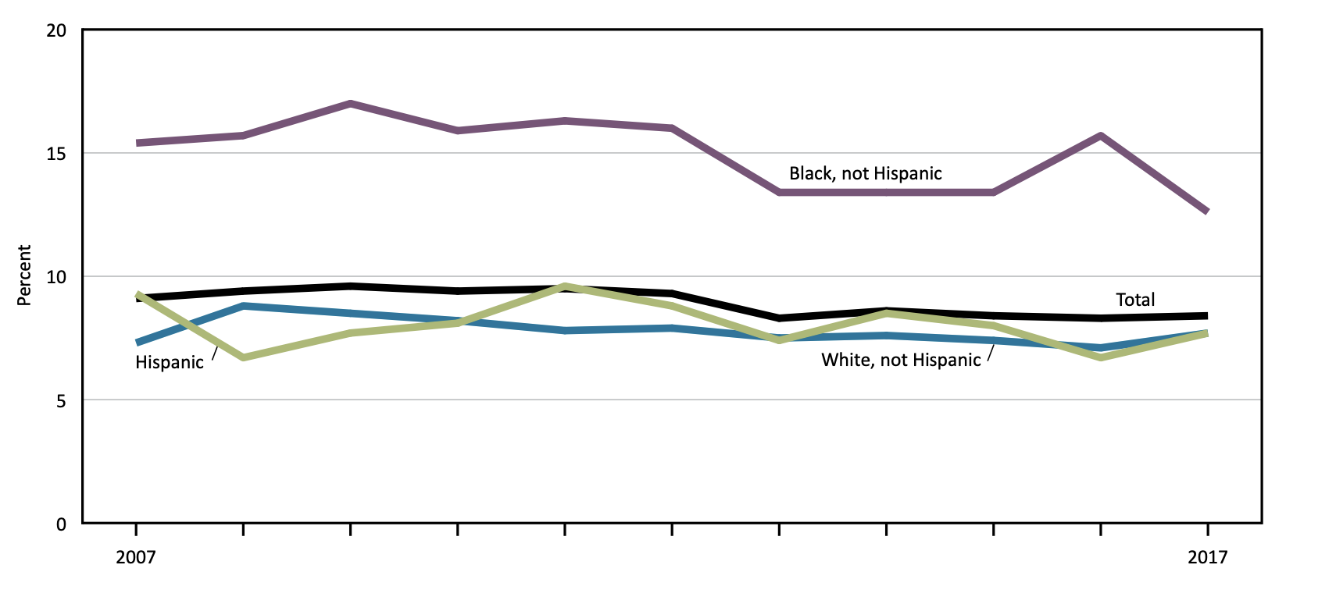
Notes: Asthma Percentage by Race From 2007 to 2017 Reprinted from “Current asthma is based on parent or knowledgeable adult responding yes to both questions, “Has a doctor or other health professional ever told you that your child had asthma?” and “Does your child still have asthma?”” Copyright 2016 by Creative Commons. Reprinted with permission. See data table for Figure 9. SOURCE: NCHS, National Health Interview Survey (NHIS). Excel and PowerPoint: https://www.cdc.gov/nchs/hus/contents2018.htm#Figure_009

Appendix B: Positive Psychology
Table 1: Three Pillars of Positive Psychology
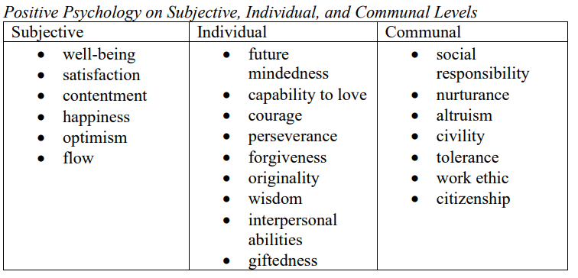
Note: The Three Pillars of Positive Psychology. Reprinted from “Black Psychology: A Forerunner of Positive Psychology” by Bethea Aaron, 2020, Psychology from the Margins 2(5). Copyright 2020 by University of Akron. Reprinted with permissions

Table 2: The Seven Strengths of Black Psychology Compared to the Six Core Virtues of Positive Psychology

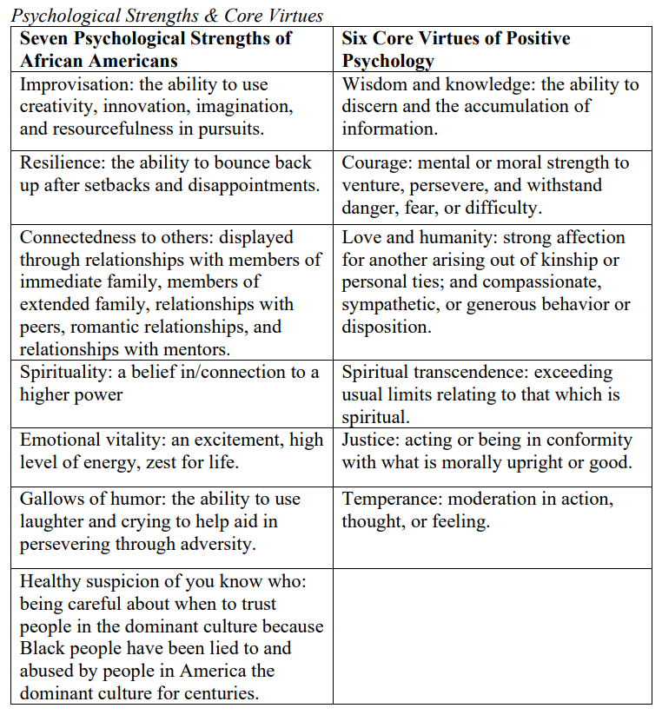
Note: Psychological Strengths & Core Virtues. Reprinted from “Black Psychology: A Forerunner of Positive Psychology” by Bethea Aaron, 2020, Psychology from the Margins 2(5). Copyright 2020 by University of Akron. Reprinted with permission.

Table 3: Character Strengths and Virtues
Character Strengths
Wisdom and knowledge – ‘cognitive strengths that entail the acquisition and use of knowledge’ | 1. Creativity: Thinking of novel ways to do things
 | 2. Curiosity (interest, novelty-seeking, openness to experience)
 | 3. Open-mindedness (judgement, critical thinking): Examining counterarguments
 | 4. Love of learning: Mastering new skills and knowledge
 | 5. Perspective (wisdom): Providing wise counsel
Courage – ‘emotional strengths that involve the exercise of the will to accomplish goals’ | 6. Bravery (valor): Not shrinking from threat, challenge, difficulty, or pain
 | 7. Persistence: Finishing what one begins
 | 8. Integrity (authenticity, honesty): Presenting oneself in a genuine way
 | 9. Vitality (zest, enthusiasm, vigor, energy): Approaching life with excitement and energy
Humanity – ‘interpersonal strengths that involve tending and befriending others’ | 10. Love: Valuing close relationships
 | 11. Kindness (generosity, nurturance, care, compassion, altruistic love, ‘niceness’): Doing favors and good deeds for others
 | 12. Social intelligence (emotional intelligence, personal intelligence): Being aware of the motives and feelings of others and of oneself
Justice – ‘civic strengths that underlie healthy community life’ | 13. Citizenship (social responsibility, loyalty): Working well as a member of a team or group
 | 14. Fairness: Treating all people equally
 | 15. Leadership: Encouraging others
Temperance – ‘strengths that protect against excess’ | 16. Forgiveness and mercy
Temperance – ‘strengths that protect against excess’ | 17. Humility: Letting accomplishments speak for themselves without seeking the spotlight
Temperance – ‘strengths that protect against excess’ | 18. Prudence: Being careful about one’s choices
Temperance – ‘strengths that protect against excess’ | 19. Self-regulation (self-control): Regulating what one feels and does
Transcendence – ‘strengths that forge connections to the larger universe and provide meaning’ | 20. Appreciation of beauty and excellence (awe, wonder, elevation)
 | 21. Gratitude: Being thankful for good things
 | 22. Hope (optimism, future-mindedness): Expecting the best and working to achieve it
 | 23. Humor (playfulness): Liking to laugh and bringing smiles to other people
 | 24. Spirituality (religiosity, faith): Having coherent beliefs about one’s purpose and meaning

Note: Character Strengths. Reprinted from “Character Strengths and Virtues: A Handbook and Classification” by C. Peterson & M. Seligman. Copyright 2004 by
Oxford University Press. Reprinted with permission

Appendix C: Future Considerations
Graphic 4: 6-month health campaign focused on exercise and nutrition for an institution (i.e., School, Church, Salon, etc.):
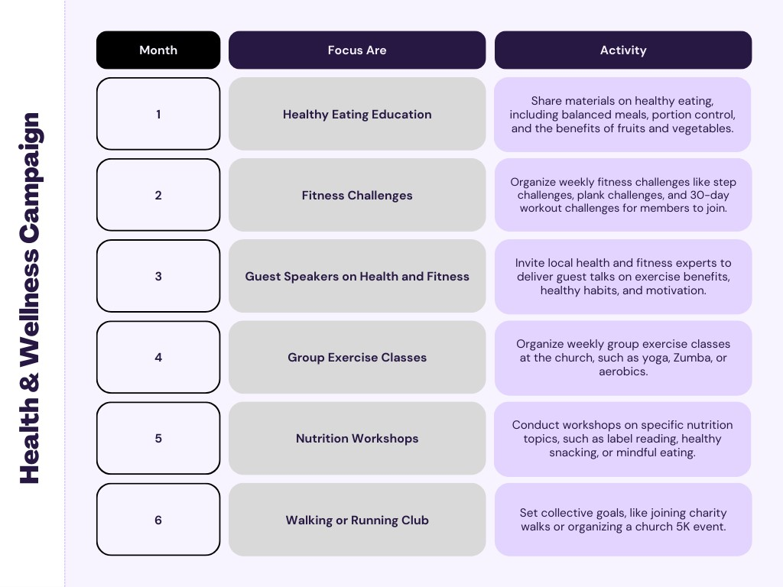
Note: Campaigns should be modified to best fit the resources and preferences of the institution/organization.

Graphic 5: Holistic WHEALTHY Framework
The positive psychology based well-being framework was created to visualize elements that contribute to an individual’s whole health.
WHEALTHY Framework: Whole Health = WHEALTHY
Wonder allows for exploration, curiosity, and creativity. [Openness]
Healing allows for growth and evolution. [Self-efficacy]
Emotion allows for expressions and care of a range of emotions. [Emotional Intelligence]
Autonomy allows for self-agency and self-efficacy. [Self-Determination]
Leadership allows support and inspires others. [Add Value]
Togetherness allows for a sense of community and unity. [Belonging]
Hope allows for inspiration and optimism. [Optimism]
Yahweh* allows for spiritual connections rooted in purpose/meaning.[Spirituality]
*Hebrew name for God

Appendix A-C References
Clinic, C. (2022, May). Heart disease risk: How race and ethnicity play a role. How Race and Ethnicity Impact Heart Disease. https://my.clevelandclinic.org/health/articles/23051-ethnicity-and-heart disease#:~:text=Cardiovascular%20disease%20is%20the%20leading %20cause%20of%20death%20for%20all,with%2036%25%20of%20white%20adults
Jamison, D. T., Breman, J. G., Measham, A. R., Alleyne, G., Claeson, M., Evans, D. B., Jha, P., Mills, A., Musgrove, P., Willett, W. C., Koplan, J. P., Nugent, R., Dusenbury, C., Puska, P., Gaziano, T. A. (2006). Chapter 44. Prevention of Chronic Disease by Means of Diet and Lifestyle Changes. In World Bank Publications. World Bank Publications.
National Center for Health Statistics: https://www.cdc.gov/nchs/hus/data-finder.htm?year=2018
Peterson, C. & Seligman, M.E.P. (2004). Character strengths and virtues: A handbook and
classification. Washington, DC: American Psychological Association.
White, J. (1984). The psychology of Blacks: An Afro-American perspective. Englewood Cliffs, NJ: Prentice Hall

