LAÏCITÉ AND GOVERNMENTALITY IN TWO PARKS BORDERING THE PARISIAN SEINE

By

Morgan E. Savige

In

Anthropology

Submitted to the
Department of Anthropology
University of Pennsylvania

Thesis Advisor: Nikhil Anand

2019

Abstract

This thesis is an ethnographic study of two parks bordering the Seine in Paris, France, one on the outskirts of the city and the other in the center of the city. Based on data gathered during the spring of 2018, this project provides an account of the location, design, and policing of these parks. Further, this thesis addresses how experiences in these two recently developed parks may constitute new ways of thinking about secularism, governmentality, and city planning. This project highlights the pitfalls of secularism, the reach of governmentality, and the ways states attempt to constitute modernity. Observations of these two parks show how the daily lives of Muslim French women debunk the binary separations called for by state secularism, how city planning can put forth a certain image of a nation, and how parks can guide people in their social interaction, behavior, and self-expression. Finally, this thesis addresses the state’s failure to fully contain the Seine, which threatens to flood each park.

Table of Contents

Abstract i
Table of Contents ii
Introduction 1
Methods 1
History of Parisian Politics and Parks 2
Political Setting 2
Geography of Parks 6
Review of the Literature 7
Paris’ City Plan 8
Environmental Anthropology 9
Governmentality 12
Secularism 13
Design and Modernity 15
Disrupting Secularism in the Grand Parc de St. Ouen 20
Establishing French identity in the Grand Parc de St. Ouen 21
The Grand Parc de St. Ouen as a space “for all” 23
Women find a safe space to wear their hijabs in the Grand Parc de St. Ouen 26
Bordering the Seine 29
Both parks receive government attention because of proximity to the Seine 29
The Seine shapes how people experience Parc Rives de Seine 33
Regulating Behavior 39
The Grand Parc de St. Ouen enforces rules for conduct 39
Parc Rives de Seine neglects to enforce rules of conduct 44
Conclusion 49
Endnotes 52
Appendix A 53
References Cited 61

Introduction

This thesis addresses how experiences in two recently developed parks in Paris, each bordering the Seine, may constitute new ways of thinking about secularism, governmentality, and city planning. These parks are the Grand Parc de Saint-Ouen and the Parc Rives de Seine.
To approach secularism, governmentality, and city planning through these two parks, I will start by contextualizing their development in a brief history of city planning in Paris and current immigration politics. Next, I will provide a background of literature on Paris’ city plan, symbolic domination, governmentality, urban ecology, and secularism, all crucial to my analysis of these two parks as state-produced and state-producing objects. Finally, I will present my ethnographic findings and how they illuminate secularism, proximity to the Seine, governmentality, and modernity.
My project highlights the pitfalls of secularism, the reach of governmentality, and the ways states attempt to constitute modernity. This project reveals how city planning can put forth a certain image of a nation, disproportionately grant freedoms among people, and encourage certain methods of self-expression. Observations of these two parks add to literature on secularism, by showing how the daily lives of Muslim French women debunk the binary separations called for by state secularism. Meanwhile, the power of the parks to guide people in their social interaction, behavior, and self-expression illustrates mechanisms of governmentality. Finally, the state’s failure to fully contain the Seine via these parks shows how forces in urban space can escape the “tidy descriptions” of city planning (Karvonen, 2011, p. 5).

Methods

My research asks about the visitor experience in two parks in Paris, each bordering the Seine. I have chosen these specific parks, because they are recently developed, illuminating the current direction of city planning in Paris and the way it seeks to produce French subjects as central and peripheral. Additionally, one of these parks lies on the periphery of Paris and the other lies in the center of Paris, which helps address the effects of Paris’ sociospatial organization.
To understand the visitor phenomenon in these two parks, I conducted weekly visits to each park, spending at least 5 hours each week for 10 weeks observing each park. In addition, I conducted ethnographic interviews of visitors who spoke either French or English. I also conducted interviews with city officials, including guards and city planning employees.
I find comparison between the two parks illuminates new ways of thinking about secularism, the Seine, governmentality, and design, as each park serves as a point of contrast for the other. While Parc Rives de Seine’s lack of immigrant population confirms Paris’ sociospatial organization, the lack of interaction with the Seine in the Grand Parc de St. Ouen highlights the proximity to the Seine for visitors to Parc Rives de Seine. Further, Parc Rives de Seine appears to set a low bar for government regulation of the park, which points out the intensity of policing in the Grand Parc de St. Ouen.

History of Parisian Politics and Parks

In this section, I provide a short explanation of Paris’ city plan, current French immigration politics, and France’s secularism policy to illustrate the political situation in which these parks were built. Then, I discuss the development and layout of the two parks.

Political Setting
The current city plan in Paris comes from the rule of Napoléon II. When Napoléon II appointed Georges-Eugène Haussmann as the prefect of the Seine in Paris in 1853, he hoped Haussmann could clear slums in the center of Paris and assert state authority in seemingly unruly areas (Harvey, 2003, p. 99). Haussmann responded with a renovation of Paris, creating clear, perpendicular streets, street lamps, and an underground sewer system (Harvey, 2003). This overhaul catered to the fears of the bourgeoisie, by increasing military control of revolutionaries and reducing intimacy between strangers (Scott, 1998; Gandy, 2014). With these changes came better health in Paris, but also the relegation of lower classes to the periphery, as the bourgeoisie enjoyed leisurely use of the city center (Harvey, 2003). This phenomenon, known as socio-spatial marginalization, still reigns in Paris today, where people who live in outer neighborhoods (arrondissements) and suburbs (banlieues) experience lower-income, poorer healthcare, and worse schools than those in the city center (Fassin 2013). Today, these peripheral areas are also largely home to immigrant populations (Fassin 2013).
France’s immigrant population is rising each year, with a reported 363,900 immigrants in 2015 (Eurostat, 2017). Recent increases in immigration are partly due to humanitarian crises in the Middle East and North Africa (Leduc, 2011). Accordingly, immigration figures prominently in French politics. One candidate in the 2017 election, Marine Le Pen, has been calling for complete closure of borders, enforcing an immediate halt of immigration, throughout her political career (Baudoin, 2010). In fact, anti-immigration politics have a long history rooted in the Front National and is recently gaining more support. Though Le Pen did not win the election, she received 34.2% of the French vote, representing some national sentiment against immigration (Le Monde, 2017). Indeed, anti-immigration sentiment is prevalent in France and Paris, and part of this sentiment and Le Pen’s campaign is based in Islamophobia, since many recent immigrants are Muslim (Betz, 2013).
Several recent incidents in France clearly demonstrate continued Islamophobia. In 2012, a Muslim woman won best nanny in a competition run by the Academy of Governesses (Jacobson, 2017). Her win caused an uproar of fear of radical Islam and public religious signage (Cohen, 1972). Specifically, many French people were afraid that her hijab would influence the children she cared for to pursue Islamic terrorism (Molinier, 2010). This fear likely comes from stereotypes about Islam, secularist assumptions that the hijab represents oppression of women, and xenophobia associated with Muslim immigrants. This fear is the effect of secularism, yet also the effect of conservative nationalist ideas about the supposedly white, Christian origins of France. There is also a strong online community expressing Islamophobia on various French sites. One of these, Résistance Républicaine, has videos taken of Muslim nannies, warning parents not to leave their children with these women (Sauvage, 2017). The website asserts: “The behavior of certain nannies in hijab poses a recurring problem of the progressive introduction of Islam into common daily life and of its many deleterious consequences,” (Sauvage, 2017). It is clear, therefore, that Islamophobic sentiment exists in France, is intimately tied to secularism, and that this combination of Islamophobia and secularism appears to target the hijab specifically.
These Islamophobic sentiments support and draw support from laïcité, roughly translated as secularism. The French tradition of citizenship first, laïcité was established in 1905 and creates a strict divide between church and state (Decherf, 2001). Affirming that the catholic church was a dangerous presence for the French government, laïcité was meant to prevent the church from influencing the government (Schlegel, 2011). Recently, however, laïcité has permitted certain Christian practices as French traditions, while separating the hijab as not a French tradition. As such, laïcité has been used to divide Muslims specifically from the rest of the French population, as in Le Pen’s recent campaign (Decherf, 2001). In 2004, a law claiming to extend laïcité specifically addressed the hijab as a religious marker in public space by banning the hijab in schools and the burka in public spaces (Scott, 2009). Simultaneously, many catholic traditions, such as holidays, have been preserved in the name of French tradition (Fedi, 2017).
These extensions of laïcité, where the hijab is banned in public schools and on fieldtrips, are often based on Islamophobia, specifically the fear that Islam will encourage terrorism or misogyny (Schlegel, 2011). French secularism and Islamophobia, therefore, have an intimate, symbiotic relationship. While secularism provides the legal basis for banning expression of religion, Islamophobia provides the motivation to target the hijab and burka specifically. Secularism, as the literature reveals, relies on the assumption that religious expression is either matter of personal choice or helplessness against authority (Mohanty, 1988, p. 80). Using this secularist framework, Islamophobia assumes that to be Muslim is a choice into a backwards religion or oppression into the religion. Laïcité, therefore, by asking Muslims to choose between their religion and their French identity, perpetuates Islamophobia by suggesting women must be freed from Islam or that being French is preferable to being Muslim. It is clear, however, that these Islamophobic feelings are somewhat shared in France, where these laws banning the hijab in the burka in certain contexts have been implemented. Consequently, laïcité and immigration politics figure prominently in Paris, where there is already a city plan that forces poorer standards of living on low-income immigrants (Fassin, 2013).
In the aftermath of Le Pen’s campaign, my thesis explores laïcité and government in two Parisian parks to understand how the parks may be the site of classist, Islamophobic, or anti-immigration sentiments. Parks are an important site at which ideas of nation and public are imagined and generated, and the parks I study are part of several recent city planning changes in Paris. Nicolas Sarkozy, president of France until May 2012, announced his “Le Grand Paris,” a project that would provide access from peripheral Parisian arrondissements to the center of the city, incorporating these neighborhoods into the boundaries of Paris (Samuel, 2008). His changes included adding stops on the Parisian metro system, for example. One of these neighborhoods includes St. Ouen, where the Grand Parc de St. Ouen is located. While seemingly democratic in the access it could provide, Sarkozy cited Haussmann ideals in his announcement of the system, hoping to advance towards a modern Paris (Samuel, 2008). On the other hand, the metro system would make it easier to commute from the periphery, reducing the burden of commuting to the city center for those residents. I explore the effects of this project on the visitors to both parks.
Sarkozy’s proposal recycles Haussmann’s strategy of placing the urban poor at the periphery, while laïcité and the 2004 ban on hijabs and burkas continues to repress the growing Muslim immigrant population in Paris. The Parc Rives de Seine and Grand Parc de St. Ouen generate new ways to see these strategies in process.

Geography of Parks
Opened on April 2, 2017, Parc Rives de Seine sits on the right bank of the Seine, which was previously closed to visitors (Paris 2017). Advertised by Paris’ Convention and Visitors Bureau, the web announcement for the park’s opening boasts its many features (Paris 2017). “The roads have been replaced by plants and countless fun things to do - just like on the left bank. More environmentally friendly than before, this new area is home to fair-trade, collaborative and locavore food outlets, and a store selling sustainable tourist products,” explains the website, revealing Paris’ progress towards sustainable landscapes (Paris 2017).
The Parc Rives de Seine is shaped as a long strip, where the edge of the park borders the Seine, and on the other side is a stone wall. In between are grassy sections and several pathways. In its green sections, the park includes some playgrounds. Near the entrance of the park, there is an exhibit of different vending stalls, explaining how they have evolved over time. Along the park, there are food stalls, boating stands, and bridges running over the park and Seine.
The other park I study is the Grand Parc de St. Ouen, opened June 9, 2013 (Martin 2018). Its website describes it as “a real link between the city and its river, reconnecting with the time when the banks were a resort and relaxation,” and boasts its gardening program and rain water management systems (Accueil). The park is on the border of Paris, in a neighborhood called St. Ouen. This park is a rectangle, broken up into various sections. There are several playgrounds, a sports field, a gardening area, a greenhouse, and a skate park. The park also includes the neighborhood’s ancient castle, which now houses a music conservatory.

Review of the Literature

Governmentality and symbolic domination are useful when I examine the role of these parks in propagating state power. Parks, as designed by the state, provide a public place for citizens to “imagine the state” (Gupta & Sharma, 2006, p. 338-9). Further, parks have the power to change the populations of certain neighborhoods or allow for easier policing by the government (Harvey, 2003). As such, for these two parks, it is crucial to account for how France or the Parisian government would want to influence development and use. Finally, secularism emerges as a consisting force in public space, clashing with what it means to be religious and shaping discussion around parks in France.
To analyze these two newly developed parks, I use a background of literature on Paris’ city plan, symbolic domination, governmentality, urban ecology, and secularism. Paris’ city plan, as previously discussed, produces classed, raced and religious citizens by suggesting certain areas of the city are for certain populations. Literature exploring these social effects and the mechanisms that enforce them is pertinent to my study of these two parks, each a part of the city plan. While paying attention to the city plan in my research, I look to anthropological approaches to urban environments, which reveal how urban environments, such as parks and rivers, can be agential in interactions with city planning.

Paris’ City Plan
Studies of the social effects of the city plan, specifically its development with Haussmannization in the 19th century, are crucial for my research. David Harvey’s Paris, Capital of Modernity (2003) and James Scott’s Seeing Like a State (1998) explain Georges-Eugène Haussmann’s remodeling of Paris in the mid-1800s. Haussmann responded to issues of poor health, unruly streets, and difficulty with policing by creating new boulevards, adding gas lamps, and creating his famous sewer system (Scott, 1998, p. 60; Harvey, 2003, p. 150). His sewer system was groundbreaking, and he offered tours of the system to showcase this dramatic improvement (Harvey, 2003, p. 150). As he improved health and hygiene, he also created increased opportunity for military control of Parisians (Scott, 1998, p. 59; Harvey, 2003, p. 150). Haussmann’s boulevards provided easy access to many neighborhoods of Paris previously inaccessible to bourgeoisie and city officials (Harvey, 2003, p.150; Scott, 1998, p. 56). Scott specifically addresses how these new street plans predisposed the sociospatial marginalization in Paris today, explaining the “pride of place” in the center of Paris forced the “displacement of the urban poor toward the periphery,” (Scott, 1998, p. 63).
My choice to study one park in the center of Paris and another on the border broaches this pattern of displacement directly. These new boulevards, gas lamps, and green spaces also made way for leisure, and part of Haussmann’s steps to improve Paris included pastoral visions of: “grottoes and waterfalls, lakes and rustic places,” that would help Parisians be healthier and more productive citizens (Harvey, 2003, p 245). These green spaces, however, were only accessible by those who had time for leisure, creating “the commodification of nature (and of access to nature)” (Harvey, 2003, p. 246). While safety, leisure, and privacy became given for some demographics, others are pushed towards the periphery of Paris (Gandy, 2014, p. 52). Haussmann’s work is continued by Sarkozy’s current project, and I explore this perpetuated inequality through difference in my research, asking how and which people access Parc Rives de Seine and the Grand Parc de St. Ouen and what freedom they have in the parks (Anand, 2012; Samuel, 2008). Much like Harvey (2003) and Scott (1998), who explore the social effects of Haussmann’s city planning, I will explore the social effects of the design of Parc de Rives de Seine and the Grand Parc de St. Ouen, specifically looking for how it may create opportunities of control over Parisians.

Environmental Anthropology
Other projects using anthropology to study urban ecology also implicate the city plan of Paris. Anthropologist Andrew Newman’s work in urban ecology addresses the city plan and is central to my use of anthropology to study these two parks in Paris. His paper “Contested Ecologies: Environmental Activism and Urban Space in Immigrant Paris,” discusses the planning and development of Jardins D’École, a park in the periphery of Paris. His project serves as a point of comparison for my studies of Parc Rives de Seine and the Grand Parc de St. Ouen (Newman, 2011). His article concludes that, while planning this park in a low-income neighborhood, “urban policy makers, designers, and planners responded to the needs of residents in some respects but they also contributed to processes of gentrification and displacement that are eroding the housing situation of Paris’ economically precarious immigrant-origin communities,” (Newman, 2011, p. 193).
Similarly, I investigate the design of Parc Rives de Seine and the Grand Parc de St. Ouen, asking if and how residents were able to give input. In addition, Newman (2011) notes the controlled behavior resulting from the design of the park: “water was a means of spatial control…restricting movement and access while still being ‘inviting,’,” (p. 200). I ask how people change their behavior in accordance with design and if there are certain freedoms not granted. Newman’s (2011) methods to understand Jardins D’École included participant observation and interviews, which I use to ask similar questions about Parc Rives de Seine and the Grand Parc de St. Ouen.
There is a large pool of projects outside of Paris using anthropology to study urban ecology outside of Paris, which also serves as a precedent for my research. Nikhil Anand’s (2012) “Municipal Disconnect: On Abject Water and its Urban Infrastructure” provides analysis of the inequality through difference I explore in my paper. Anand’s (2012) work focuses on how Muslim settlers in Mumbai are differentiated by the state through their access to water. He demonstrates how abjection is produced by infrastructural projects, and I apply the same idea to my analysis of Parc Rives de Seine and the Grand Parc de St. Ouen (Anand, 2012). I investigate how differences “are realized and reproduced through the production and management of urban infrastructure,” (Anand, 2012, p. 490). Specifically, the production of governmentality through infrastructure created a unique set of shared experiences for Anand’s (2012) differentiated informants. I address a similarly shared set of experiences surrounding the use of these parks. Anand (2012) also notes the gaps between the government and his informants, where informants are billed for water they do not receive and the government labels them as delinquent. I look for similar miscommunications in the design of the park, where residents’ needs are and are not accounted for.
Another example of anthropology used to study urban ecology comes from Kajri Jain’s (2017) work. Her work helps me address how the designs of Parc Rives de Seine and the Grand Parc de St. Ouen may try to suggest their own modernity. In her “Tales from the Concrete Cave,” Jain (2017) explains: “urban eco-parks–including ones with real, organic trees– are more affordable and visible ways of participating in green-ness, and hence in the signification of modernity and globality (not to mention the generation of desirable real estate), than protecting forests from mining and rivers from toxic waste,” (p. 134). Based on her work in Indian parks, I look for design elements in Parc Rives de Seine and the Grand Parc de St. Ouen that may create an effect of modernity, and I ask how people perceive these elements. Other themes of control created through urban green space will inform my research. I look for ways the designers of the green space in Parc Rives de Seine and the Grand Parc de St. Ouen may be trying to encourage people to be a certain type of Parisian citizen, perhaps productive or moderate (Schwenkel, 2017).
Finally, literature on the environment itself as an agent is useful in my discussion of the Seine, especially in exploring the flooding of the Parc Rives de Seine during my research. Bruce Braun’s (2005) paper discusses how to address nonhuman agents in writing about urban space. He pulls from Gandy (2002) to explain that the city “is fully part of nature, with nonhuman nature everywhere present in its shifting and uneven geographies,” (Braun, 2005, p. 640). Specifically, Braun (2005) explores how water has been described as an actor in urban space. He highlights the agency of water by describing its properties: “Water flows. It reacts with certain chemicals and dissolves others…Water evaporates when warmed, condenses when cooled, and, as any homeowner in Minneapolis knows, expands when it freezes,” (Braun, 2005, p. 645). Braun (2005) notes the agency of the nonhuman, arguing that an “unbounding” of the city is necessary to transcend binary divisions between city and nature (p. 637).
Other studies seem to abide by Braun’s (2005) conviction that nature is its own agent that interacts with the city. Both Ranganathan (2015) and Anand (2015) study water’s movement in cities. Ranganathan (2015) focuses on storm water drainage in Bangalore. For Ranganathan, storm drains, by guiding water, “possess a force-giving materiality,” (p. 1). She explains that the stormwater infrastructure “has always been agential” because it can fluctuate enough to regulate state power (Rangnathan, 2015, p. 8). Similarly, in Anand’s (2015) study of Mumbai, water becomes agential by leaking. Leaks, as Anand (2015) explains, “are often beyond the institutional control of the very municipal departments that have designed and managed these water systems,” (p. 308). Meanwhile, leaks in Mumbai also create water access for those who cannot receive water legally, and water leaking creates work for engineers, consultants, and city officials (Anand, 2015, p. 308). In this project, I similarly investigate the flooding from the Seine and discover the state’s inability to fully govern the Seine.

Governmentality
Since the park is a state-produced space, and its rules, design, and policing are controlled by the city, Foucault’s governmentality provides my research with understanding of how states set up measures, such as park design, to enforce control. Foucault’s (1991) “governmentality” analyzes authority and how it is managed. He defines government as the “right disposition of things,” therefore different from sovereignty (Foucault, 1991, p. 92). Government creates a “common good,” encouraging obedience to laws (Foucault, 1991, p. 92). Foucault (1991) uses the metaphor of a good governor who “does not have to sting” to demonstrate that a good government does not need to punish its people, but instead psychologically instills the desire to obey for the common good (p. 96). Governmentality, therefore, describes the broad range of tactics for enforcing government power, finding compliance in people’s internalized need to obey or feel normal (Foucault, 1991, p. 102). These tactics include park placement and design, and I address these tactics in my research. Foucault (1991) also traces forms of power from the pastoral to the state, concluding power and resistance “manifest in a massive and universalizing form, at the level of the whole social body,” consisting of power relations, strategy relations, and their interaction (p. 224). At the heart of my research is the interaction between government power in the creation of a park and people who experience the park.
Gupta and Sharma (2006) discuss governmentality as a technology of power that perpetuates neoliberalism. Neoliberalism, they write, “works by multiplying sites for regulation and domination through the creation of autonomous entities of government that are not part of the formal state apparatus and are guided by enterprise logic,” (Gupta & Sharma, 2006, p. 337). In other words, neoliberalism works through governmentality by expanding its mechanistic reach in the form of non-government entities, so that there are more places where people can self-govern (Gupta & Sharma, 2006). These two parks create another place in Paris where people ought to self-govern, expanding the government’s reach without extending many resources. Park-goers are encouraged self-govern by images and instructions of the state throughout the parks. Gupta & Sharma explain: “imagining the state takes place through the everyday practices of government bureaucracies,” as well as through “everyday material objects like money, medicines, and certificates that bear the stamp, steal, or signature of the state,” (Gupta & Sharma, 2006, p. 338-9). In this thesis, I look at the everyday material, within the context of these parks, to see how the state uses design and placement of the park to control behavior and reinforce Paris’ socio-spatial marginalization.

Secularism
Finally, I explore the social position of Muslim women in French society under laïcité, so I rely on literature on French secularism and Muslim experience in France (Fernando, 2010, p. 21). Since secularism is written into laws in France, it is crucial to understand how secularism operates: “secularism is taken to be a sign of modernity, the opening to democracy, the triumph of reason and science over superstition, sentiment, and unquestioned belief. The state becomes modern, in this view, by suppressing or privatizing religion because it is taken to represent the irrationality of tradition,” (Scott, 2009, p. 95). Secularism deems itself the modern truth, contrasting against antiquated religion, best suited to the task of bringing a nation into the modern (Scott, 2009, p. 95). In the new religion of secularism, the state is its own system of belief and claims to provide protection for individuals against “the claims of religion,” (Scott, 2009, p. 98).
Due to this secularism and the laws of laïcité, wearing a hijab in public in France is a debated right. A study by Le Figaro in 2012 and 2013 showed the the majority of French people oppose wearing religious signage in public spaces (Beyer & Leclerc, 2013). Specifically, the study found that in 2012, 89% of interviewed people opposed Muslim hijabs in public schools, while 63% of people are opposed to hijabs “in the street” (Beyer & Leclerc, 2013).
Common arguments in favor of the laïcité ban on hijabs claim that the hijab represents oppression, employed by Muslim men to control women (Tissot, 2007). Others argue that the choice to wear a hijab can emancipate Muslim women from certain rules and restrictions (Fernando, 2010). Both of these arguments, however, seem to accept that Muslim women are “subjects outside of social relations” (Mohanty, 1988, p. 80). Rather than analyzing “the way women are constituted as women through these very structures,” these arguments assume that wearing the the hijab is a binary matter: personal choice or authority, oppression or freedom (Mohanty, 1988, p. 80). Instead of asking how the hijab may lie outside these binaries, typical arguments surrounding laïcité take on Eurocentric assumptions that Muslim French women are oppressed, traditional, and unaware of their own rights, which “erases all marginal and resistant modes of experiences,” (Mohanty, 1988, p. 80).
Fernando (2010) points out how these arguments accept this “strict distinction between normative authority and personal autonomy,” and argues this dichotomy is a tenet of secularism (p. 30). Laïcité, therefore, contributes to “secular assumptions” that pit autonomy against authority (Fernando, 2010, p. 22). On the contrary, the lived experience of “religiosity inhabited” involves obligation by choice (Fernando, 2010, p. 22). Fernando’s (2010) informants view “practices like veiling, praying, and fasting both as modalities of personal freedom and as authoritatively prescribed acts necessary to becoming a proper Muslim subject,” which contradicts the over-simplified secular narrative of the hijab as a personal choice (20). Fernando (2010) shows how laïcité actually restricts women’s freedoms, rather than freeing them from their own religion, as those in favor of the policy argue.
Due to secularism of the French Republic, Muslim French can find they “disrupt that conventional narrative” when they “stake a claim to France as full French citizens” (Fernando, 2017, p. 21). A study by Wenden and Whitol (1998) on the economic and social integration of Muslim immigrant women in France concurs that these women are caught between two identities: the identity of being a French citizen in a laïcité state, and the other of being a Muslim woman. The study points out that fears of radical Islam and the loss of a secular state often demands an “allegiance” from Muslim French women (Wenden & Whitol, 1998). Though these people are French citizens, their “public practice of Islam” appears contradictory to some under the secularism of the French Republic (Fernando, 2017, p. 21).

Design and Modernity

Since the park is a place of imagining a nation, the design of each park demonstrates how the government may want Parisians to imagine Paris and France. The government highlights that each park belongs to the state with the signage discussed in the previous section. I will now discuss how the government uses these parks to put forth a certain image of France as modern in its technological, environmental, and ergonomic advancements. Each park’s design suggests progress with its updated features, suggesting a certain vision of modernity. Both parks have layouts that accommodate a particular flow of activities, suggesting careful consideration in the design. In Parc Rives de Seine, its linear structure demonstrates a consideration of its use. As previously discussed, the Parc Rives de Seine has built-in lanes for different activities, with a raised section for walking, a wider area for bikes and skateboards, and a grassy area for sitting. Not only is this design neatly streamlined, with each section clearly suggesting a certain activity, but it suggests that the park’s update is formatted to cater to its users. Simultaneously, however, this laned structure controls the behavior of park-goers, encouraging three categories of activities in the park for those who wish to stay in “line” (Bourdieu, 1977, p. 157).
Similarly, the sectional layout of the Grand Parc de St. Ouen designates zones for different activities. The Grand Parc de St. Ouen has play areas, distinguished by the spongy ground around different forms of play equipment. The play equipment areas, while marked for certain age groups, feature benches nearby, inviting parents to watch their children. The park also features a gardening area, sectioned off by a low barrier for each patch of soil. The garden area has a few cleared paths for walking, but discourages visitors from walking through the gardens. Other parts of the Grand Parc de St. Ouen include a large field for sports, often occupied by organized groups, and a skateboard park, often empty. With this sectioned layout, the Grand Parc de St. Ouen suggests certain activities and behavior for its visitors while suggesting that it has been updated to accommodate the needs of its guests. Further, these activities are largely constructive, involving exercise or relaxation, pushing for beneficial use of the park (Schwenkel, 2017).
The two parks also express a type of progress with their programming and amenities, many of which concern the environment, technology, and learning. As Jain (2017) writes, “urban eco-parks–including ones with real, organic trees– are more affordable and visible ways of participating in green-ness, and hence in the signification of modernity and globality,” (p. 134). Each of these parks converse with the environment and technology to suggest their own “modernity,” and advancement.
In Parc Rives de Seine, signage offers visitors Wi-Fi and information about the various organizations involved in the park’s upkeep. The signs feature various environmental organizations and concerns, telling visitors not to litter, for example. Close to the entrance of the park is a chalkboard with “Parc Rives de Seine” painted in rounded font (See Appendix A, Figure 5). Though the chalkboard does not seem to include chalk, it is covered in various signatures of the park’s visitors, suggesting an artistic space where the city encourages participation and creativity. In addition, the park features a small sort of exhibit, with vending stalls as they have evolved over time (See Appendix A, Figure 6). The exhibit explains the different models of these green stalls, which can be folded up and locked to store merchandise between use.
The Grand Parc de St. Ouen has similar programs, expressed through signage. One of its main programs is its gardening program, where local gardeners can use the plots in the park to cultivate their own plans. Many signs around the park address the program, telling visitors that gardeners have planted these areas and not to hurt their plants. The park features similar signage around other plantings, which sit separately from the gardens. These plants are maintained by the city’s gardeners, and the signs explain the importance of these plantings and trees in a city environment. These signs, which seek to educate about environmental concerns, are joined by signs explaining opportunities physical activity. Throughout the Grand Parc de St. Ouen, different seating areas feature signs about how they can be used to exercise. A wooden chaise, for example, sits next to a sign that explains how to do sit-ups on the chair (See Appendix A, Figure 2). Other areas, such as a set of steps, instruct how to run the steps for exercise. These environmental and health concerns seem to reflect a knowledgeable government encouraging its population to learn and live a healthy and eco-friendly lifestyle (Schwenkel 2017).
The play areas in both parks seem to express these environmental and technological concerns associated with progress and modernity. In Parc Rives de Seine, each piece of play equipment appears integrated with the surrounding environment. The playgrounds are incorporated into the existing features of the park, such as a wooden climbing structure attached to the wall that forms the border of the park. Other play equipment includes a wooden dome for climbing or stepping areas formed by branches of trees. All of these play areas appear to work with the environment of the park, as they are made with natural colors and materials, rather than with bright colors. In this sense, the play areas of Parc Rives de Seine express a collaboration with the environment indicative of modernity (Jain, 2017). In the Grand Parc de St. Ouen, equipment is made with industrial materials, clean lines, and muted colors, articulating its modernity through an allusion to technological advancement. The play equipment is made mostly with metal. They are not green or wooden like those in Parc Rives de Seine, but are metallic colors and largely unpainted from their original shade. In both parks, the playground equipment is almost subtle in appearance, tending to blend in with the setting of the park. In the Grand Parc de St. Ouen, for example, the equipment matches the sleekness of the new residential buildings that surround the park.
One afternoon in the Grand Parc de St. Ouen, an Algerian woman, Mariam (2018), sat next to a play area, watching her son run around the equipment. Her daughter sat next to her in a stroller, wearing miniature replicas of her mother’s sneakers. I sat down on this bench next to Mariam (2018) and spoke with her about her experience in the park. Mariam (2018) told me she had been in Paris for six years since leaving Algeria, where she spoke French since childhood. In Paris, she studied business, but expressed that she has had trouble finding employment. Mariam (2018) explained: “I’m actually interested in sociology. I wish I had pursued that. I’m thinking of going back to school to study sociology.” Since she is not working right now, she is able to bring her kids to the park so they can play (Mariam, 2018). Her son, however, prefers another park in the district (Mariam, 2018). “He finds this park too modern,” Mariam (2018) told me, gesturing to her son, who was swinging around on the play equipment, “he asks to go to the other park. It’s more traditional.” She pointed to the residential buildings around the park, describing them as “very modern,” and mentioned the smoke stacks in the distance, visible from the park (Mariam, 2018). Though Mariam (2018) clearly found the park “modern,” she did not necessarily find this favorable. She had no strong opinions about the park, calling it, “completely agreeable,” but did find her son reacting negatively to the park (Mariam, 2018). Though the park may express advancement towards technological and environmental understanding, Mariam (2018) did not classify this “modern,” quality as a favorable advancement.
While this “modern” sense is mainly conveyed through the sleekness and muted colors of the play equipment, it is important to note that even Mariam’s (2018) son picked up on these features as quintessentially modern, which suggests that current narratives about what is modern coincide with these colors and materials, which echo those of the newly constructed buildings around the park. While during Haussmann’s era, modern may have been articulated through lighting and wide streets, current narratives seem to be more machine-oriented (Scott, 1998).
These design features, along with the surroundings of each park, create a certain narrative of progress for the visitors. Parc Rives de Seine, for example, is surrounded by the Seine, intricate historic bridges, Ile de Cité, and the nearby Louvre and Musée d’Orsay. In this setting, with much of the history of Paris visible from the park, this public space expresses the government’s continued care for the city. Though surrounded by older buildings, the park shows how the Parisian government can simultaneously maintain a high-tech, environmental space that features Wi-Fi. The Grand Parc de St. Ouen also features a historic structure, its ancient castle. On the other hand, the park is surrounded by new residential buildings that replaced old factories and brought a younger population to the neighborhood. Consequently, these surroundings set the scene for visitors in this refurbished space around a historical monument.

Disrupting Secularism in the Grand Parc de St. Ouen

Each time I went to the Grand Parc de St. Ouen, groups of Muslim women wore their hijabs and occupied benches surrounding the play area. Located in a peripheral neighborhood, or banlieue, the Grand Parc de St. Ouen has a higher immigrant and Muslim visitor population than central neighborhoods, due to the sociospatial distribution in Paris (Fassin, 2013). Haussmann’s work still remains and is upheld in the parks. Specifically, frequenters of Grand Parc de St. Ouen are often Muslim, immigrant women with their children, while those in Parc Rives de Seine are tourists, Parisian students, or wealthy Parisians of the surrounding neighborhood.
At no point during my interviews did any informants, park-goers or officials, bring up laïcité, though this avoidance only appeared to confirm the tension that exists surrounding the debate. I was also instructed by professors in France not to bring up laïcité or hijabs in my interviews, because the topic is too uncomfortable for these women. Taken at face value, these instructions suggest that secularism is so powerful as to make these women uncomfortable with their own religion. On the other hand, the instructions may also suggest the fragility of secularism, as my professors hoped these women would not have the opportunity to contest laïcité. Park officials, by avoiding the discussion of laïcité, revealed the unspoken quality of French secularism. Further, these officials indicated they were beyond religion by abandoning the need to speak about laïcité, which reinforces the false dichotomy at the core of secularism: the secular modern versus the religious antiquated (Scott, 2009, p. 95). Using literature on secularism, in this section I will unpack some of the unspoken challenges to secularism put forth by Muslim park-goers.
In wearing the hijab, these women engage in in “public practice of Islam,” alluding to the mixed dynamic of obligation and choice that necessitates the hijab (Fernando, 2017, p. 21). They push back on secularism, putting its binaries into question. During my visits to the Grand Parc de St. Ouen, I was able to witness this confrontation with secularism, where these women claim their rights to citizenship by establishing French identity, their right to public space, and safety from harassment.

Establishing French identity in the Grand Parc de St. Ouen
Many of the Muslim women who visit the Grand Parc de St. Ouen found a way to express their French identity by using this park. Parks provide a place to express identity, and this expression is well-studied. For example, one scholar, Danielle Tartakowsky (2005) explored how various people have, throughout French history, appropriated public space to promote their rights. Further, Bertrand Tillier (2004) notes how French painters, such as Monet, Manet, and Renoir, presented the streets of Paris as strategic for power struggles. Wendy Pojmann (2010) studied how Muslim women have appropriated public space for social movements and feminist causes. Pojmann notes how a French feminist organization has helped some Muslim women participate in the movement and form a sense of identity as a group. The citizenship formation in the Grand Parc de St. Ouen serves as an example of what Fernando refers to as disrupting “the conventional narrative” and staking “a claim to France as full French citizens” (2017, p. 21).
On the 29th of March, 2018 at 4:20 pm, a woman wearing an orange hijab entered the Grand Parc de St. Ouen, where she comes every day. Ferozah (2018) is a regular visitor, almost citizen, of the Grand Parc de St. Ouen, and so her experience in this space is shaped by her frequent presence. Ferozah (2018) walked through the gate of the park and sat down on a bench between two play areas and faced the buildings and the smokestack on the horizon. She was happy to speak to me, especially about this park that she knows so well. Ferozah (2018) eagerly recounted much of the history of the park and its modernization. Speaking of the park’s past as an industrial area, she explained that she used to bring her daughter to this area for neighboring parks.
Ferozah (2018) finds her Parisian identity as a resident of St. Ouen. She told me that she has known the neighborhood for 30 years, and raising her daughter has been intertwined with St. Ouen as well (Ferozah, 2018). Her understanding of the park was clear when she explained the history and evolution of the park, which she has been able to witness (Ferozah, 2018). With regard to St. Ouen, she brought up the “Grand Paris” project of Sarkozy’s (Samuel, 2008; Ferozah, 2018). While the project looks to include more territory in the scope of Paris, Ferozah (2018) insisted it has done little to change St. Ouen’s individuality. For Ferozah (2018), St. Ouen remains its own neighborhood, where she is a resident. She explained that she feels she is from “this soil,” and the park reminds her of this origin (Ferozah, 2018).
Beyond her identity as a St. Ouen resident, Ferozah (2018) also addressed her French identity within the park. When we compared French parks and American parks, she described the French education that comes through in the behavior of the visitors. “One is educated in the French system to use the park in a certain way,” she told me (Ferozah, 2018). Ferozah (2018) gave me an example: when people eat their lunches in the park, they must “collect all of their lunch,” she asserted. She believes this behavior comes from the French educational system, and she seemed to find a certain French pride in this behavior (Ferozah, 2018).
Though the debates surrounding laïcité seem to work against a possible identity of French citizen for Ferozah (2018), in this park she builds her self-image as a citizen. Ferozah (2018) shows how the binaries of secularism do not hold when applied to people; she is simultaneously a French citizen, from “this soil” and wears her hijab as an obligation of her religion.

The Grand Parc de St. Ouen as a space “for all”
Though she did not sit with a group, Ferozah (2018) was quick to bring up the democratizing, social space of the park. She affirmed that the park is made for “all,” and that she often meets her friends at the park (Ferozah, 2018). Public spaces like the Grand Parc de St. Ouen often lend themselves to socializing and forging a social identity for marginalized groups. One study argues that public spaces like parks create a space where people can meet each other and form bonds (Weiseman, 2012). A park differs from a friend’s house, for example, because it opens the door to meeting a new person without the intimacy of hosting them (Weiseman, 2012). Further, these meetings are not pre-planned, which makes them more relaxed (Weiseman, 2012). Parks are also open to the public, so they create a space for people who would not normally cross paths to meet (Weiseman, 2012). For some Muslim women in the Grand Parc de St. Ouen, the park also creates a unique set of shared experiences, as infrastructure does for Anand’s (2012) differentiated informants. Since these women are often openly discriminated against in France, they are differentiated, but the park gives them a space to find shared experiences and social identity. Laïcité, therefore, expresses itself with these differentiated women, who push back on the secular assumptions by wearing their hijabs and asserting their right to the space.
Another park visitor, Adiva (2018), pointed out that the park serves people of “every origin,” and that this reflects the “cosmopolitan,” composition of the area. For Adiva (2018), the park seems to represent an inclusive space where she can freely wear her hijab. She also told me about the friends she has in the park, partly why she always brings her children to the park (Adiva, 2018). Adiva (2018) mentioned that her children’s school is nearby, and she appreciates that there is now a park so convenient for her children after school. In these subtle ways, Adiva (2018) is able to appropriate the Grand Parc de St. Ouen to serve her parenting needs, meet friends, and feel safe. Despite laïcité’s rules for how she can express her religion in public space, Adiva (2018) finds the park allows her to define her social reality, “the strongest form of power,” (Gal, 1995, p. 315).
For the Muslim women who frequent this park, they often find social groups on the benches around the play areas. There are usually three or four groups of women in hijabs, each on its own bench. One day, each group told me they did not speak French, and they continued to speak to each other in Arabic (Private Communication, March 29, 2018). While the park only has signage in French, these women find a common language for their conversations. By meeting each other in the park, they can speak in a comfortable language and create a space of their own power and social life in Paris. Here, the social element is clear; they can speak Arabic together in the park. Further, it is important to note that Arabic is often marginalized, as the French government often does not tolerate languages besides French in schools or government. Here, however, women find a public space where they can share their differentiated linguistic similarity (Anand, 2012).
The practices of these hijab-wearing women speaking Arabic in this public space reveals the fallacies of French secularism. While French secularism demands that religion be separate from government, these women make it clear that this separation is artificial. In this government-built public space, they are obligated to embody their religion by wearing their hijabs. Further, there is no true separation of public space and religion, as seen by the Arabic they speak together in the park. Even aside from their hijabs, these women find each other in a public space and share their religious identity via a common language, thus demonstrating the inextricable ties between public space and religious expression. Secularism breaks down when religion is so thoroughly embodied, as by these women, that it cannot be removed from a public space.
As Weiseman (2012) predicts, the park becomes a place to find community. Since building this park is a method governance, the community these women create in the park is innately tied to the state’s power of governance. In other words, the solidarity these women find in the park may reflect the goals of the government in building the park. Though they have their own community here, their solidarity is still mediated through the permissions of the park. Therefore, governmentality expands through the park, where the park allows the government to mediate even the social interactions of these women. By creating a space for community-building, the government also reaches into the social lives of its citizens and can control the timing, location, and behavior of socializing through the instrument of the park.
In my interview with a government official, he noted this social aspect of the park, calling it “a place of social life,” confirming the government’s interest in the park a space for community-building (Martin, 2018). In fact, the park has certain previsions for social gatherings. The official, Louis Martin (2018), explained that certain buildings around the park are used by neighborhood groups for meetings, and the gardens in the park are “shared,” creating a place for people to meet and socialize over their interest in gardening. Since this space was previously an industrial site, M. Martin (2018) explained, it is now another place for residents to socialize. He also pointed out several events that have taken place in the park, such as The Party of Docks, referencing the neighborhood group My Neighbor of Docks.
“No one can forbid you from entering the park during the open hours,” she told me (Ferozah, 2018). With this quote, Ferozah (2018) argued that the park reinforces the community of the neighborhood, because it serves all of the residents. At the same time, however, she illustrates that this equality is always in a relationship with the government’s power over the park; the equality ends when the park closes (Ferozah, 2018). Further, if Ferozah chose to wear a burka, she would be forbidden from entering the park, since face-coverings are illegal in public space (Vandoorne, 2010). She did not, however, make this distinction, and chose to express a more liberal idea of public space, despite the French government’s strict ban. By finding a social, public space like this park, these Muslim women claim their right to citizenship, but still confined within the governmentality of the park (Fernando, 2017, p. 21)

Women find a safe space to wear their hijabs in the Grand Parc de St. Ouen
One woman in a hijab, Mariam (2018), was watching her children on play equipment when I spoke with her in the park. Her children wore small, puffy jackets as they swung in and out of the equipment. We spoke while she kept her eyes focused on them. “The guards give me a sense of security,” Mariam (2018) explained, adding that she feels safe bringing her children to this park, because of the guards.
Mariam’s (2018) experience seemed to be common. While public space can underline differentiated bodies, a group can appropriate a park to be a safe space for this difference (Parr, 2011). It is this security that many Muslim women find in the Grand Parc de St. Ouen. The space is basically comfortable for the women I spoke with, especially since they live in this neighborhood, but the park is still full of reminders that the space is not theirs. For example, while the rules for behavior, written in French, are meant to provide security, they also reinforce language barriers and the government’s control over the space. Additionally, the patrol of the guards who walk through the park also serves as a reminder that these women do not control this public space in a state that upholds laïcité in many of its public works. This relationship is thus complicated, as the guards are meant to enforce the safety of everyone who visits the park, but simultaneously appear to police the same population (Fassin, 2013). Ferozah (2018) remarked: “one does not know the guards unless one works in the government,” emphasizing the complex, distant relationship between the guards and these women who visit the park. The fact that these women still feel safe in this space that is clearly the government’s and not their own may suggest that they feel a sense of belonging to the French nation, despite secularist assumptions that they do not. On the other hand, it is also possible that, against attempts to make them feel unwelcome, these women are accustomed to feeling differentiated and are comfortable in this outsider role.
Mariam (2018), however, found the guards and rules to be a comfort. In fact, she told me that her choice to come to this park was not only for her children, but for herself. “I find respite in a patrolled, public space,” she told me, and described all of her interactions with the guards as pleasant (Mariam, 2018). Her use of the word “respite,” implies the guards and the safety of the park are a contrast from the neighborhood around the park. In fact, she may find that outside the park walls, she is subject to harassment for wearing her hijab or feels unsafe with her children. While the neighborhood around the park, St. Ouen, is not unsafe, the flux of residents moving into the new apartments near the park and the recently added metro station may make Miriam (2018) feel less comfortable. In the park, however, she feels protected from harassment and can feel comfortable letting her children play. Though the guards could remind her that she may not have their same symbolic power, expressed in the authoritative forms of their uniforms and patrol, Mariam (2018) finds a way to have the guards serve her enjoyment of the park (Bourdieu, 1992).
Though M. Martin (2018) described the park as “big enough” for “each person to find their place,” he admitted that the place and safety of women in public space is still a problem. He qualified that, in reality, it can be difficult for women to feel safe in a public space (Martin, 2018). As previously mentioned, M. Martin (2018) did not bring up laïcité or the hijab, though most women who visit the Grand Parc de St. Ouen wear hijabs. He likely did not bring it up because of the tensions surrounding laïcité, and he generally avoided discussing immigrant visitors the park (Martin, 2018). He spoke instead about the new residents of the surrounding buildings who would be visiting the park, excluding the local residents entirely. As Gal (1995) remarks, gender and power relations can lend linguistic power to create a certain reality. M. Martin (2018) made the backdrop of laïcité recede when he brushed past the harassment of Muslim women. In fact, fear of harassment would likely be accentuated for women who openly demonstrate their Muslim faith with a hijab in France, but M. Martin (2018) chose to exclude this from his narrative of the park. In removing religion from the conversation, he adhered to the secular notion that religion can and should remain separate from the conversation about public space. The Muslim women in the park, however, contradict this possibility through their presence alone.
Upon visiting the park, a community among Muslim women is evident, as they wear their hijabs, sit on benches in groups, and chat. Almost as a protective measure, the group seems to prevent these women from feeling unsafe. Their conversations in Arabic flow, and they seem unbothered by their surroundings. Another group of women told me they do not speak French, but speak to each other in Arabic and to their children in German, referencing their past travels. Though these women might be excluded from M. Martin’s (2018) narrative of the park, or from certain ideals of the French citizen, they seem to find power by defining the “social reality” of this park, where they can comfortably enjoy leisure time (Gal, 1995). Though they may threaten the idea of French citizenship in the debate of laïcité, they experience a type of ownership in this park.

Bordering the Seine

Like laïcité, the Seine brought an influence to each park, particularly because the Seine is a large cultural landmark in Paris’ history. A constant physical threat to each park, the Seine brought planning concerns and even a flood to Parc Rives de Seine during my research. In fact, since the Seine floods consistently, the government may build these parks to provide a barrier and protect the city from the brunt of the floods. Further, the Seine’s history as a cultural landmark brought overall attention, accounting for the effort to design and build each park. For visitors, however, the Seine looms more prominently over the Parc Rives de Seine than the Grand Parc de St. Ouen.

Both parks receive government attention because of proximity to the Seine
For the Parc Rives de Seine, its original conception was based in its location on the Seine. The park was constructed as a renovation of the right bank of the Seine (Paris 2017). From the start of the park’s creation, the Seine served as a motivation for the Parisian government to put resources into the creation of the park. Specifically, Mairie de Paris, the mayor’s office, directed money and human resources to revamping this side of the Seine to turn it into a park with certain amenities. These amenities are easily visible in the park. They include the park’s playgrounds, chalkboard, Wi-Fi, and teaching exhibit regarding the vending booths along the seine. All of these public amenities required money and effort from the Parisian government and require continual upkeep. The government’s motivation for maintaining such an equipped park likely derives from the park’s location on the Seine. As Scott (1998) discusses in his Seeing like a State, “pride of place” can motivate a state to direct attention towards a historic or attractive landmark (p. 63). This park and its location on the Seine give it “pride of place” in Paris, encouraging the government to pour resources into its maintenance and appearance (Scott, 1998, p. 63). As a result, the Seine, a historic and cultural attraction in Paris, is appealing for tourists who visit and welcomes them with its amenities. This pride in the Seine encouraged the government to renovate this space because of its centrality, and simultaneously the park reproduces the symbolic power of this central location (Scott, 1998, p. 63). On the other hand, the power of this central location implies that some places are not a source of pride for the Parisian government, creating what Gandy refers to: that while safety, leisure, and privacy become given for some demographics, others are pushed towards the periphery of Paris (Gandy, 2014, p. 52; Scott, 1998, p. 63). While Parc Rives de Seine has benefitted from its location on the Seine, other parts of Paris do not receive these resources, because they are diverted to this “prideful” place in Paris.
Elsewhere, The Grand Parc de St. Ouen also receives government attention because of the Seine. On April 11th, 2018, I took line 13 of the Parisian metro to the stop “Mairie de St. Ouen,” a recently added stop as part of the project “Grand Paris” initiated by Nicholas Sarkozy (Samuel, 2008). The stop deposited me a 10-minute walk from the Grand Parc de St. Ouen. More importantly, it deposited me across the street from the Administrative Center Fernand Lefort, where I was to meet with Louis Martin at 9 AM. Louis Martin, the director of the Clean Living Space subset of Plaine Commune, agreed to meet with me after I submitted a request to the Mairie de St-Ouen website.
Across from the City Hall of St-Ouen, the Administrative Center Fernand Lefort appeared less assuming, lacking a waving French flag and built of red brick. M. Martin’s (2018) office sits in the far left wing of the second floor, around a few dark corners. His office, where he offered me coffee and a seat, was plastered with maps and plans of the neighborhood. He sat behind his desk, which took up most of the space, and referenced his maps as he explained the development of the Grand Parc de St. Ouen.
He began with the initiative to create the park, which was in a “Zone d’Aménagement,” or a transformation zone (Martin, 2018). This “Zone d’Aménagement,” was determined by the park’s location on the Seine, which inspired Mairie de St. Ouen to clean-up the environmentally-concerned area (Martin, 2018). Where the park sits today, he explained, was once surrounded by industrial factories (Martin, 2018). The park itself was a waste zone of these factories (Martin, 2018). Once the factories and construction rights were sold to a development company, it was announced they would be converted into new apartments (Martin, 2018). The Mairie de St. Ouen wanted to update the park “before the new residents arrived” M. Martin (2018) explained. Similar to Parc Rives de Seine, the Grand Parc de St. Ouen was created, in part, due to its location on the Seine that inspired development of the surrounding buildings and intervention by the Mairie de St. Ouen (Martin, 2018).
M. Martin (2018) also described the various government organizations that were involved in the design and development of the park. These organizations included M. Martin’s (2018) own, Mairie de St. Ouen and Plaine Commune. It also included, however, several ecological groups, concerned with the landscape of this park on the Seine (Martin, 2018). Once of these organizations, Agence TER, which plans “urban landscapes,” was charged with designing the park (Agence). Again, these organizations would not have been involved if not for the park’s location on the Seine. As a result, the Grand Parc de St. Ouen includes many environmental considerations, such as its gardens and open-air playgrounds. In addition, the Grand Parc de St. Ouen is one of few green spaces in the area, and the Seine likely inspired the designers to create a green space.
My interview with M. Martin (2018) also raises the question of who is meant to use the Grand Parc de St. Ouen. While the zone was always on the Seine, it took the development of new housing and the potential introduction of new residents for the Mairie de St. Ouen to update the space. This opportunity for development recalls Neil Smith’s (1982) work on uneven development, where he explains that rent gaps lead the urge to develop residential buildings or parks, moving capital in and out of those neighborhoods with lower rent (p. 150). Both the park and the buildings constitute a movement of capital into this neighborhood, where rents are low due to previous draining of capital. As Smith (1982) explains, uneven development creates opportunities for investment by depriving certain neighborhoods of capital and creating a rent gap. Mairie de St. Ouen is one such neighborhood, where lower prices from past devalorization make the opportunity to construct new residential buildings (Smith, 1982, p. 149). In this case, the park also contributes to uneven development, as it “follows” the recently built residential buildings (Smith, 1982, p. 151).

The Seine shapes how people experience Parc Rives de Seine
On May 11th, 2018, two women from Denmark walked down the steps into Parc Rives de Seine with cheese, bread, and wine. They sat down in the grassy, innermost part of the park, and leaned against the inner wall to face the Seine. As they ate and discussed in Danish, one of them revealed a map of Paris, pointing to various parts of the city. After 20 or so minutes, I approached them and asked if they spoke English and, then, if they would be willing to answer a few questions for my project. They agreed, and, between mouthfuls of bread and cheese, explained what brought them to the park (Private Communication, May 11th, 2018).
“We’re on break from university,” one of the two students told me, accounting for their visit to Paris (Private Communication, May 11th, 2018). I asked them what brought them to the park, and they explained they had been in the area the day before, specifically to go to Notre Dame, a popular tourist destination in Paris. “We saw this park from the bridge,” one of them described, so they decided to come back the next day for lunch, where I found them eating and drinking wine (Private Communication, May 11th, 2018). They told me they enjoyed the view of the river and appreciated the space to sit outside on a day of good weather (Private Communication, May 11th, 2018). While the two women may not have specifically wanted to visit the Seine, they discovered the park by visiting local attractions, such as Notre Dame, and decided to return to enjoy this park on a river. Therefore, it’s clear that the river adds to the scenery that attracted them to the park. Even their view “from the bridge,” refers to this park’s specific location on a river.
As suggested by its name, Parc Rives de Seine incorporates the Seine into the design, just as these students saw the park from the bridge. In fact, people in the park can feel the physicality of the river because of many structural features. To start, the river is visible from all parts of the park, so that it consistently figures as a part of the park-going experience. Visitors can also hear the river at all times, which adds to the Seine’s dominance of the park. Additionally, the park abuts the Seine, so that if visitors go to the fenced border of the park, they can look directly down at the Seine. At some points, the fence disappears, and visitors are only a sloping barrier away from the river. Whether visitors lean over the fence to look at the Seine, throw things in the river, or joke about jumping in, the river figures as a predominant force in the park, drawing attention from most visitors. The wall opposite the Seine blocks any sort of view in the other direction, encouraging most visitors to sit facing the Seine, reinforcing that this park is fundamentally about enjoying the Seine.
Parc Rives de Seine also prominently features boating as an activity, further highlighting the Seine as its main feature. While visitors sit watching the Seine, one of the main focal points is the boats that pass by, usually featuring the name of the boating company on the side of the boat. The boats will also often feature the price of the tour, the various features of the tour. Since the boats are so close to the park’s edge, visitors in the park can see the passengers on the boat, usually tourists who take pictures or wave at park-goers. These boats consistently pass the park during the daytime, reinforcing the Seine’s dominance of the park. Further, in several places along the park, there are booths where visitors can purchase tickets for these boating tours. Some of these booths are also the departure points for the boating tours, so visitors can embark on the boat directly from the park. Not only do these boat tours remind visitors that the Seine is right next to the park, but they give visitors the option to interact even further with the Seine. In addition, the boating tours emphasize the “pride of place” of the Seine, encouraging tourists to respect and revere the Seine as a tourist attraction on its own (Scott, 1998, p. 63). The boat tours often offer to drop tourists at other historic attractions such as the Louvre or the Eiffel Tower, subtly placing the Seine among these other alluring, quintessentially Parisian attractions.
The park takes its layout from the bordering Seine, adding to the Seine’s impact on the lived park experience. Since the park is essentially defined by its proximity to the Seine, it takes a linear shape, encompassing a strip of land that borders the Seine. The linear shape is further incorporated into the design, with the park softly divided into three strips. The outermost strip of the park borders the Seine and consists mainly of a raised, paved area for walking or running along the Seine. On the outer edge of this paved strip is a fence separating park-goers from the Seine. The middle strip of the park is a slightly lower, wider paved area for biking, skateboarding, running, or walking. Finally, the inner-most strip of the park is a line of grass, where people sit. This linear design for the park arises from its proximity to the Seine, which forces a lengthwise structure. Further, the design encourages certain behavior in the park as well. While the strip of grass encourages sedentary activity, the two paved sections encourage movement along the Seine. In fact, the large width of the middle strip even seems to designate it as the area for using wheeled equipment. In this sense, the linear structure of the park serves to implicitly label certain areas for different activities, ensuring that a skateboarder would not hit a group of seated park visitors.
The Seine’s grasp of the park became more clear during my research, when flooding of the park forced its closure for several weeks. While the Seine usually rests at 4.9 feet deep, in January of 2018 it reached 19.66 feet due to heavy rain (Josh Gabbatiss). As a result, Parc Rives de Seine was completely underwater and inaccessible to visitors (See Appendix A, Figures 5 and 8). Though visitors could not access the park, the park-going experience still took place, specifically by those who stood on adjacent bridges and streets to look at the flooded Seine. In fact, the Seine’s flooding turned the area into a different kind of spectacle, demonstrating the Seine’s power over the park and its visitors.
With the Seine flooded, the park became part of an exciting part of Paris, where the swelled Seine rushed past and threatened to flood even more of Paris’ streets. While tourists stopped in the rain to take pictures, even Parisian residents stopped on their runs to look at this performance by the Seine. In fact, the Seine’s flooding impacted both residents and tourists, who found traffic and bus routes to be delayed by flooding. Further, many museums were forced to close to protect their basement collections, and all boat tours were forced to close operation while the flooding made it impossible to pass under bridges. The flood was able to reach its impact past the park it flooded, meaning that it expanded to affect people who may never visit the park, but would find their buses delayed or museums closed.
This agential water regulates state power by defying the river’s boundaries (Rangnathan, 2015). While the government may have been trying to use the park as a barrier to the river, coaxing the river to stay within these suggested boundaries, the river’s effect spanned past the park with its impact on traffic and museums. The river breaks down Haussmannization and the control of urban space, where the river refuses to stay in its lane as Haussmann would prefer it to. Just as Anand’s (2015) leaks “are often beyond the institutional control,” of the city officials, the flooding of Seine is beyond the control of city planners, museums, and residents. The flooding defies another expression of governmentality. The park may be placed to suggest that people view the Seine, but it also governs the Seine, by suggesting it stay in its place. The flood becomes such a spectacle, then, because it shows the fragility of urban space. With a metropolis, such as Paris, the city plan requires buildings approaching right up to the Seine. Simultaneously, the city plan sacrifices control of these buildings to the whims of the river, exercised during floods like this one.
On March 12th, 2018, once the park was re-opened, two Parisian male students sat on the edge of one of Parc Rives de Seine’s playgrounds, facing the river. Both of them wore their backpacks, as if they were not planning to stay for a long time. They wore mostly dark clothing and sat up straight, speaking to each other in French.
I approached the two of them, and they agreed to talk to me about their thoughts on the park (Private Communication, March 12th, 2018). “It’s our first time here, so I’m not sure how much we have to say,” one of them told me, but I assured them their input would still be helpful (Private Communication, March 12th, 2018). I thought it was odd that it was their first time at the park, because they told me they lived in Paris and both attended Paris VII, one of the local universities (Private Communication, March 12th, 2018). “We don’t live near here,” one of them told me, explaining why they had never been to the park before (Private Communication, March 12th, 2018). I asked why they had decided to come to the park, and they told me the unusually good weather encouraged them to spontaneously go to the park (Private Communication, March 12th, 2018). “The weather was good, so we thought we’d come see the Seine,” one of them told me, citing specifically the river as reason for visiting this park specifically (Private Communication, March 12th, 2018). When I asked them if they go to other parks in Paris, they said no, and explained they do not live near any parks (Private Communication, March 12th, 2018).
Not only did our conversation reinforce the Seine’s dominance over the park – they came to the park to see the Seine – but it also showed the park’s importance as a place of “pride” in Paris (Scott, 1998). For these two students, this park was preferable to any other, because it gave them an opportunity to see a landmark of Paris, the Seine (Private Communication, March 12th, 2018). As such, they left their neighborhoods that lack such a park, and came to Parc Rives de Seine on a rare day of good weather in March (Private Communication, March 12th, 2018). It became clear the the Seine was a large reason many people visited the park, indicating the Seine may be responsible for the park’s heavy traffic.
These conversations with students revealed how proximity to the Seine defined the park for visitors. In addition, it is important to note that these conversations took place during the day. While these students came to see the Seine, they also needed to have the time and money to visit the park by metro or walking. All of them were able to come to the park, and their visits could be classified as leisure. As Klingle (2006) notes in “Fair Play,” this leisure and access to an environmental feature, the Seine, provides these students with a certain privilege of access, one that is not granted to all Parisians.
A look at the Grand Parc de St. Ouen makes the Seine’s effects in Parc Rives de Seine even more clear. In Grand Parc de St. Ouen, the Seine is not visible, which means visitors have less interaction with the river. During my visits and conversations in Grand Parc de St. Ouen, no one brought up the Seine as a motivation for visiting the park. In fact, the Seine is not actually visible from the park. The view is blocked by the residential buildings, which M. Martin (2018) mentioned were developed to replace industrial factories that previously sat around the park. As a result, the Seine does not seem to contribute to most people’s experiences of the park. Instead, visitors cited the park’s playgrounds, garden, and the park’s old castle as reasons for visiting. The castle, a previous chateau of a king, is now home to a music conservatory for children, draws visitors to the park, mostly parents bringing their children to music lessons (Martin 2018). The castle is a much stronger cultural center of attraction than the Seine for the Grand Parc de St. Ouen, despite its placement along the river (Urban, 2010).
Ironically, however, the park is, like Parc Rives de Seine, likely to flood, and potentially built to absorb the effects of flooding. In my conversation with M. Martin (2018), he explained the park was designed to accommodate flooding. When Agence TER constructed the park, it put into place certain mechanisms, such as absorptive ground materials, in case the park was flooded (Martin, 2018). Though visitors hardly seem to note the Seine, the park’s designers and planners paid high attention to the Seine’s presence next to the park, possibly building the park as a sponge to absorb flooding. The park, however, does not seem to receive visitors who are interested in seeing the Seine.

Regulating Behavior

The Grand Parc de St. Ouen enforces rules for conduct
In the Grand Parc de St. Ouen, expressed rules are relatively abundant, and there are set mechanisms to enforce these rules. Mainly, the park is frequented by guards who reestablish the rules when they are broken. In fact, each time I visited the park, there were guards present.
Saturday the 24th of March at 11 am, three guards walked around the Grand Parc de St. Ouen. (Hadidja & Steeve, 2018). Clearly marked by their clothing, they stopped several times to talk to visitors (Hadidja & Steeve, 2018). Two of the officials stopped a family to remind them to stay off the grassy field, for example (Hadidja & Steeve, 2018). While this public space remained for the visitors, it was clear that these guards served as a reminder that the park is government property (Foucault 1991). Their uniforms, markedly green and featuring the logo of the mayor’s office, signified their employment with the state (Gupta & Sharma, 2006; Bourdieu, 1992). Even before the guards stopped park-goers, their gaze and patrolling were palpable affirmations of their power over this space.
Though these guards at first appeared formidable – I worried they would find me accidentally breaking one of the park’s many rules – most people in the park described them as “agreeable,”. Their presence did, however, seem to influence the behavior, because visitors followed the rules much more strictly than they did in the Parc Rives de Seine. No one in the park used any sort of bike, skateboard, or rollerblades. Parents respected the age limits on the play equipment, restricting themselves to the nearby benches. On the rare occasions rules were broken, such as by the family on the sporting field, the guards came over to gently remind them of the rules.
One of these guards, Mme. Ahmed Hadidja, was surveying with another, M. Mathis Steeve (2018). The two stopped in front of the park’s castle, where I approached them to ask about their work in the park (Hadidja & Steeve, 2018). They gladly described themselves and their work. M. Steeve, who was worked in the park for four years, ceded most of the conversation to Mme. Hadidja, who told me she has worked in the park for seven years (Hadidja & Steeve, 2018). Their work, Mme. Hadidja explained, centers on “recalling the rules” of the park to its visitors (Hadidja & Steeve, 2018).
While in Parc Rives de Seine the rules of conduct are only posted at the entrance of the park, the rules are posted throughout the Grand Parc de St. Ouen. There are, for example, signs at the entrance to the gardens, the ends of certain pathways, and at several entrances to the park, featuring the rules (See Appendix A, figure 1.) The rules are similar to those in the Parc Rives de Seine, addressing skateboarding, dogs, and littering. Their rules make repeated appearances in Grand Parc de St. Ouen, creating a strong “[imagination] of the state,” and adding authority to these rules (Gupta & Sharma, 2006). More rules and regulations follow specifically pertaining to the gardens. These include a strict procedure for obtaining a plot in the garden and specific banned behaviors in the gardens themselves, such as harming the plants. Of course, having these guards continuously present extends the reach of the rules that are posted throughout the park.
These rules include hours of closing and opening, which Mme. Hadidja described as the most difficult to enforce. Some architectural features make this job easier. The park is structured to have only a few entrances and exits, for example. As such, to enter the park, visitors have to walk around certain barriers and enter at the designated access points, gates at several points along the park’s border. This structure helps these guards enforce the closing and opening times of the park, since they can close the entry points rather than having to patrol the entire park. These barriers also seem to serve as an announcement of the park’s space. When visitors walk through a specific gate into the park, they are more likely to see the rules posted next to the gate. Further, walking through the gate enriches the experience of entering the park, making a more pronounced separation between the street and the park. When visitors pass through the gates, they become aware that this park is a separate space, with its own rules of conduct.
Mme. Hadidja’s allusion to closing the park might bring up ideas of asking homeless visitors to leave the park when it closes, but she glossed over the potential topic, laughing, “when it’s so beautiful like today, no one wants to leave,” (Hadidja & Steeve, 2018). In fact, throughout the conversation, Mme. Hadidja avoided any topics that were not picturesque, perhaps because I told her I was a student from the United States (Hadidja & Steeve, 2018). We discussed the park’s castle, which seemed to be a source of pride for them (Hadidja & Steeve, 2018). When I asked about their relationship with the visitors, they told me that “all goes well,” and they enjoy their rapports with frequent visitors (Hadidja & Steeve, 2018). Their harmonious relationship with the visitors speaks to the power of governmentality, in that even their presence discourages visitors for violating the listed rules.
The Grand Parc de St. Ouen also suggests behavior for its visitors, rather than just banning certain behaviors on the list of rules. Most prominent among the behavioral suggestions are the previously mentioned exercise instructions, which outline how to exercise using certain amenities of the park. These signs feature a small drawing of a person demonstrating the exercise, and they also include a number of repetitions for the exercise (See Appendix A, Figure 2.). As such, the park overtly tries to elicit certain actions in its visitors. There are also more implicit behavioral suggestions stemming from the park’s garden, castle, and play areas. Both the garden and castle have structured programming for their use, with the garden’s program to assign plots and the castle’s music recitals and classes. This programming serves as an implicit recommendation from the government, that engaging with music and gardening are beneficial activities. Additionally, the play areas are designed with implicit suggestions, such as where parents should sit to watch their children. Though Parc Rives de Seine also includes play areas, these have less strict designs, and do not feature the nearby benches found in the Grand Parc de St. Ouen. The Grand Parc de St. Ouen play areas are clearly outlined by their unique ground material, and the benches for adults are distinguished by their placement only a few feet from the play area.
Both the rules of conduct and behavior suggestions work to create compliance by taking advantage of visitors’ desire to conform. These rules and suggestions profit from individuals’ desire “[to conform] to the social order…[by] respecting rhythms, keeping pace, not falling out of line,” or “habitus” (Bourdieu & Nice, 1977, p. 157). In the Grand Parc de St. Ouen, when visitors who respect architectural guidelines, comply when the guards approach them, and abide by the posted rules illustrate the strength of habitus in practice. Further, park-goers may pay attention to the suggested behaviors for similar reasons, because they look to stay in line with what is expected.
The Grand Parc de St. Ouen offers some opportunities for self-expression, but these are largely filtered through a government lens. During the Grand Parc de St. Ouen’s construction, the various organizations designing the park opened a filtered opportunity for community suggestions. In my discussion with M. Martin (2018), he described several workshops with the local residents, where government officials looked to hear ideas for the new park. Though these workshops were meant for community input, they were run by the government organization, Plaine Commune, and as such were mediated by government authority (Martin, 2018). Similar to Newman’s (2011) study of Jardins d’Éole, a park in a low-income neighborhood in Paris. The developers of the park also looked for community input, but Newman (2011) found that, “the republican cultural politics of the park reproduced the dominant political position of middle class, non-immigrant origin French residents vis-à- vis their less affluent immigrant-origin counterparts,” (p. 202). These cultural politics took hold in the design of the Grand Parc de St. Ouen as well, where M. Martin (2018) had trouble describing any park features that came out of these community workshops. Additionally, I spoke with many residents of St. Ouen who did not know these workshops had occurred. Though these workshops may have looked to create an outlet for expression in the park, the park was ultimately government built and designed. A government agency chose a group, Agence TER, to design the park, and organized the gathering of ideas from the community (Martin, 2018).
In addition, it is important to consider why the park was built, which M. Martin (2018) explained, was for the new residents moving into the buildings around the parks. Here, Newman’s (2011) conclusion is quite apt: “urban policy makers, designers, and planners responded to the needs of residents in some respects but they also contributed to processes of gentrification and displacement that are eroding the housing situation of Paris’ economically precarious immigrant-origin communities,” (p. 193). For the Grand Parc de St. Ouen, the outlets of self-expression, where input was considered, were designed with the incoming residents in the new buildings in mind. This imbalance shows how uneven development can also apply to preference (Smith, 1982). While uneven development usually refers to one neighborhood developed before another, here we see park features unevenly developed in favor of one population, the incoming residents.
As a result, there are several parts of the park, M. Martin (2018) explained, that do not seem to suit its visitors. These include the skate park, which is usually empty. M. Martin (2018) told me that skaters have told Mairie de St. Ouen that the design of the skate park makes it dangerous to use. Other impractical features include the previously present tire swing which, M. Martin (2018) described, used to break so often that it was no longer worth fixing.
After the park’s design and construction, other opportunities for expression, mainly the gardens, have been maintained with strong government influence. The garden plots have a regulated procedure for use; local gardeners must apply for a waiting list to get a plot of land (Martin, 2018). Those gardeners who maintain the rest of the park are part of a government-selected team (Martin, 2018). As is clear, the written rules of the Grand Parc de St. Ouen are enforced and the opportunities for self-expression mediated. Next, I will look at the same politics in Parc Rives de Seine, finding that there are fewer enforced limits on behavior.

Parc Rives de Seine neglects to enforce rules of conduct
Compared to the Grand Parc de St. Ouen, Parc Rives de Seine creates flexibility for visitor behavior. Of note, however, is that the visitors in Parc de Rives de Seine are often unfamiliar with the park, while visitors at the Grand Parc de St. Ouen are often regular visitors. While this can mean that visitors at Grand Parc de St. Ouen are comfortable with the park and its guards, their behavior remains restricted. Conversely in the Parc de Rives de Seine, tourists are free to behave without the watchful eye of guards, but feel uneasy in a space that is not their own.
On April 7th, 2018 in the Parc Rives de Seine, rowdy groups of tourists and Parisians sit on the park’s ledge, dangling limbs over the Seine. Most of these groups range between 15 and 30 years old. They drink wine, use drugs, play music, and chat with their friends. The most illicit activities, mainly older men selling drugs to these groups, take place under the bridges that cover parts of the park. These historic bridges keep the sales out of sight from anyone on the street above, including policemen. Though much of this behavior is harmless to the general public, it does violate most of the rules of the park. Groups who bring speakers to play music during their outing break the noise restrictions in the park. Other groups litter in the Seine or smoke marijuana, which are also forbidden in the lists of rules at the park’s entrance.
In Parc Rives de Seine, expressed rules are limited, though they do exist. There are relatively few signs with posted rules, though at certain entrances to the park, there are signs listing the rules of conduct in the park (See Appendix A, Figure 3). These rules are extensive, including a restriction on wheeled equipment, such as skateboards and rollerblades, in walkways. Their specificity, however, is limited. It is not clear in Parc Rives de Seine which pathways are for walking and which are for bikes, and the rules do not describe which pathways are designated for which activities. The presence of the rules, however, does contribute to a conception of the state’s presence in the park. The rules are marked with the signature of Bertrand Delanoë, previous mayor of Paris. As such, if visitors see the rules when the walk into the park, they may be encouraged to “imagine the state,” through this “signature of the state,” (Gupta & Sharma, 2006). In building this park, the government is creating a nation to imagine, highlighted by signage referring to the state. Outside of these written restrictions, the park lacks suggestions of how visitors should behave. For example, the signs do not provide tips on how to use the park. In this sense, the park does not take advantage of an opportunity to create certain behaviors in its visitors. It limits itself at providing restrictions on behavior instead. In turn, the park exerts little control over its visitor’s behavior.
The limited rules and suggestions in the park create seemingly uninhibited behavior amongst the park’s visitors. In part, these posted rules are seldom enforced, because the park lacks guards or government officials to remind the park-goers about where they should use their skateboards. Lacking this human resource, the park neglects another opportunity to remind visitors about the state, which could serve to regulate behavior (Gupta & Sharma, 2006). The night group, therefore, has little concern about these rules, since no government officials come into the park to bother to enforce them. Further, during the day, visitors use their skateboards and bikes wherever seems convenient, violating some of the rules. Another rule throughout the Parc Rives de Seine is the age limits on play equipment, which designate each play area as suited to a certain age, usually up to 16 years old (See Appendix A, Figure 7). These rules are also not respected, however, as parents play with their children on the equipment and often sit on the equipment to watch their kids. At night, the behavior is even more relaxed, since the park is taken over by nightlife.
During one of these night scenes, I sat with some other students from universities in the United States who are studying abroad in Paris. One of them remarked, “I think it’s just like they don’t really bother anybody and no one’s gonna bother them,” referring to this night crowd as a collective “they,”. Her comment seemed to address the core of these posted rules in the park, that the rules are mainly a framework so that the government can maintain control of the public space. They do, however, determine a hierarchy, where certain rules do not need to be enforced, unless visitors disrupt the status quo of the park or bother other visitors. Other rules, however, are enforced through vague suggestion of government presence. While there are no guards present in this park, there are also no visitors who attempt to violate the rules of laïcité by wearing a burka, for example. Parc Rives de Seine shows governmentality in this public space, where the suggestion of government is enough to uphold rules without expending man power to patrol the park. As long as visitors do not “bother” anyone else, they are practically free to sleep, play music, and use skateboards in the park, though other violations are deemed more egregious. Nominally, however, the state retains its power to enforce its designated rules if a situation mandates it.
Unlike the Grand Parc de St. Ouen, Parc Rives de Seine leaves space for park-goers to express themselves, providing a public outlet for communication. Among the park’s spaces for expression are its chalkboard and vending spots. The park offers a chalkboard at one of its entrances where any visitor, Parisian or tourist, can make their mark on this public space. Not only does this create a sense of comfort among park-goers, but it also welcomes creativity. While usually graffiti or vandalism in a public space is illegal, the park offers a space for that exact purpose, legalizing and welcoming art on its walls.
In addition, visitors feel their art is welcome in the park, as the park features some ad-hoc art installations added by park-goers (See Appendix A, Figure 4). These include photography stuck to the wall of the park and stationary musical performances. These artists, by bringing their art to the park, express that they feel welcome to add their mark to this public space. Further, they have chosen this space for their art, suggesting some sort of attachment to the park.
Another type of self-expression is economic enterprise, where independent vendors are permitted to run businesses in the park. Firstly, the park includes the historic green vending pods, which the exhibit addresses. Outside of the exhibit, the updated versions of these pods are still in use. Vendors unlock their metal boxes to reveal an array of books, postcards, and often art. They sell these near the entrance to the park. Though the target audience is often tourists, there are also Parisian residents who stop to browse the selection of books. Further, distinct from these green vending booths, there are food and boating vendors in the park. Along the grassy section of the park, there are several areas where visitors can buy snacks and drinks to eat in the park. These vendors have permission to rent a certain space in the park, where they can sell their refreshments. In addition, there are the previously mentioned boat ticket booths, where visitors can buy tickets for various boat tours on the Seine. These opportunities for enterprise offer another form of self-expression in the park. These merchants appropriate the park space for their business opportunities, and the park permits them to profit from its traffic. The park offers a space, and the merchants choose this space to sell their goods.
The lack of behavior regulation in this park offers an extension to thinking on governmentality and city planning. Parc Rives de Seine provides more freedom and methods of self-expression for visitors than Grand Parc de St. Ouen, which shows the power of the city plan to shape citizens. In designing this park, the government is able to encourage citizens to express themselves in certain ways, such as art or entrepreneurship. Governmentality, then, can create behavior in parks, and this park shows how that behavior can be specifically self-expressive. The difference between the two parks illustrates how governmentality may treat different segments of its citizens differently. The state has a firmer hand in guiding expression in the Grand Parc de St. Ouen, while in Parc Rives de Seine, expression is unregimented.

Conclusion

This project has revealed how Muslim French women like Ferozah (2018) debunk the binaries of secularism, as she is firmly both a French citizen and wears her hijab by religious obligation. Not only are these binaries disrupted, but secularism’s main tenets rely on fallacy, as shown here by women who are obligated to embody their religion by wearing their hijabs in a government-built public space. Despite the consistent efforts in France to uphold secularism, evidenced here by my conversation with M. Martin (2018) where he attempted to exclude religion, this project has shown how secularism is too binary to capture the complexities of people. As such, this project pushes for a refinement of secularism. Rather than secularism as a rejection of the religious, this project redefines secularism as an impossible request for the separation of religion and state. It is impossible for these Muslim French women to separate their religion from the state, because they embody their religion and the use public spaces. Secularism, therefore, must be reconsidered as an unrealistic burden.
Further, this project has pointed out how women like Ferozah (2018) engage with secularism by debunking its binaries. These women are forced to grapple with the fantasies of secularism, as secularist state policies impact them daily. This project encourages a reconsideration of secularism as not just state-produced, but shaped by the citizens who inhabit the spaces where the state bans religious expression. Separation of church and state is not just a top-down measure, where the government introduces secularism via legislation. Instead, this project shows how secularism must be considered a burden on the collective, where citizens feel the weight of attempting to enact these impossible separations between religion and state.
Regarding governmentality, the study of these two parks has revealed the far-reaching mechanisms of governmentality. When the state designs a park, it can extend its grasp into the social interactions and even exercise routines of its citizens. Further, the government’s power is most illustrated when it “does not have to sting,” as with the guards in the Grand Parc de St. Ouen (Foucault, 1991). These guards can maintain a cheerful relationship with park-goers, precisely because the visitors would not dare to imagine breaking these rules. This project demonstrates that governmentality should be considered as a driving force in any stable behavior in public space. Future considerations of governmentality should look to parks as a site where the steady ongoing peace is a reminder of state-power to create acquiescent behavior.
Government and city planning break down when the Seine floods, as this thesis reveals. While the government may attempt to use these park as a barrier to the river, the Seine still defies the state’s suggestion, demonstrating how a state’s city planning can fail to completely control urban space. This project pushes for governmentality to be considered not only as a state governing its people, but as a state governing a space. As the flooding of the Seine demonstrates, both human and nonhuman actors are subjects of government, and it is crucial to consider the nonhuman actors when considering any state-produced space. Governmentality is not just the reason peace is maintained in parks, but also the reason water resists flooding the park.
Finally, this project adds to literature on city planning, showing how parks can put forth a certain image of a nation. In this case, the suggested image of France is technologically, environmentally, and ergonomically advanced. City planning also grants preferences to certain portions of the population, as with the Grand Parc de St. Ouen, where its design was preferentially catered to incoming residents rather than existing residents. These parks also encourage methods of self-expression, revealing how city planning in parks can encourage citizens to pursue certain activities. This thesis asks for a reconsidering of city planning not only as a way to create an image of a nation, but as a way to differentiate residents from this image of the nation. As shown here, city planning can simultaneously put forth an image of France while excluding certain residents from that ideal image. Some citizens are encouraged to express themselves in art and entrepreneurship, while others are made to feel that they need help catching up to the ever progressing France. City planning should be reexamined as a way of both suggesting a nation-state ideal and excluding some citizens from this model image.

Endnotes

Appendix A
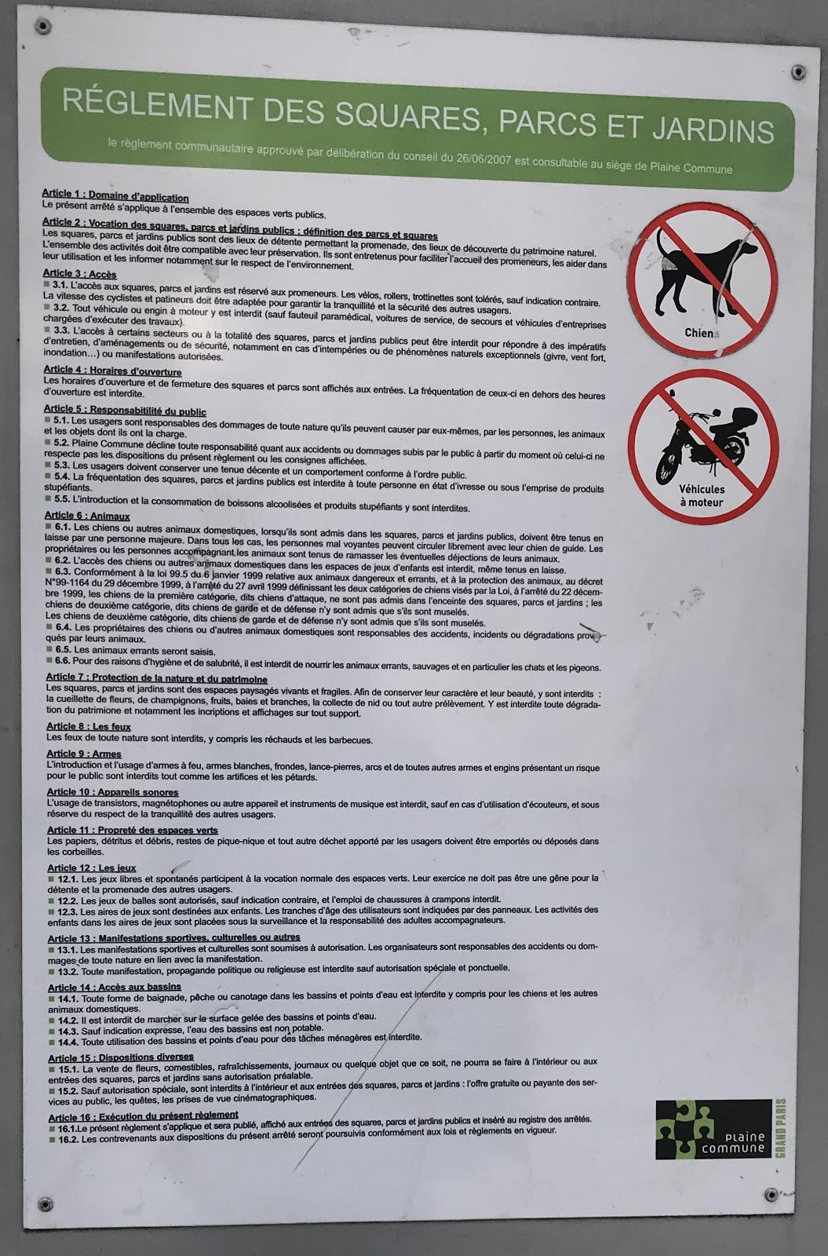
Figure 1. Rules of conduct in the Grand Parc de St. Ouen
Image by Morgan Savige March 6th, 2018.

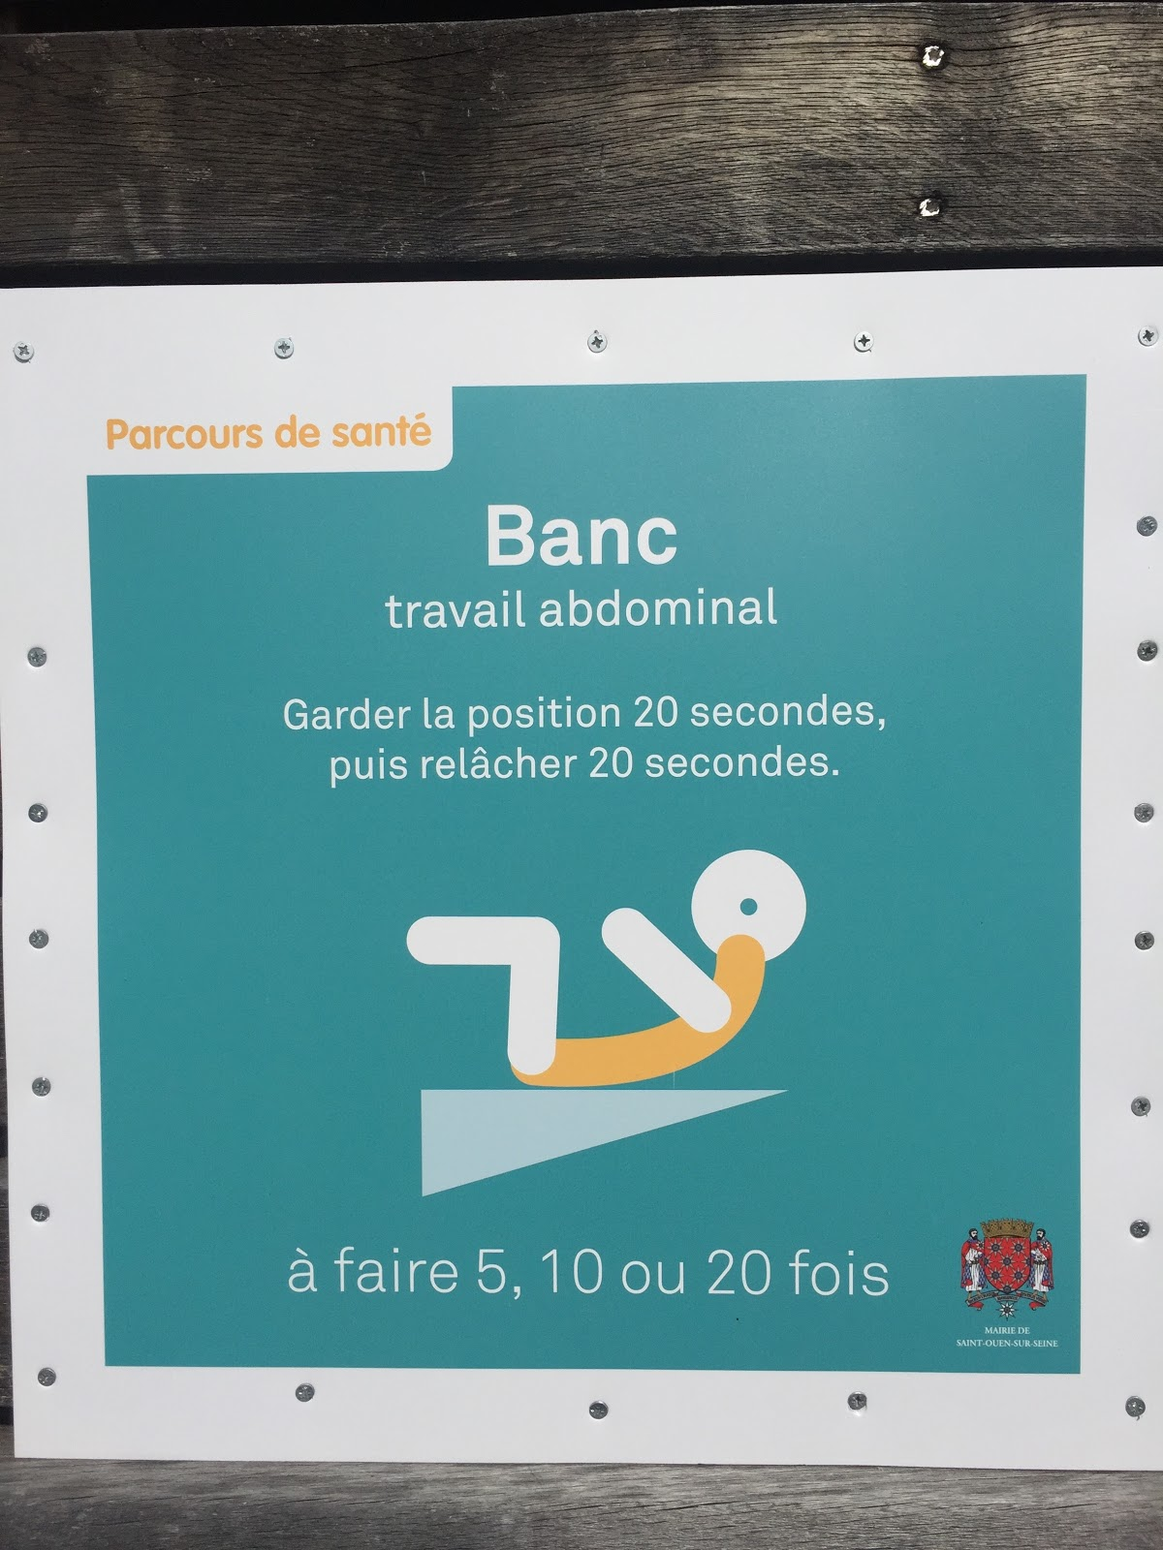
Figure 2. Exercise suggestion in the Grand Parc de St. Ouen
Image by Morgan Savige March 15th, 2018.

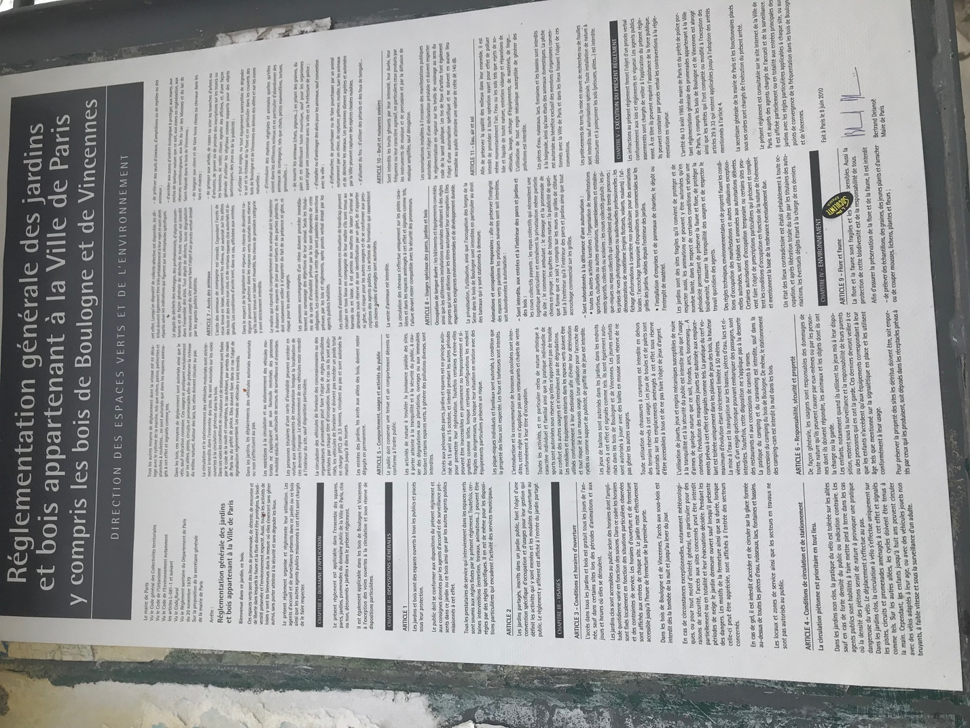
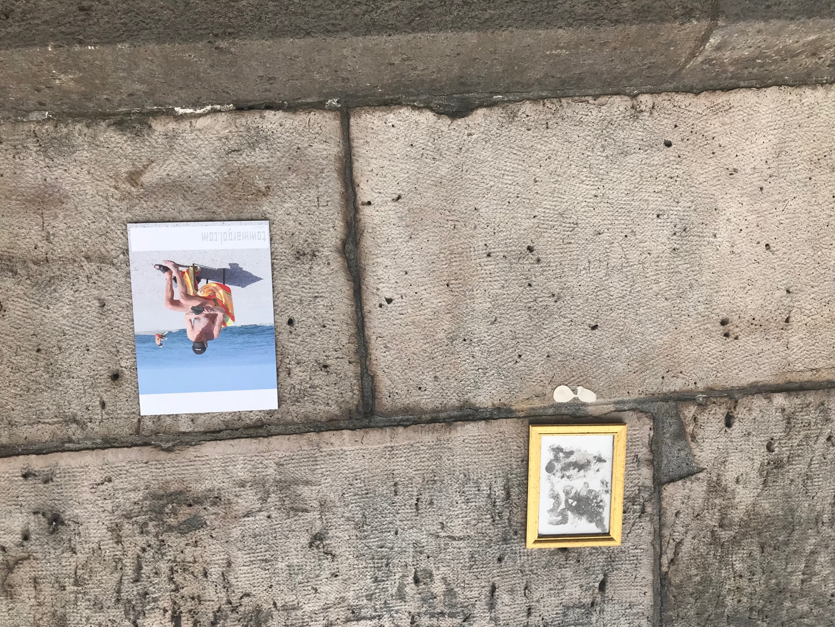
Figure 3. Rules of conduct in the Parc Rives de Seine
Image by Morgan Savige March 12th, 2018.

Figure 4. Art added to the back wall of Parc Rives de Seine
Image by Morgan Savige March 12th, 2018.
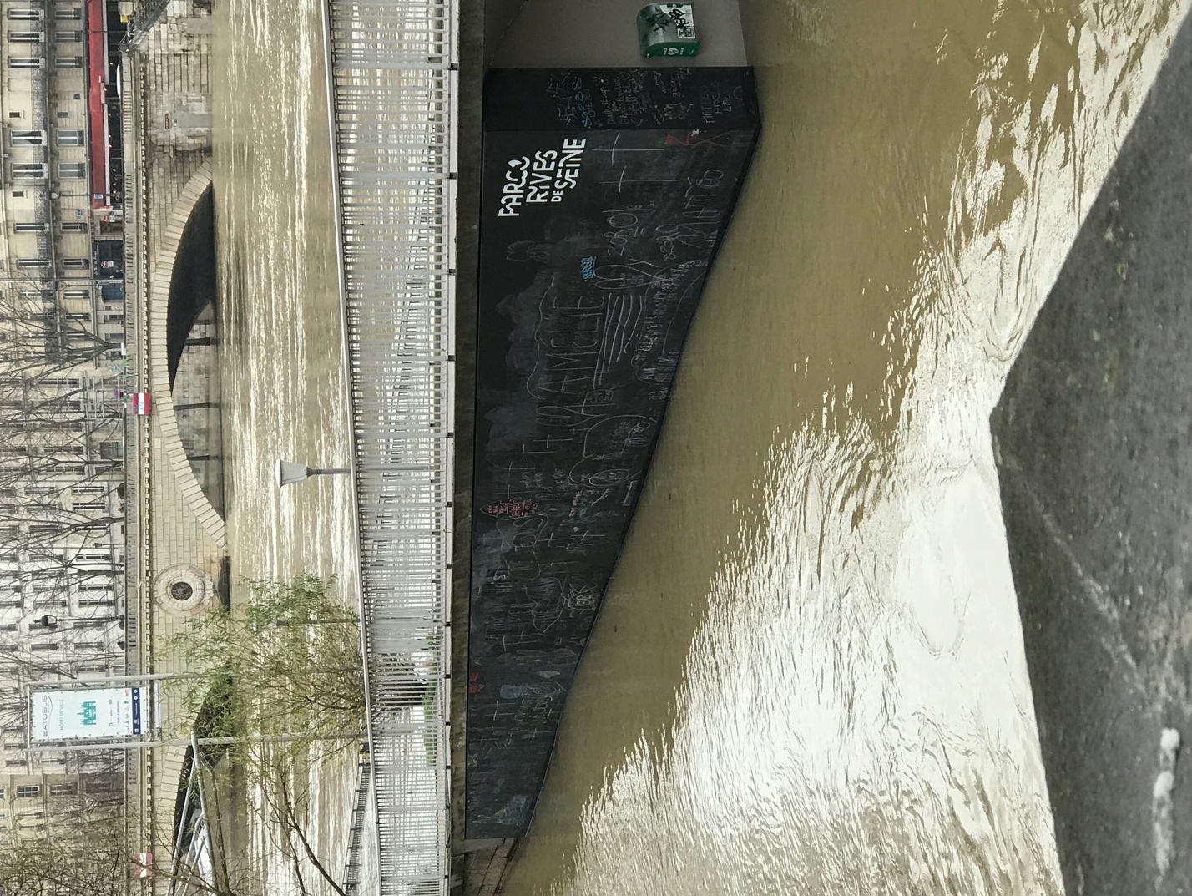
Figure 5. The Parc Rives de Seine chalkboard during the flood
Image by Morgan Savige January 23rd, 2018.

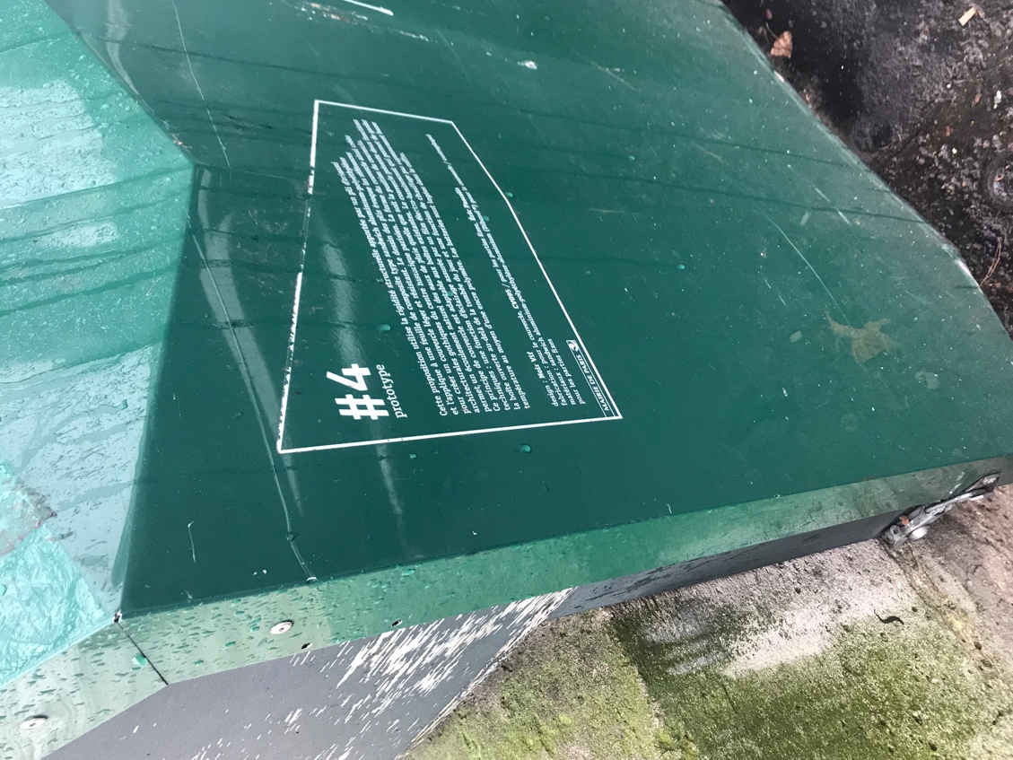
Figure 6. A prototype vending stall from the exhibit
Image by Morgan Savige January 23rd, 2018
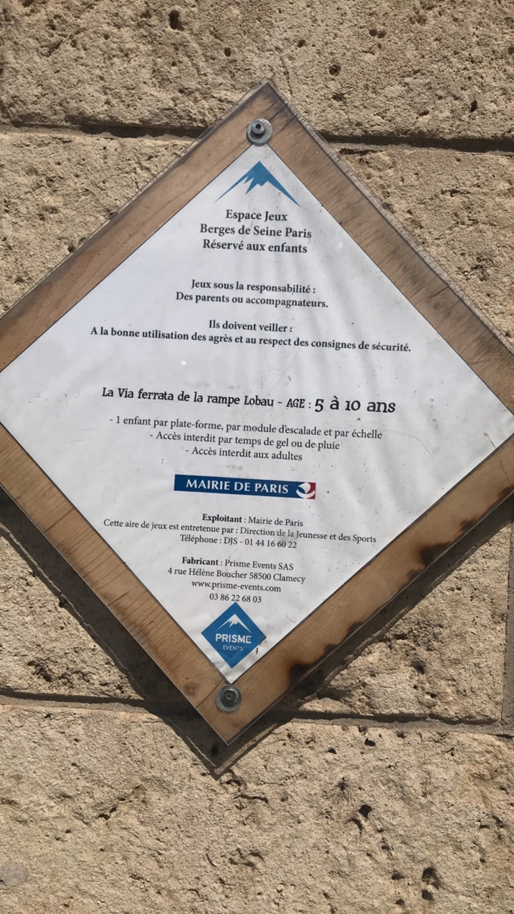
Figure 7. Age rules for play equipment in the Parc Rives de Seine
Image by Morgan Savige May 11th, 2018
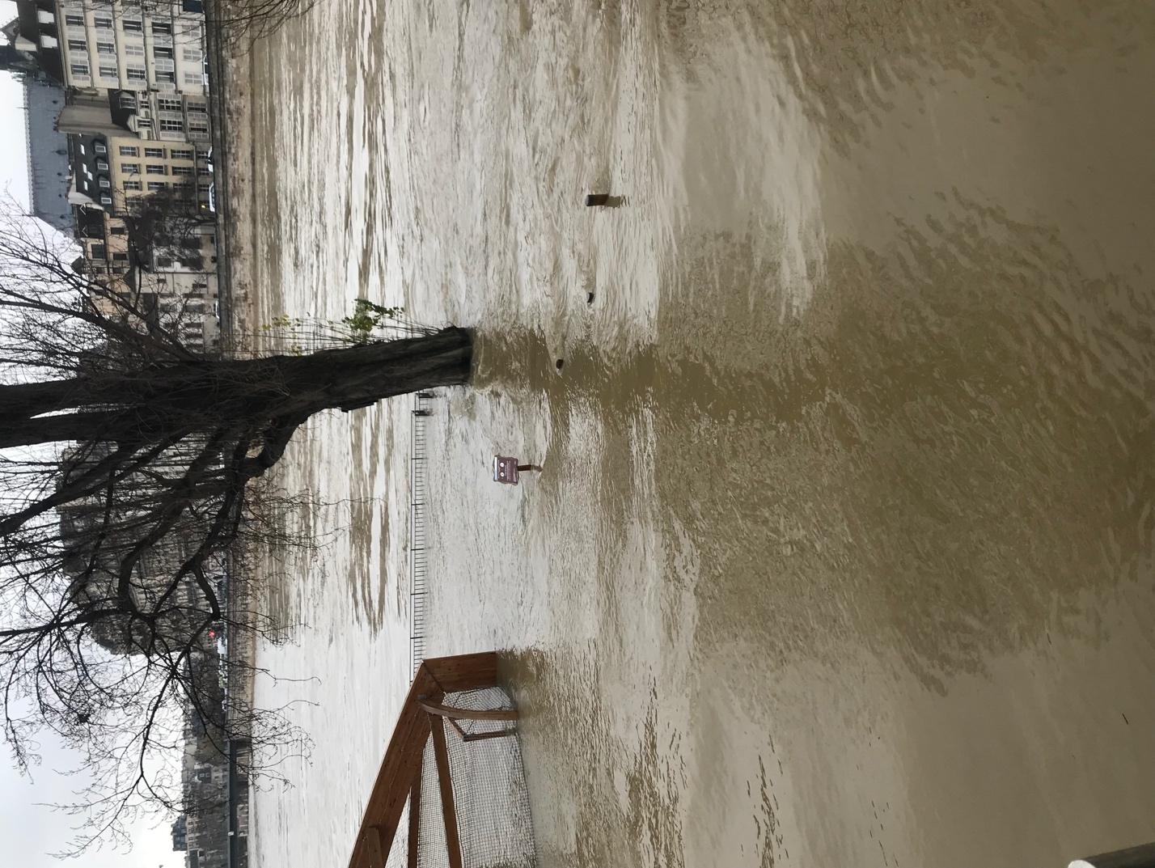
Figure 8. The Parc Rives de Seine during the flood
Image by Morgan Savige January 23rd, 2018

References Cited

A. (n.d.). Agence. Retrieved from http://agenceter.com/en/agence/

Accueil. (n.d.). Retrieved from http://www.saint-ouen.fr/services-infos-pratiques/environnement-et-espaces-verts/118-le-grand-parc.html

Adiva. Private Communication. Paris, France. 23 mars, 2018.

Anand, N. (2012). Municipal disconnect: on abject water and its urban infrastructures. Ethnography, 13(4), 487-509.

Anand, N. (2015). Leaky states: Water audits, ignorance, and the politics of infrastructure. Public Culture, 27(2 (76)), 305-330.

Baudoin, L. (2010, July 8). Marine Le Pen: “Si j’étais president…” Nations Presse. Retrieved from https://web.archive.org/web/20110313235113/http://www.nationspresse.info/?p=106307

Betz, H. G. (2013). Mosques, minarets, burqas and other essential threats: The populist right’s campaign against Islam in Western Europe. Right-wing populism in Europe: Politics and discourse, 71-88.

Beyer, C. & Lerclerc, J-M. (2013). « Une majorité de Français contre le voile islamique à l’université ». Récupéré de http://www.lefigaro.fr/actualite-france/2013/08/08/01016-20130808ARTFIG00457-une-majorite-de-francais-contre-le-voile-islamique-a-l-universite.php

Bourdieu, P., & Nice, R. (1977). Outline of a Theory of Practice (Vol. 16). Cambridge: Cambridge university press.

Bourdieu, P. (1992). The Production and Reproduction of Legitimate Language. In Erickson, P. A., & Murphy, L. D. (Eds.). (2013). Readings for a history of anthropological theory (407-423). Toronto: University of Toronto Press.

Braun, B. (2005). Environmental issues: writing a more-than-human urban geography. Progress in human geography, 29(5), 635-650.

Cohen, S. (1972). Moral panics and folk devils. London: MacGibbon & Kee, 9.

Decherf, D. (2001, July 1). French Views of Religious Freedom. Brookings Institute. Retrieved from https://www.brookings.edu/articles/french-views-of-religious-freedom/

Eurostat Statistics Explained. (2017). Migrant and Migrant Population Statistics. Retrieved from http://ec.europa.eu/eurostat/statistics -explained/index.php/Migration_and_migrant_population_statistics

Fassin, D. (2013). Enforcing order: An ethnography of urban policing. Polity.

Fernando, M. L. (2010). Reconfiguring freedom: Muslim piety and the limits of secular law and public discourse in France. American Ethnologist, 37(1), 19-35.

Fernando, M. L. (2017). Myths of the French Republic. In Ramey, S. (Ed.). (2017). Fabricating Difference (13-38). Bristol, CT: Equinox Publishing.

Ferozah. Private Communication. Paris, France. 12 mars, 2018.

Fedi, L. (2017). « Laïcité et civilisation ». L’esprit du temps, « Outre-Terre », (51), 102-113.

Foucault, M. (1991). The Foucault effect: Studies in governmentality. University of Chicago Press.

Gal, S. (1995). Language, Gender, and Power: An Anthropological Review. In Erickson, P. A., & Murphy, L. D. (Eds.). (2013). Readings for a history of anthropological theory (315-324). Toronto: University of Toronto Press.

Gandy, M. (2003). Concrete and clay: reworking nature in New York City. MIT Press.3

Gandy, M. (2014). The fabric of space: Water, modernity, and the urban imagination. MIT Press.

Gupta, A. & Sharma, A. (2006). Globalization and Postcolonial States. In Erickson, P. A., & Murphy, L. D. (Eds.). (2013). Readings for a history of anthropological theory (336-377). Toronto: University of Toronto Press.

Hadidja, A., & Steeve, M. Private Communication. Paris, France. 24 mars, 2018

Harvey, D. (2003). Paris, capital of modernity. Psychology Press.

Jacobsen, C. M. (2017). Veiled Nannies and Secular Futures in France. Ethnos, 1-21.

Jain, K. (2017). Tales from the Concrete Cave. In Rademacher, A., & Sivaramakrishnan, K. (Eds.). (2017). Places of Nature in Ecologies of Urbanism (108-137). Hong Kong: Hong Kong University Press.

Josh Gabbatiss Science Correspondent. (2018, January 27). River Seine flooding threatens Paris as it nears record high. Retrieved from https://www.independent.co.uk/news/world/europe/paris-flood-2018-river-seine-wine-cellars-museums-record-high-oecd-climate-change-a8181191.html

Karvonen, A. (2011). Politics of urban runoff: nature, technology, and the sustainable city. MIT Press.

Klingle, M. (2006). Fair Play: Outdoor Recreation and Environmental Inequality in Twentieth-Century Seattle. The nature of cities, 122-156.

LeDuc, S. (2011, April 25). Refugees face humanitarian crises on Paris’ doorstep. France24. Retrieved from http://www.france24.com/en/20110425-humanitarian-crisis-paris%E2%80%99-doorstep

Le Monde. (2017, May 7). Présidentielle 2017: revivez l’élection d’Emmanuel Macron, nouveau président de la République . Le Monde. Retrieved from http://www.lemonde.fr/election-presidentielle-2017/live/2017/05/07/suivez-la-soiree-electorale-en -direct_5123713_4854003.html

Mariam. Private Communication. Paris, France. 16 April, 2018.

Martin, P. Communication privée. Paris, France. 11 avril, 2018.

Mohanty, C. T. (1988). Under Western eyes: Feminist scholarship and colonial discourses. Feminist review, (30), 61-88.

Molinier, Pascale. « Au-delà de la féminité et du maternel, le travail du care », Champ psy, vol. 58, no. 2, 2010, pp. 161-174.

Newman, A. (2011). Contested ecologies: Environmental activism and urban space in immigrant Paris. City & Society, 23(2), 192-209.

Paris Convention and Visitors Bureau. The new Parc Rives de Seine. Retrieved December 7, 2017 from https://en.parisinfo.com/discovering-paris/sustainable-tourism-in-paris/the-new-parc-rives-de-seine

Parr, H. (2001). Feeling, reading, and making bodies in space. Geographical review, 91(1‐2), 158-167.

Pojmann, W. (2010). Muslim Women's Organizing in France and Italy: Political Culture, Activism, and Performativity in the Public Sphere. Feminist Formations, 22(3), 229-251.

Ranganathan, M. (2015). Storm drains as assemblages: The political ecology of flood risk in post‐colonial Bangalore. Antipode, 47(5), 1300-1320.

Samuel, H. (2008, June 5). Nicolas Sarkozy plans for ‘Grand Paris.’ Telegraph. Retrieved from http://www.telegraph.co.uk/news/worldnews/europe/france/2080999/Nicolas-Sarkozy-plans-for-Grand-Paris.html

Sauvage, G. (2017, 05 mai). « Vidéo-choc : le scandale des nounous musulmanes voilées ». Récupéré de http://resistancerepublicaine.eu/2017/03/05/video-choc-le-scandale-des-nounous-musulmanes-voilees/

Schlegel, J. L. (2011). La laïcité irritée par la visibilité des religions. Esprit, (5), 80-94.

Schwenkel, C. (2017). Eco-Socialism and Green City Making in Postwar Vietnam. In Rademacher, A., & Sivaramakrishnan, K. (Eds.). (2017). Places of Nature in Ecologies of Urbanism (45-67). Hong Kong: Hong Kong University Press.

Scott, J. C. (1998). Seeing like a state: How certain schemes to improve the human condition have failed. Yale University Press.

Scott, J. W. (2009). The politics of the veil. Princeton University Press.

Smith, N. (1982). Gentrification and uneven development. Economic geography, 58(2), 139-155.

Tartakowsky, D. (1998). Les manifestations de rue en France, 1918-1968 (Vol. 42). Publications de la Sorbonne.

Tillier, B. (2004). De la balade à la manif'. Sociétés & Représentations, (1), 87-98.

Tissot, S. (2007). L'Etat et les quartiers. Genèse d'une catégorie de l'action publique (p. 299). Seuil.

Urban, G. (2010). A method for measuring the motion of culture. American Anthropologist, 112(1), 122-139.

Vandoorne, S. (2010, September 15). French Senate approves burqa ban. Retrieved from http://www.cnn.com/2010/WORLD/europe/09/14/france.burqa.ban/index.html

Wenden, D., & Wihtol, C. (1998). Young Muslim women in France: Cultural and psychological adjustments. Political Psychology, 19(1), 133-146.

Wiesemann, L. (2012). Public spaces, social interaction and the negotiation of difference.

This name has been changed to protect the identity of the informant.
This name has been changed to protect the identity of the informant.
Ferozah, 2018
This name has been changed to protect the identity of the informant.
This name has been changed to protect the identity of the informant.
This name has been changed to protect the identity of this informant.
Plaine Commune is an urban planning development group including several areas outside Paris, all part of Seine-Saint-Denis (Martin, 2018).
This is the mayor’s office of the neighborhood where the Grand Parc de St. Ouen is located.

