1 INTRODUCTION

In fast developing world, gender continues to be a concern regarding equity and opportunity. Gender identity within a society often determines the individual’s roles, responsibilities, and behaviours. Gender discrimination can explain the distinct distribution of power and resources within society (Khanduri, 2018). For judicious use of natural resources, it is beneficial to demarcate who uses what and where. An ethical gender approach to freshwater-related issues means that all decisions regarding the design, localization, management, and use of freshwater resources must consider the needs of both men and women and are allowed to influence, participate in, and benefit from water development (Hannan-Anderson, 1995). Women and water are intrinsically linked. Both are thought to be the wellspring of life, and domestic water management is feminized in many societies, including India (Kher et al., 2015; UNDESA, 2004). Women have considerable knowledge of water resources, including quality, natural variations of water availability and accessibility. This knowledge is gained through personal experience and interpersonal and intergenerational female knowledge sharing (SIDA, 1994). However, women’s relation with and knowledge about water is frequently not considered by decision-makers, for example, engineers and policymakers are usually men (Baden, 1993). However, the UN Commission on the Status of women asserts that women are gaining recognition as crucial intermediaries between the ecosystem services and social issues, hence, are essential actors, in conservation and safeguarding of natural resources.
A feminist political ecology approach urges researchers to move beyond the scale of the household to individuals’ social difference when examining the socio-cultural dimensions of resource use (Rocheleau et al., 2008). For example, gender and age are two social differences which influence the impact of water stress. The UNDP report (2001) mentioned that women and children experience water insecurity most acutely through increased instances of waterborne diseases, insufficient drinking water, and physical violence induced by water stress. Women and children’s high vulnerability to water stress is in part caused because they have less access to substitutes when water sources become degraded (Mayers, 2009).
Furthermore, the exclusion of women from the design and planning of water supply and sanitation projects in developing countries is a significant obstacle to development (World Bank, 1989). It is known that there are gender differences in the social determinants of waterborne diseases because there are different household roles by each gender which influence the risk of infection (Rathgoberetal, 1993). Gender also has an impact and influence on health policies and their effects on both men and women (Vlassoffetal, 2005). Therefore, gender must be considered all through the research process from the identification of problems to the framing of solutions.
This paper is an investigation into the gendered water insecurity and poor health impacts due to sub-standard quality of consumptive water taking case from Haldwani city which is a mid-sized city lying in the foot hills of the Himalayan state - Uttarakhand (India). An assessment into gender and household water resource management was undertaken in one of the slums known as Dholak Basti, which is a vulnerable socio-economic group in the city.

2 MATERIAL AND METHODS

2.1 Study Area
Haldwani is located at 29.21’83° N and 79.51’30° E in Nainital district of Uttarakhand State, in Indian Himalayan Region. It is situated on the bank of Gaula River covering an area of 44.11 km². According to the 2011 census report, the population of Haldwani was 156,078 and has grown significantly over past two decades witnessing high in-migration rate from upper reaches of Uttarakhand for various prospects (Mamgain &Reddy, 2015). This has led to huge surge in informal population across the city. Administratively, Haldwani is divided into 25 municipal wards or sub municipal boundaries with as many as 22 slums distributed mostly in the southern wards.

2.2 Methodology
This study involved a mix of methods including quantitative and qualitative data spatial and statistical methods. Under the quantitative research method, census data of India 2011 was used for GIS-based spatial analysis for the city. The study area was selected based on a spatial analysis of all 25 wards in Haldwani with respect to ward-wise literacy and percentage sex ratio as per census data. This led to identification of Ward-22 which had very low literacy rate and low sex ratio. Following the identification, a survey was carried out at three different locations in the slum area of Dholak Basti : Eastern Subdivision-1 from Jain Temple side, Central Subdivision-2 is the Middle portion of Basti and Western Subdivision-3 is from the Railway Station side These areas are differentiated based on their dependency on different type of water supply systems in their locality – Subdivision-1 has Community Pipeline Connections, Subdivision-2 is dependent upon community tube-wells and Sibdivision-3 uses public taps for their daily water requirements. Approximately 150 out of 300 households in Dholak Basti were surveyed using stratified random survey technique through structured questionnaire with 50 households surveyed in each of the three Subdivisions. Under qualitative research method, personal/household interviews were done as well as key informant interviews. Out of the 150 respondents, 87 respondents were female, and 63 respondents were male each representing their household. The respondents, both men and women fell under three age classifications i.e., below ages 18, ages 18 to 60 and above age 60 categorized as minor, adult and old respectively in this case study. Five respondents (1 boy and four girls were minors, 142 respondents (59 men and 83 women were adults, and three respondents (all women were old. A fully structured questionnaire was used for survey which had questions related to water access, supply, quantity, quality, sanitation and management of water as well as health related aspects of history water-borne diseases and type of individual. The survey was then collated in statistical format to derive inferences from the data collected.
3 ANALYSIS AND RESULTS

3.1 Ward Wise Literacy
Figure 2 show the Ward Wise Literacy Map. Haldwani has an overall average literacy ratio of 70.2%. A low literacy rate of 84.48% is observed in southeast wards in comparison to average literacy 87.6% in the city. Wards 24 (49.7%), 14 (51.8%), 21 (53.5%) and 22 (57.9%) show lowest literacy rates in Haldwani. Literacy rate has a positive correlation with socio-economic status (UNDP, 2006). Therefore, these Wards have lower than average socioeconomic status relative to other wards which have higher literacy rates. Also, wards show a relatively low female literacy, namely, wards 24 (47.9%), 14 (48.0%), 21 (49.4%) and 22 (55.7%), this observation correlates with socio-economic status, the higher the socio-economic status the higher the literacy ratio and thus the lower the inequality in literacy between men and women (Omelanjuk, 2005). One possible explanation is that women from low socio economic status perform both domestic and wage work. This often means that rather than attending the school girls participates in household’s tasks, hence the literacy ratio is lower in these wards. This is in part caused by cultural norms which place greater emphasis on the education of boys over girls (Abbas, 2003). This trend may be exacerbated by poor water access because girls and women are predominantly the water collectors, as established during the household surveys where 100 percent of households had women and girls fetch water whereas only34 percent households had men involved in water collection. Therefore, where the literacy ratio is low, this may indicate wards where water access is poor, meaning girls and women must spend more time collecting water and missing out on education. Households which have low socio-economic status, and less accessible water supplies are far more vulnerable to water insecurity as they are unable to purchase water privately and the shared water sources are under more pressure.

Figure 1: Ward Wise Percentage Literacy Rate  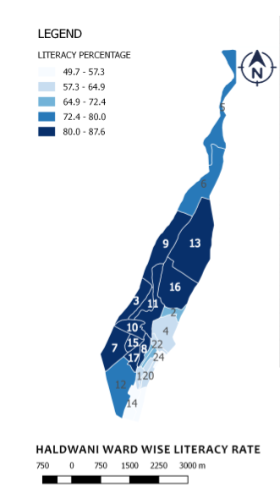 | Figure 2: Ward Wise Sex Ratio  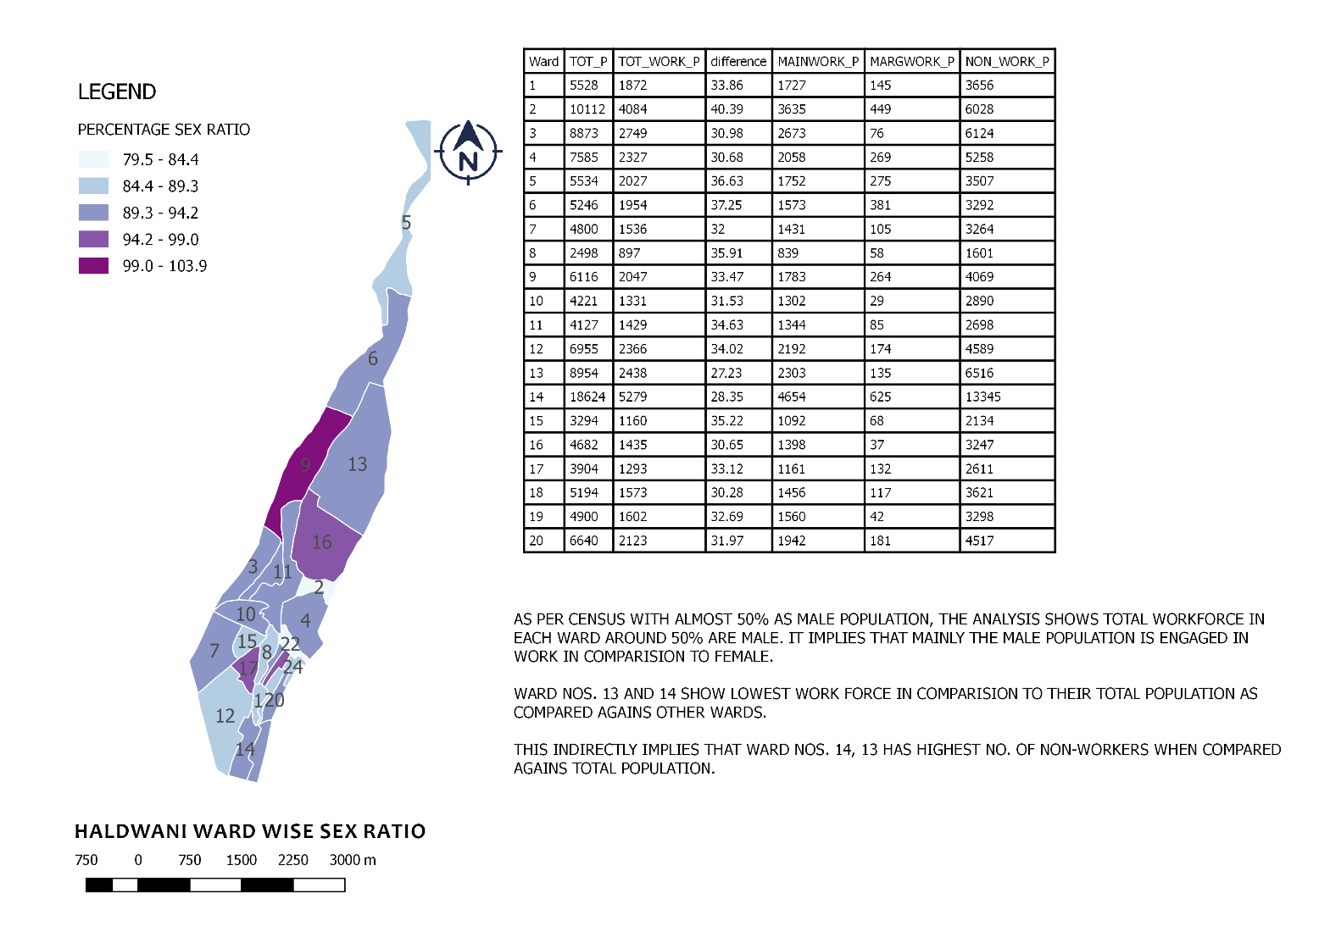
The range of literacy percentage, from 49.7%-87.6%, has been split into 5 equal categories (with the exception of category 3 (64.9-72.4) whose difference is 7.5% rather than 7.6%). The categories correspond to a blue colour gradient. The lightest blue colour corresponds to the lowest total percentage literacy of 48.7-57.3. For example, Ward 14 with 51.8%. The darkest blue corresponds to wards with the highest percentage literacy between 80.0-87.6%. For example, Ward 15 with 84.1%. | This shows the number of females per 1000 males, as a percentage, for each ward. The percentage sex ratio ranges from 79.5-103.9%. This range has been split into five equal categories. These categories correspond to a colour gradient; light blue to dark purple. The lightest blue indicates the lowest percentage sex ratio of 79.5-84.4%. For example, Ward 22. The darkest purple shows the highest percentage sex ratio category of 99.0-103.9%. For example, Ward 9.
Source: author's analysis based on Census of India, 2011 data

3.2 Ward Wise Sex Ratio
Figure 2, shows the Ward Wise Sex Ratio Map. There is a potential spatial pattern with each end of this linear settlement, containing Wards 5 and 12, in the lowest category of 84.4-89.3% and the central portion of the city displaying a high percentage sex ratio Wards 9 and 16. This may suggest that peripheral wards are more prone to lower sex ratio.
Wards 2 (79.5%), 22 (83.9%), 1 (86.5%) and 12 (88.02%) have the lowest sex ratio in comparison to the other wards in the city (90.44%). Considering literacy rate, Ward 22 again was one with lowest sex ratio implying that men significantly outnumber women in this Ward. This is a concern because a low sex ratio often correlates with low socio-economic status (Hesketh and Wei Xing 2006).
Ward 22 has an anomalously low percentage sex ratio of 83.9%. This may be explained by the presence of Basti, a slum, in Ward 22 which has a high level of poverty (UNDP, 2006). The relationship between poverty and a low sex ratio is complex and based on many potential explanatory factors. One possible reason to link urban poverty and gender might be gendered mortality. Gendered mortality is the term used to describe a gender imbalance in mortality rates. In areas where women are more likely to die, a low sex ratio may be present. The reasons for an increased female mortality rate are many and complex. Often a high rate of female mortality will correlate with low socioeconomic status. This correlation may be caused by poorer access to healthcare, water and food which frequently disproportionally impact women (WHO, 2009). In addition, death through childbirth may be a contributing factor because women with a low socio-economic status are more likely to die in childbirth due to less access to healthcare and poor nutrition, amongst other things (Filippi et al., 2006). Therefore, a high female mortality rate could be, in part, responsible for the low sex ratio found in Ward 22. However, further research would be required to assess the specific causes of the low sex ratio present in Ward 22, and those discussed above may or may not be responsible.

3.3 Water Sources

Dholak Basti slum, falling under Ward 22 was chosen and primary survey was conducted dividing the area into 3 Subdivisions based on their location and dependencies on water.
Table-1 Shows that residents in Subdivision-1 have access to community pipeline connections in their households. Residents in Subdivision-2 can access water from community tube wells. In study Subdivision-3 the survey found that residents did not have access to any water connection or supply source near their homes. Instead they must fetch water from public taps which are located outside the community boundary.

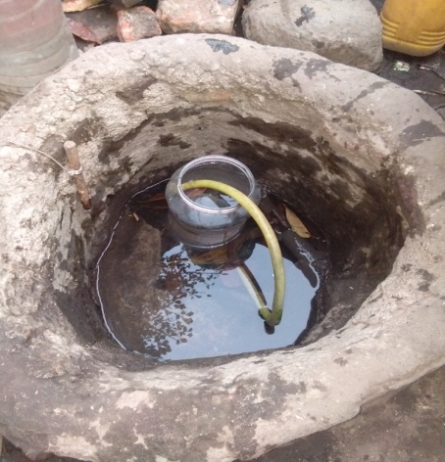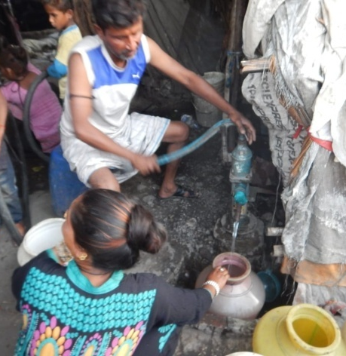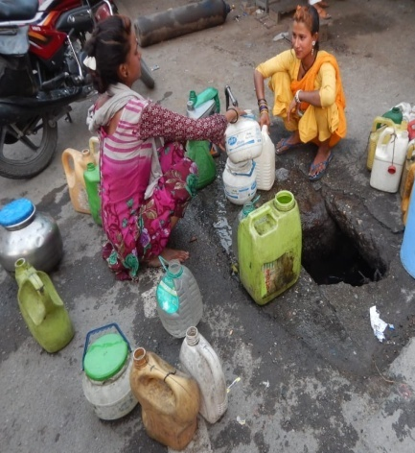
Figure 3: Different Water Collection Sources in Dholak Basti

Study Sites | Water Source | Time Spend in Fetching Water per  5 ltr (minutes) | Amount of water  Fetching  Daily (Liters)
Subdivision-1 | Community Pipeline Connections | 5-6 | 10-15
Subdivision-2 | Community Tube wells | 2-3 | 10-12
Subdivision-3 | Public Taps | 2-3 | 15-20
Table 1: Water source, time spent and amount of water fetch daily
All families in Dholak Basti fetch water from community water sources by taking number of small (around 5 litres) containers with them. After filling one container the community member is required to give way for other residents to fill their containers and wait for their turn again to fill their next container. Thus in order to get daily requirement of water each resident carries 4 to 5 numbers of small containers and wait for their turn to fill all their containers one container at a time. Also, due to poor water discharge speed in the pipelines/ taps the process is slow and takes a long time before each resident is able to completely fetch minimum amount of water required for their daily needs. The data for time spent fetching water (Table 1.) showed that in Subdivision-1, one pipeline connection is there which is further subdivided into several connections and due to this subdivision of the main connection the speed of water discharge gets very slow. From each sub connection, 4-5 families fill their water containers thus after filling one container of 5 liters they give chance to other to fill their container and wait for their turn to come again. Thus filling 10-15 liters of water takes 50-60 minutes. Residents spent about 5-6 minutes when fetching 5 liters of water. Thus, in fetching 10-15 liters of water they spent 50-60 minutes daily. Same condition is at Subdivision 2, residents fetch water from tube wells after filling their one container they have to give chance to other thus, At Subdivision-2 the time spent by the residents when fetching 5 liters of water was about 2-3 minutes. Thus, in fetching 10-12 liters daily, the residents spent about 20-30 minutes. At Subdivision-3 the time spent in collecting 5 liters of water was about 2-3 minutes, therefore, when fetching 15-20 liters of water they spent about 2-3 hours daily, including filling time and the time it takes to walk to the public taps as the public taps are at some distance from the community.

3.4 Gendered Water Collection

Study Sites | Gender involved in Fetching Water (%)
Study Sites | Female | Male
Subdivision-1 | 100% | 28 %
Subdivision-2 | 100% | 14 %
Subdivision-3 | 100% | 60 %
Table 2: Gender contribution in fetching water from all studies Subdivisions

Table 2 shows the gender contribution to fetching water. In all the three study Subdivisions 100% of the women surveyed were involved in fetching water for domestic use. However, the male contribution varied at each Subdivision. At Subdivision-1, 28% of men were involved in fetching domestic water. In Subdivision-2, 14% of men contributed to water collection, this was the lowest contribution out of the three Subdivisions. Subdivision-3 presented the highest percentage contribution of 60%.

3.5 Water Quality
Study Sites | Affected by water borne diseases
Study Sites | Children |  | Youth |  | Adults |  | Older Adults
Study Sites | Boy (%) | Girl (%) | Men (%) | Women (%) | Men (%) | Women (%) | Men (%) | Women (%)
Subdivision-1 | 2.5 % | 0.95 % | 0.32 % | 0 | 2.9 % | 2.2 % | 0.32 % | 0.32 %
Subdivision-2 | 0.48 % | 0.73 % | 0.24 % | 0 | 3.17 % | 0.73 % | 0.24 % | 0.24 %
Subdivision-3 | 0.50 % | 0.50 % | 1.00 % | 1.00 % | 0.75 % | 0.25 % | 0 | 0
Table 3: Water quality and the percentage of population affected by waterborne diseases
Table 3 is a breakup of the percentage of persons affected by the water-borne disease at Subdivision 1, 2 and 3. The columns show the child (0-8 years), Youth (9-17 years), Adults (18-60 years) and Old (61 years and above).
At Subdivision 1, total 50 survey were conducted in which 20 adult men, 28 adult women and 2 young women were surveyed. In the survey male adults and male children show a higher percentage 2.9% and 2.5% of water-borne diseases. Male children are more affected as compared to female children (0.95%). In Adults, percentage of affected men and women are very close 2.9% and 2.2% respectively. 0.32% of Young Male, Old Male and Old Female were affected. In the case of young women, the percentage of affected is 0%.
At Subdivision 2, 50 survey were conducted among which 19 adult men, 29 adult women, and 2 young women were surveyed and the trend is similar only in the case of adult men affected by water borne disease is 3.17% which is followed by 0.73% for girls and adult women each, 0.24% for young male and other adult men and women, each. Then 0.48% of boys are affected by a similar trend of 0% in the case of female children.
At Subdivision 3, again 50 survey were conducted in which 22 adult men, 27 adult women, and 1 young man were surveyed and the results show a different trend where young boys and girls are highly affected by the water-borne diseases which are 1% each. Male and female adults are affected at 0.75% and 0.25% respectively. Male and female children are equally affected at 0.50% each. At this Subdivision, none of the old male and female are affected with any of the diseases. Impact of waterborne diseases by gender and age

Study Sites | Men (%) | Women (%)
Subdivision-1 | 6.05 % | 3.50 %
Subdivision-2 | 4.15 % | 1.71 %
Subdivision-3 | 2.25 % | 1.75 %
Table 4: Percentage of Water Borne Disease (Male and Female)
Table 4 shows the disease-stricken percentage of people in Dholak Basti at Subdivision 1, 2 and 3. The waterborne diseases- Jaundice, Typhoid and Diarrhea, are identified in men and women. All three study Subdivisions demonstrated that men were more inclined to waterborne illness in contrast to women. Subdivision 1 shows more percentage of illness (4.77%) as compared to Subdivision 2 and three which is 2.93% and 2% respectively.
One likely reason for the skew towards men in Ward 22 can be explained by meaning the number of men suffering from waterborne diseases is higher than the number of women. Out of the total 62 men and 88 women surveyed in the all the three sites 45 men (72.5%) and 25 women (28.4%) in all age categories were found affected with water borne diseases such as Jaundice, Diarrhea and Typhoid. However, it is unlikely this can account for the whole difference between the number of females and males suffering from the waterborne disease.
Another possible explanation for more number of men suffering from water borne diseases is supported by the workforce data which shows that out of the total workforce population 86.2% are men and only 13.8% women. The nature of the work also suggests the vulnerability of particular gender to severe illness.
In Dholak Basti case, the main occupation of men pertains to making dholaks (musical instrument) and selling them outstation which demands greater mobility than women. They travel to bordering countries as well as intra-state cities to sell their products wherein they consume the available water from various natural or municipal sources. Whereas in case of women, they are engaged in day labour jobs such as rag-picking and scavenging other than taking care of the household/fetching potable water. The vulnerability to illness does exist in case of women too because of the non-conducive work environment. Studies by authors (Shrivasta et al 2015; Udoh, 1987; Adeyemi, 2004; Dixit and Shanker, 2009) has established that dirty water is the only carrier of water borne disease like Jaundice, Diarrhea and Typhoid, thus this may be the reason increased number of illness in men in comparison to women in the community. From the interviews conducted our qualitative results reflected that the women generally do not consume water/food outside their household. This is may be another explanation of why women are less prone to water-borne diseases. Other factors might include gender difference in sanitation habits and occupations which could hinder individual’s immune systems. Though these are some of the possible explanation and might not account for the total difference between the number of females and males suffering from waterborne diseases. Owing to different occupations, it is quite likely that there are other factors and merit further investigation.

4 DISCUSSIONS
Ward 22 has an exceptionally low sex ratio of 83.9% (Census 2011). This is below the national average of 99.1%, the urban average of 95.6% and below the city average. This low sex ratio may indicate an average low socio-economic status. Further research would be required to investigate the reasons for the low sex ratio in Ward 22. This is important as by understanding the causes of the problem policymakers can work on solutions. For example, if there is higher average mortality in girls and women in Ward 22 policymakers could launch a public health campaign which is focussed on women and girl’s health.
The total literacy percentage of ward 22 is (57.9%), the fourth lowest total literacy percentage in Haldwani. This is well below the National and State average and therefore, a significant concern is required. A low literacy rate can be an indication of high unemployment or low economic status which forces children to miss out on education. Furthermore, women in ward 22 show a lower literacy rate (25.40%) as compared to men (32.54%); this could be an indication of poor water access. As women and girls are the most frequent collectors of water, where access to water is poor, they may miss out more education relative to their male counterparts. One key aspect of improving literacy levels may be improving access to water. By decreasing the time taken to collect water, policymakers may free more time for education.
In the case of water sources and time spent in fetching water, there were three different types of sources used for collecting water. In Subdivision-1 the pipeline was the source used for managing water. However, because the residents that attached many pipes to the first significant pipeline to run the water to their homes, the discharge rate of the water has dropped. This results in residents having to spend more time fetching water. In Subdivision-2 the water source was tube wells which were managed by the community members. Residents did not have to spend much time carrying the water because it is pulled from groundwater. However, in the summer season, the time spent in fetching water increased as the water table was depleted. In Subdivision-3 there is no water source inside the community so the residents must fetch water from public taps located in the market area. The market is a considerable distance from Subdivision-3, and therefore the residents must spend time walking to fetch water. This is problematic because carrying water over a distance is very hard physical work and can impact the health of those fetching the water. It can be particularly detrimental to the health of pregnant women and children who are developing (UNDESA, 2004).
In case of gender involved in fetching water, all the three study Subdivision-s showed that there was complete involvement of females in the activity of fetching water and that female contribution was significantly higher than the male contribution in all three Subdivisions. This suggests that in Basti domestic water management is constructed as a female role within household labour division. This is a phenomenon recognized across India and in many other developing societies (Kher et al., 2015). The involvement of males in water collection in Subdivision-1 and 2 was far less than their contribution in Subdivision-3. One possible explanation is that the water sources are nearer to the household. However, for Subdivision-3 the distance of the water source results in male members of the household needing to contribute to water fetching so that the household can meet their daily water needs. It is likely that the women carry empty containers with them to the public taps in the market, fill them and then male members of their household help them to carry the full containers back to their home. The domination of women involved in fetching water in Basti means that women are disproportionally impacted by water stress in Basti. If water insecurity increases, female residents may have to spend more time collecting water. In case of gender more affected by the waterborne disease, all three study Subdivision-s showed that the male gender, including the age class adult, young and child, is more prone to waterborne disease mainly from jaundice and diarrhoea as compared to the female gender. This is significant because much of the literature suggests that adult and female children are most vulnerable to waterborne diseases because they have the most contact with water and less access to unpolluted alternatives (WDR, 2012) Therefore, the results from Basti contradict the trend of female-dominated sufferers from waterborne diseases reported widely in the literature which can have probable explanation such as low sex ratio itself and then exposure of men to non-conducive environment in their respective occupation
In most research papers and articles, it is observed that women are more prone to water-borne diseases than males, but in our research, the findings showed that males are more prone than females. One key reason may be the high sex ratio found in Ward 22 which means there are more men and thus, the number of men who suffer from waterborne diseases is likely to be higher. However, this factor alone might not be solely accountable for the total gender difference. Another reason may be because of the natural mobility in the occupation male members might have drank from places other than the slum itself while women are more engaged in household works and have the basic sense of knowledge related with the purity and quality of water than. Other factors could include gender differences in sanitation and occupation. However, further research is required to investigate the potential causal factors of this gender difference.
The research carried out in the studied area concluded that the time invested in water collection and carrying heavy loads from far distances is gruelling everyday ritual, particularly in Subdivision-3. Through our research, it is evident that there is an acute water shortage in the area. The numbers of households affected with water-borne diseases can be most evidently because of the poor water quality or contamination. Though further analysis of local water samples are required to prove this inference, however, as per authors (Halder and Islam, 2015, (Shrivasta et al 2015; Udoh, 1987; Adeyemi, 2004; Dixit and Shanker, 2009) poor water quality is one of the major reasons for water-borne diseases. While the Dholak Basti area falls under category three slums where the government cannot take the responsibility of water provisioning as the population is not recognized officially by the Urban Local Body which grants land tenure rights. This doesn’t devoid them of their fundamental human rights. Through this research project as well as the findings from the qualitative and quantitative methods, the issues with quantity and quality were found. To address the issue and overcome this problem, installation and use of filtration systems at the community level can be explored. Water can be treated by chlorination, boiling or by using filtration system. In this regard, Bio-sand filters might be a feasible option since they are very cheap to construct, and their maintenance cost is low. Also, the installation of filters at the community level in the slum will reduce the time involved in fetching water and female drudgery because residents can take water directly from the filters according to their daily drinking requirements. This could allow girls to improve their education and women to have more time for other domestic duties or wage employment.

5 CONCLUSION
From the above discussion it is evident that female gender play a major role in household water management. Inability of the system to recognize slums in the mainframe of city services and amenities is a major challenge to the health and security of the lower income class and informal groups. Basic services like water and shelter are one of the major challenge to be met by the residents in these poor pocket communities and with increase in climate led extremities like urban flooding they will be the most vulnerable groups since both climate and urban phenomena shall exacerbate the water stress in Haldwani (Habeeb et al, 2019).
If these stresses are not assessed, residents may have to spend significantly more time collecting water which leaves less time for wage employment, education and leisure time. In all the three studied Subdivisions and the percentage of residents affected by water-borne diseases is also high, to overcome this problem it is requisite to look for those techniques which can not only help in purification of water but also aid in provision of sufficient water quantity to meet their daily needs.
In case of gender involved in fetching water, if water insecurity increases female residents may have to spend more time collecting water. This is significant because it may result in women missing out on education and wage employment, a common phenomenon reported by the (WHO, 2005) in water stress areas. Therefore, due to socially constructed gender roles in the household water stress in Haldwani may impact women more. Hence, these factors must be considered when forming new practices and strategies for water management.

List of Figures and Tables:
Figure 1: Ward Wise Percentage Literacy Rate 5
Figure 2: Ward Wise Sex Ratio 5
Figure 3: Different Water Collection Sources in Dholak Basti 6

Table 1: Water source, time spent and amount of water fetch daily 7
Table 2: Gender contribution in fetching water from all studies Subdivisions 7
Table 3: Water quality and the percentage of population affected by waterborne diseases 8
Table 4: Gender vs. Water Borne Disease 8

REFERENCES

Abbas, T. The impact of religio-cultural norms and values on the education of young South Asian women. British Journal of Sociology of Education, 24(4), 2003: pp.411-428.
Adeyemi OT (2004). Oil Exploration and Environmental Degradation: The Nigerian Experience. Environmental Informatic Archives, 2: 389-93.
Baden, S. Practical strategies for involving women as well as men in water and sanitation activities. Institute of Development Studies at the University of Sussex, 1993.
Cho, Yoon Je; Coats, Jr., Warren L.; Evenhouse, Eirik; Kafka, Barbara; Long, Millard F.; Mann, Catherine; Pohl, Gerhard; Vittas, Dimitri; Vogel, Robert; Wieland, Robert. 1989. World development report 1989 (). World development report; World development indicators. Washington, DC: World Bank Group. http://documents.worldbank.org/curated/en/667381468339905228/World-development-report-1989
Dixit U, Shanker R (2009). Detection of water-borne pathogens: culture plate to genomics. Indian Journal of Science and Technology, 2:11.
Filippi, V., Ronsmans, C., Campbell, O.M., Graham, W.J., Mills, A., Borghi, J., Koblinsky, M. and Osrin, D. Maternal health in poor countries: the broader context and a call for action. The Lancet, 368(9546), 2006: pp.1535-1541.
Habeeb, R., Gupta, Y., Chinwan, H., & Barker, E. (2019). Assessing Demographic and Water Sensitivities Arising due to Urban Water Insecurity in Haldwani, Uttarakhand (India): a GIS-Based Spatial Analysis. Journal of Geovisualization and Spatial Analysis, 3(2), 8.
Halder J.N. and Islam M.N. Water Pollution and its Impact on the Human Health: Journal of Environment and Human, 2015.

Hannan-Anderson, C. A Gender Perspective on Water Resources Management, Stockholm, Sweden: SIDA, 1995.
Hesketh, T. and Xing, Z.W. Abnormal sex ratios in human populations: causes and consequences. Proceedings of the National Academy of Sciences, 103(36), 2006: pp.13271-13275.
https://census2011.co.in/census/city/24-haldwani-and-kathgodam.html
Khanduri, S. ‘Gender and Development: some evidence from Uttarakhand’ in Development Dynamics of a Himalayan state, eds. Nautiyal and Datta., 2018
Kher, J., Aggarwal, S. and Punhani, G. Vulnerability of poor urban women to climate-linked water insecurities at the household level: a case study of slums in Delhi. Indian Journal of Gender Studies, 22(1), 2015: pp.15-40.
Mamgain, R. P., & Reddy, D. N. Out-migration from the Hill Region of Uttarakhand: Magnitude, challenges, and policy options. Rural Labour Mobility in Times of Structural Transformation: Dynamics and Perspectives from Asian Economies, 2015: 209–235.

Mayers, J. Water Ecosystem Services and Poverty Under Climate Change: Key Issues and Research Priorities: Report of a Scoping Exercise to Help Develop a Research Programme for the UK Department for International Development (No. 17). IIED, 2009.
Omelanjuk, I. Gender, Poverty Reduction and Migration. World Bank, 2005.
Rathgeber, E.M. and Vlassoff, C. Gender and tropical diseases: a new research focus. Social science & medicine, 37(4), 1993: pp.513-520.
Rocheleau, D.E. Political ecology in the key of policy: From chains of explanation to webs of relation. Geoforum, 39(2), 2008: pp.716-727.
Shrivastava, A., Tandon, S. A., & Kumar, R. (2015). Water quality management plan for Patalganga river for drinking purpose and human health safety. International Journal of Scientific Research in Environmental Sciences, 3(2), 71.
SIDA. Gender and Water Resources Managemcwr Vol I , Report from a workshop held in Stockholm December 1993 SIDA, Stockholm, 1994.
Udoh RK (1987). Geographical Regions of Nigeria, Ibadan, Nigeria: Heinemann Educational Books (Nigeria) Ltd., Ibadan,. pp. 22-27.
UNDP. Choices for the Poor. New York. http://www.undp.org, 2001.
UNDP. Poverty in Focus. http://www.ipc-undp.org/pub/IPCPovertyInFocus9.pdf, 2006.
UNESCO. http://www.unesco.org/women, 2003.
Vlassoff, C and Garcia Moreno, C. Placing gender at the center of health programme: Challenges and limitations. SocSci Med. 2005 ;54;1713-23.
World Health Organization. Celebrating Water For Life. The International decade for Action 2005-2015.http://www.un.org/arabic/waterforlifedecade/who%20english.pdf, 2005.
World Health Organisation. Women and Health; Today’s evidence tomorrow’s Agenda, 2009.
World Bank. World Development Report 2012 : Gender Equality and Development. World Bank, 2012.

