A Model for Developing Sustainable Math Instructional Leadership

The Responsive Math Teaching Project

Project Overview 3
Guiding Principles 4
Context 4
Developing a Shared Understanding of High-Quality Math Instruction 5
The Instructional Model 7
The Planning and Coaching Protocol 9
The Task Bank 2
Ongoing Professional Development 3
YEAR 1: EXPERIENCE 5
YEAR 2: TEACH 6
YEAR 3: LEAD APPRENTICESHIP 9
YEAR 4: LEAD NETWORK 11
Leadership Development for Sustainability 11
Building a Culture of Instructional Improvement 13
Ongoing research 14
Developing a New Vision of Math Instruction 14
Developing a New Vision of Math Instructional Leadership 16
Next Steps 17
Project team 18
References 19


This work was supported by a grant from the National Science Foundation (DRK12-1813048). The opinions, findings, and conclusions or recommendations expressed are those of the author(s) and do not necessarily reflect the views of the National Science Foundation

Over the last three years, the Responsive Math Teaching project has been developing and refining a model for the development of mathematics instructional leadership in a network of 13 urban under-resourced elementary schools. The project is a research-practice partnership with Learning Network 2 in the School District of Philadelphia, a city where more than 80% of students live below federal poverty levels in a state with some of the largest gaps in the country between wealthy and poor districts. The RMT project is built around five core components:
- Developing a shared understanding of high-quality math instruction
- Ongoing professional development
- Building a school culture of instructional improvement
- Leadership development for sustainability
- Ongoing research for continual improvement
This report summarizes the core elements of this model for developing sustainable math instructional leadership for systemic change at the district level.

Project Overview
The overall goal of the Responsive Math Teaching project is to increase the quality of math instruction and improve outcomes for students by building the knowledge, skills, and competencies of school-based teachers and leaders. Many instructional improvement initiatives provide a short-term infusion of intensive support or training, and when that ends, the impact of the initiative fades out. In contrast, this project focuses on developing a sustainable model for instructional improvement by building capacity from within each school, increasing opportunities teachers and leaders have for professional learning situated in practice, and fostering a networked community across schools (Ball & Forzani, 2009; Coburn et al., 2012; Penuel et al., 2006).
The project was designed to build coherence throughout the different organizational levels of the instructional system (Cobb et al., 2018) by leveraging the resources of the university to provide critical links to help translate the district instructional vision into classroom practice. These linkages include: (a) developing a shared understanding of high-quality math instruction; (b) providing tools and routines for collaborative lesson design, peer-coaching, and reflection; and (c) practice-based professional and leadership development.
Drawing on research on professional learning, teacher leadership capacity is developed through new visions of mathematics teaching and learning (Munter, 2014; Wilhelm, 2014), practice-based pedagogies of enactment and reflection (Grossman, 2018; Grossman et al., 2009); and mentored engagement in collaborative lesson design and implementation (Hiebert & Morris, 2012).
Novice leaders first learn what high quality math instruction and instructional leadership looks and feels like, then develop the necessary teaching and coaching skills and practices through enactment, reflection, and receiving feedback from peers and more experienced mentors. Over time, and with supported opportunities for practice, teacher leaders take over facilitation and coaching roles in their own schools, and across the network. The project is studying how teachers learn to take on leadership roles by tracing their development over time along several dimensions of leadership capacity, and continually analyzing the data to improve and refine the model in response to emerging evidence.

Guiding Principles
The Responsive Math Teaching project is guided by the following set of core principles derived from existing research on the learning and teaching of math and the development of instructional leadership:

High quality math instruction is responsive to both student thinking and mathematical goals. Deep and meaningful learning occurs when students are engaged in thinking, reasoning, and problem solving around cognitively demanding tasks that are facilitated by the teacher to focus on developmentally appropriate mathematical ideas. (Fuson & Murata, 2007; Hiebert & Grouws, 2007; Jackson et al., 2012; Kazemi et al., 2009; Stein et al., 1996)

Teachers and leaders need opportunities to learn new instructional and leadership practices, and practice is not learned in the abstract. Opportunities for investigation, rehearsal, practice, and refinement of new instructional and coaching moves in a safe and supportive environment are critical for change in practice (Ball & Forzani, 2009; Cobb et al., 2018; Grossman et al., 2009; Lampert & Grazinani, 2009).
- Capacity for instructional leadership needs to be developed within the school in order to foster deep and meaningful change at the classroom level. Teacher leaders hold tacit knowledge about the needs and cultures in their buildings and can provide just-in-time support that is situated in and responsive to practice (Crowther et al., 2002; Kazemi et al., 2009; Fullan, 1994; Silva et al., 2000; Wasley, 1991).
- Networked communities can provide support for instructional improvement. Communities of practice are essential for change in instructional vision and practice (Little, 2002; Munter & Wilhelm, 2020). Common professional learning experiences across the network can help to build a community of learners with varying levels of expertise (Coburn et al., 2012; Penuel et al., 2006).

Context
An important goal of the project was to build intentional supports and structures for a set of resource-challenged and underperforming schools that were not well-positioned to take advantage of district-wide curriculum and instruction reform efforts. The School District of Philadelphia is divided into 16 learning networks, each led by an assistant superintendent who oversees school principals and instruction. Despite the diversity of the poorest large city in the country, neighborhoods and neighborhood schools are largely segregated by race. Over the first 3 years of this project, the composition of Learning Network 2 shifted slightly, but the 12 schools that remained in the network for all three years were all in the West Philadelphia region; all but one school had a significantly higher proportion of students of color than the district as a whole and half of them had over 90% students of color. In 2019, only 23% of the students in grades 3-8 in the network scored proficient or advanced on the state math assessment.
Despite overall low math performance, the district had focused much of its energy on improving literacy instruction in elementary schools, driven by the “anchor goal” that all 8-year-olds are reading at or above grade level. In 2018, at the start of the project, there were some signs of a renewed focus on math: the district had just hired a math director, adopted new math curriculum materials, and required all schools to designate a math leader. Support for these math leaders consisted of periodic “turn-around” trainings, where they walked through professional development sessions that they were then expected to provide to the rest of their school staff during designated staff development days. In 2018, the first year of the project, the school district faced a myriad of challenges that were local front page headlines and that disproportionally affected neighborhood schools serving poorer communities: aging schools that were found to be toxic from lead and asbestos, an alarmingly high teacher turnover rate, and a transition from 16 years of state control to a locally elected school board.

Developing a Shared Understanding of High-Quality Math Instruction
Early on in our work with schools in the network, we learned that K-8 teachers did not have a model for math instruction that engaged students in reasoning, discourse, and collaboration; as a result, they were defaulting to a direct instructional model where the teacher demonstrates how to solve problems and students practice learned procedures or skills (often referred to as “I do, we do, you do”). In order to shift classroom practice, we recognized that teachers needed to develop a deep understanding of what high-quality math instruction looks like and what it entails. We drew from the literature in math education that describes ambitious math instruction and worked collaboratively with district leaders to define and detail the teaching practices that are essential components of high-quality math instruction. The resulting framework went through several cycles of revision and refinement and currently serves as a guide and anchor for RMT professional development (PD), coaching, lesson study, and research. At the heart of this framework is the idea of teaching that is responsive to both students and to content (Kavanagh et al., 2020, Kazemi et al., 2009).
Ambitious teaching requires that teachers teach in response to what students do as they engage in problem solving performances, all while holding students accountable to learning goals that include procedural fluency, strategic competence, adaptive reasoning, and productive dispositions.
(Kazemi, Franke, & Lampert, 2009)

The work of teaching can be thought of as working within the gap of what students currently understand and the mathematics they need to learn, and the goal is to shrink that gap, bringing student understanding closer to the mathematical earning goals or standards. But in order to do this, teachers need to know where students are in their current understanding and build on that. At the same time, they need to connect student thinking or steer it towards the mathematics. In other words, they need to simultaneously be responsive to student thinking and to the mathematics.
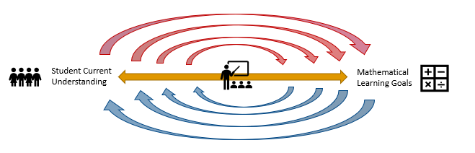
Responsive math teaching is instruction where the teacher continuously elicits information about what students currently know and understand and responds in ways that moves them forward in relation to developmental and grade-level mathematical goals. Recognizing what students know and can do and leveraging that to move towards higher level reasoning and problem solving ensures equity and access to mathematics for all students. When the teacher responds simultaneously to student thinking and a mathematical goal, each and every student is recognized as a capable learner who can develop deep, meaningful, and flexible understandings.
In order to build coherence through the different organizational levels of the instructional system (Cobb & Jackson, 2011) we have developed a set of tools and structures to help leaders and classroom teachers engage around this vision of math instruction and translate it into classroom practice.

Figure 1. RMT Tools that provide links between organizational levels of the instructional system.
Instructional Model
Task Bank
Planning and Coaching Protocol
Classroom Instruction
Instructional Vision

The Instructional Model
The RMT Instructional Model breaks high-quality math instruction down into seven core components:
- Plan: Select or adapt an appropriate task, identify the mathematical goal(s), and anticipate possible solution paths and challenges.
- Launch: Set up the task so that students understand the problem and can access the important mathematics.
- Facilitate productive struggle: Support students to engage in authentic problem solving.
- Make student thinking visible: Facilitate the sharing of student strategies and reasoning and engage students in making sense of each other’s thinking.
- Connect to the mathematics: Guide students to make explicit connections between their strategies and solutions and the key mathematical ideas.
- Build and expand: Facilitate application and/or practice that builds off and extends students’ current understanding.
- Reflect: Engage students in connecting and consolidating their understanding of the mathematical ideas.
Responsive Math Teaching requires a safe and supportive classroom community where students feel respected and supported as learners and are encouraged to take risks as problem solvers.
During each of these parts of a lesson, the teacher needs to be intentionally helping learners develop positive identities as mathematicians.

[Call out]
It's a way of looking at the different learners in your classroom, seeing what prior knowledge they have and just pushing them a little bit farther, wherever they're at. Allowing them to struggle, but not get frustrated, and helping them learn from each other. Being responsive to the kids’ needs.
(SBTL, RMT Network Lead)

Figure 2. RMT Instructional Model

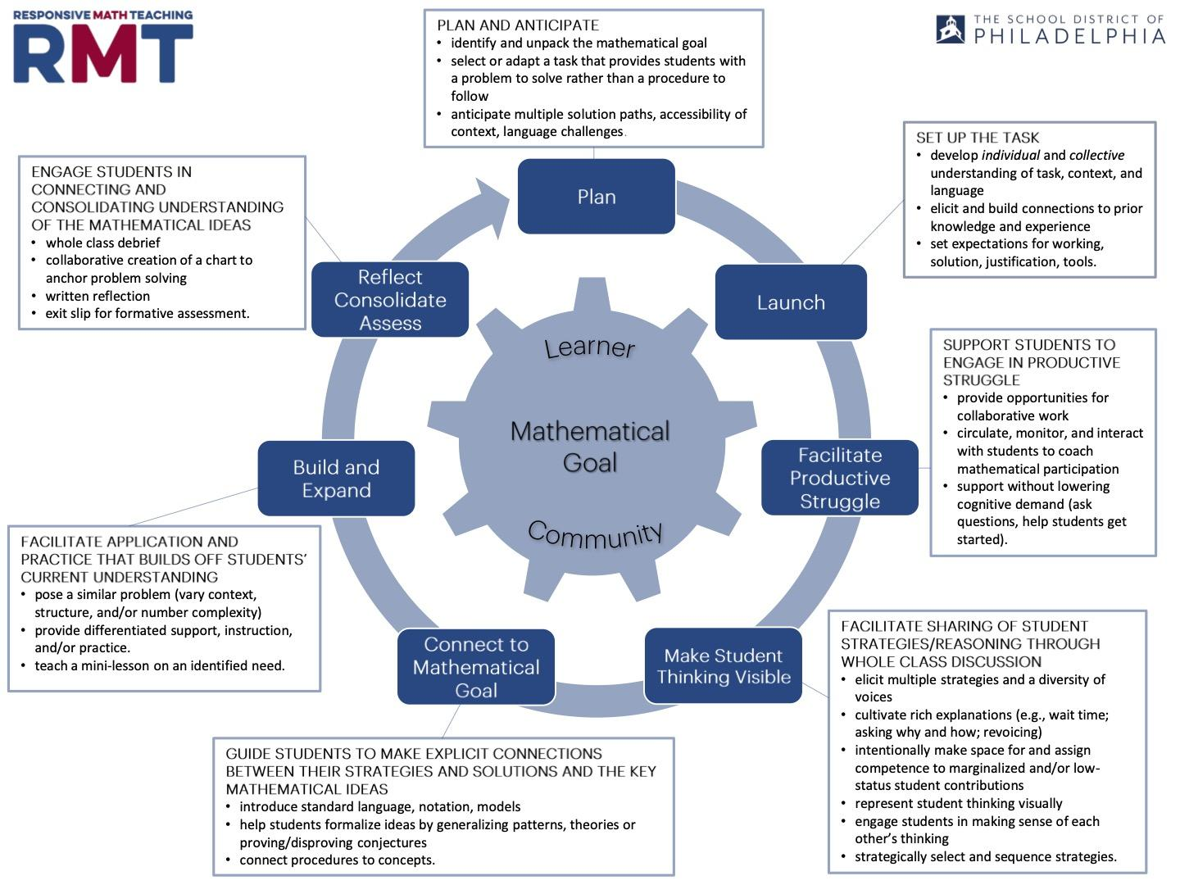

The teaching represented by this framework is challenging and involves learning new practices, instructional moves, and dispositions. Research suggests that in order to achieve this kind of instructional reform, teachers need opportunities to develop mathematical knowledge for teaching (Hill et al., 2008), sophisticated visions of high-quality math instruction (Munter, 2014; Wilhelm, 2014), the belief that their students are mathematically capable (Jackson et al., 2017), and new instructional practices (Ball & Forzani, 2009). Translating new ideas into practice has been an enduring challenge for educational reformers. As Kennedy (1999) describes, this “problem of enactment” can result in teachers having a change in vision while continuing to enact habitual practices, “without even noticing the contradiction” (2016, p. 947). The RMT project built a series of tools and supports to help address this problem of enactment and provide coherence across levels of the instructional system (Cobb & Jackson, 2011).

The Planning and Coaching Protocol
The Planning and Coaching Protocol is an 18-page booklet that breaks down each component of the instructional model into specific teaching practices and provides examples of questions and facilitation moves to support planning, implementing, coaching, and/or reflecting on an RMT lesson. Figure 3 shows this breakdown for the Launch, the portion of a lesson where the teacher develops individual and collective understanding of the task, elicits students’ prior knowledge, and sets the expectations for student work on the task. Teachers and teacher leaders use this protocol for lesson planning during RMT professional development sessions, and RMT mentors and teacher leaders use to it to structure coaching observations and reflections.

Figure 3 Planning and Coaching Protocol for the Launch
LAUNCH
How will you help learners begin to make sense of the task individually?
Give multiple ways to process the task (e.g. hearing it read out loud, reading silently, choral reading, different voices)  When developmentally appropriate, encourage learners to write notes about their thinking | - Listen carefully. I’m going to read it twice.  - Your only job right now is to read the problem and try to make sense of it yourself.  - Feel free to write on the problem to help you make sense of it.  - Lizzy, will you read the problem out loud?
Have learners describe task or problem in their own words | - Who wants to try summarizing the problem in their own words?  - What are we being asked to figure out?
Ask learners to visualize the problem and describe what is happening in the situation | - What is happening in this situation? What’s going on here?
How will you establish collective understanding of the task and context (without telling them how to do it)?
Elicit and/or make connections to prior knowledge and experience and fill gaps as needed | - Who here has cooked with a family member before? Did you use measuring cups? Can you share a personal story about your experience?  - This problem uses the term regular polygon. We learned about them last month when we did the ____ activity. Talk to your partner about what it means to be a regular polygon.
Provide opportunity for clarification of task and vocabulary (scaffolded or open-ended questions) | - What do you think it means when it says a ‘fair share’?  - Is this the kind of problem that could have more than one solution, or are we looking for a single correct solution?
Record group sense-making of problem | - List important information/constraints the group agrees to on the board.
If needed, ask explicit questions without specifying an equation, strategy, or operation for solving | - It asks us to find the largest rectangle. Could the answer be a square? Why or why not?
How will you build a bridge to solving?
Set expectations for working (individuals, partners, groups, timing), products (solution AND justification), and available tools | - Take a few minutes to start solving the problem yourself. In a few minutes I’ll ask you to start talking with someone else about your ideas.  - Think about using the counters or the base ten blocks up here if they might help you.  - So you have two jobs. First--to find out how much money he started with. Second—to have some kind of work that shows your thinking and proves your solution.  - In fifteen minutes, I’m going to ask each group to share what they are finding.
Assess individual and class readiness to engage in productive struggle on the problem | - Consider: Is there anyone who seems like they may need extra support understanding the problem or getting started?

[Call out]
The launches have really gotten better...The concept of creating a stronger, better, more inclusive "ground floor" entry point for the more difficult word problems in my curriculum has really influenced the way that I approach word problems - so that each kid can access it and contribute in some way.
- Fifth grade teacher

The Task Bank
The Task Bank is a collection of high-quality math tasks pulled from a variety of sources including well-vetted math websites and curriculum materials. The Task Bank is organized by grade band (K-2, 3-5, and 6-8) and includes tasks that can be used and adapted for different grade levels. Tasks are grouped according to mathematical domains: general problem solving, place value, number sense, addition and subtraction, multiplication and division, fractions, geometry, data analysis and measurement, patterns and algebra, number theory, proportional reasoning, and probability. To increase teacher implementation and coherence, some tasks were adapted directly from the district math curriculum materials.
RMT teachers and teacher leads are also developing short implementation guides for these tasks that includes adaptations for different grade levels, sample student solution strategies, launch notes, and suggestions for supports or scaffolds for learners. This is a growing resource that is designed to expand in breadth and depth through implementation over time.

Ongoing Professional Development
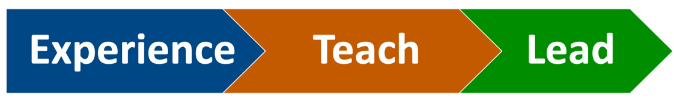
The RMT professional development program is a sequence of three year-long courses. In the first course, teachers and teacher leaders experience responsive math teaching as learners, working through challenging high-quality tasks and engaging in rich discussions about mathematics, and then using the RMT instructional model to reflect on their own learning and the pedagogical choices and practices of the professional development facilitator. In the second course, participants (1) unpack, analyze, and rehearse RMT instructional practices and (2) collaboratively plan, and teach responsive math lessons in their own classroom. In the third course, a smaller set of teacher leaders are directly engaged in learning to lead: learning how to support other teachers to adopt and refine Responsive Mathematics Teaching instructional practices.
Throughout the three professional development courses, sessions involve opportunities for participants to learn new teaching and facilitation practices through pedagogies of enactment (Grossman et al, 2009), as shown in Figure 4. In addition to seeing and experiencing responsive math teaching, participants regularly reflect on both the form and function of instructional practices and engage in activities such as simulations, coached rehearsals, and collaborative inquiry around their own pradimuctice. The Teach and Lead courses also involve inquiry cycles where participants co-plan, enact, and reflect on artifacts of enactment (e.g., student work or video clips).

Figure 4. Pedagogies of Enactment (Grossman et al. , 2009)

Once teachers have developed a new vision for mathematics instruction, they need support to put those ideas into practice. At the same time, teacher leaders need support in learning how to coach or support other teachers in their building. In the first two years of the project, this support was offered to select schools through a school-based support model, where an RMT mentor would work side by side with a teacher leader to implement high-quality math lessons in their own classrooms and/or also to begin to coach other teachers. In response to school closures from COVID-19 in the Spring of 2020, the project transitioned from a school-based support model to a collaborative cross-school lesson development model in the virtual online space.

Each year a new cohort of schools and teachers is introduced to Responsive Math Teaching through the Experience professional development course. Teachers who show continued interest can move on to Teach and Lead courses in subsequent years, as shown in Figure 5. By the fourth year of involvement, a small set of teacher leaders are ready to take on leadership roles in the network, providing professional development and lesson study cycles for their own and other schools. In this way, expertise in responsive math teaching is being continually built and the program is self-sustaining.

Figure 5. The Experience Teach Lead Sequence

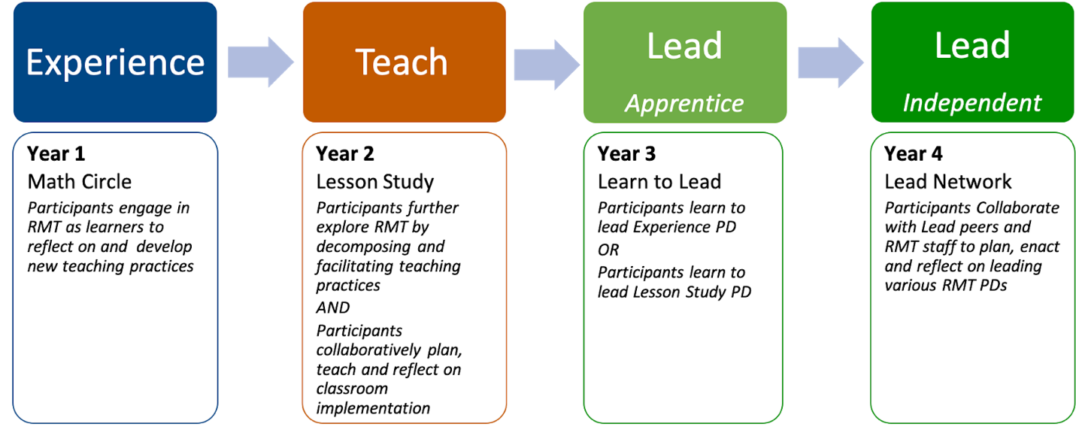

YEAR 1: EXPERIENCE
Experience professional development involves participating in a community of learners to experience RMT as a learner, reflecting on that experience in order to understand how to teach responsively, and beginning to make adjustments to math instruction. Evidence from teacher experiences suggest that by the end of this course, teachers are primed and ready to learn new skills and practices to help bring their developing visions into practice in the classroom (Ebby et al, 2020).

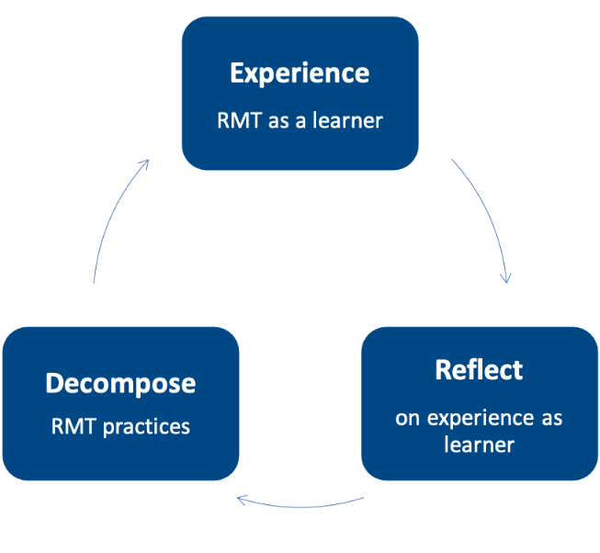
Representation: Participants engage in the instructional model as learners.

Decomposition: Participants use the instructional model to decompose the facilitator’s practice in relation to their own experience as learners.

Every time I left [a PD], there was something that I learned that I would never forget because I developed the knowledge on my own and no one gave it to me. So for me, it was like I own this because I struggled through it, that whole productive struggle. (Math Coach)
It's given [my teachers] an authentic opportunity to engage experience right reflect and then apply. –Assistant Principal

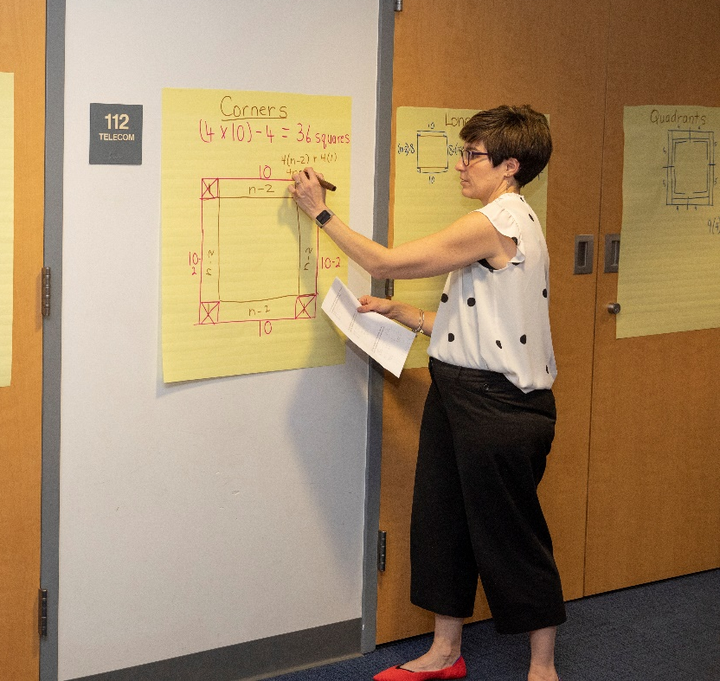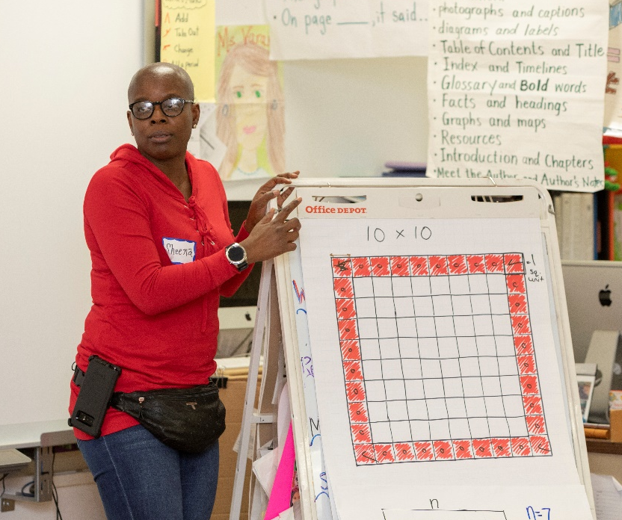
Teacher Leaders share their problem solving strategies in Experience PD

YEAR 2: TEACH
The second year involves coordinated cycles of professional development and cross-school collaborative lesson design and enactment.
Teach PD. Teach professional developments involve reflecting on, rehearsing, and developing specific instructional practices.

Not sure how to show that these two things overlap but also create a cycle
TEACH PD

Representation: Participants view videos of particular components of responsive math teaching (e.g., a teacher facilitating productive struggle).

COLLABORATIVE LESSON DEVELOPMENT
Decomposition: Participants identify specific teaching moves in their own and others’ practice and articulate the pedagogical reasoning behind those moves.
Approximation: Participants engage in simulated or hypothetical teaching experiences to generate possible teaching moves, practice decision making, and execute teaching moves in response to cues from the learner. They also record and collaboratively reflect on video clips of their own practice, generating new representations of practice.
[Call Out]
It's just a delight to practice something new, not just being told it, but actually getting to walk in it and get comfortable in it.

[Video recording my instruction has] been very beneficial because it allows me to see what I am doing well, and what I need to work on. How am I posing my questions and what effect is having on my student work.

(District Math Coach)

Collaborative Lesson Development. Collaborative lesson design and development takes place in grade level online groups that meet regularly to engage in lesson-study cycles in which they collaboratively plan RMT lessons, teach those lessons in their own classrooms, and then debrief and reflect on artifacts from the implementation of the lesson with their peer partners. The RMT instructional model, the RMT Planning and Coaching Protocol, and a bank of RMT tasks for each grade level are used to scaffold and support the planning, enactment, and reflection on these lessons. Artifacts such as student work, video and audio clips, and student surveys are used to anchor reflection and revision.

In response to COVI9-19 school closures, for Year 3 this model replaced in-school mentoring and coaching of math leads. It has proven to have several advantages. First it makes more efficient use of the mentor’s time, because multiple teachers from different schools can be supported at the same time. Second, it does not require teachers or leaders to have released time during the school day, a commodity that is lacking in the most resource-challenged schools. It was rare for mentors to be able to schedule and complete planning, observation, and debrief sessions during the school day. Third, teachers appreciate the opportunity to collaborate with grade level partners in different schools, and meeting after school on Zoom makes that possible in a way it never had been before.

“It’s nice to hear that people have similar struggles and to get fresh perspectives on what's going on in my classroom. Sometimes it's hard when you're in it to sort of step back and see it. . . but it is also nice for somebody else to say, well you know, have you tried this? or have you explored that?”
Middle School Math Teacher

“I have had an opportunity to spend time working with teachers to plan their lessons, which involves taking a math task and really analyzing the problem, deciding if it needs to be tweaked at all so that it's accessible for all students, and then anticipating struggles that kids may have interpreting the problem, struggles they may have solving the problem. And this really requires teachers to think deeply about the problem and to plan for as many different situations as they can think of, and then execute that. I’ve been able to improve my skills as a leader to really help teachers through the that process.”
School Based Teacher Leader

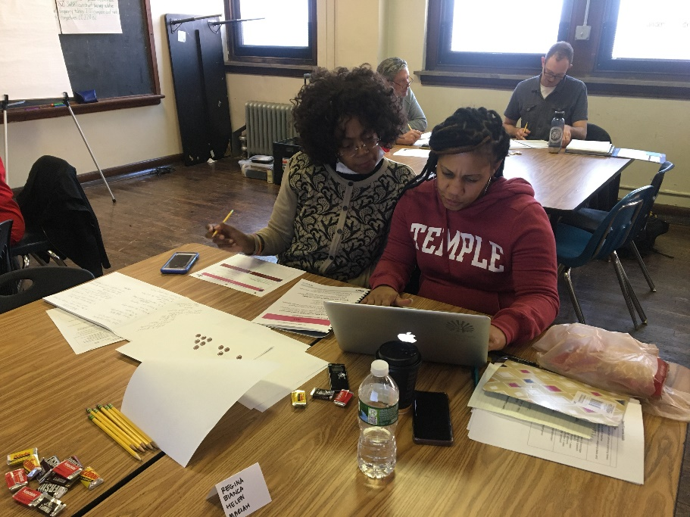
Collaborative Lesson Design

YEAR 3: LEAD APPRENTICESHIP
During the lead apprenticeship year, participants are supported to plan and facilitate either professional development sessions or collaborative lesson design sessions for other teachers in their own and other schools. During lead professional developments, apprentice leaders collaboratively plan, rehearse, and debrief the facilitation of experience professional development sessions. Apprentice collaborative lesson design leaders meet with an RMT facilitator to plan for the sessions and increasingly take on more leadership of the sessions as the year goes on.

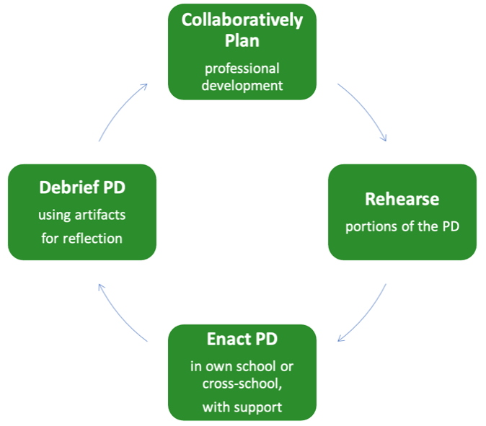
Representation: Participants watch video recordings of Experience PD sessions facilitated by more experienced leaders.

Decomposition: Participants identify facilitation moves and pedagogical reasoning behind those moves.

Approximation: Participants rehearse portions of the PD and debrief facilitation decisions with peers and RMT experts.

When I got together with leaders from other schools, that was really positive and helped me grow. We focus on the positives. We record ourselves teaching and doing PDs with teachers, we come back, we examine the videos and the artifacts together and identify what each of us did that really worked and how we could build upon that. So every step of this process has been really positive, and you can see how making a math environment positive for kids can really help them grow also.

--School Based Teacher Leader
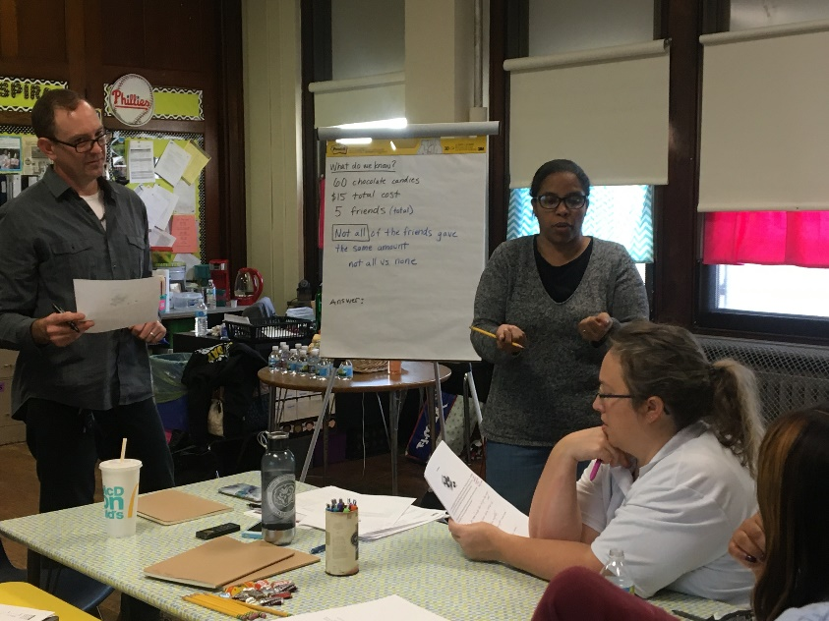
Rehearsing a PD session

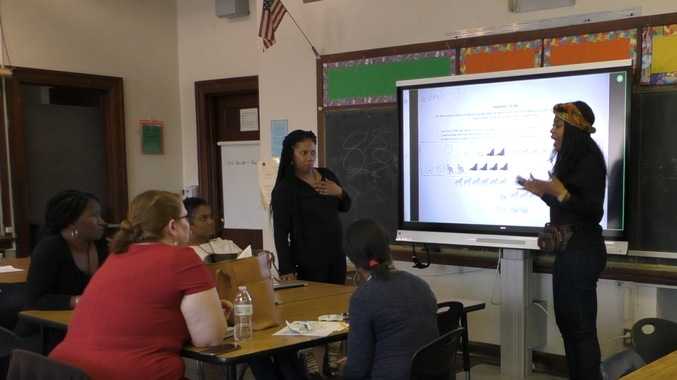
An apprentice leader facilitating RMT Experience PD at her school

YEAR 4: LEAD NETWORK
Four leaders who began in the pilot year are now in their fourth year of involvement and are serving as leaders for other teachers in the network by facilitating RMT Experience PD’s or collaborative lesson design for teachers across schools, allowing the project to continue expanding its reach. These network leaders are supported by an RMT mentor in planning, enacting and debriefing the sessions.
Not only has it helped me with my own practice as a leader, but it has helped me with actually being more intentional with my professional development, what do I want my teachers to walk away with from this, the big idea that I need them to walk away with? Not only that, it helped me to be a better coach, because now, I truly understand, or learning to understand because it's like really a growth process. The more we get into it, the more I learn about what I really want.
--School-Based Teacher Leader

Leadership Development for Sustainability
The RMT professional development course sequence (Experience-Teach-Lead) coupled with grade-level collaborative lesson development groups are designed to build teacher expertise in effective math instruction and teacher leader expertise in facilitating adult learning and growth. Teacher leaders are expected to be able to lead their colleagues in collaborative lesson design as well as facilitate professional development. This involves developing pedagogical expertise, relationship-building skills, a professional vision for instructional leadership, and group facilitation skills (Cobb et al, 2018).
By bringing a new cohort into Experience professional development each year, the RMT project aims to spread knowledge and capacity for high-quality math instruction within and across schools. At the same time, as new leaders are developed through the Experience-Teach-Lead sequence, the capacity to lead this professional development grows. Over time, the need to rely on outside expertise is diminished. Figure 6 shows how this expertise has expanded in the network of schools by bringing in new cohorts of 3-5 schools every year over a period of five years. Common professional learning experiences across the network help to build a networked community of learners with varying levels of expertise.

“Educators who are leading, you can see that they're becoming more comfortable and as you become more comfortable doing it with educators, you can be more comfortable doing within your classroom, so every just see how everybody is just growing.”
Assistant Principal

Figure 6. Cohort Model for Sustainability

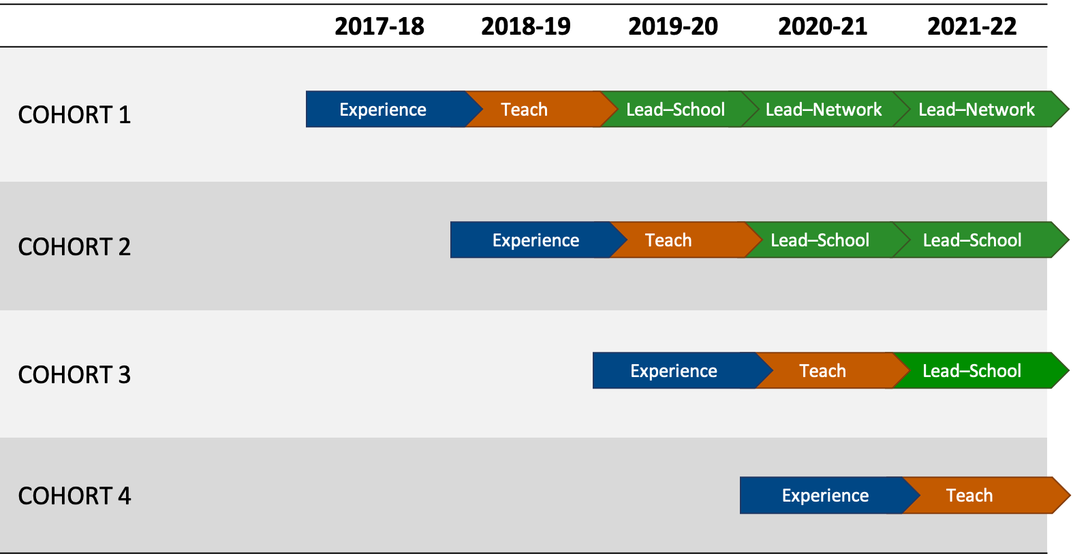

In the third year (2020-21), this model has expanded the reach of RMT to over 200 educators from Learning Network 2. Four teacher leaders who have been involved since the planning year are currently serving as math instructional leaders at their own schools and leading professional development or collaborative lesson planning sessions for teachers the network. Six additional teacher leaders are apprentice RMT leaders, learning to lead collaborative lesson planning or professional development sessions for teachers in LN2 with support of RMT mentors.

Educators in Learning Network 2 Who Have Received RMT Support from 2017-2021

 | 2017-18 | 2018-19 | 2019-20 | 2020-21
Schools Involved in RMT | 6 | 8 | 13 | 15
Participants in Experience PD  (RMT-led) | 7 | 14 | 28 | 14
Participants in Experience PD  (school-based) |  |  | 22 | 50
Participants in Teach PD |  | 6 | 10 | 19
Participants in Collaborative Lesson Design  * Individual Coaching first 3 years  **includes Teach PD participants | *2 | *3 | *7 | **34
Apprentice Leaders in Lead PD  (Facilitating Experience PD or CLD) |  |  | 4 | 6
Independent Leaders  (Facilitating Experience PD or CLD) |  |  |  | 4
TOTAL | 7 | 20 | 64 | 108

Like many large urban districts, the school district has a very high rate of teacher turnover or “churn” (teachers moving to new grade levels from year-to-year), particularly in lower performing schools. In addition to the designated math teacher leader, we try to identify and recruit additional grade level teachers that might serve as leaders for their peers at each school.

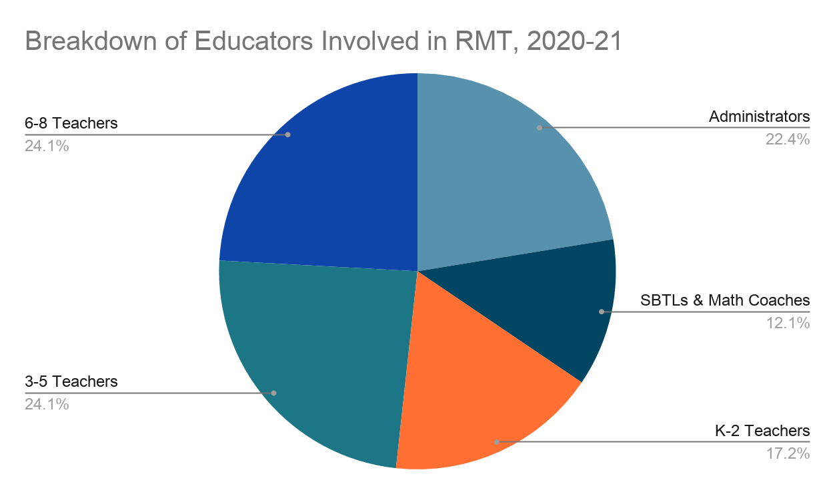

Building a Culture of Instructional Improvement

At the school level, as the number of teachers who receive RMT PD grows, a culture of builds around common language, tasks, and practices for instructional improvement. A third-grade teacher leader explained how in the second year, as more teachers and the math coach got involved in RMT, dialogue around math instruction opened up at her school and teachers started to visit each other’s classrooms:
I love it and I think they love it. You know we'll talk about, “So I did this lesson with the kids” “Oh yeah, you did? I was thinking about trying, you know trying it with my group, do you think it will work with kindergarten?” You know we have really excited conversations about teaching a particular skill or particular lesson to our different grades and figuring out how it worked out. “Well listen, if you do it during my prep I'll come down, I'll pop in.” … That was a great aspect of having other people in the building, who are doing it. . . It's nice when something good spreads through the building.
-5th grade math teacher leader

Common professional learning experiences help to build a networked community of learners with varying levels of expertise, both within schools and across the network. At several schools, teachers and leaders noticed a difference when they walked into classrooms:
Our students have gotten used to really thinking about math problems, instead of simply wanting to just solve them right away. They're comfortable in the fact that there's many ways to solve each problem and each person thinks in their own unique way so they've gotten really used to seeing each other's work being able to analyze each other's work and talk about it.
-School Based Teacher Leader

Ongoing research
The research component of the project involves studying how teachers take on instructional leadership roles.
Developing a New Vision of Math Instruction
Interviews of teachers and leaders after the first year of the RMT Experience PD indicated that they developed new understandings of what it means to learn mathematics and engage in productive struggle from a learner’s point of view, and that this in turn gave them a new perspective on the teacher’s role. Many teachers were also able to translate specific practices they saw the facilitator doing into their own math instruction. Others perceived a gap between their evolving vision for math instruction and what they felt they were capable of enacting in their own classroom.
Once you get that feeling of, ‘Oh, this is how it's supposed to feel, this is how it's supposed to look,’ then when you bring it back into your classroom you can kind of tell. Is that how it looks in here? What am I striving for? How am I going to get my classroom to kind of equal what we're doing at the training? (Grade 1 teacher)

See “Teaching Them How to Fish”: Learning to Learn and Teach Responsively (Ebby et al., 2020) for more on the analysis of what teachers learned from the first year of Experience PD.

Extant research has shown that teachers’ instructional vision is related to enactment of cognitively demanding tasks and overall improvement in practice (Munter & Correnti, 2017; Wilhelm, 2014). As Cobb et al. (2018) state: “A vision represents something that teachers are working toward—a conception of the instructional practice that they aspire to enact.” (p. 53) We are using Munter’s (2014) instrument for assessing participants visions of high-quality math instruction (VHMQI), which asks interviewees to imagine what they would see happening in a classroom where high-quality math instruction would take place, and includes probes about tasks, classroom discourse, the and teacher’s role.

Analysis of this data from teacher leaders before and after the Experience year of RMT PD show important shifts in how teachers thought about the structure of a math lesson, the classroom environment, the nature of the task, the teacher’s role, student engagement, and equity, as summarized in Table 1. For some teachers these shifts represented changes in their thinking, for others, there was an increase in depth or the addition of new aspects of that dimension of math instruction.

Table X. Shifts in Teacher’s Instructional Vision after the Experience Year.

Dimension | Shifts in Teacher’s Instructional Vision
Structure of a math lesson | - Small groups can be used to engage students in collaboration and problem solving, rather than only a means for differentiation  - Whole group discussions are important at the beginning and end of a lesson for launching a task and for students to share and make sense of each other’s thinking.
Classroom environment | - The classroom environment needs to allow students to feel comfortable taking risks and making mistakes
Nature of the Task | - Tasks should be open to multiple solution strategies  - Tasks should have multiple entry points
Teacher’s role | - Teachers can facilitate students’ struggle to make sure its productive  - Teachers can support student engagement with the mathematics through strategic questioning  - Clarifying a task before sending students off to solve will lead to more productive work on the mathematics  - Students should have opportunities to make sense of each other’s thinking  - Planning for math instruction involves anticipating student thinking and potential difficulties
Student role | - Students need to take on the cognitive load for math learning  - Students benefit from collaboration  - Students should engage in mathematical reasoning and argumentation
Equity | - We need to ensure that all students have opportunity to participate mathematically  - There is value in different perspectives and approaches

Developing a New Vision of Math Instructional Leadership
In the same way that teachers develop and refine their visions of high-quality math instruction, teacher leaders who have participated in the project for multiple years have developed and refined their ideas about how to best support teacher learning and growth-- their vision of instructional leadership. At the same time, they are developing new skills and practices for supporting teacher learning and growth. We continue to explore the following questions around instructional leadership vision:
- What are the priorities of the leader in designing learning opportunities for teachers?
- What kind of relationships does the leader strive to create with individuals and across the school community?
- What does the leader see as their role in facilitating teacher learning and growth?
Preliminary analysis highlights some important shifts in these aspects of instructional leadership vision over time. Initially, many teacher leaders viewed their role as one of having expertise to share with others. Over time, as they participated in various leadership activities, supported by RMT, (coaching, leading collaborative lesson design, and planning and leading PD) their views of instructional leadership expanded and shifted in ways that were less transmission or “leader-centered” to acknowledge the importance of building rapport and trust, taking the time to understand individual teacher’s strengths and needs, and learning through active and social participation in a community of practice. In other words, their visions of leadership grew to include the idea of being responsive to teachers’ learning.
Figure 5 illustrates some of the key growth points in the development of Responsive Instructional Leadership. In many ways this diagram also illustrates the path of our own development as a research-practice partnership in creating a networked learning community.

Figure 5. Growth Trajectory in the Development of Responsive Instructional Leadership

Next Steps
As we look forward to Year 4 of the project, the overall goal is to instantiate this model into the day to day operations of schools in the network, drawing on Coburn’s (2003) conceptualization of scale-up as a combination of depth, sustainability, spread, and shift in ownership. The gradual increase in the number of schools, principals, teacher leaders, and teachers involved will allow us to ensure that the district vision and instructional model are being implemented with depth (i.e., resulting in changes in classroom practice), and also to study whether and under what conditions these changes persist over time. The involvement of school and district leaders is key to this process.

The educators who have been doing it...the level of discourse that's taken place in those classes is beautiful, it's music to my ears. So now they've really taken on more of a facilitation-style strategy as opposed to being the one who is dominating the conversation.. and [the learners] are engaging authentically.
- Assistant Principal

The teachers that have participated in RMT feel more comfortable really digging into one single problem, working with students to share their solutions to each other, and using specific talk moves to facilitate student discussion.
--School Based Teacher Leader

I just I feel like so many more children are talking about math and it's it's really joyful for me to hear children be brave and share their thinking…. And i'm just always so amazed that RMT has provided me with this framework to get as many people talking about math as possible it's been a really it has had a huge impact on my math instruction.
--Middle School Math Teacher

Project team
Caroline B. Ebby, Ph. D., Principal Investigator
Caroline Watts, Ed. D., Co-Principal Investigator
Joy Anderson Davis, Ed. D., School-Based Coaching Specialist

Brittany Hess, Research Specialist and Lesson Study Mentor
Lizzy Pecora, Project Coordinator
Lindsay Goldsmith-Markey, Doctoral Research Assistant and Professional Development Specialist
Jennifer Valerio, Doctoral Research Assistant and Lesson Study Mentor

References
Ball, D. L. & Forzani, F. M. (2009). The work of teaching and the challenge for teacher education. Journal of Teacher Education, 60(5), 497-511.

Cobb, P., Jackson, K., Henrick, E., & Smith, T. M. (2018). Systems for instructional improvement: Creating coherence from the classroom to the district office. Harvard Education Press.

Cobb, P., & Jackson, K. (2011). Towards an empirically grounded theory of action for improving the quality of mathematics teaching at scale. Mathematics Teacher Education and Development, 13(1), 6-33.
Coburn, C. (2003). Rethinking scale: Moving beyond numbers to deep and lasting change. Educational Researcher, 32, 3-12.
Coburn, C. E., Russell, J. L., Kaufman, J. H. & Stein, M. K. (2012). Supporting sustainability: Teachers’ advice networks and ambitious instructional reform. American Journal of Education, 119, 137-182.
Crowther, F., Kaagen, S., Ferguson, M., & Hann, L. (2002). Parallelism: Building school capacity through shared leadership. Developing teacher leaders: How teacher leadership enhances school success (p. 36-38). Thousand Oaks, CA: Corwin Press.
Coburn, C. E., Russell, J. L., Kaufman, J. H., & Stein, M. K. (2012). Supporting sustainability: Teachers’ advice networks and ambitious instructional reform. American Journal of Education, 119(1), 137-182.

Ebby, C. B., Hess, B., Pecora, L., & Valerio, J. (2020). “Teaching Them How to Fish”: Learning to Learn and Teach Responsively. Working Paper Retrieved from https://repository.upenn.edu/gse_pubs/558

Fullan, M. (1994). Coordinating top-down and bottom-up strategies for educational reform. In R. J. Anson (Ed.), Systemic reform: Perspectives on personalizing education, (p.7-24). Washington, DC: US Government Printing Office
Fuson, K. C., & Murata, A. (2007). Integrating NRC principles and the NCTM process standards to form a class learning path model that individualizes within whole-class activities. National Council of Supervisors of Mathematics Journal of Mathematics Education Leadership, 10(1), 72-91.

Grossman, P. (Ed.). (2018). Teaching core practices in teacher education. Harvard Education Press.

Grossman, P., Hammerness, K., & McDonald, M. (2009). Redefining teaching, re‐imagining teacher education. Teachers and Teaching: Theory and Practice, 15(2), 273-289.

Hiebert, J., & Morris, A. K. (2012). Teaching, rather than teachers, as a path toward improving classroom instruction. Journal of teacher Education, 63(2), 92-102.
Hiebert, J., & Grouws, D. A. (2007). The effects of classroom mathematics teaching on students’ learning. In F. K. Lester (Ed.), Second Handbook of Research on Mathematics Teaching and Learning (p. 371-404). Charlotte, NC: Information Age Publishing.

Hill, H. C., Blunk, M. L., Charalambous, C. Y., Lewis, J. M., Phelps, G. C., Sleep, L., & Ball, D. L. (2008). Mathematical knowledge for teaching and the mathematical quality of instruction: An exploratory study. Cognition and instruction, 26(4), 430-511.

Jackson, K. J., Shahan, E. C., Gibbons, L. K., & Cobb, P. A. (2012). Launching complex tasks. Mathematics Teaching in the Middle School, 18(1), 24-29.

Kavanagh, S. S., Metz, M., Hauser, M., Fogo, B., Taylor, M., & Carlson, J. (2020). Practicing responsiveness: Using approximations of teaching to build teachers’ instructional judgment. Journal of Teacher Education, 71(1), 94-107.
Kazemi, E., Lampert, M., & Franke, M. (2009). Developing pedagogies in teacher education to support novice teachers’ ability to enact ambitious instruction. In R. Hunter, B. Bicknell & T. Burgess (Eds.), Crossing divides: Proceedings of the 32nd annual conference of the Mathematics Education Research Group of Australasia. (Vol. 1, pp. 12-30). Palmerston North, NZ: MERGA.
Kennedy, M. M. (2016). How does professional development improve teaching? Review of Educational Research, 86, 945-980.
Lampert, M., Franke, M. L., Kazemi, E., Ghousseini, H., Turrou, A. C., Beasley, H., ... & Crowe, K. (2013). Keeping it complex: Using rehearsals to support novice teacher learning of ambitious teaching. Journal of Teacher Education, 64(3), 226-243.

Lampert, M., & Graziani, F. (2009). Instructional activities as a tool for teachers' and teacher educators' learning. The Elementary School Journal, 109(5), 491-509.

Little, J. W. (2002). Locating learning in teachers’ communities of practice: Opening up problems of analysis in records of everyday work. Teaching and Teacher Education, 18(8), 917-946.

Munter, C., & Correnti, R. (2017). Examining relations between mathematics teachers’ instructional vision and knowledge and change in practice. American Journal of Education, 123(2), 000-000.
Munter, C., & Wilhelm, A. G. (2020). Mathematics teachers’ knowledge, networks, practice, and change in instructional visions. Journal of Teacher Education, Advance online publication: https://doi.org/10.1177%2F0022487120949836
Penuel, W. R., Frank, K. A., & Krause, A. (2006). The distribution of resources and expertise and the implementation of schoolwide reform initiatives. In Proceedings of the 7th International Conference on Learning Sciences (pp. 522-528). International Society of the Learning Sciences.
Silva, D. Y., Gimbert, B., & Nolan, J. (2000). Sliding the doors: Locking and unlocking possibilities for teacher leadership. Teachers College Record, 102(4), 779-804.

Wasley, P. A. (1991). Teachers who lead: The rhetoric of reform and the realities of practice. New York: Teachers College Press.
Wilhelm, A. G. (2014). Mathematics teachers' enactment of cognitively demanding tasks: Investigating links to teachers' knowledge and conceptions. Journal for Research in Mathematics Education, 45(5), 636-674.

In 2020-21 the district as a whole enrolled 52% students of color, .
2017-18 was a planning/pilot year before the officially funded project began in 2018-19.

