Liana Kaye-Lew

1997 Asian Financial Crisis Propagation:
Corporate Sector Reform and South Korea’s Economy

Introduction:

In the 1990s, South Korea was an economic inspiration among developing countries, having transformed itself from one of the world’s poorest countries to a newly industrialized nation ranked as the eleventh largest economy in 1997. This boom was brought to a dramatic halt during the 1997 Asian Financial Crisis when the “value of its currency had dropped by nearly half, its stock market had plummeted, thirteen merchant banks and several major corporations were essentially bankrupt, and the government was struggling to meet foreign exchange requirements,” according to the 1997 Congressional Research Service (CRS) Report for Congress. While contagion from an exchange rate crisis in Thailand sparked the hard landing of South Korea’s flourishing economic development from the later half of the twentieth century, the resulting effects of the crisis were largely due to flaws in the country’s ascent to global dominance, particularly within the corporate sector. While the country suffered as a result of the financial crisis, the events of 1997 brought to light institutional weaknesses and put pressure on the government to move the country off the path which had enabled its initial success. To rebound from the 1997 Asian Financial Crisis, South Korea executed reactionary measures within the corporate sector which advanced the nation’s overall financial and economic progress.

The sudden depreciation of the Thai baht in 1997 caused by a collapse in exports set off a slew of financial and currency crises in developing Asian countries, including South Korea. Being the largest economy hit by the crisis, South Korea received the most direct financial aid from the International Monetary Fund (IMF) as its economic failures would have the greatest impact on the global financial system. The IMF’s support package was not without its caveats. Emergency loans were contingent upon demonstrated efforts by South Korea to strengthen its economy. South Korea was required to take measures which would make its financial system more sound, transparent, and efficient and would need to impose more supervision on its markets and increase competition. At the root of South Korea’s financial deficiencies were chaebols, large family-owned business conglomerates whose presence extended across industries that had shown international success leading up to the crisis. In addition to creating imbalance in South Korea’s economy by taking up almost half of the country’s corporate turnover, these conglomerates were unsupervised and not held accountable when it came to their procurement of loans from financial institutions and associated operations. While this lack of transparency within the corporate sector proved effective prior to the crisis, enabling international expansion and financing of multiple ventures, this unwavering support of big business became a clear vulnerability in the economy. Bankers were more averse to the widespread effects of a chaebol bankruptcy than not receiving debt payments from these powerful conglomerates, making the corporate sector fragile given the extensive debt of companies perceived to be too-big-to-fail.

Responding to the demands of the IMF, the South Korean government took extensive steps to establish management accountability and transparency within the corporate sector and lower the large debt-equity ratios amassed by chaebols. Reform to focus on core businesses and exit unsustainable ones forced these conglomerates to shift their expansionary management style to a profit-oriented approach. Additional measures which eliminated cross-debt guarantees and consolidated accounts aimed to improve corporate governance over chaebols. Finally, the government made efforts to reinforce the interests of shareholders, requiring chaebol leadership to bring in individuals from outside their corporations and encouraging more agency given to their minority shareholders. While these reforms marked a dramatic official shift in South Korea’s corporate sector, their impact on the inner workings of chaebols is still up for debate. However, the improved debt to equity ratio and increased private competition brought forth by chaebol reforms left a lasting impact on South Korea’s economy and can be attributed to the country’s financial and economic growth following the 1997 Asian Financial Crisis.

Debt-to-equity ratios and development of the financial sector:

The too-big-to-fail perception of chaebols enabled excessive funding of risky investment in the corporate sector prior to the crisis, causing the average debt-equity ratio of the top 30 chaebols to be almost 600% in 1997. While state measures to lower this massive debt-equity ratio were intended for the solvency crisis in the corporate sector, they provided an opportunity for chaebols to establish equity management and shift away from debt financing.

In “The financialization of non-financial firms: The case of South Korea, 1997-2015,” Chan-ung Park and Gru Han argue that pressures to lower chaebol debt-equity ratios drove financialization, or the development of South Korea’s financial sector as part of its overall economy. As the South Korean stock market was essentially dormant before the 1997 Asian Financial Crisis, the government imposed little to no corporate governance in the interests of minority shareholders, making equity financing a nonviable option for corporations. Additionally, the familial ownership of chaebols undermined the need for corporate activities to be tied to the financial sector. Park and Han hypothesize that given these factors, chaebols lacked any natural incentive towards financialization. Structural reforms initiated by the IMF’s rescue package to reduce debt-equity ratios, however, led chaebols to drive the shift from debt to equity financing, contributing to the ultimate creation of the country’s financial sector. Analysis data from publicly traded South Korean firms tests two aspects of this hypothesis: if chaebol firms were more likely to increase financialization than non-chaebol firms, which would substantiate chaebols’ function in growing the financial sector, and if chaebol firms with higher debt at the time of the 1997 crisis were more likely to increase financialization than those with lower debt, which would indicate that these efforts towards financialization came as a result of government reforms to lower chaebol debt-equity ratios. Comparing firm financialization, represented by the proportion of financial assets to total assets, of chaebols and non-chaebols and firms with varying debt levels at the time of the 1997 crisis, Park and Han’s estimation models affirm their hypotheses regarding the influence of chaebol reforms on the advancement of South Korea’s financial sector. Using multiple estimation methods, their analysis reveals chaebol firms were more likely to demonstrate measures of financialization (Figure 1, Row 1). Analysis of 1997 debt reveals higher debt is positively correlated with financialization for chaebol firms (Figure 2, Row 3 + Row 4), but negative in some estimation models for non-chaebol firms (Figure 2, Row 3).

Not only did the 1997 Asian Financial Crisis provoke institutional changes in South Korea’s corporate sector, it brought forth a rise in equity financing via chaebol reforms as shown in the findings from Park and Han’s research. The increase in financial assets among chaebols following the crisis illustrates that by being one of the main sources of South Korea’s economic vulnerability at the end of the twentieth century, chaebols drove financial development in response to reforms implemented to strengthen the economy. As stock markets were not an integral part of South Korea’s economy prior to chaebol reforms, the rise in equity financing among these conglomerates signified growth in regards to financial sophistication as a result of the 1997 Asian Financial Crisis. Thus, reactionary measures in the corporate sector as a result of the crisis can be attributed to having a positive impact on South Korea’s overall financial and economic development.

Productivity growth, competitiveness, and innovation:

In addition to lowering debt-equity ratios, chaebol reforms confronted the dominance of these family-owned conglomerates within South Korea’s economy. Increased transparency, improved corporate governance, and fewer restrictions on foreign investment lowered barriers to entry within the private sector, which was virtually impenetrable for non-chaebol firms prior to the 1997 Asian Financial Crisis. The increased participation of non-chaebol firms as a result of these reforms created more competition in South Korea’s economy, and in turn, allowed for a shift to innovation-based growth and accelerated productivity across industries. In “Chaebols and firm dynamics in Korea,” Philippe Aghion, Sergei Guriev, and Kangchul Jo posit that chaebol reforms enabled competition in South Korea's economy, triggering the country’s transition from investment-based growth to innovation-based growth. For developing countries, this shift indicates a higher level of development under the Schumpeterian growth theory. Despite being a source of economic vulnerability in 1997, chaebols made significant contributions regarding South Korean industrialization and export-led-growth leading up to the crisis. While chaebols initially drove South Korea’s economic growth, their disproportionate share across industries inhibited competition which in turn limited innovation. Aghion, Guriev, and Jo argue the reactionary measures within the corporate sector brought forth by the IMF’s support package provided the necessary changes to advance South Korea’s stage of economic growth as a developing country. Using demographics and productivity growth of chaebol dominated industries as well as patenting activity, they empirically assess whether or not chaebol reforms fostered competition and innovation. They perform a difference-in-difference regression to estimate post-crisis effects on dependent variables including productivity, entry and exit, and patenting depending on the level of chaebol dominance within an industry leading up to the crisis (Figure 3). Their regression analysis reveals industries with greater chaebol dominance prior to the crisis saw higher labor productivity and total factor productivity growth. Additionally, entry and patenting of non-chaebol firms increased across industries following the corporate sector reforms of 1997. These findings suggest that changes in the corporate sector empowered smaller firm participation in the market, a positive implication on competition and private innovation within the economy.

While chaebols still hold a significant share of South Korea’s corporate sector, non-chaebol behavior shifts following the 1997 crisis illustrate how chaebol reforms did more than simply resolve weaknesses which enabled the financial crisis. According to Schumpeterian growth theory, innovation needed to increase productivity and drive economic growth emerges not by chance but from pressures of competition. Not only did the lack of corporate governance and too-big-to-fail perception of chaebols create significant economic deficiencies, these elements of the corporate sector suppressed entry of non-chaebol firms, hindering the competitive incentive for innovation. Thus, while there may have been individual firm incentives to increase productivity within chaebols, this sentiment was not strong enough to drive South Korea to the next stage of its economic development. The 1997 Asian Financial Crisis provided an opportunity to overcome these shortcomings in the corporate sector by weakening the power of chaebols to allow room for new players across industries.

Empirical Evidence:

The value of chaebol reforms in driving firm participation necessary to create competition in South Korea’s economy can be shown using the World Bank’s Global Financial Development Database. Plotting the indicator for the number of publicly listed companies per 1,000,000 people in South Korea from 1990 to 2005 shows a dramatic spike following the chaebol reforms of the 1997 Asian Financial Crisis. This analysis illustrates the effects of both lower barriers to entry and improved debt-equity ratios induced by chaebols reforms. The spike in companies in the years following the crisis (most chaebol reforms were implemented in 1998 and did not immediately take effect on the market) suggests a transition to more competitive markets in South Korea’s corporate sector which could provide opportunities for innovation and productivity growth. Similarly, as the companies are publicly listed, this graphical analysis indicates an increase in corporate activity tied to the stock exchange. Thus, this corporate participation encouraged by chaebol reforms was tied to financial markets, likely due to financialization brought forth by the shift to equity financing following the financial crisis. In sum, graphical analysis of this financial indicator reveals chaebol reforms progressed South Korea’s financial and economic development from two angles: by increasing finance’s role in corporate activities and by opening up industries to stimulate corporate competition.

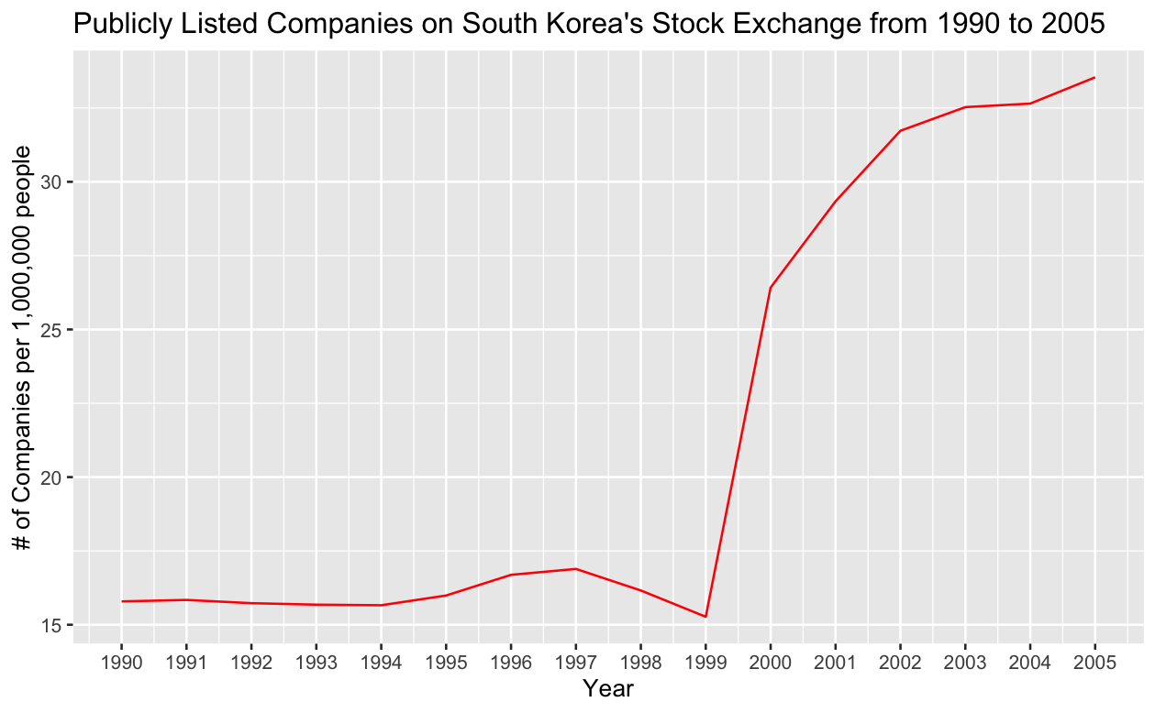

Conclusion:

The effectiveness of chaebol reforms is still a matter of debate. While the government put pressure on family-owned conglomerates following the 1997 Asian Financial Crisis, chaebols often found ways to appease these government imposed restrictions without making any major structural changes. For instance, to lower debt-equity ratios, they developed circular shareholding, issuing equity across companies within the same conglomerate to raise equity without minimizing corporate control. Scholars also argue that the increase in transparency and corporate governance from chaebol reforms diminished the enthusiasm which defined South Korea’s economy during the second half of the twentieth century. Despite questions regarding efficacy in altering the corporate sector, chaebol reforms induced shifts which should be attributed to South Korea’s overall economic and financial growth. While South Korea was on track to be a major economic power prior to the 1997 Asian Financial Crisis, it lacked incentives to further the sophistication of its financial sector. Similarly, chaebols’ dominance across industries hindered competition needed to stimulate innovation. The 1997 Asian Financial Crisis provided these necessary mechanisms for the continuation of South Korea’s financial and economic development.
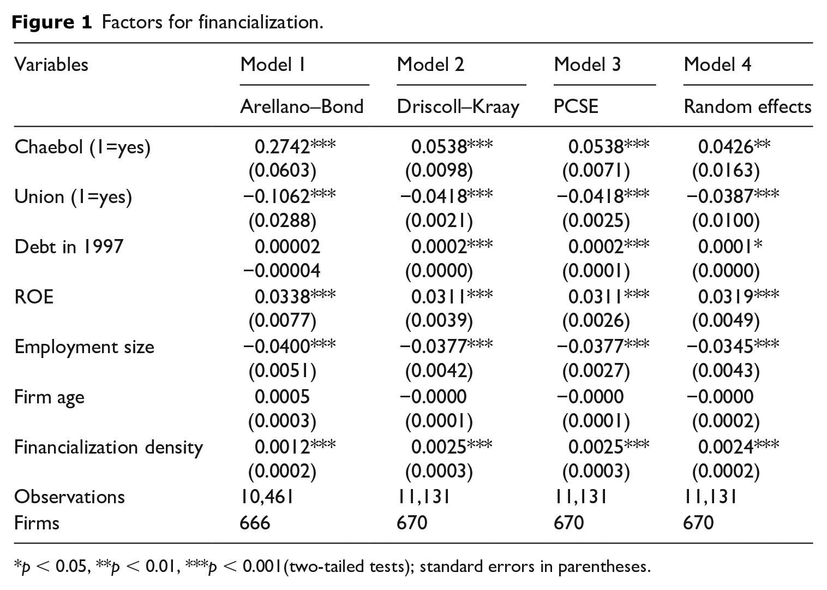

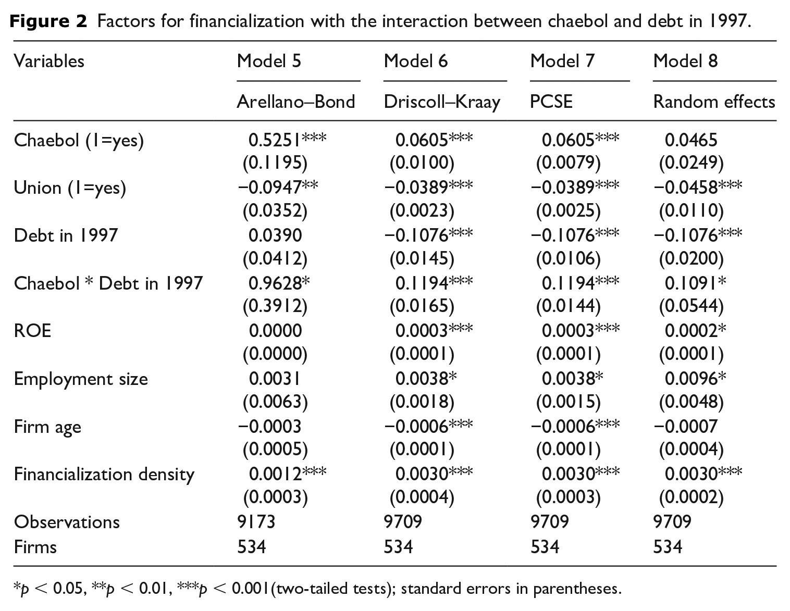

Figure 3 Y_{it} = 𝛂_{i} + 𝛃₁ Post crisis_{t} + 𝛃₂ ( Chaebol share_{i} x Post crisis_{t} ) + u_{it}
Y_{it} is dependent variable.
References

Aghion, Philippe, Chang-Tai Hsieh, and Sang Yoon (Tim) Lee. "Chaebols and Firm Dynamics in Korea." American Economic Review 109, no. 10 (2019): 3545-3576.

Corden, W. Max. "The Asian Crisis: A perspective after 10 years." Asian Economic Papers 8, no. 1 (2009): 1-32.

Jung, Dong-hyeon. "Korean Chaebol in Transition." Asia Pacific Business Review 11, no. 3 (2005): 299-303.

Lee, Jong-Wha and Changyong Rhee. "Crisis and recovery: what have we learnt from the South Korean experience?" Journal of Asian Economics 18, no. 1 (2007): 146-164.

Library of Congress. Congressional Research Service. "South Korea's Economy and the 1997 Financial Crisis." CRS Report for Congress RL30012 (2003).

Park, Chan-ung and Gru Han. "The financialization of non-financial firms: The case of South Korea, 1997–2015." Review of International Political Economy 26, no. 4 (2019): 734-757.

World Bank. The Global Financial Development Database. https://www.worldbank.org/en/publication/global-financial-development-database.

Library of Congress, Congressional Research Service, "South Korea's Economy and the 1997 Financial Crisis," CRS Report for Congress RL30012 (2003), 3.
Library of Congress, "South Korea's Economy," RL30012, 3.
W. Max Corden, "The Asian Crisis: A perspective after 10 years," Asian Economic Papers 8, no. 1 (2009), 9.
Corden, "The Asian Crisis," 19.
Library of Congress, "South Korea's Economy," RL30012, 5-6.
Dong-hyeon Jung, "Korean Chaebol in Transition," Asia Pacific Business Review 11, no. 3 (2005), 301.
Jung, "Korean Chaebol in Transition," 301.
Jong-Wha Lee and Changyong Rhee, "Crisis and recovery: what have we learnt from the South Korean experience?," Journal of Asian Economics 18, no. 1 (2007), 160.
Jung, "Korean Chaebol in Transition," 302.
Chan-ung Park and Gru Han, "The financialization of non-financial firms: The case of South Korea, 1997–2015," Review of International Political Economy 26, no. 4 (2019).
Philippe Aghion, Chang-Tai Hsieh, and Sang Yoon (Tim) Lee, "Chaebols and Firm Dynamics in Korea," American Economic Review 109, no. 10 (2019).
Aghion et al., "Chaebols and Firm Dynamics."
Park and Han, "The financialization of non-financial firms."
Lee and Rhee, "Crisis and recovery," 161.

