University of Pennsylvania School of Dental Medicine

Analysis of BiP Expression in the Cervical and Lumbar Spinal Cord following Painful Whole-Body Vibration

THESIS

Kosuke Tanaka, D.D.S.

06/17/14

Thesis committee

Beth A. Winkelstein, Ph.D.
Co-Advisor
Professor
Department of Bioengineering
Associate Dean, Undergraduate Education
School of Engineering and Applied Science

Kelly L. Jordan-Sciutto, Ph.D.
Co-Advisor
Chair and Professor
Department of Pathology
School of Dental Medicine

Syngcuk Kim, D.D.S., Ph.D., M.D. (Hon)
Interim Chair and Louis I Glossman Professor
Associate Dean for Global Education
School of Dental Medicine

Elizabeth Barton, Ph. D.
Associate Professor
Department of Anatomy and Cell Biology
School of Dental Medicine

Table of Contents

Literature Review
1. Facet joint and pain 4
a) Facet joints 4
b) Cervical facet and pain 5
c) Lumbar facet and pain 7
2. Whole-body vibration and pain 8
3. Integrated stress response 8
4. Reactive oxygen species 12
5. References 13

Manuscript

Introduction 20
Material and Methods 21
Results 24
Discussion 30
Conclusion 36
References 36

ACKNOWLEDGEMENT

I would like to express my deepest appreciation to my principal investigator, co-advisor, Dr. Winkelstein for giving me the opportunity to join her research team and conduct this study. Without her patience, guidance and encouragement, my masters program would have not been like this. I sincerely thank her for all the support and guidance.

I would like to thank Dr. Jordan-Sciutto for her constant help and input through this whole process.

I would also like to thank Dr. Barton for being my committee member, and putting insight to enrich this thesis.

Lastly, but not least, I would like to thank Dr. Kim, for connecting all wonderful researchers and helping me meet them to pursue my research. In addition to the Endodontic residency program, this masters program enriched my study not only in Endodontic perspective but in science as well.

And I thank all members of SPRL and people that I met from Dr. Sciutto’s lab, faculty and residents in Endodontic department.

LITERATURE REVIEW

- Facet joint and pain

a) Facet joints
The facet joints, also referred to as “zygapophyseal joints”, or “Z-joints”, are paired joints in the posterior aspect of the spine. Along with the intervertebral disc anteriorly, they make up the basic functional unit of the spine (Figure A). They are numbered based on the vertebrae involved in forming the joint and named as left or right. The facet joints consist of the inferior articular process of one vertebra and the superior articular process of the adjacent inferior vertebra.
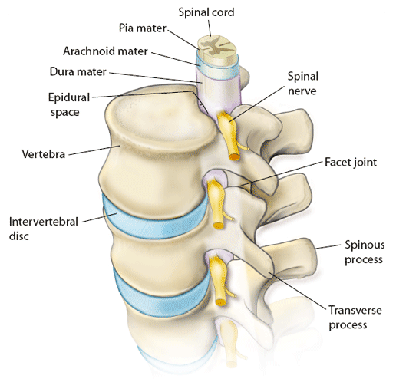
Figure A. The spinal column, cord and vertebrae.
(www.columbianeurosurgery.org/)

Each facet joint is a diarthrodial joint with a distinct joint capsule that encloses a joint space that can accommodate approximately 1-1.5cc of fluid (Glover 1977). Studies have demonstrated that facet joint capsules are innervated richly with encapsulated, unencapsulated, and free nerve endings (Cavanaugh et al. 1996, Inami et al. 2001, McLain 1994). Nerve endings containing both substance P and calcitonin gene related protein (CGRP) along with neuropeptide Y, have been found in the facet capsule, which indicates the presence of nociceptive afferent and sympathetic efferent fibers (Kallakuri et al. 2004). Substance P nerve fibers also have been found in the subchondral bone and intraarticular inclusion in degenerative spines (Beaman et al. 1993). It has been shown that the C6-C7 facet joint in the rat has cell bodies in the C7 DRG, and the majority of them are CGRP containing (Figure B) (Kras et al. 2013). Thus, that anatomic study suggested that peptidergic afferents in the C7 DRG play a major role in pain from the C6-C7 facet joint (Kras et al. 2013).

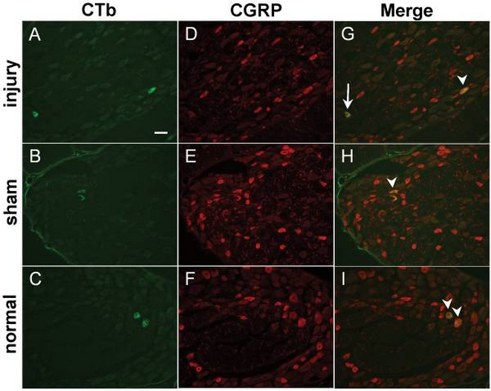
Figure B. CGRP labeled neurons in the C7 rat DRG in rats (Kras et al. 2013).

b) Cervical facet joint and pain
The cervical spine of the human vertebral column is a heterogeneous structure that consists of three distinct joints at each spinal level. The bilaterally located facet joints are involved in degenerative disorders such as facet arthrosis. In addition, these joints are implicated in spinal dysfunction secondary to traumatic events, such as low-speed rear end crushes (Aprill et al. 1990, Barnsley et al. 1994). In the particular case of vehicular-related injuries, commonly known as whiplash or whiplash-associated disorders, the mechanism of injury is attributed to sliding, stretching, and/or pinching of the facet joint during the early stage of the rear impact acceleration (Bogduk & Yoganandan 2001, Yoganandan & Pintar 2000).

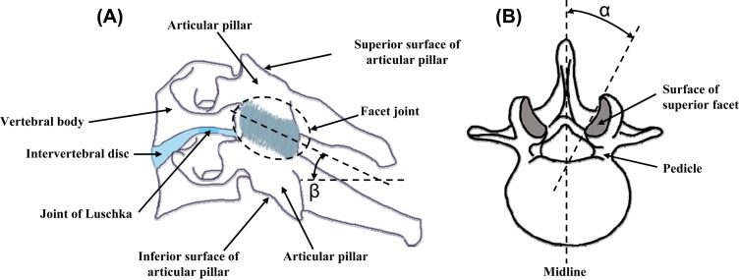
Figure C. Lateral view of the cervical spine (a) and axial view of a lumbar vertebra (b) showing the overall anatomy and the facet joints (Jaumard et al. 2011).

Whiplash-associated disorders are among the most common injuries associated with motor-vehicle accidents. In the United States, more than 59% of insurance claimants for motor-vehicle injury reported neck injuries in 1993 (Insurance Research Council 1999). Studies of the natural history of whiplash-associated disorders have suggested that chronic pain with continuous symptoms develops in 6% to 33% of acutely injured victims (Barnsley et al. 1994, Hildingsson & Toolanen 1990). The social cost of whiplash injury, including medical and legal expenses, is enormous, reaching as high as $29 billion annually in the United States alone (Freeman et al. 1999).

c) Lumbar facet joint and pain
Pain originating from the lumbar facet joints is a common cause of low back pain in the adult population (Strine & Hootman 2007). Chronic low back pain (LBP), defined as pain lasting more than 3 months, is the second most common reason for visits to a physician and the most common reason for missing work across all socioeconomic strata in the United States (Andersson 1999, Deyo & Weinstein 2001, Freburger et al. 2009). Chronic LBP occurs in 5% to 8% of community-dwelling persons (Cassidy et al. 1998, Elliot et al. 1999) and is reported in 19% of working adults (National Center for Statistics 2001). The total costs of the condition are estimated at more than $100 billion annually, with two-thirds of that due to decreased wages and productivity (Katz 2006).
Chronic LBP is known to be associated with degeneration of the spinal motion segment (Adams & Roughley 2006, Edgar 2007, Kallewaard et al. 2010). Degeneration is thought to initiate in the intervertebral disc with subsequent degeneration occurring in the facet joints (Adams & Roughley 2006). Although disc degeneration occurs frequently with aging and may be asymptomatic in many individuals, it can cause severe LBP in some cases (Adams & Roughley 2006, Andersson 1999, Cassidy et al. 1998, Devo & Weinstein 2001, Elliot et al. 1999, Freburger et al. 2009, Katz 2006, National Center for Statistics 2011).

2. Whole-body vibration and pain
Several epidemiological studies have linked exposure to whole body vibration (WBV) with neck and back pain (Boshuizen et al. 1992, Boshuizen et al. 1999, Bovenzi & Hulshof 1988, Nevin & Means 1999), suggesting that vibration can lead to the onset of both such pain syndromes. American male workers operating vibrating vehicles, such as industrial trucks and tractors, have been reported to have a higher prevalence of low back pain and are three-times more susceptible to acute herniated lumbar discs than workers whose occupations do not involve such exposures (Boshuizen et al. 1999, Kelsey & Hardy 1975).
A limited number of studies have defined the biomechanical response to vibration and related resonance and vibration frequency to physiological responses known to be involved in pain-related injuries. The resonant frequency of the seated human undergoing vertical vibration has been reported to be 4.5 Hz from a series of studies using accelerometers on the first and third lumbar vertebrae (L1, L3) and the sacrum of volunteers exposed to vertical vibrations, ranging in frequencies from 2 to 15 Hz (Mansfield & Griffin 2000, Panjabi et al. 1986).
The resonant frequency of the prone rabbit exposed to horizontal vibration between 2 and 8 Hz also was approximately 4.5 Hz (Weinstein et al. 1988). In contrast, the resonance of the seated primate in the vertical direction ranges from 9 to 15 Hz (Smith & Kazarian 1994). A repeated WBV exposure for 30 min of 15 Hz vibration at a magnitude of 0.56 g establishes pain (Baig et al. 2013). In addition to these biomechanical studies, studies have reported changes in pain-related neuropeptides and damage to arterial endothelial cells for WBV exposures ranging from 4.5 to 60 Hz (Curry et al. 2002, Weinstein et al. 1988). These studies provide evidence of important mechanical and physiological changes in tissues involved in WBV and suggest WBV as a putative mechanism for chronic pain.

3. Integrated stress response
The integrated stress response (ISR), also known as the endoplasmic reticulum (ER) stress response, is a common cellular response to disruption of homeostasis in injury or disease status (Dong et al. 2008, 2011, Lindl et al. 2007). ER is a dynamic network of interconnected membrane tubules that essentially reaches every part of the cell, including dendrites (Spacek & Harris 1997) and axons (Westrum & Gray 1986) in neurons (Figure D). The ER is associated with microtubules (Feiguin et al. 1994) and largely contributes to local calcium homeostasis and signaling, and protein and lipid biosynthesis. Thus, the ER may be one of the main organelles that sense the disruption of the axon and reacts by sending back information to the soma. Inflammation can lead to reactive oxygen species (ROS), which within the endoplasmic reticulum can initiate three different pathways; (1) double-stranded RNA-activated protein kinase (PKR)-like endoplasmic reticulum stress kinase (PERK) (Harding et al. 1999), (2) inositol-requiring enzyme 1 (IRE1a) (Wang et al. 1999), and (3) activating transcription factor 6 (ATF6) (Haze et al. 1999). Activation of the ISR culminates in increased expression of the ISR binding protein (BiP), which plays a major role in the repair of unfolded and misfolded proteins (Schröder & Kaufman 2005).
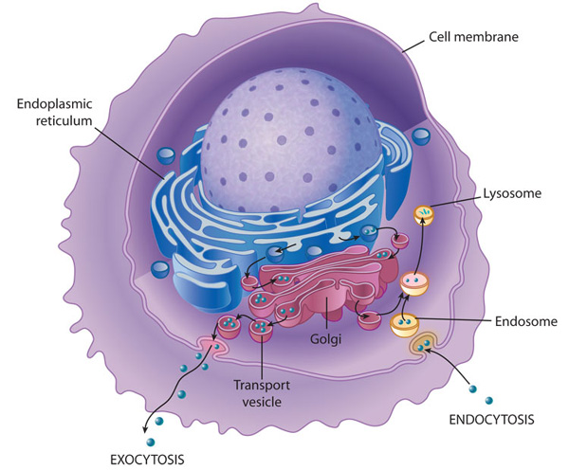
Figure D. The Structure of the endoplasmic reticulum (ER), (O'Connor & Adams , 2010).

Under unstressed conditions, BiP binds to the luminal domains of IRE1, PERK, and ATF6 to prevent their dimerization. With the accumulation of the unfolded proteins, BiP released from IRE1 permits dimerization to activate its kinase and RNase activities to initiate XBP1 mRNA splicing, thereby creating a potent transcriptional activator. BiP release from ATF6 permits transport to Golgi compartment where ATF6 is cleaved by SIP and S2P proteases to yield a cytosolic fragment that migrates to the nucleus to further activate transcription of unfolded protein response (UPR) -responsive genes (Chen et al. 2002). Finally, BiP release permits PERK dimerization and activation to phosphorylate eukaryotic initiation factor 2 alpha (eIF2 alpha), which leads to general attenuation of translational initiation. Through its phosphorylation of eIF2 alpha, PERK blocks the synthesis of new polypeptides, in this manner reducing the entry of nascent polypeptides into ER lumen. This allows the ER time to refold misfolded proteins and dispose that are terminally misfolded, important elements of the cells “unfolded protein response” (UPR), which seeks to restore ER homeostasis. eIF2 alpha is known to be phosphorylated by four different kinases, including double stranded RNA-activated PKR, PERK, GCN2, and HRI in response to a variety of stress stimuli. Phosphorylation of eIF2 alpha inhibits the dissociation of eIF2 alpha, thereby preventing the exchange of GDP for GTP and reducing the rate of ternary complex formation. This lowers the rate of protein synthesis and enhances he translation of mRNAs.
Interestingly, phosphorylation of eIF2 alpha favors translation of activating transcription factor 4 (ATF4) (Harding et al. 1999), which has been shown to promote apoptotic cell death via transactivation of C/EBP-homologous protein (CHOP) (Yamaguchi et al 2007).
Figure E. Schematic illustration of the integrated stress response (ISR), (Tanaka K et al. 2013).

4. Reactive oxygen species
Oxidative stress, cytotoxic effects of reactive oxygen species (ROS), is considered a prominent factor in many degenerative neurological conditions, such as Alzheimer disease, Parkinson disease, and other brain dysfunctions (Gerlach et al. 1994). ROS are oxygen containing chemicals, free radicals and non-radicals, such as oxidative phosphorylation and monoamine oxidase reaction (Gerlach et al. 1994). Under normal physiological conditions, production of ROS is balanced by several cellular antioxidant mechanisms (Jenner 1994). In certain conditions, levels of ROS rise to the point that may endanger the functional and structural integrity of cells, sometimes leading to irreversible damage (Jenner 1994). To counteract oxidative stress, cells have complicated mechanisms of defense against this toxicity, one of the most important mechanisms involves the activation of Nrf2 pathway (Kensler et al. 2007), which leads to the expression of cytoprotective enzymes, such as NAD(P)H: quinone oxidoreductase 1 (NQO-1) and heme oxygenase 1 (HO-1) (Figure E). Recent studies indicate that ROS are also involved in persistent pain (Kim et al. 2004). Also, increased production of ROS (Park et al. 2006) and enhanced antioxidant activity (Guedes et al. 2006) were observed in the spinal cord after a peripheral nerve injury. Increased levels of extracellular hydrogen peroxide were also observed in the spinal trigeminal nucleus after formalin injection into the lip of the rat, and this increase coincided with pain behaviors (Viggiano 2005). These studies suggest that higher levels of ROS and increased antioxidant activity in the spinal cord and brainstem after peripheral nerve injury or tissue inflammation may be important factors in persistent pain.

5. References
Adams MA, Roughley PJ. What is intervertebral disc degeneration, and what causes it? Spine 2006; 31:2151–2161.
Andersson GB. Epidemiological features of chronic low-back pain. Lancet 1999; 354:581–585.
Aprill C, Dwyer A, Bogduk N. Cervical zygapophyseal joint pain patterns II: A clinical evaluation. Spine 1990; 15:458–461.
Baig. HA, Guarino BG, Lipschutz D, Winkelstein BA Whole Body Vibration Induces Forepaw and Hind Paw Behavioral Sensitivity in the Rat. J Orthop Res 2013; 31:1739-1744.
Barnsley L, Lord S, Bogduk N. Clinical Review: Whiplash Injury. Pain 1994; 58:283–307.
Beaman DN, Graziano GP, Glover RA, et al. Substance P innervation of lumbar spine facet joints. Spine 1993; 18:1044Y9.
Bogduk N, Yoganandan N. Biomechanics of minor injuries to the cervical spine. Clin Biomechan 2001; 16:267–275.
Boshuizen HC, Bongers PM, Hulshof CT. Self-reported back pain in fork-lift truck and freight-container tractor drivers exposed to whole-body vibration. Spine 1992; 17:59–65.
Boshuizen HC, Bongers PM, Hulshof CT. Effect of whole body vibration on low back pain. Spine 1999; 24:2506–2515.

Bovenzi M, Hulshof CTJ. An updated review of epidemiologic studies on the relationship between exposure to whole-body vibration and low back pain (1986–1997). Int Arch Occup Environ Health 1988; 72:351–365.
Cassidy JD, Carroll LJ, Cote P. The Saskatchewan health and back pain survey. The prevalence of low back pain and related disability in Saskatchewan adults. Spine 1998; 23:1860–1866.
Cavanaugh JM, Ozaktay AC, Yamashita HT, King AI. Lumbar facet pain: biomechanics, neuroanatomy and neurophysiology. J Biomech 1996; 29:1117–1129.
Chen X, Shen J, Prywes R. The luminaldomain of ATF6 senses endoplasmic reticulum (ER) stress and causes translocation of ATF6 from the ER to the Golgi. J Biol Chem 2002; 277: 13045–13052.
Curry BD, Bain JLW, Riley DA. Vibration injury damages arterial endothelial cells. Muscle Nerve 2002; 25:527–534.
Deyo RA, Weinstein JN. Low back pain. N Engl J Med 2001; 344:363–370.
Dong L, Guarino BB, Jordan-Sciutto KL, Winkelstein BA. Activating transcription factor 4, a mediator of the integrated stress response, is increased in the dorsal root ganglia following painful facet joint distraction. Neuroscience 2011; 193: 377–386.
Dong L, Odeleye AO, Jordan-Sciutto KL, Winkelstein BA. Painful facet injury induces neuronal stress activation in the DRG: implications for cellular mechanisms of pain. Neurosci Lett 2008; 443:90–94.

Edgar MA. The nerve supply of the lumbar intervertebral disc. J Bone Joint Surg Br 2007; 89:1135–1139.
Elliott AM, Smith BH, Penny KI, Smith WC, Chambers WA. The epidemiology of chronic pain in the community. Lancet 1999; 354:1248–1252.
Feiguin F, Ferreira A, Kosik KS, Caceres A. Kinesin-mediated organelle translocation revealed by specific cellular manipulations. J Cell Biol 1994; 127:1021–1039.
Freburger JK, Holmes GM, Agans RP, et al. The rising prevalence of chronic low back pain. Arch Intern Med 2009; 169:251–258.
Freeman MD, Croft AC, Rossignol AM, Weaver DS, Reiser M. A review and methodologic critique of the literature refuting whiplash syndrome. Spine. 1999; 24:86-96.
Gerlach M, Ben Shachar D, Riederer P, Youdim MB. Altered brain metabolism of iron as a cause of neurodegenerative diseases? J Neurochem 1994; 63:793–807.

Glover JR. Arthrography of the joints of the lumbar vertebral arches. Orthop. Clin. North Am. 1977; 8:37Y42.
Guedes RP, Bosco LD, Teixeira CM, Arau´jo AS, Llesuy S, Bello´-Klein A, Ribeiro MF, Partata WA. Neuropathic pain modiﬁes antioxidant activity in rat spinal cord. Neurochem Res 2006; 31:603–609.

Harding HP, Zhang Y, Ron D. Protein translation and folding are coupled by an endoplasmic-reticulum-resident kinase Nature, 1999; 397:271–274.

Haze K, Yoshida H, Yanagi H, Yura T, Mori K. Mammalian transcription factor ATF6 is synthesized as a transmembrane protein and activated by proteolysis in response to endoplasmic reticulum stress Mol. Biol. Cell 1999; 10:3787–3799.

Hildingsson C, Toolanen G. Outcome after soft-tissue injury of the cervical spine. A prospective study of 93 car-accident victims. Acta Orthop Scand. 1990; 61:357-9.

Inami S, Shiga T, Tsujino A, Yabuki T, Okado N, Ochiai N. Immunohistochemical demonstration of nerve fibers in the synovial fold of the human cervical facet joint. J Orthop Res 2001: 19:593–596.
Insurance Research Council. Injuries in auto accidents: an analysis of auto insurance claims. Malvern, PA: Insurance Research Council; 1999.
Jaumard NV, Welch WC, Winkelstein BA. Spinal facet joint biomechanics and mechanotransduction in normal, injury and degenerative Conditions. Journal of Biomechanical Engineering 2011; 133(7): 071010.

Jenner P. Oxidative damage in neurodegenerative disease. Lancet. 1994; 344:796–798.

Kallakuri S, Singh A, Chen C, Cavanaugh JM. Demonstration of substance P, calcitonin gene-related peptide, and protein gene product 9.5 containing nerve fibers in human cervical facet joint capsules. Spine 2004; 29: 1182-1186.

Kallewaard JW, Terheggen MA, Groen GJ, et al. Discogenic low back pain. Pain Pract 2010; 10:560–579.

Katz JN. Lumbar disc disorders and low-back pain: socioeconomic factors and consequences. J Bone Joint
Surg Am 2006; 88(suppl 2):21–24.

Kelsey JL, Hardy RJ. Driving of motor vehicles as a risk factor for acute herniated lumbar intervertebral disc. Am J Epidemiol 1975; 102:63–73.

Kensler TW, Wakabayashi N, Biswal S, Cell survival responses to environmental stresses via the Keap1–Nrf2–ARE pathway, Annu. Rev. Pharmacol. Toxicol 2007; 47:89–116.

Kim HK, Park SK, Zhou JL, Taglialatela G, Chung K, Coggeshall RE, Chung JM. Reactive oxygen species (RoS) play an important role in a rat model of neuropathic pain. Pain 2004; 111(1-2):116-124.

Kras JV, Tanaka K, Gilliland TM, Winkelstein BA. Anatomical and immunohistochemical characterization of afferents innervating the C6–C7 facet joint after painful joint loading in the rat. Spine 2013; 38(6):E325-31.
Lindl KA, Akay C, Wang Y, White MG, Jordan-Sciutto KL. Expression of the endoplasmic reticulum stress response marker, BiP, in the central nervous system of HIV-positive individuals Neuropathol Appl Neurobiol. 2007 Dec; 33(6):658-69.

Mansfield NJ, Griffin MJ. Non-linearities in apparent mass and transmissibility during exposure to whole-body vertical vibration. J Biomech 2000; 33:933–941.
McLain RF. Mechanoreceptor endings in human cervical facet joints. Spine 1994; 19:495–501.
National Center for Health Statistics. http://www.cdc.gov/nchs/data/hus/hus05.pdf. Accessed November 5, 2011.
Nevin RL, Means GE. Pain and discomfort in deployed helicopter aviators wearing body armor. Aviat Space Environ Med 2009; 80:807–810.
O'Connor, C. M. & Adams, J. U. Essentials of Cell Biology. Cambridge, MA: NPG Education, 2010.
Panjabi MM, Andersson GJ, Jorenus L. In vivo measurements of spinal column vibrations. J Bone Joint Surg 1986; 68:695–702.
Park ES, Gao X, Chung JM, Chung K. Levels of mitochondrial reactive oxygen species increase in rat neuropathic spinal dorsal horn neurons. Neurosci Lett 2006; 391:108–111.

Schröder M, Kaufman RJ, ER stress and the unfolded protein response. Mutat Res, 2005; 569:29–63.

Smith SD, Kazarian LE. The effects of acceleration on the mechanical impedance response of a primate model exposed to sinusoidal vibration. Ann Biomed Eng 1994; 22:78–87.
Spacek J, Harris KM. Three-dimensional organization of smooth endoplasmic reticulum in hippocampal CA1 dendrites and dendritic spines of the immature and mature rat. J Neurosci 1997; 17: 190–203.
Strine TW, Hootman JM. US national prevalence and correlates of low back and neck pain among adults. Arthritis Rheum 2007; 57:656–65.

Tanaka K, Baig G, Guarino BB, Smith JR, Winkelstein BA, Jordan-Sciutto KL, Painful whole-body vibration is associated with decreased BiP expression in the lumber spinal cord. 2013 AAE Annual meeting.

Viggiano A, Monda M, Viggiano A, Viggiano D, Viggiano E, Chiefari M, et al. Trigeminal pain transmission requires reactive oxygen species production. Brain Res 2005; 1050:72–78.

Wang XZ, Harding HP, Zhang Y, Jolicoeur EM, Kuroda M Ron D. Cloning of mammalian Ire1 reveals diversity in the ER stress responses EMBO J 1998; 17:5708–5717.

Weinstein J, Pope M, Schmidt R, et al. Neuro- pharmacologic effects of vibration on the dorsal root ganglion. Spine 1988; 13:521–525.
Westrum LE, Gray EG. New observations on the substructure of the active zone of brain synapses and motor endplates. Proc R Soc Lond B Biol Sci 1986; 229: 29–38.
Yamauchi T, Sakurai M, Abe K, Matsumiya G, Sawa Y. Impact of the endoplasmic reticulum stress response in spinal cord after transient ischemia Brain Res, 2007; 1169:24–33.

Yoganandan N, Pintar FA, eds. Frontiers in Whiplash Trauma: Clinical & Biomechanical. The Netherlands: IOS Press; 2000.

Manuscript

Introduction

Facet joints are implicated as a major source of neck and low-back pain. Whiplash-associated disorders are among the most common injuries associated with motor-vehicle accidents. In the United States, more than 59% of insurance claimants for motor-vehicle injury reported neck injuries in 1993 (Insurance Research Council 1999). Studies of the natural history of whiplash-associated disorders have suggested that chronic pain with continuous symptoms develops in 6% to 33% of acutely injured individuals (Hildingsson & Toolanen 1990). The social cost of whiplash injury, including medical and legal expenses, is enormous, as high as $29 billion annually in the United States alone (Freeman et al. 1999).

Pain originating from the lumbar facet joints is a common cause of low back pain in the adult population. Chronic low back pain (LBP), defined as pain lasting more than 3 months, is the second most common reason for visits to a physician and the most common reason for missing work across all socioeconomic strata in the United States (Andersson 1999, Deyo & Weinstein 2001, Fregurger et al. 2009). Chronic LBP occurs in 5% to 8% of individuals (Cassidy 1998, Elliot et al. 1999) and is reported in 19% of working adults (National Center for Health Statistics 2001). The total costs of the condition are estimated at more than $100 billion annually, with two-thirds of those costs due to decreased wages and lost productivity (Katz 2006).

Whole-body vibration (WBV) has been linked to the development of chronic cervical and low-back pain. Yet, the mechanism of its development and the cellular cascades responsible for its maintenance remain poorly understood. One of the mechanisms may be dysfunction of the integrated stress response (ISR), also known as the endoplasmic reticulum (ER) stress response. This common cellular pathway responds to disruption of homeostasis in injury or disease status (Dong et al. 2008, Lindl et al. 2007). The ER is a dynamic network of interconnected membrane tubules that essentially reaches every part of the cell, including the dendrites (Spacek & Harris 1997) and axons (Feiguin et al. 1994) in neurons. The ER is associated with microtubules and largely contributes to local calcium homeostasis and signaling, as well as protein and lipid biosynthesis (Ron & Walter 2007). Thus, the ER may be one of the main organelles that sense the disruption of the injured axon and reacts by sending information back to the soma. Studies from Dong. et al. have demonstrated a correlation between the activation of the ISR and facet mediated pain in a rat model (Dong et al. 2008, 2011).

Although inflammation and cellular activation are known to be involved in pain, the role of the mediators of the integrated stress response in cells in the spinal cord following painful exposures has not been investigated. The purpose of this study was to evaluate changes in the major chaperone protein of the endoplasmic reticulum, BiP, in the spinal cord in association with pain after WBV using a novel model in the rat (Baig et al. 2013, Kartha et al. 2014).

Materials and Methods

All procedures used male Holtzman rats (275-325g), were IACUC-approved, and adhered to the guidelines for Research and Ethical Issues of the International association of Study for pain (IASP).

Whole-Body Vibration Exposure
Vibration exposure was performed under inhalation anesthesia (4% isoflurane for induction, 3.5% for the maintenance), according to previous published methods (Baig et al. 2013, Kartha et al. 2014).

Fig. 1. Schematic illustrating the timeline for WBV exposures (blue) and behavioral assessment (orange circles) at days 0, 1, 6, 7, 10, 14. Harvests were performed at day 1 and day 14 in separate groups of rats.

Whole-body vibration was applied daily for a period of 30 minutes on 7 consecutive days (Fig. 1). During each WBV exposure session, the rat was placed in a prone position and secured to a customized acrylic platform by Velcro straps (Fig. 2). The platform was rigidly fixed to a linear servomotor (MX80L; Parker Hannefin) that was programmed and controlled by a digital driver (VIX500IH; Parker Hannefin) to translate the platform through a full stroke distance of 1.5mm. A laser LVDT (LTC-050-10; MTI) also tracked the platform motion. Two miniature quartz shear accelerometers (ACC104A; Omega) were used to quantify accelerations of the moving plate and also embedded in a Velcro strap that secured the rat to the plate near the lower thoracic and upper lumber spines (Fig. 2).
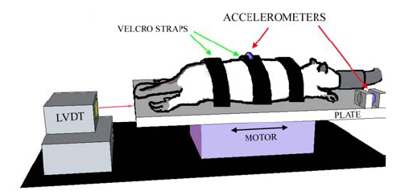
Fig. 2. Schematic of WBV device, indicating the set-up and instrumentation.

Behavioral Assessment
Behavioral sensitivity was assessed by measuring mechanical hyperalgesia in both the forepaws and hind paws during the study period. Hyperalgesia was measured prior to (day 0) the first day of WBV exposure and daily on the morning following the prior day’s WBV session (Fig. 1). For each session, the plantar surface of each paw was stimulated with a range of von Frey filaments (0.4-26g) using customary methods. The average threshold was taken as the threshold for each paw, day, and group. Response thresholds were also measured for an additional 7 days after the cessation of the WBV exposure. A repeated-measures ANOVA with post hoc Bonferroni compared response thresholds between WBV and sham control groups over time.

Treatment | Day 14 Lumbar | Day 1 Cervical | Day 1 Lumbar
WBV | N=4 | N=4 | N=4
Sham | N=4 | N=4 | N=4
Table 1. Sample size of each group of animals.

Western Blot Analysis
Spinal cord tissue was harvested on day 1 and 14 to quantify BiP expression using Western blot analysis (Table 1). The cervical and lumber enlargements were separately isolated and whole protein lysates obtained. Total protein concentration of the lysates was determined using a BCA protein assay reagent kit (Pierce Biotechnology). Protein (1.35μg/μl in 37μl) was loaded into each lane of a 4-12% Bis-Trisgel for separation. A broad-range molecular weight ladder was also run on each gel to identify the approximate size of the molecule. Subsequent to separation, proteins were transferred onto a PVDF membrane and blocked in TBS with 1% Tween-20 (TBS-T) and 5% non-fat milk for 2hrs at room temperature. The membrane was incubated at 4℃ overnight with mouse monoclonal antibody to BiP (1:1000; BD BioSciences) in TBS-T, followed by goat anti-mouse antibody (1:15,000; LI-COR). The membrane was imaged and analyzed by the Odyssey infrared fluorescence detector system (LI-COR) to quantify the expression level of BiP. BiP expression for each sample was normalized by Beta-tubulin (1:1000; Convance) levels and compared between WBV and Sham groups using separate t-test for each of cervical and lumbar spinal cord segments.

Results

Behavioral Sensitivity

To determine if WBV induced behavioral sensitivity, mechanical hyperalgesia was measured using the paw withdrawal threshold. WBV induced an immediate decrease in paw withdrawal threshold in both the forepaw and hind paw starting on day 1, that was sustained for 7 days after the cessation of the WBV exposure (Fig. 3 & 4). The response threshold was significantly reduced in forepaw on day1 (p=0.001), Day 14 (P=0.01), and hind paw on day 1 and 14 (p=0.01).

painful
Fig. 3. Average withdrawal thresholds in WBV and Sham groups in the forepaw. *=WBV significantly lower than Sham (p=0.001) on day 1. **= WBV significantly lower than Sham (p=0.01) on day 14.

Fig. 4. Average withdrawal thresholds in the WBV and Sham groups in the hind paw. *= WBV significant lower than Sham on day 1 and day 14 (p=0.01).

Western Blot Analysis

We hypothesized that neuronal cells in the spinal cord would be under endoplasmic reticulum stress following WBV. To measure this, the levels of the ISR marker, BiP, in protein extracts from lumbar spinal cords in WBV treated rats at day 14 was measured and compared with levels in sham control rats at that same time. BiP expression levels were assessed by immunoblot of protein lysates extracted from the spinal cord (Fig. 5). We found that there was no significant difference in BiP between sham and WBV-treated rats at day 14 by immunoblot (Figs. 5 & 6).
In order to assess the ER stress at an earlier stage in this model, we investigated the level of BiP, as well as the PERK target, phospho-eiF2 alpha (peIF2-alpha) at day 1 in the cervical spinal cords of rats exposed to WBV compared with sham. At this time point we did not see changes in BiP levels (Fig. 7). Phosphorylation and expression levels of normalized peIF2-alpha, eIF2-alpha, and BiP were compared in cervical tissue at day 1, with phosphorylation level in the WBV group significantly lower (p=0.04) than control sham group (Fig. 8). Normalized expression of peIF2-alpha (p=0.01), eIF2-alpha (p=0.02) were also significantly lower, while BiP levels (p=0.06) were not significantly different in the WBV group than in the sham control group.

Membrane 1:
WBV----------- | Sham --------|
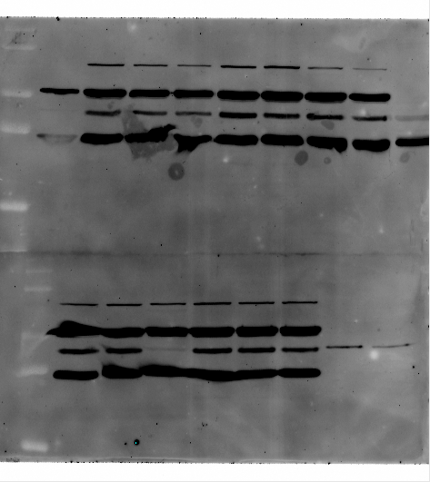 BiP
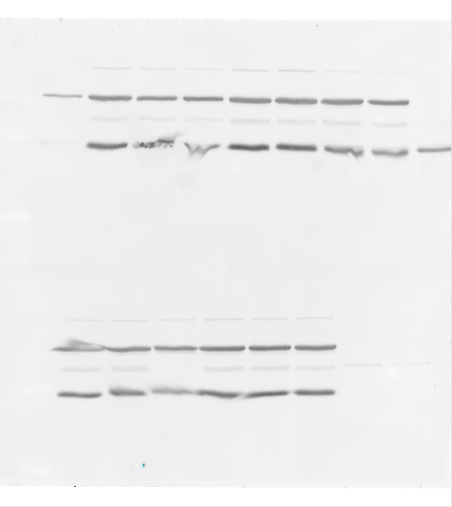 β-III tubulin
GAPDH

Membrane 2:
WBV-------| Sham ---------------|
BiP
β-III tubulin
GAPDH

Fig. 5 Immunoblot of BiP, β-lll tubulin, GAPDH.

Fig. 6 Normalized BiP levels in the WBV and sham groups at day 14.

|WBV----|Sham----| |WBV----|Sham---|
BiP
peIF2alfa
eIF2alpha

Fig. 7. BiP expression normalized by Beta Tubulin (*p=0.06).

Fig. 8. Phosphorylation level (*p=0.04), and the expression level of normalized peIFa-alpha, eIF2-alpha, and BiP.

WBV-----| Sham----| |WBV-----| Sham---|
BiP
peIF2alfa
eIF2alpha

Fig. 9. BiP expression normalized by Beta Tubulin in the lumbar spinal cord (p=0.16)

Fig. 10. Phosphorylation level, and the expression level of normalized peIF2-alpha, eIF2-alfa, and BiP.

Another site of injury may be the lumbar spinal cord where we also assessed activation of ER stress using the same makers, peIF2 alpha, eIF2 alpha, and BiP (Figs. 9 & 10). Phosphorylation and expression levels of normalized peIF2-alpha, eIF2-alpha, and BiP were compared in lumbar tissue. There was no significant changes in phosphorylation level (p=0.1), or the normalized expression of peIF2-alpha (p=0.15) and eIF2-alpha (p=0.29) (Fig. 10). BiP expression level was also unchanged (p=0.16) (Fig. 10).

Discussion

This study demonstrates that a single exposure of whole body vibration is sufficient to induce an immediate behavioral sensitivity in both the forepaws and hind paws (Figs. 3 & 4). In this study, however, there was no significant difference in the expression level of BiP in either of the cervical or lumbar spinal cords following WBV at either day 1 or day 14 (Figs. 7 & 9). In a previous study, an increase in neuronal BiP expression in the DRG was demonstrated seven days after a painful joint distraction (Dong et al. 2008, 2011). Extending those studies to examine BiP changes in the spinal cord showed that the effects of this model on BiP expression appeared to be limited to the DRG.
In order to analyze BiP expression at the earlier stage of injury, we investigated the BiP expression at day 1 (Figs. 7 & 9). However, we detected no significant differences in either the cervical or the lumbar spinal cords (Figs. 7 & 9). In order to estimate the ideal sample size, power analysis calculation was performed, indicating that a sample size of 8 rats is needed for each group in order to test statistically significant difference. This analysis indicates the need for larger sample sizes for cervical tissues of day 1. Interestingly, using this same model, our group has found out that BiP expression is increased in the DRG at day 1 following the WBV (Fig. 11).
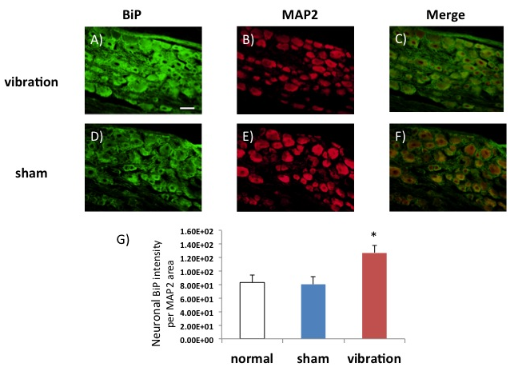Fig. 11. BiP (green) expression in neurons (red; MAP2) of cervical DRG. BiP expression was increased at day 1 after whole-body vibration (A-C) compared to sham (D-F). Red and green colocalize to yellow. (H) Quantification of neuronal BiP intensity normalized to MAP2 area shows significant (* p<0.01) increase of BiP in vibration group compared to sham and normal group. Scale bar (50μm) applies to all panels. Taken from thesis of Gharbi N. 2013.

Western blot analysis uses tissue homogenates, which does not enable profiling specific cell types within the tissue. So, it must be determined what the distribution of BiP in a spinal cord is by region and by cell type, as well as in comparisons between DRG and spinal cords responses. Additional studies are needed for that work. To further investigate the correlation of the behavioral sensitivity and normalized BiP expression as well as the individual difference in perceiving pain, the BiP expression of each rat in the cervical and lumbar cord was compared to withdrawal threshold (Figs. 12 & 13). There is a trend in the WBV group in lumbar at day 14 (Fig. 12-1) and WBV group in lumbar at Day 1 (Fig. 12-3), however, there is no trend in the cervical and lumbar cord at day 1(Fig. 12-1), BiP expression in the animals at day 1 was scattered in cervical and lumbar spines.

Fig. 12-1. Correlation of normalized BiP expression and withdrawal threshold (Day 14 Lumbar).

Fig. 12-2. Correlation of normalized BiP expression and withdrawal threshold (Day 1 Cervical).

Fig. 12-3. Correlation of normalized BiP expression and withdrawal threshold (Day 14 Lumbar).

Fig. 13. Comparison of both cervical and lumbar BiP expression in each of the rats in this study.

Under ER stress conditions, BiP binds to unfolded proteins and activates the ER stress response. While activation of IRE1 activates the endonuclease domains that cleave X box DNA-binding protein (XBP) mRNA and generates an activated form of XBP1, PERK activation results in phosphorylation of the eIF2 alpha and inhibits translation initiation. Therefore, to analyze the pathways upstream of BiP expression, we investigated the phosphorylation of eIF2-alpha. There were no significant differences in phosphorylation of eIF2-alpha between WBV and sham controls in lumbar cord, but spinal express was significantly lower in the WBV group in cervical. After exposure to ER stress, the pathway activated most rapidly is translational repression mediated by PERK. Because eIF2 alpha is a direct substrate of PERK, its phosphorylation does not depend on nuclear translocation. Consequently, the inhibition of protein synthesis occurs very rapidly following exposure to ER stress. For example, eIF2 alpha phosphorylation and translational repression are complete as soon as 30 minutes after exposure to stress (Novoa et al. 2003). Considering this immediate ER stress response, day 1 may be too late with respect to the peak of the phosphorylation. Additional studies are needed to determine that definitionally.
Phosphorylation of eIF2 alpha plays an important role in the inhibition of translation initiation induced in cells exposed to different stressful conditions including heme depletion in reticulocytes (Chen 2000, Ochoa 1983,), viral infection (Kaufman 2000), exposure to arsenite (McEwen et al. 2005), and ischemic reperfusion (Burda et al. 1994, DeGarcia et al. 1996, Martin de la Vega et al. 2001). Under these circumstances, four specific eIF2 kinases are responsible for eIF2 alpha phosphorylation and integrate the diverse stress signals into a common pathway (de Haro et al. 1996, Shi et al. 1998, Wu & Kaufman 1997). Compelling evidence indicates that PP1 contributes to the cellular recovery from stress by acting as an eIF2a phosphatase (Brush et al. 2003, Novoa et al. 2001). PP1 was first identified as an eIF2a phosphatase in reticulocyte lysates (Ernst et al. 1982) and has in fact been established as the physiological eIF2a phosphatase (Brush et al. 2003, Novoa et al. 2001). Three PP1 regulators, Inhibitor-1 (I-1), GADD34 (growth arrest and DNA-damage-inducible protein 34) and CReP (constitutive repressor of eIF2a phosphorylation), have been implicated in targeting PP1c to eIF2, thereby regulating the eIF2a-phosphorylation state (Connor et al. 2001, Hemmings et al. 1984, Jousse et al. 2003, Kojima et al. 2003, Marciniak & Ron 2006, Novoa et al. 2001).
Following an episode of cerebral ischemia, translation initiation is strongly inhibited upon reperfusion. Phosphorylation of eIF2 alpha, which occurs rapidly at early reperfusion, is the main mechanism responsible for reperfusion-induced translational repression (Burda et al. 1994, DeGarcia et al. 1996). It has been reported that phosphorylation of eIF2 alpha occurs rapidly during the first minutes of post-ischemic reperfusion after an episode of cerebral ischemia, and the highest level of phosphorylation was after 30 minutes of perfusion, and decreased significantly after 4 hours (Garcia et al. 2007). Taking those studies together, it can be hypothesized that there might have been such a dynamic phosphorylation at the earlier stage before day 1. It has also to be considered that the different result of this study from previous study (Fig. 11) may be due to the difference of anatomical location (Figure A). The DRG, lying along the vertebral column surrounded by fibrous tissue, may receive a large magnitude of tissue injury compare to spinal cord that is enclosed by vertebrae. Thus, it is not surprising that the ISR is only present in DRG, and not contributing to the onset of the sustained behavioral sensitivity.
Further study, specifically investigating the other transmembrane proteins, such as IRE1 and ATF6 are needed to confirm possible upstream BiP activities. Also, by determining the distribution of BiP and peIF2-alfa in both the DRG and the neuronal cells in spinal cord including at earlier time points than day 1 will give us a better understanding of ISR in WBV injury model.

Conclusions

The present study demonstrates that painful whole body vibration induces an increased behavioral sensitivity that is sustained even 7 days after the cessation of the vibration. Despite this, BiP expression was not changed in the lumbar at Day 1 or day 14, while phosphorylation of eIF2 alpha in the cervical spinal cord at day 1 is significantly lower than that of lumbar spinal cord. This finding warrants further investigation given that behavioral sensitivity remains until day 14.

References

Andersson GB. Epidemiological features of chronic low-back pain. Lancet 1999; 354:581–5.
Baig HA, Guarino BB, Lipschutz DE, Winkelstein BA. Whole body vibration induces forepaw and hind paw behavioral hypersensitivity in the rat. Journal of Orthopedic Research. 2013; 31(11):1739-1744.

Burda J, Martin M E, Garc ́ıa A, Alca ́zar A, Fando J Land Salinas M Phosphorylation of the a subunit of initiation factor 2 correlates with the inhibition of translation following transient cerebral ischaemia in the rat. Biochem. J. 1994; 302, 335–338.
Cassidy JD, Carroll LJ, Cote P. The Saskatchewan health and back pain survey. The prevalence of low back pain and related disability in Saskatchewan adults. Spine 1998; 23:1860–6.

Chen J-J Heme-regulated eIF2a kinase, in Translational control of gene expression (Mathews M. B., ed.), 2000, pp. 529–546. Cold Spring Harbor Laboratory Press, New York.
DeGracia DJ, Neumar RW, White BC and Krause GS. Global brain ischemia and reperfusion: Modifications in eukaryotic initiation factors associated with inhibition of translation initiation. J. Neurochem. 1996; 67, 2005–2012.
de Haro C., Me ́ndez R. and Santoyo J. The eIF-2a kinases and the control of protein synthesis. FASEB J. 1996; 10, 1378–1387.
Deyo RA, Weinstein JN. Low back pain. N Engl J Med 2001; 344:363–70.
Dong L, Odeleye AO, Jordan-Sciutto KL, Winkelstein BA. Painful facet joint injury induces neuronal stress activation in the DRG: implications for cellular mechanisms of pain. Neurosci Lett. 2008 Oct 3; 443(2): 90-94.

Dong L, Guarino BB, Jordan-Sciutto KL, et al. Activating transcription factor 4, a mediator of the integrated stress response, is increased in the dorsal root ganglia following painful facet joint distraction. Neuroscience 2011; 193: 377–386.
Elliott AM, Smith BH, Penny KI, et al. The epidemiology of chronic pain in the community. Lancet 1999; 354:1248–52.
Feiguin F, Ferreira A, Kosik KS, Caceres A. Kinesin-mediated organelle translocation revealed by specific cellular manipulations. J Cell Biol 1994; 127: 1021–1039.

Freburger JK, Holmes GM, Agans RP et al. The rising prevalence of chronic low back pain. Arch Intern Med 2009; 169:251–8.
Freeman MD, Croft AC, Rossignol AM, Weaver DS, Reiser M. A review and methodologic critique of the literature refuting whiplash syndrome. Spine. 1999; 24:86-96.

Gharbi N, Painful whole-body vibration is associated with increased expression of binding protein (BiP) in dorsal root ganglion neurons. 2013.
Hemmings Jr H. C., Greengard P., Tung H. Y. and Cohen P. DARPP-32, a dopamine-regulated neuronal phosphoprotein, is a potent inhibitor of protein phosphatase-1. Nature 1984; 310:503–505.
Hildingsson C, Toolanen G. Outcome after soft-tissue injury of the cervical spine. A prospective study of 93 car-accident victims. Acta Orthop Scand. 1990; 61:357-9.

Insurance Research Council. Injuries in auto accidents: an analysis of auto insurance claims. Malvern, PA: Insurance Research Council; 1999.

Katz JN. Lumbar disc disorders and low-back pain: socioeconomic factors and consequences. J Bone Joint Surg Am 2006; 88(suppl 2):21–4.

Kartha S, Zeeman ME, Baig HA, Guarino BB, Winkelstein BA. Upregulation of BDNF & NGF in cervical intervertebral discs exposed to painful whole body vibration. Spine 2014; Jun 11.

Kaufman R J, The double-stranded RNA-activated protein kinase PKR, in Translational control of gene expression (Mathews M. B., ed.) 2000, pp. 503–527. Cold Spring Harbor Laboratory Press, New York.

Lidia Garc ́ıa-Bonilla, Cristina Cid, Alberto Alca ́zar, Jozef Burda, à Irene Ayuso, Matilde Salinas. Regulatory proteins of eukaryotic initiation factor 2-alpha subunit (eIF2a) phosphatase, under ischemic reperfusion and tolerance. J. Neurochem. 2007; 103:1368-1380.
McEwen E, Kedersha N, Song B, Scheuner D, Gilks N, Han A, Chen JJ, Anderson P, Kaufman RJ. Heme-regulated inhibitor kinase-mediated phosphorylation of eukaryotic translation initiation factor 2 inhibits translation, induces stress granule formation, and mediates survival upon arsenite exposure. J. Biol. Chem. 2005; 280:16925–16933.
Marciniak S. J. and Ron D. Endoplasmic reticulum stress sig- naling in disease. Physiol. Rev. 2006; 86:1133–1146.
National Center for Health Statistics. http://www.cdc.gov/nchs/data/hus/hus05.pdf. Accessed November 5, 2011.
Novoa I et al. Stress-induced gene expression requires programmed recovery from translational repression. EMBO J. 2003; 22:1180–1187.
Ochoa S. Regulation of protein synthesis initiation in eukaryotes. Arch. Biochem. Biophys. 1983; 223:325–349.
Ron D, Walter P. Signal integration in the endoplasmic reticulum unfolded protein response. Nat Rev Mol Cell Biol 2007; 8:519–529.

Shi Y, Vattem KM, Sood R, An J, Liang J, Stramm L, Wek RC. Identification and characterization of pancreatic eukaryotic initiation factor 2 a-subunit kinase, PEK, involved in translational control. Mol. Cell. Biol 1998; 18:7499–7509.

Spacek J, Harris KM. Three-dimensional organization of smooth endoplasmic reticulum in hippocampal CA1 dendrites and dendritic spines of the immature and mature rat. J Neurosci 1997; 17: 190–203.
Wu S, Kaufman R. J. A model for the double-stranded RNA (dsRNA)-dependent dimerization and activation of the dsRNA-activated protein kinase PKR. J. Biol. Chem. 1997; 272:1291–1296.

