Supplementary Information

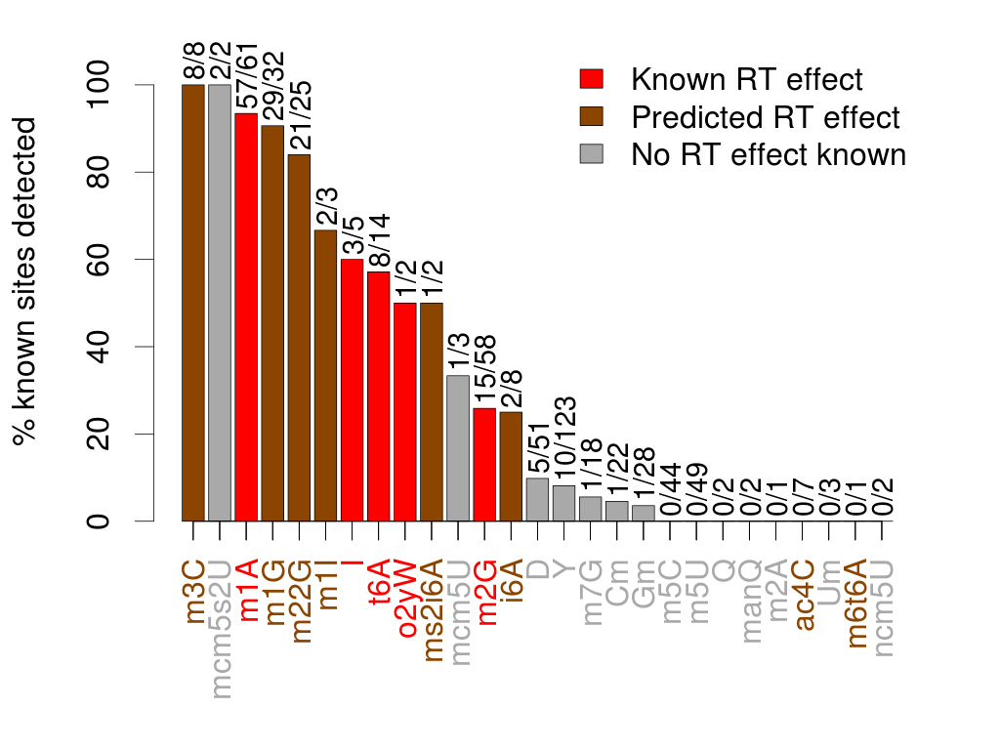

Supplementary Figure 1: Sensitivity for known modified sites in H. sapiens using H₀¹ . Under this null hypothesis SNP-like mismatch patterns are allowed, therefore the A>G pattern associated with inosines results in their inclusion as true positives.

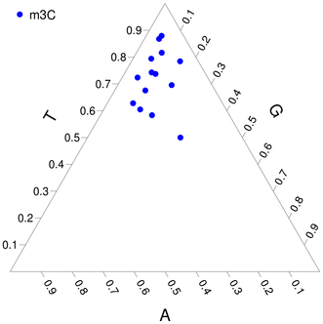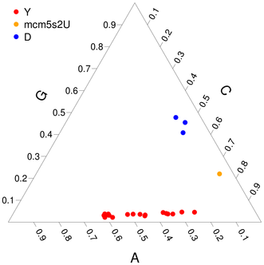

Supplementary Figure 2: Nucleotide patterns at modified cytidines and uridines in H. sapiens using H₀². m3C (3-methylcytidine) is the only cytidine modification that was detected using this null hypothesis. D (dihydrouridine) and Y (pseudouridine) are not predicted to affect RT incorporation in this experiment, yet they show low levels of mismatches nonetheless.

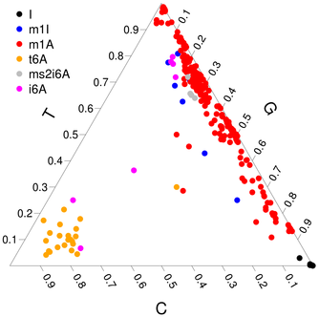

Supplementary Figure 3: Nucleotide patterns at modified adenosines in H. sapiens using H₀¹ . Under this null hypothesis SNP-like mismatch patterns are allowed. The A>G mismatch pattern for inosine (I) is apparent in the lower right corner.

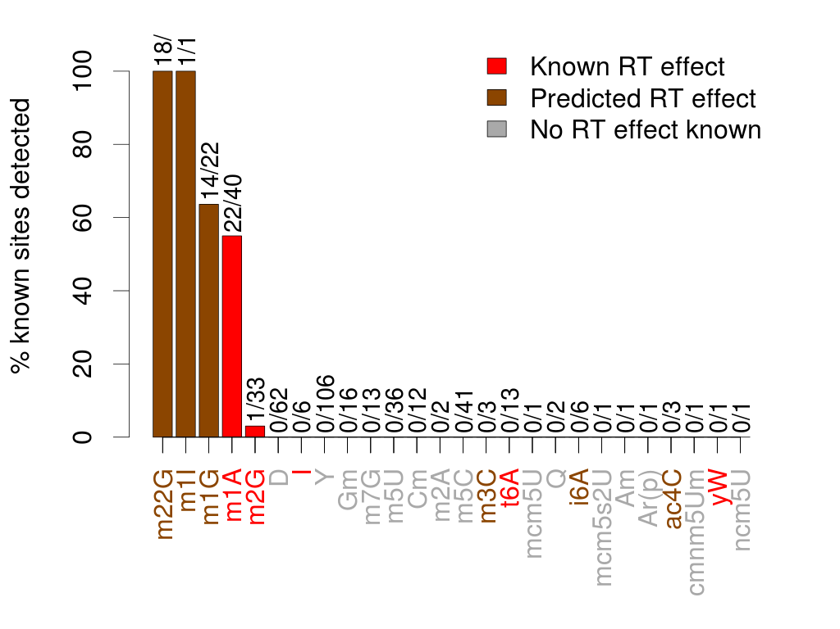

Supplementary Figure 4: Sensitivity for known modified sites in S. cerevisiae using H₀²

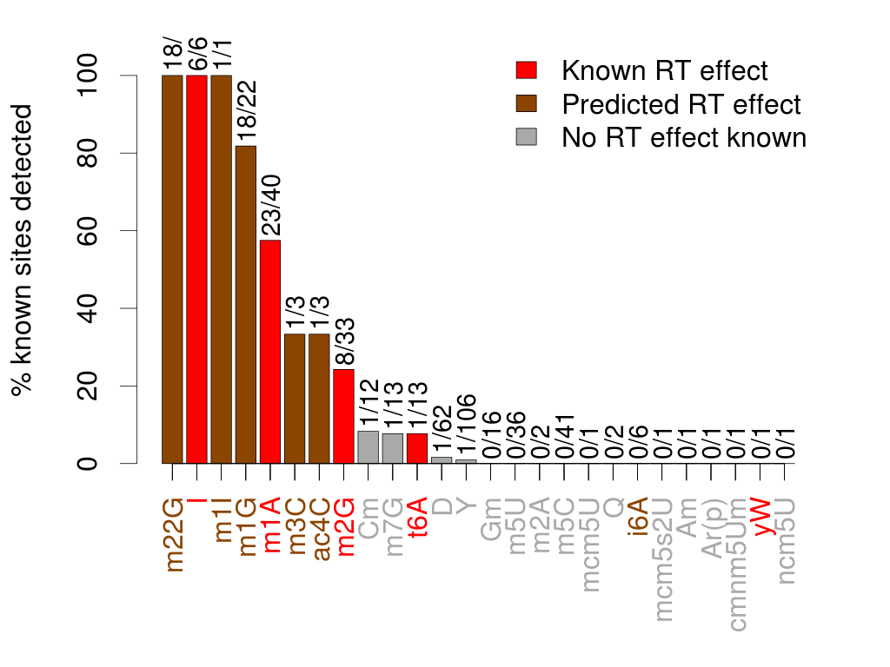

Supplementary Figure 5: Sensitivity for known modified sites in S. cerevisiae using H₀¹

