Supplemental Materials

Ex vivo recapitulation of trauma-induced coagulopathy and preliminary assessment of trauma patient platelet function under flow using microfluidic technology

Ruizhi Li¹, Hanna Elmongy¹, Carrie Sims², Scott L. Diamond¹
¹Institute for Medicine and Engineering

¹Department of Chemical and Biomolecular Engineering
1024 Vagelos Research Laboratories
University of Pennsylvania
Philadelphia, PA 19104, USA

²The Trauma Center at Penn
3400 Spruce Street, 2 Dulles
Philadelphia, PA 19104

Supplement: Figures S1-S8
Supplementary Materials and Methods

Blood collection
Whole blood was collected from healthy donors either into 100 μM PPACK or into an empty BD syringe. 1 mL of whole blood from the empty syringe was then aliquoted into four separate tubes containing 10 μL PPACK at 1, 2, 3, and 4 min after the initial blood draw to mimic phlebotomy collection methods in the HUP trauma and resuscitation bay.

Validation by flow cytometry that minor delays in anticoagulation do not affect platelet activation
All fluorescent antibodies were purchased from BD Biosciences. Each well of a flat-bottom 96 well plate (Corning, Corning, NY, USA) was loaded with 72 μL HBS, 2 μL of Cy5 annexin V, 2 μL PE anti-CD62P, and 4 μL FITC PAC-1. Each row received 10 μL of 1:10 diluted whole blood inhibited at 0, 1, 2, 3, 4 min post-phlebotomy. ADP and collagen (final concentration 50 μM and 100 nM respectively) were selected as agonists to stimulate platelet activation. Ten minutes prior to flow cytometry analysis, 10 μL of a 10X stock of the appropriate agonist or HBS was added, giving a final volume of 100 μL. Accuri C6 flow cytometer with CSampler was used for plate handling. The sample flow rate was set to slow, and samples were analyzed for 1 min following the 10 minute incubation with agonist(s).

Validation of thrombin inhibition by 100 µM PPACK in whole blood anticoagulated up to 4 min after initial phlebotomy
Fluorogenic thrombin substrate Boc-Val-Pro-Arg-methylcoumarinamide (Boc-VPR-MCA) was obtained from Bachem (King of Prussia, PA). Boc-VPR-MCA diluted in HBS was added to each well in a 384 well plate (Corning). Whole blood inhibited with 100 µM PPACK at 0, 1, 2, 3, 4 min post-phlebotomy was diluted in HBS. Diluted whole blood was added simultaneously to each row of substrate to ensure a simultaneous detection of thrombin activity yielding a final concentration of 9 μM Boc-VPR-MCA and 20% whole blood. A fluoroskan (Fluoroskan Ascent, Thermo Scientific, Waltham, MA) detected the fluorescence of the released aminomethylcoumarin (AMC) reporter group. Each well was read twice per minute for 45 min. Fractional conversion of the fluorogenic substrate was determined according to:
$$C=\frac{F-F_{min}}{F_{max}-F_{min}}$$
where C is the fractional conversion, F is the instantaneous fluorescence at any time, F_{min} is the minimum fluorescence for that well, and F_{max} was set to be 600 from stimulation with 5 U thrombin/well as previously established (Chatterjee et al. 2010).

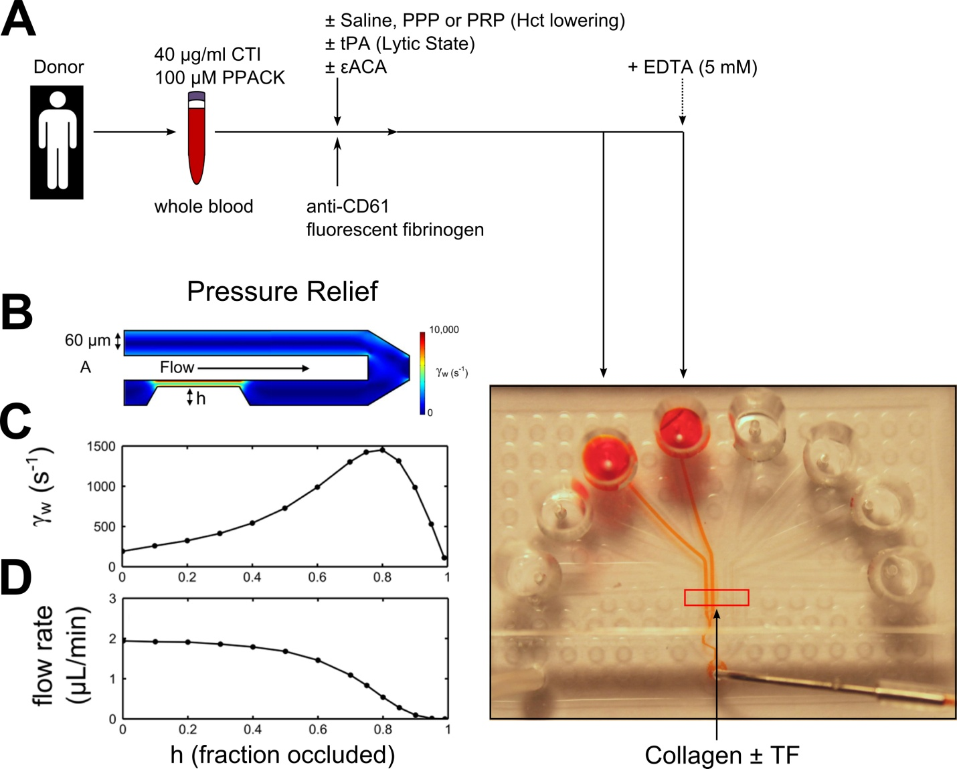

Supplemental Figure 1. Ex vivo protocol to mimic resuscitation-induced hemodilution and hyperfibrinolysis in the 8-channel microfluidic device under pressure relief mode.
(A), WB is inhibited with 40 µg/ml CTI or 100 µM PPACK and diluted with saline, PPP or PRP to mimic Hct lowering. To promote a 'lytic state' exogenous tPA (0-50 nM) was added to whole blood. (B), Flow through a cross section of a pair of microfluidic channels was previously modeled using COMSOL. The growing clot with variable height was represented by a trapezoidal shape in a single channel (2). Pressure relief mode was recreated by setting the flow rate at the outlet to 4 µl/min. (C), Shear rate calculated at the wall in the center of the model clot (2). (D), Flow rate calculated at the wall in center of the model clot (2).

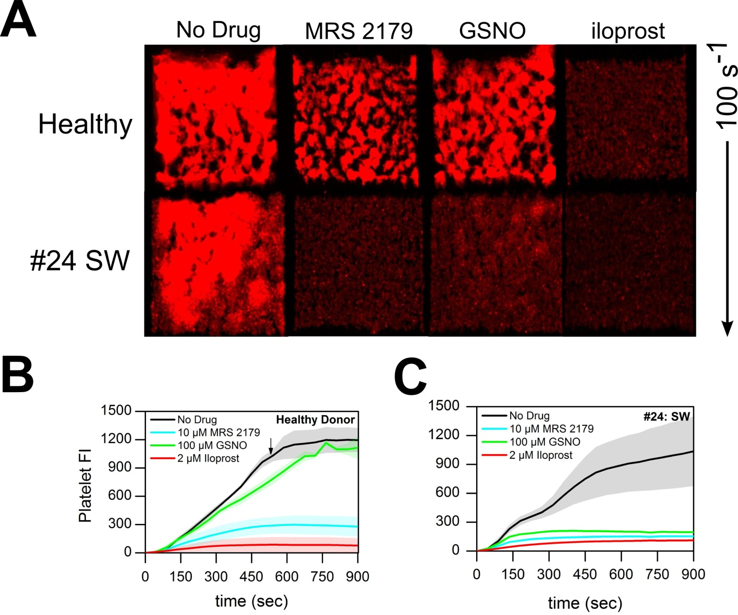
Supplemental Figure S2. Platelet accumulation dynamics & final platelet accumulation at 900 sec in representative healthy donor and trauma patient (#24) in response of ex vivo MRS 2179, GSNO, or iloprost. (A), Total platelet accumulation at 900 sec following ex vivo treatment with antagonists MRS 2179, GSNO, or iloprost. (B), Platelet fluorescence dynamics in representative healthy donor in the presence of indicated concentrations of ex vivo MRS 2179, GSNO, or iloprost. (C), Platelet fluorescence dynamics in trauma patient (#24) in the presence of indicated concentrations of ex vivo MRS 2179, GSNO, or iloprost. Shaded traces are the mean and standard deviation of 4 clotting events from each healthy donor or patient.

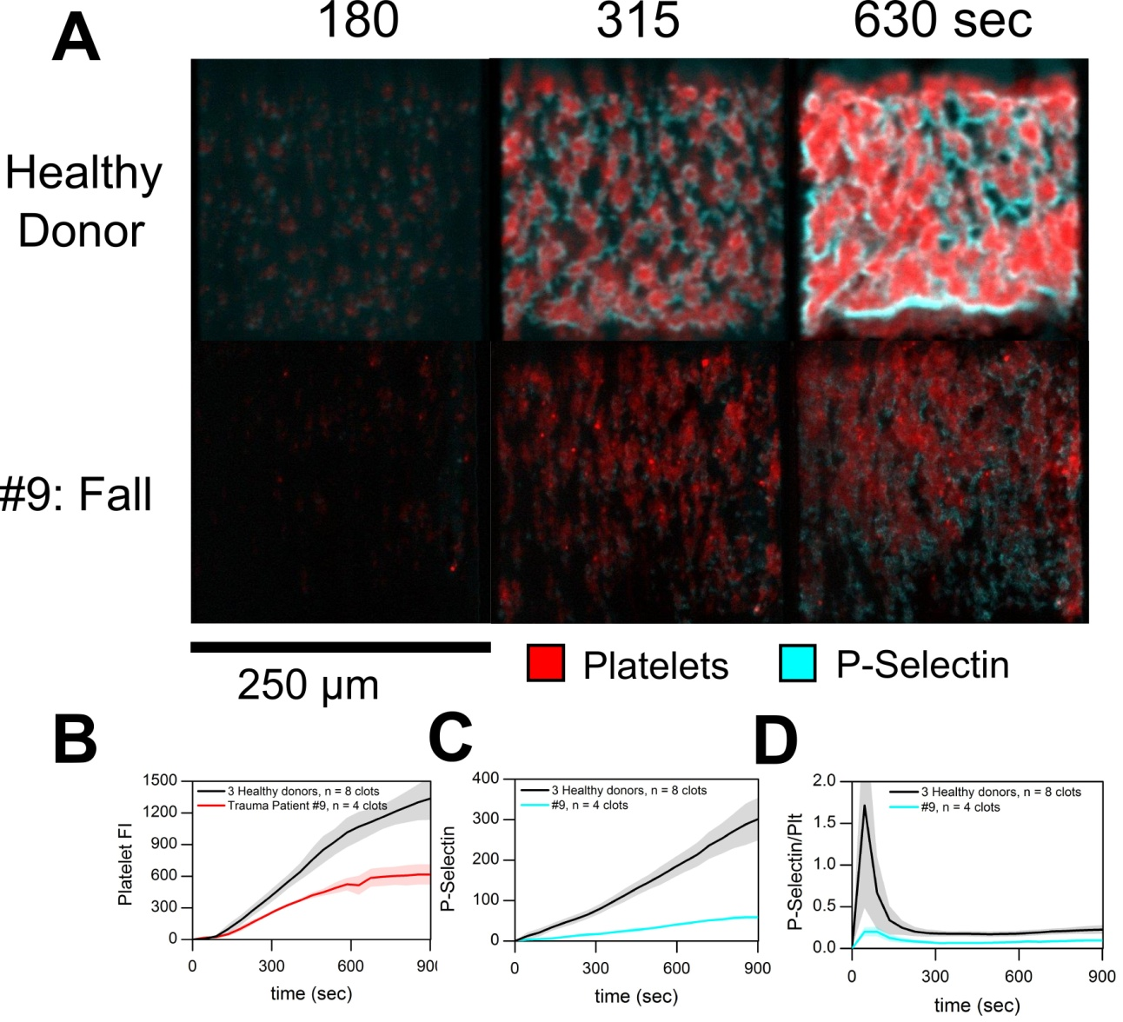
Supplemental Figure S3. Dynamic p-selectin expression and platelet accumulation in representative healthy donor and trauma patient (9). (A), Overlay of platelet deposition (red) and p-selectin expression (aqua) over the time course of the flow assay. (B), Platelet fluorescence and p-selectin expression dynamics over time in three healthy donors in comparison to a trauma patient (#9). Shaded traces are the mean and standard deviation of a minimum of 4 clotting evens from each donor or patient.

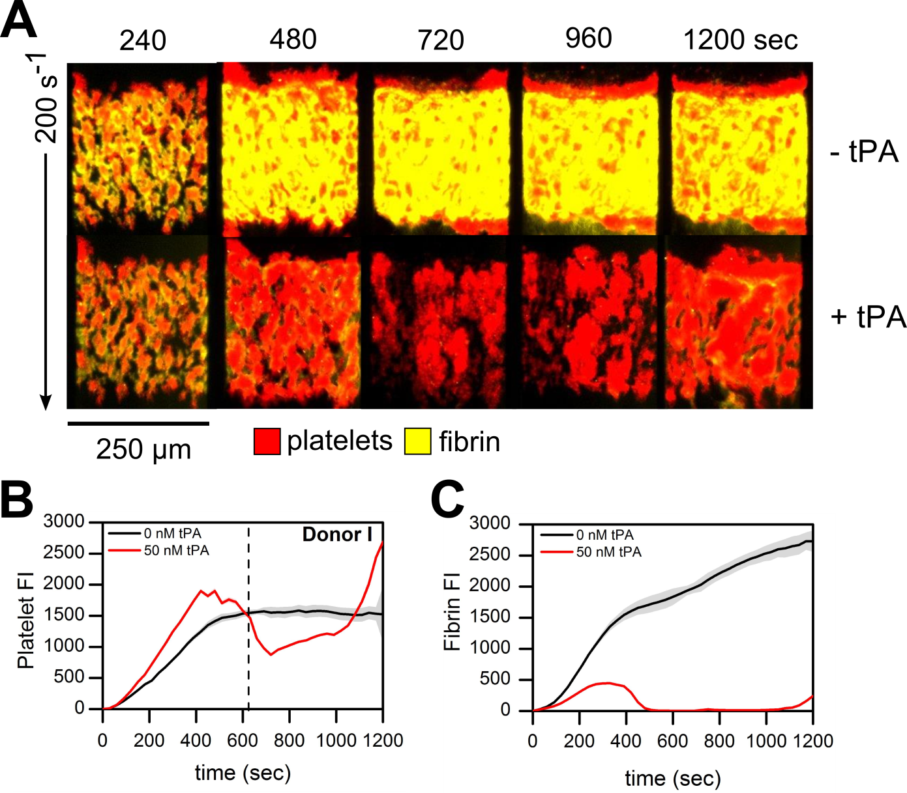
Supplemental Figure S4. Disintegration of platelet aggregates and fibrin accumulation in response to exogenous tPA ± εACA at venous shear rates.
(A), Overlay of platelets (red) and fluorescent fibrinogen (yellow) deposition at 200s⁻¹. (B), Platelet fluorescence intensities vs. time with exogenous tPA ± εACA. (C), Fibrin fluorescence intensities vs. time with exogenous tPA ± εACA. Shaded traces are the average and standard deviation of two clotting events.

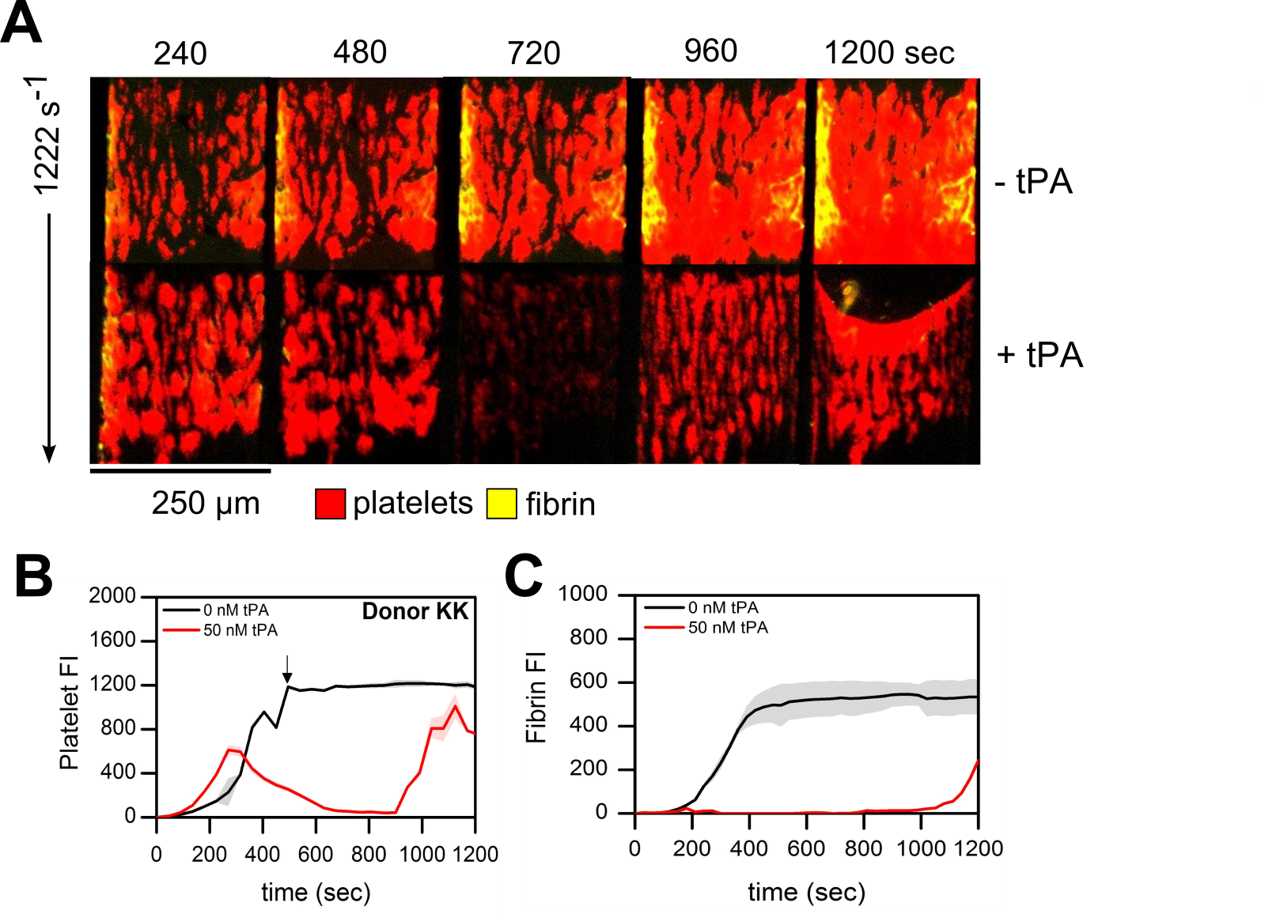
Supplemental Figure S5. Disintegration of platelet aggregates and fibrin accumulation in response to exogenous tPA ± εACA at arterial shear rates.
(A), Overlay of platelets (red) and fluorescent fibrinogen (yellow) deposition at 1222 s⁻¹ over the time course of the 20 min assay. (B), Platelet fluorescence intensities vs. time with exogenous tPA ± εACA. (C), Fibrin fluorescence intensities vs. time with exogenous tPA ± εACA. Shaded traces are the average and standard deviation of two clotting events.

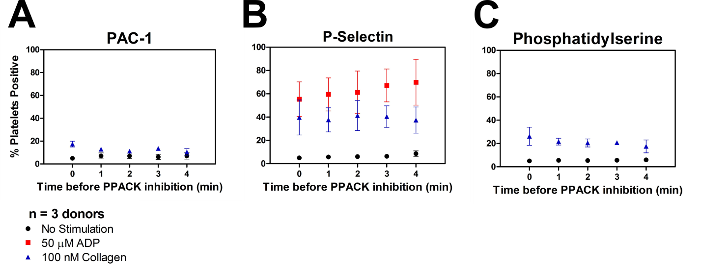
Supplemental Figure S6. Stimulation of whole blood anticogulated with PPACK up to 4 min post-phlebotomy with ADP or collagen in flow cytometry The percentage of platelets staining positive for PAC-1 expression (A), P-Selectin expression (B), and PS exposure (C) upon stimulation with indicated agonists in 1% whole blood samples anticoagulated with 100 µM PPACK at 0, 1, 2, 3, 4 min following initial blood draw. These results indicate that platelets were not significantly activated for up to 3 minutes in the syringe prior to anticoagulation. Markers are the average and standard deviation of 3 measurements from 3 donors.

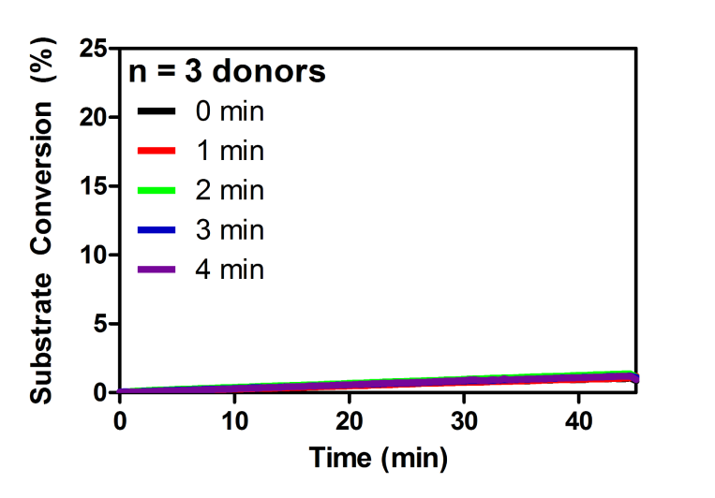
Supplemental Figure S7. Conversion of fluorogenic thrombin-sensitive substrate in whole blood anticoagulated with PPACK up to 4 min post-phlembotomy
To evaluate whether 100 µM PPACK fully inhibits thrombin generation post-phlebotomy, the conversion of the thrombin sensitive flurogenic substrate was measured for 45 min. A delay of up to 4 min prior to anticoagulation with PPACK does not illicit thrombin generation. Shaded traces are the average and standard deviation of 12 measurements from 3 donors.

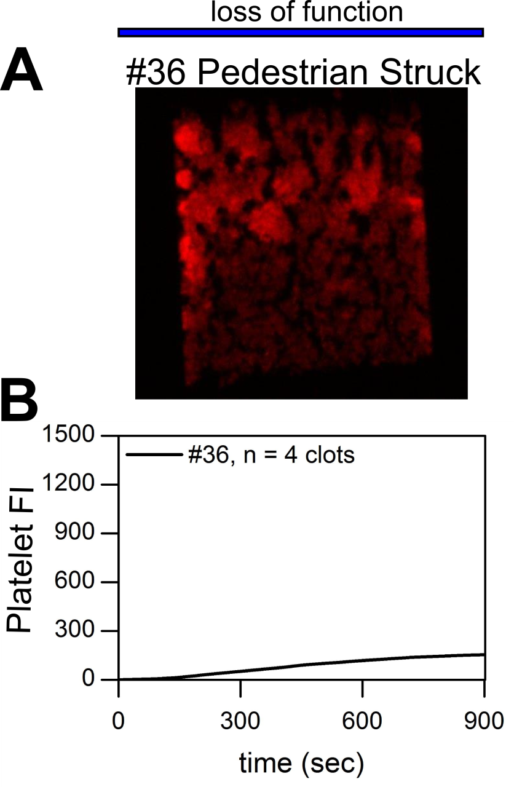
Supplemental Figure S8. Trauma Patient #36. (A) Total platelet accumulation at 900 sec.
(B) Platelet deposition dynamics at venous shear rates (100s⁻¹). Shaded trace is the mean and standard deviation of 4 clotting events from patient #36.

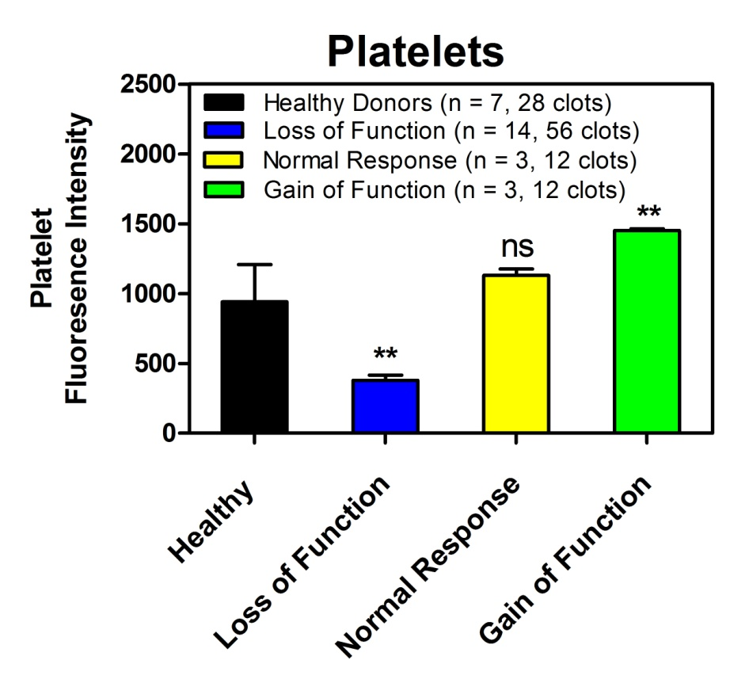

Supplemental Figure S9. Comparison of healthy and trauma patient total platelet accumulation at 900 sec. Bars are average and standard deviation from the indictated number of donors or patients tested (n) at 4 clotting events per donor or patient. **p<0.001

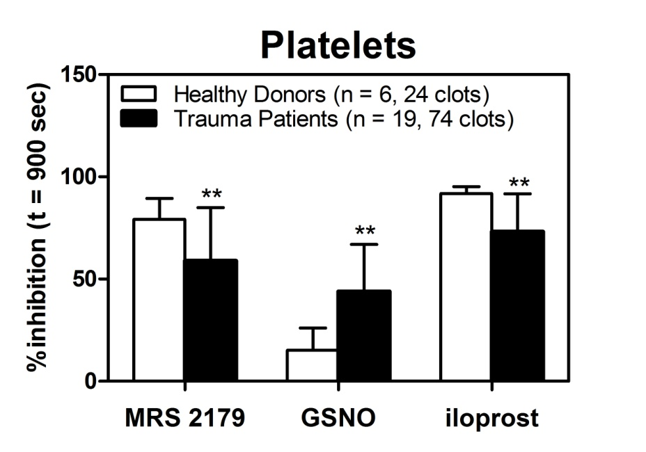
Supplemental Figure S10. Ex vivo addition of GSNO reduced total platelet accumulation more significantly in trauma patients then healthy donors. Trauma patients responded less to ex vivo antagonism with MRS 2179 or iloprost. Bars are average and standard deviation from the indictated number of donors or patients tested (n) at 4 clotting events per donor or patient. **MRS 2179: p = 0.003, GSNO: p < 0.001, Iloprost: p < 0.001
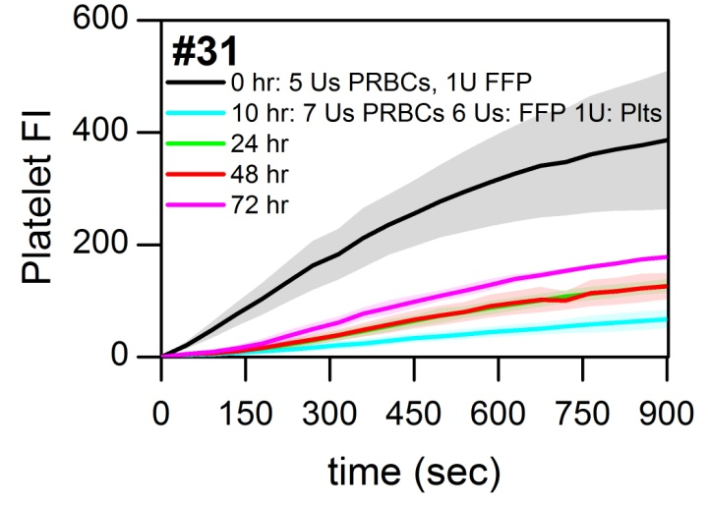
Supplemental Figure S11. Platelet fluoresence vs. time for massively tranfused patient #31. Shaded traces are the average and standard deviation of 4 clotting events.

