Pollsters and data analysts have widely estimated the Black Lives Matter protests of 2020 as the largest protest movement in American history, peaking on June 6, 2020, when half a million people in almost 550 locales nationwide and 66,000 people in Philadelphia took to the streets. The demand to “defund the police” undergirded much of the movement’s messaging, foregrounding the role of law enforcement as a pivotal issue in the political contests that have followed. Three years prior to the movement’s surge, Philadelphia elected its most progressive district attorney in recent history; one year after that summer, Philadelphia reelected him by an ever larger margin. Democrat Larry Krasner’s rise garnered national attention in large part due to the novelty of his politics in the position of district attorney: he was one of the first candidates for district attorney in any city in the country to describe himself as a “progressive prosecutor” on the campaign trail. The shift in the politics of Philadelphia’s district attorney’s office happened within an election cycle of the shift in the national political discourse towards racial injustice, particularly as perpetuated by systems of policing, incarceration, and law enforcement, that the 2020 Black Lives Matter demonstrations embodied.
Flanking the popular uproar of the Black Lives Matter in 2020, Krasner’s back-to-back electoral successes present an opportunity to assess how, if at all, the 2020 protests affected public opinion. Analyses of past election data from the Philadelphia City Commissioners Office and the Office of the Controller show that electoral support for Krasner leapt from his first campaign to his second, even despite the fact that gun violence and arrests for illegal gun possession also spiked in that time. An increase in the Philadelphia Police Department’s budget accompanied these two hikes, complicating and perhaps helping to explain the growth in electoral support for the incumbent district attorney amid a parallel growth in violent crime as the persistent violence validated Krasner’s critique of traditional investments in law enforcement. However, given the stark juxtaposition between the crime spike and Krasner’s surging popularity, the clearest explanation for the Krasner’s growth in support appears to corroborate political scientist Samuel Popkin’s theory of the reasoning voter—the idea that most voters make decisions based on small sets of particularly salient information rather than the true, numerous, and nuanced policy stances of their elected officials. In all likelihood, the Black Lives Matter movement helped shore up electoral support for Krasner’s progressive candidacy by raising the salience of racial equity in the explicit context of the criminal justice system among Philadelphians.
When Krasner first ran for office in 2017, he established himself as the progressive of the field—and as a candidate more concerned with reforming Philadelphia’s criminal justice system than doubling down on existing law enforcement norms. Krasner had worked as a defense attorney for Black Lives Matter earlier in his career, and throughout his campaign, he made explicit commitments to fight for racial equity in Philadelphia’s criminal justice system. In the final months before the 2017 primary, Krasner received substantial support from billionaire George Soros in the form of $1 million in advertising of Krasner’s support for the Black Lives Matter movement and other progressive stances. His platform implored the Philadelphia district attorney’s office to end cash bail for people charged with nonviolent offenses, prosecute fewer nonviolent and “insignificant” cases to optimize the office’s operational capacity, decriminalize drug addiction, and cease pursuing the death penalty, among other progressive recommendations. In the five years after his first election to the office, Krasner held his progressive course.
In 2017, Krasner beat his closest primary contender by almost 20 points, but for much of the campaign season, his victory appeared far from certain. Krasner faced six opponents in his first primary. His most formidable opponent was Joe Khan, a more moderate candidate—the only one of the seven candidates in the race to oppose parole eligibility for people serving life sentences for murder in Pennsylvania after 15 years served. Rich Negrin, another primary contender, held a more moderate position than Krasner as well, with an ambiguous stance on ending cash bail for nonviolent offenders in contrast to Krasner’s unequivocal opposition to the practice. A third rival, Michael Untermeyer, maintained a public image that appeared moderate from the outset of his campaign, largely because Untermeyer had ran as a Republican for district attorney in 2009 and City Council in 2011. The moderate challenge to Krasner’s 2017 primary bid compounded under intense opposition from Philadelphia’s police union. The union’s president, John McNesby, called Krasner’s candidacy “hilarious” early in the campaign season. This political ensemble composed the backdrop of Krasner’s first campaign.
In 2021, Krasner faced a similar sort of moderate challenge from Carlos Vega, a former assistant district attorney of Philadelphia. Vega voiced intentions to escalate prosecutions for certain crimes that Krasner opposed prosecuting; Vega supported the death penalty while Krasner opposed it; Vega emphasized the need to convict people charged with illegal gun possession while Krasner stressed a broader need to “invest in prevention” of gun violence in more proactive ways. Moreover, the opposition from Philadelphia’s police union that Krasner initially encountered in 2017 intensified in his second campaign. The union not only endorsed Vega but also encouraged its mainly Republican membership to switch parties in order to vote against Krasner in the primary. Former Democratic Pennsylvania Governor Ed Rendell also endorsed Vega, and the Philadelphia Democratic committee declined to endorse Krasner—two additional blows to Krasner’s electoral prospects from moderate wings of his own party. Nonetheless, Krasner far outperformed himself in his second campaign.
In both elections, Krasner performed well, but he encountered a substantial jump in support from the first to the second. In 2017, Krasner won 38.2% of the vote in a seven-candidate race and almost doubled the vote share of Khan, the candidate with the second most votes. In 2021, Krasner’s share jumped to 66.8% of the vote in a two-candidate race, more than doubling the vote share of Vega. Under the assumption that Khan, Negrin, and Untermeyer alone represented the moderate challenge to Krasner in 2017 (and that voters for Tariq El-Shabazz, John O’Neill, and Teresa Carr Deni would have simply realigned under Krasner in the absence of other progressive options), Krasner’s 2021 gain of 28.6 points exceeded the vote share of just 19.1 points that he would have gained from other progressive candidates’ constituencies if voters held their behavior constant from 2017 to 2021. Alternatively, if voters for candidates beyond those moderate three did not see Krasner as a next best option in 2017, the growth of his base in 2021 appears all the more noteworthy.
This jump in support stands in stark contrast to the parallel spike in violent crime that occurred between Krasner’s first and second electoral wins. Three of Philadelphia’s ten City Council districts saw shooting incidents more than double from the day of Krasner’s 2017 electoral win to the day before his 2021 electoral win; another three districts saw shooting incidents increase by between 85% and 95% in that time. Vega built a large part of his campaign around this shift, holding the spike in violence as evidence that Krasner’s policies did not serve the public well. And yet, at a 5% level of significance, there is no statistically significant correlation between this spike in crime and the increase in support for Krasner. A linear regression of the percent change
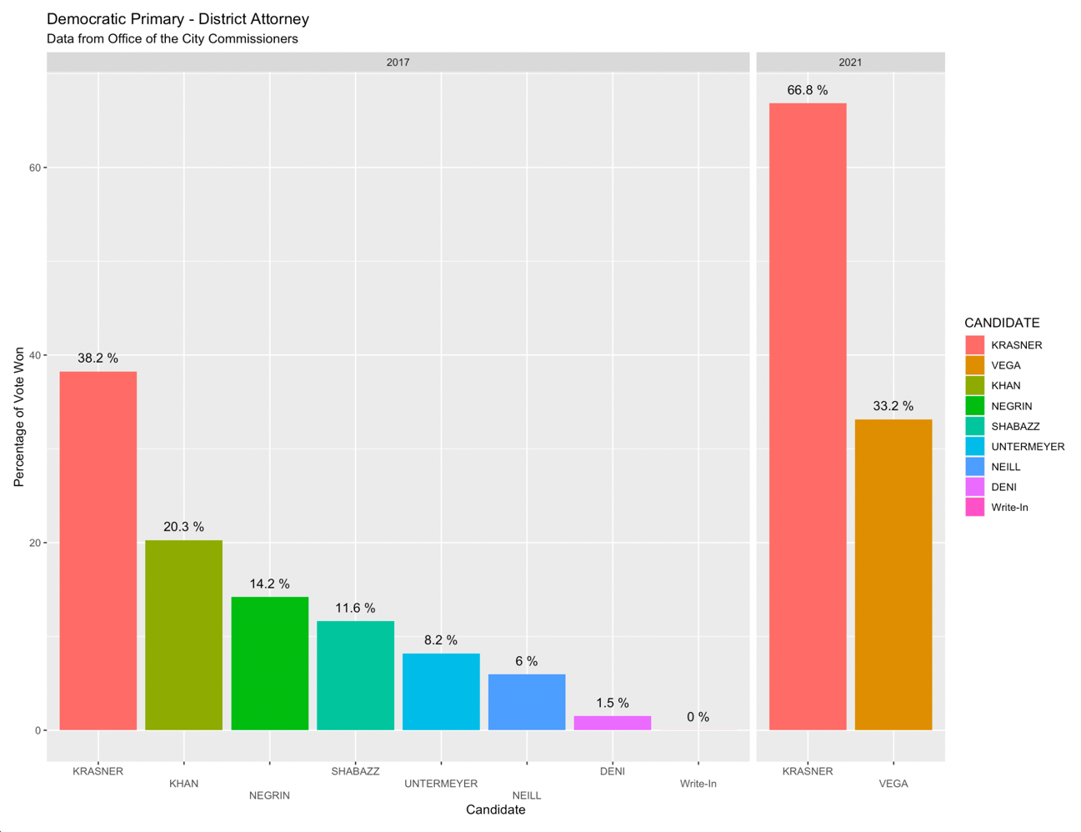
Figure 1. Democratic Primary Results for District Attorney (graph by author).

in gun violence incidence on the percent change in support for Krasner finds a t-value of 0.619, in excess of the critical value of 0.553. District 5, the district which witnessed the greatest increase in gun violence incidence between Krasner’s first and second electoral victories at 145.2%, and District 3, the district which witnessed the least increase at only 40.4%, each increased their support for Krasner in his second election by between 30% and 40%. District-specific spikes in crime did not deter voters from leaning into new enthusiasm for Krasner.
At the same time, City Council’s repeated approval of budget increases for the Philadelphia Police Department did not deter city-wide spikes in crime, cleaving another clear contrast between Krasner’s public image and the political dilemmas he confronted—this time, perhaps, to his benefit. Krasner’s strong electoral performance in 2021 came on the heels of a nationwide
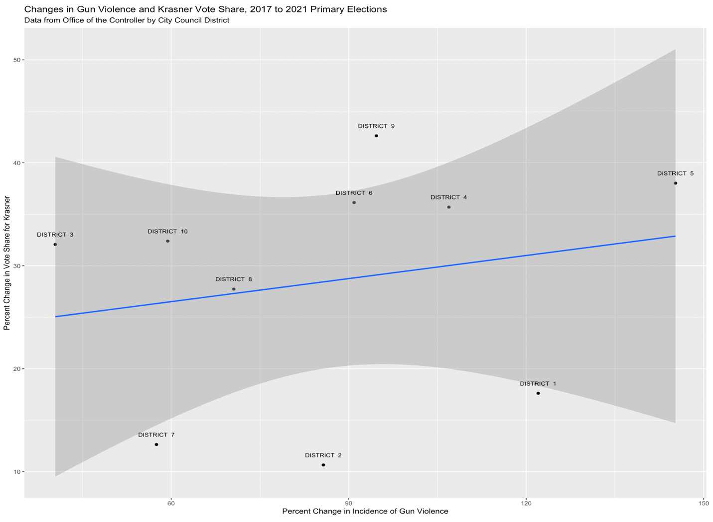
Figure 2. Percent changes in gun violence incidence and Krasner support (graph by author).

movement with a strong Philadelphia chapter—Black Lives Matter—explicitly campaigning for the immediate discarding of traditional investments in law enforcement. In the ten years prior to the 2020 protests, City Council approved repeated expansions of the police budget, collectively amounting to a 24% increase since 2010. However, while the city homicide rate underwent a noteworthy drop in the early 2010s, the homicide rate had increased every year for the six years preceding the 2020 sweep of Black Lives Matter protests. The concurrent increases in violent crime and the city’s police budget may have validated Krasner’s critique of retroactive and punitive approaches to law enforcement as ineffective, especially when compared to the proactive and reparative approaches he claimed to champion. The Black Lives Matter movement, in turn, came at a time when that validating narrative would likely prove advantageous as Krasner prepared to face off against a moderate candidate with well-established political friends.
Without commanding certainty on the subject, the lack of a correlation between the increase in violent crime and the increase in Krasner’s vote share suggests that something else must have played a role in catalyzing the dramatic increase in support for Krasner—and the Black Lives Matter movement is a strong candidate for one such catalyst. Popkin has proposed that voters with limited information and energy to know their political representatives in detail use information shortcuts akin to “fire alarms” rather than “police” squadrons, or signals that “alert” them to certain priorities worthy of attention rather than requiring them to proactively “look for smoke” on patrol. In 2020, the Blacks Lives Matter movement dominated the national political conversation, directing voters’ attention to crises of racial injustice in the specific context of the criminal justice system like a fire alarm, without requiring much intellectual “patrol” of any voter to arrive at some corner of the discourse. Critics of the Black Lives Matter movement often criticize the movement’s political goals as vague, if defined at all, and the criticism is not without merit; the home webpage of the Black Lives Matter Global Network Foundation, a self-proclaimed hub of the movement, does not even list an easily accessible set of policy demands. However, the fact that the movement may have helped catapult Krasner to a heightened position of political prominence offer one way to respond to those criticisms and remedy them where necessary. Popkin’s model of the typical voter implies that popular movements can have tremendous indirect influence on the agendas of elected officials when they exert direct influence on the public’s social consciousness and cultural priorities, whether by setting of “alarms” through scandal and protest or by redirecting ambient political conversation to the issues relevant to the cause. The case study of Larry Krasner’s growth of electoral support shows that targeted efforts to awaken public political consciousness can help people with nonconformist politics secure powerful positions.
It would be presumptuous to assert that the Black Lives Matter movement alone prompted greater support for Krasner’s service as district attorney. Krasner has had time to build a record of his own achievements that he has used to campaign to constituents, among a multitude of other potentially influential factors. However, it is clear that an overwhelming number of Philadelphia voters do not associate continued failings of the criminal justice system or escalating violence in their city with the course that Krasner has held as district attorney, and the largest protest movement in the nation’s history stands as one formidable candidate for helping the public make that distinction. The case study of his rise to political prominence provokes questions about the opportunities for mass political organizing that movements like Black Lives Matter might be able to seize if they focus their efforts on clearer political goals.

References
“#DefundThePolice.” Black Lives Matter Global Network Foundation. May 30, 2020.
https://blacklivesmatter.com/defundthepolice/.
Booker, Brakkton. “This D.A. Won by a Landslide. He’s Still Mad.” Politico, June 6, 2021.
https://www.politico.com/newsletters/the-recast/2021/06/11/larry-krasner-philadelphia-
district-attorney-election-policing-493220.
Brennan, Chris. “Joe Khan’s Pitch to Be Philly’s Next DA: ‘Only in America.’” Philadelphia
Inquirer, May 3, 2017. https://www.inquirer.com/philly/news/politics/city/Joe-Khans-pitch-to-
be-Phillys-next-DA-Only-in-America.html.
Buchanan, Larry, Quoctrung Bui & Jugal K. Patel. “Black Lives Matter May Be the Largest
Movement in U.S. History.” New York Times, July 3, 2020.
https://www.nytimes.com/interactive/2020/07/03/us/george-floyd-protests-crowd-size.html.
“City Council Districts.” Committee of Seventy. Accessed November 16, 2022.
https://seventy.org/political-maps-of-philadelphia/city-council-districts.
D’Onofrio, Michael. “City Democratic DA Primary Heats up As Vega Accuses Krasner of
Going Soft on Crime.” Philadelphia Tribune, April 1, 2021.
https://www.phillytrib.com/news/local_news/city-democratic-da-primary-heats-up-as-vega-
accuses-krasner-of-going-soft-on-crime/article_32930055-8f37-5726-af11-b9f8f5a46fd9.html.
D’Onofrio, Michael. “FOP Has New Plan to Oust Krasner in the May Primary.” Philadelphia
Tribune, February 22, 2021. https://www.phillytrib.com/news/local_news/fop-has-new-plan-
to-oust-krasner-in-the-may-primary/article_5a492e3d-b380-5f6c-8da0-538edd50c1dc.html.
Jacobs, Harrison. “The Inside Story of how Trump United a City of Activists to Elect the Most
Progressive District Attorney in a Generation.” Insider, November 12, 2017.
https://www.businessinsider.com/larry-krasner-philadelphia-election-platform-trump-
2017-11#the-soros-money-takes-the-race-from-close-to-a-blowout-7.
Marin, Max. “With 35 Years of Experience, Carlos Vega Wants to Be Philly’s Next District
Attorney.” Billy Penn, March 3, 2021. https://billypenn.com/2021/03/03/philadelphia-district-
attorney-krasner-challenger-carlos-vega-democrat-2021-election/.
McCrone, Brian. “Carlos Vega: Who Is the Man Running for Philly DA against Larry Krasner?,”
NBC10, April 26, 2021, https://www.nbcphiladelphia.com/news/politics/carlos-vega-who-is-
the-man-running-for-philly-da-against-larry-krasner/2789022/.
Office of the Controller. Data Release: Police Budget and Citywide Homicides. June 16, 2020.
https://controller.phila.gov/philadelphia-audits/data-release-police-budget-and-homicides/.
Office of the Controller. Mapping Philadelphia’s Gun Violence Crisis.
https://controller.phila.gov/philadelphia-audits/mapping-gun-
violence/#/?year=2022&map=11.44%2F39.97934%2F-75.11098.
Office of the Philadelphia City Commissioners. Past Election Results.
https://vote.phila.gov/resources-data/past-election-results/.
“On the Issues.” Larry Krasner for District Attorney. https://krasnerforda.com/platform.
Orso, Anna. “Philly DA Candidate Who Used to Be GOP: Actually I’ve Almost Always Been a
D.” PolitiFact, May 12, 2017. https://www.politifact.com/factchecks/2017/may/12/michael-
untermeyer/philly-da-candidate-who-used-be-gop-actually-ive-a/.
Otterbein, Holly. “Progressive Firebrand Larry Krasner Wins District Attorney Primary.”
Philadelphia Magazine, May 16, 2017. https://www.phillymag.com/news/2017/05/16/larry-
krasner-wins-district-attorney-race/.
Palmer, Chris, Dylan Purcell, Mike Newall, & Mensah Dean. “Philly Gun Arrests Are on a
Record Pace, But Convictions Drop under DA Krasner.” Philadelphia Inquirer, March 30,
2021. https://www.inquirer.com/news/philadelphia-gun-arrests-2021-convictions-vufa-
20210330.html.
Popkin, Samuel. The Reasoning Voter: Communication and Persuasion in Presidential
Campaigns. Chicago: University of Chicago Press, 1991.
Smith, Allan. “Progressive Das are shaking up the criminal justice system. Pro-police groups
aren’t happy.” NBC News, August 19, 2019. https://www.nbcnews.com/politics/justice-
department/these-reform-prosecutors-are-shaking-system-pro-police-groups-aren-n1033286.

1. Larry Buchanan, Quoctrung Bui & Jugal K. Patel, “Black Lives Matter May Be the Largest Movement in U.S. History,” New York Times, July 3, 2020, https://www.nytimes.com/interactive/2020/07/03/us/george-floyd-protests-crowd-size.html.
2. “#DefundThePolice,” Black Lives Matter Global Network Foundation, May 30, 2020, https://blacklivesmatter.com/defundthepolice/.
3. Allan Smith, “Progressive DAs Are Shaking up the Criminal Justice System. Pro-Police Groups Aren’t Happy,” NBC News, August 19, 2019, https://www.nbcnews.com/politics/justice-department/these-reform-prosecutors-are-shaking-system-pro-police-groups-aren-n1033286.
4. Samuel Popkin, The Reasoning Voter: Communication and Persuasion in Presidential Campaigns (Chicago: University of Chicago Press, 1991).
5. Holly Otterbein, “Progressive Firebrand Larry Krasner Wins District Attorney Primary,” Philadelphia Magazine, May 16, 2017, https://www.phillymag.com/news/2017/05/16/larry-krasner-wins-district-attorney-race/.
6. Harrison Jacobs, “The Inside Story of how Trump United a City of Activists to Elect the Most Progressive District Attorney in a Generation,” Insider, November 12, 2017, https://www.businessinsider.com/larry-krasner-philadelphia-election-platform-trump-2017-11#the-soros-money-takes-the-race-from-close-to-a-blowout-7.
7. “On the Issues,” Larry Krasner for District Attorney, https://krasnerforda.com/platform.
8. Jacobs; Chris Brennan, “Joe Khan’s Pitch to Be Philly’s Next DA: ‘Only in America,’” Philadelphia Inquirer, May 3, 2017, https://www.inquirer.com/philly/news/politics/city/Joe-Khans-pitch-to-be-Phillys-next-DA-Only-in-America.html.
9. “On the Issues.”
10. Anna Orso, “Philly DA Candidate Who Used to Be GOP: Actually I’ve Almost Always Been a D,” PolitiFact, May 12, 2017, https://www.politifact.com/factchecks/2017/may/12/michael-untermeyer/philly-da-candidate-who-used-be-gop-actually-ive-a/.
11. Otterbein.
12. Max Marin, “With 35 Years of Experience, Carlos Vega Wants to Be Philly’s Next District Attorney,” Billy Penn, March 3, 2021, https://billypenn.com/2021/03/03/philadelphia-district-attorney-krasner-challenger-carlos-vega-democrat-2021-election/; Brian McCrone, “Carlos Vega: Who Is the Man Running for Philly DA against Larry Krasner?” NBC10, April 26, 2021, https://www.nbcphiladelphia.com/news/politics/carlos-vega-who-is-the-man-running-for-philly-da-against-larry-krasner/2789022/; Chris Palmer et al., “Philly Gun Arrests Are on a Record Pace, But Convictions Drop under DA Krasner,” Philadelphia Inquirer, March 30, 2021, https://www.inquirer.com/news/philadelphia-gun-arrests-2021-convictions-vufa-20210330.html.
13. Michael D’Onofrio, “FOP Has New Plan to Oust Krasner in the May Primary,” Philadelphia Tribune, February 22, 2021, https://www.phillytrib.com/news/local_news/fop-has-new-plan-to-oust-krasner-in-the-may-primary/article_5a492e3d-b380-5f6c-8da0-538edd50c1dc.html.
14. Brakkton Booker, “This D.A. Won by a Landslide. He’s Still Mad,” Politico, June 6, 2021, https://www.politico.com/newsletters/the-recast/2021/06/11/larry-krasner-philadelphia-district-attorney-election-policing-493220.
15. Office of the Philadelphia City Commissioners, Past Election Results, https://vote.phila.gov/resources-data/past-election-results/.
16. Office of the Philadelphia City Commissioners.
17. Office of the Controller, Mapping Philadelphia’s Gun Violence Crisis, https://controller.phila.gov/philadelphia-audits/mapping-gun-violence/#/?year=2022&map=11.44%2F39.97934%2 F-75.11098.
18. Michael D’Onofrio, “City Democratic DA Primary Heats up As Vega Accuses Krasner of Going Soft on Crime,” Philadelphia Tribune, April 1, 2021, https://www.phillytrib.com/news/local_news/city-democratic-da-primary-heats-up-as-vega-accuses-krasner-of-going-soft-on-crime/article_32930055-8f37-5726-af11-b9f8f5a46fd9.html.
19. Office of the Controller, Data Release: Police Budget and Citywide Homicides, June 16, 2020, https://controller.phila.gov/philadelphia-audits/data-release-police-budget-and-homicides/.
20. Office of the Controller, Data Release.
21. Popkin, 49.
22. Joseph Williams, “What Does the Black Lives Matter Movement Really Want?” U.S. News & World Report, August 24, 2015, https://www.usnews.com/news/articles/2015/08/24/what-does-the-black-lives-matter-movement-really-want; “Black Lives Matter,” Black Lives Matter Global Network Foundation, https://blacklivesmatter.com.

