Introduction
The greater purpose of this essay is not to devalue Internet memes (IMs) nor to define them as unethical. Neither is the purpose to claim there is any causal relationship between IMs and societal desensitization. Rather, I am proposing a new interdisciplinary lens through which to further study IMs. Particularly, their normalized use of images with originally violent or sensitive contexts. By sensitive, I mean contexts that neither depict violence nor are inherently violent but are simultaneously seen as an unconventional subject of humor—such as someone’s death. For one, this research is an analytical observation of IMs’ social intricacies and how these cultural units hold a significant role in online activity and communication. The main purpose is to propose a way in which to analyze the social influence of IMs—in their creation, recreation, and diffusion. This lens can contribute to theoretical work on IMs as language, on their relations between desensitization and media, and to overall propose a new manner from which to study the social influence of IMs. As IMs continue to be a popular form of online discourse, understanding the social effects of IMs on Internet users will further the general understanding of online behaviors’ effects on users’ social conceptions on- and off-line. Especially among the growing population of digital natives, who have grown up with the influence of and have been socialized by the Internet—including SNSs (Hargittai, E., 2010).
Throughout the beginning of my analysis, I define IMs, assess their distinct qualities, and establish the specific types of IMs I focus on for the sake of this analysis. I do so to develop an understanding of how IMs are used as a form of communication, which is one of the foundations of my central point— how they relate to media influenced desensitization. I do so by examining existing theoretical research on IMs and on media’s relationship to social desensitization to draw a connection between the conceptual framework and the perspective I present with which to analyze IMs. Particularly, I refer to the creation and popularity of IMs in which sensitive or violent media are used and modified in a manner that removes the original contexts of these images—often for the sake of humor.

Methodology
I perform a secondary analysis on research that analyzes IMs—which focus on defining them and identifying how they are used in online discourse— and on research that discusses the relations between exposure to violent media and desensitization. I use findings from this research to formulate how IMs, particularly the types I focus on in this essay, fit into research on the link between media and desensitization to propose a new perspective that could further the literature.
I use the IM database “Know Your Meme” as the main source for examples throughout this paper. This is a database in which IMs are submitted by online users to be researched and verified by a team of professional editorial and research staff that run the site. Other examples, due to their recent occurrence, are obtained from reputable news outlets.
My analysis focuses on IMs for “use” as they best define what I am referring to, and what is generally referred to as an “Internet meme”, in contrast to IMs for “view” which are more closely related to what are now called “viral” images or videos. I focus on this genre of memes because the methods in which these memes are created and the manner in which they express messages are central to my argument. Although viral videos can correlate to issues of desensitization through media, the cultural behavior in creating and the intertextuality of “use” type IMs are what allow them to be used in discourse—which are unique characteristics central to my analysis. In sum, “IMs” specifically refer to those of “use” in the following section.

What are Internet memes?
As Patrick Davison notes, IMs are “a piece of culture, typically a joke, which gains influence through online transmission” (Davison, 2012). Another notable definition is that by Carlos Mauricio Castaño Díaz. He proposes that IMs are:
“…a unit of information (idea, concept or belief), which replicates by passing on via Internet (e-mail, chat, forum, social networks, etc.) in the shape of a hyper-link, video, image, or phrase. It can be passed on as an exact copy or can change and evolve. The mutation on the replication can be by meaning, keeping the structure of the meme or vice versa. The mutation occurs by chance, addition or parody, and its form is not relevant.”
For Castaño Díaz, IMs depend “…on a carrier and a social context where the transporter [creator] acts as a filter and decides what can be passed on” (Castaño Díaz, 2013).
The term meme was first coined by Richard Dawkins in his 1976 book The Selfish Gene. Memes, like genes, are replicators, but rather through DNA they replicate through imitation; they are “a unit of cultural transmission” (Dawkins,1976). They are learned, subject to interpretation, constructed by culture—such as social institutions— and greatly determine much of human behavior (Dawkins, 1976). However, Dawkins’s early classification of memes are a vague definition for something as unique as IMs— they do not account for some of the more specific communication aims that have surfaced in online platforms (Castaño Díaz, 2013; Davison, 2012; Shifman, 2014). There are several perspectives across disciplines which make it difficult for IMs to have a concrete definition across academia (Castaño Díaz, 2013). For this reason, I focus on the two previously stated definitions by Davison (2012) and Castaño Díaz (2013) as they best fit the perspective in which this paper will view IMs.
Dawkins also explained that there are three key characteristics necessary for memes to be successful: longevity, copy fidelity, and fecundity (Dawkins, 1976). Longevity refers to the duration a meme lasts, copy fidelity is the accuracy in which a unit can be copied, and fecundity is how many units of memes can be created in a certain unit of time (Dawkins, 1976). These characteristics are still relevant to IMs, however, are greatly magnified due to the power of the Internet (Castaño Díaz, 2013; Shifman, 2014). This is so because the Internet allows information to be stored indefinitely, to be replicated without loss of information, and to be quickly transferred and diffused across itself (Castaño Díaz, 2013; Shifman, 2014). The way in which the Internet strengthens these characteristics needed for memes to be successful is precisely why IMs have become a social phenomenon as seen by their consistent virality online.
Davison (2012) explains that there are two basic genres of IMs, memes for “view” and memes for “use”; these genres refer to the way in which memes gain popularity. IMs for “view” gain popularity through being shared in their original form, while memes for “use” are created through the replication and modification of original memes. The “malleability” and “interactivity” of these memes encourage the recreation of original memes by other individuals and are a quality important to their popularity (Davison 2012; Castaño Díaz, 2013). A meme for “view” would be the 2009 video created by Forrest Whiley for “The Duck Song” by Bryant Oden which became so famous that the original video now has over 300 million views since its creation (The Duck Song, 2012). The viewing and sharing of the original video are what made it popular rather than its ability to be recreated—as evident by its very minimal recreations (The Duck Song, 2012). On the other hand, the “Squinting Woman” (Figure 1 & 2) meme would be

Figures 1 & 2. Original posts by @Solo_Kalin
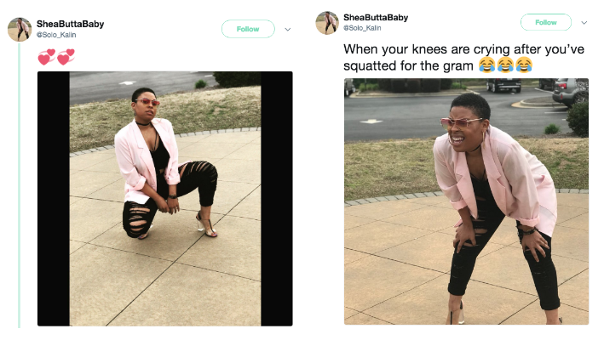
considered a meme for “use”. This meme came from a set of photos originally posted by Twitter user “@Solo_Kalin”. However, it became popular as an IM not only through the original tweet gaining views, but specifically through the several online users who reused and edited the original image in order to create their own memes such as the ones in Figure 3-6 on the next page.

Figures 3-6. “Squinting Woman” memes created by other, random, Twitter users

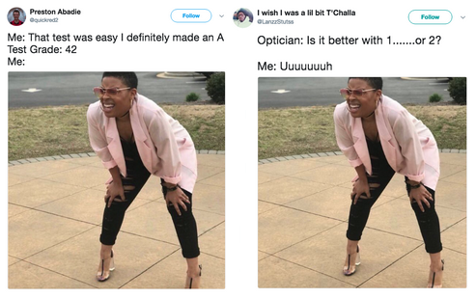
IMs, specifically memes for “use”, are also successful due to their intertextuality, as the interconnection of cultural contexts within IMs add on to their efficiency as a form of visual rhetoric. These cultural references allow numerous ideas, from jokes to political messages, to be conveyed to and understood by online audiences (Huntington, 2013). When an Internet meme’s message is generally appealing and understood by the online public, it is vastly shared and/or remade which makes itself a popular Internet meme. Similarly, IMs greatly depend on their characteristics of “mutability” and “adaptability”—which rely on context (Castaño Díaz, 2013). Adaptability refers to its ability to be replicated, while mutability refers to its inability to be replicated—primarily when its context is not understood (Castaño Díaz, 2013). Thus, if it’s adaptable it can stay relevant and if its mutable it has the risk of being ignored (Castaño Díaz, 2013).
Internet memes as a Form of Discourse
IMs have undoubtedly become a social phenomenon, as evident by the thousands of IMs that have been created, “liked”, shared, and recreated. The IM database Know Your Meme alone provides examples of several thousand IMs with counted views for each meme on its site. Social media platforms, where IMs are commonly shared, also hold examples of “viral” IM posts that show immense numbers of likes and shares by users. This success can be accredited to the three qualities Dawkin’s identified being strengthened through the application of the Internet. These magnified characteristics are what allow the several “mutations” involved in successful IM culture, these mutations in turn further strengthen the “fecundity” of IMs because they entice online users to continue the cycle of contributing their own memes (Knobel & Lankshear, 2007). Other important elements that contribute to IMs’ continued cycle of recreation are humor and intertextuality (Knobel & Lankshear, 2007). Humor and intertextuality play a key role in Internet meme’s fecundity and online relevance, because the general users’ understanding of an Internet meme’s message is essential to its popularity. User’s having an understanding to the context or message of the IM is what allows them to relate to it. This does not mean that the viewer must relate to the IM in the exact way the creator intended, but rather that there is some message which can be generally understood to some degree and the more vastly it is understood the greater likelihood of its popularity; this is opposed to an IM with no coherent context or a context understood by a very limited and specific audience. This necessary understanding exemplifies how they serve as a method of online discourse, in which users are exposed to an Internet meme, understand the message(s) being expressed in the meme, and show their response through likes, shares, comments, and recreations of the meme.
The continued discourse of an IM or several IMs is what continues their growth in popularity and their online relevance, therefore, the degree of popularity these memes attain illuminates the ideas the general public relates to. For example, “Reaction memes” memes that use images or videos in order the express a specific feeling during a specific situation, encompass a sub-genre known as “Relatable posts” memes. “Relatable posts” memes, which start with the phrase “When you…” followed by a certain situation and a photo to represent the creator’s sentiments during that situation use images which would be unrelated otherwise (Figures 7-10). These types of IMs became popular because users that are exposed to them both relate to the message of the meme (as evident in likes and shares) and may even create their own version. IMs not only convey messages, but their popularity evince ways in which they build community as they show patterns of collectively accepted ideas through the amount of views, likes, and shares gathered. This normalized behavior of using photos or videos—regardless of their original context— as a form of expression—whether they be done for humor, social commentary, or otherwise—is the main focus of this analysis on societal desensitization and IM use.

Figures 7-9: Examples of: Relatable posts” memes.
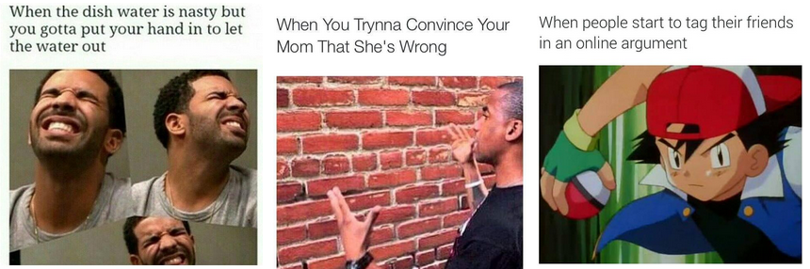

Internet memes and Desensitization
Several existing studies theorize how exposure to violent media correlate to increases in violent occurrences and increases in societal desensitization when confronted with these sorts of situations and contexts in real life. One such example is evidence found by Craig A. Anderson et al. (2003) linking media violence to the increased likelihood of violent and aggressive behavior in both short- and long-term instances. These authors’ overview the literature on this subject to present how it has been studied in different methods and in different contexts; one limitation they point out is the lack of research on exposure to Internet-based media violence (Anderson et al., 2003). Another source makes a connection between the General Aggression Model (GAM), in Figure 10, which is a model that combines various prior models to theorize the relationship between violent media and increases in aggression-related outcomes (Anderson & Carnagey, 2004a, as cited in Carnagey et al. 2007a).
Some researchers have also focused on the effects of violent media on physiological arousal, since arousal itself has been linked to human aggression (Carnagey et al., 2007a). Such as in the case of “excitation transfer theory” which states that arousal caused by external sources (like violent video games) can “be misattributed as anger” in scenarios “involving provocation” and in turn increases “the chances of the situation resulting in aggressive behavior” (Zillmann, 1983; as cited in Carnagey et al., 2007a). In relation to this theory, other research has linked violent media to physiological desensitization—which refers to a reduction in physiological reactivity after exposure to violence (Carnagey et al. 2005). Normally, individuals have an “automatic aversive emotional response” to situations of violence—such as changes in heart rate and “skin conductance” which called the “galvanic skin response. Past research has exhibited that after exposure to violent media, participants showed reduction in skin conductance and heart rate when encountering succeeding depictions of real violence (Carnagey et al., 2007b). This study provides a model (Figure 11) that explains how exposure to “initially fearful stimuli” in a positive context can lead to extinction of anxiety or fearful (desensitized) reactions to violence (Carnagey et al., 2007b). A different study also examined the links between habitual media violence exposure and desensitization to violent media stimuli; its findings suggests that observed desensitization effects are specific to violent content (Krahé, Barbara et al., 2011).

Figure 10: A brief description of GAM. GAM illustrates “how a cyclical pattern of interaction between personal factors (e.g., knowledge structures, trait aggression) and situational factors (e.g., provocation, recent exposure to violent media) influences the likelihood of aggressive behavior in the current situation and the development of aggressive personality over time. These input variables influence behavior ultimately by affecting decision processes through three primary routes: cognitive, affective, and physiological arousal.” From Anderson, C.A., & Carnagey, N.L. (2004b)
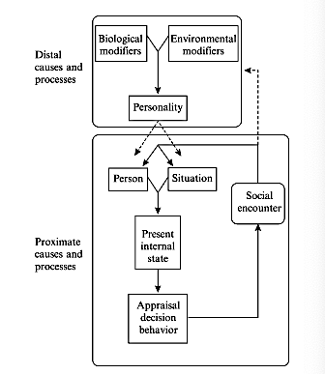

One study found that this desensitization can display cognitive effects—such as decreased perception of injury severity, decreased attention to violent events, decreased sympathy for violence victims, increased belief that violence is normative, and decreased negative towards violence—and even behavioral outcomes—such as decreased helping and increased aggression (Bushman et al., 2009). Thus, I propose if violent media presented in a positive context, such as video games, can hold desensitizing effects, then these same effects could potentially occur from the used of and exposure to violent media in IMs—with humor serving as the positive context. I further propose that this could equally be the case for sensitive media, defined earlier as neither depicting violence nor being inherently violent, when events—such as the examples of Lil Mama presented later in this text— are presented in the positive context of humor.

Figure 11: Model of the effects of exposure to media violence, from Carnagey et al. 2007b.
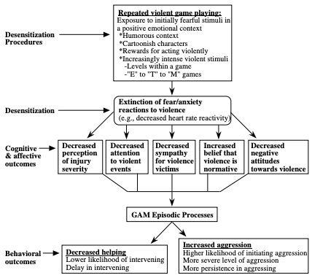

Specifically, desensitization that causes lower empathy, as users adapt to either ignore or remove the original violent or sensitive contexts of these images to make them into jokes or other messages. One study conducted an experiment in which fourth and fifth graders were exposed to real-life and media violence exposure to test association with levels of empathy and attitudes towards violence (Funk et al. 2004). The study found video game violence was associated with lower empathy and both video game and movie violence to be associate with pro-violence attitudes; the study also suggests how desensitization should be further studied (Funk et al. 2004).

IMs’ reliance on intertextuality and their malleable quality make it easy for users to manipulate images to create a range of messages—often jokes. If this is so, then the same can be said about images in which the context is sensitive or violent. Jokes of this type “dark humor”, like “Internet disaster jokes”, have been posted online about several events of violent or sensitive context— such as jokes about the terrorist attack of September 11, 2001 (Kuipers, G. 2002). Another common example is the popular genre of Adolf Hitler and Holocaust IMs, shown in Figures 12-13. In many cases, IMs referencing Adolf Hitler or the Holocaust

Figure 12 & 13: These memes are related to the popular IM phrase “Hitler did nothing wrong” in which the phrase was used either used seriously but mostly for satirical purposes. The first image is directly from that trend. The second had influence from the phrase but using the popular meme trope “I Wish I Could Talk to Ponies”.
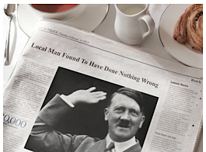
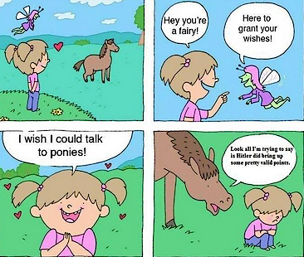

Figures 14 & 15: The first figure references an older meme “Bad Luck Brian” in which the Sandy Hook shooter Adam Lanza is joked of being Brian’s new friend, thus referring to the joke of him having bad luck. The second image is of the “That’d be Great” meme (Know Your Meme) taken from the 1999 film Office Space, the character in the film was known as being humorously non-confrontational by always ending an order with the phrase “that’d be great”; the creator of this image added on to the humorous meme by adding the phrase “Yeah, if all the school shootings would stop…”.
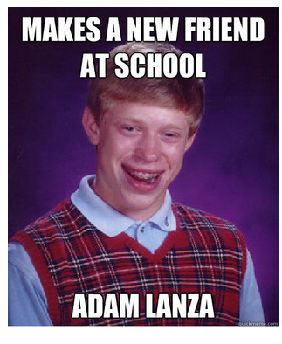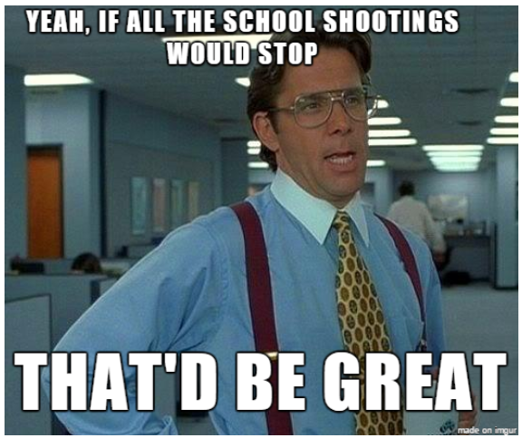
are for the sake of humor, although they may hold satirical elements, they make light of this violent historical event. An example related to current issues would be IMs on the contemporary crises of school shootings, in which they are also used in a satirical and humorous manner. (Figures 14 & 15).
Relating to the previous point on how sensitive images, of not inherently of violent context, are also treated in this fashion, to create humorous memes, I provide the following example. In 2011, American hip-hop artist Niatia Jessica Kirkland, known by her stage name as “Lil Mama” (NIATIA, Twitter), had an interview on New York radio station Power 105.1 during a “The Breakfast Club” segment (Ent, Q. YouTube, 2011). During this segment she is questioned about her intentions with her music career, to which she brings up the struggle she went through releasing an album at the age of seventeen while her mother was dying of cancer (YouTube). This melancholic moment resurfaced over Twitter and other social media platforms when an image from that interview was made into an IM (Figure 16-19). Although this meme of Lil Mama is of a moment when she was experiencing serious grief, it was made into a comedic reaction meme to signify moments in which one experiences betrayal. The creation of these memes, at the same time, have made light of another individual’s sensitive and intimate moment of distress for the sake of humor. This exemplifies my previous point on the creation and use of IMs in a manner that shows a lack of empathy. Especially due to the original context being drastically divorced from the image.

Figures 16-19: Images of Lil Mama cry memes.



One search on Google for any of these recurring IM themes could lead you to thousands of similar memes—whether it be building off past IMs or referencing current events—using violent or sensitive media to create messages, in most cases for the sake of humor. Thus, if exposure to violent media in a positive context is correlated to desensitization as research suggests, then it is plausible that media of violent or sensitive context is being used in a humorous manner—a positive context— can potentially be associated to desensitization.
The correlations I propose are especially pertinent to the ongoing studies on the “desensitization hypothesis” since the viewing and creating of IMs have become a wide-spread online norm. Therefore, the behavior of minimizing violent or sensitive media through humor has also become a norm. This can be especially evident among youth, digital natives, which have essentially “grown up” online, as seen by the average starting age on Social media being as young as 12 years old (Common Sense Census). By the same token, if minimizing violent or sensitive situations for humor continues to be commonplace, evident by consistent creation and spread of these IMs, does this mean IMs could also be correlated to the effects presented in past research? For example, as I previously stated there has been a recent IM trope that jokes of school shootings, recent data has shown an increase in school shooting threats by 12% and increase in violent incidents by 59% between 2016 and 2017 (Auer 2018). In relevance to the Hitler IMs, which have made light of the violent acts he has orchestrated against millions of people, specifically the Jewish population, could there be some relation to the recent rises in anti-Semitism? For example, the recent incident where unknown individuals spray painted swastikas in the office of Professor Elizabeth Midlarsky at Columbia University (Anthony, 2018). I do not claim there to be any causal relationship, as the evidence is lacking for such claims, however these are relevant points to consider in relation to the concept this paper poses.

Limitations:
This paper is only an insightful proposal to a new approach on IM and media desensitization research based off existing research within the literature. Thus, only a few memes were sampled to illustrate the case. The mass number of IMs that exist within the categories of my focus were not quantified, thus making it difficult to fully understand their impacts. Future research could look into memes for “view”, as they also have the potential to be associated to media-influenced desensitization. Future research should also take the suggested direction to conceptualize the prevalence of IMs that exhibit normalization of desensitized humor—such as “dark humor”. This could be done through qualitative measures, in which a sample of these IMs would be used to gain an understanding on the use of, types of, and rules or boundaries of IM creation from the perspective of other users—specifically those classified as digital natives. These conceptions could be used to then sample and quantify the prevalence of these IMs through classifications presented by online users. Furthermore, because IMs are cultural units, which hold potential psychological effects, that are used as a form of language, the concepts I bring up are quite interdisciplinary. Particularly, these concepts would serve best to be studied by the fields of Sociology, Psychology, and Linguistics—the insight of scholars from other fields would be greatly beneficial in developing this proposed lens.
Conclusion:
I do not claim that this form of “dark” or “minimizing” humor is a new social behavior, but instead that the vehicle in which this type of humor is expressed—IMs—is rather new. Since IMs have several characteristics that make them abundant and prominent online, then the messages they express, specifically this dark humor, also spread to great lengths online. So much so, it is possible that the dark humor IMs express could be seen by society as something normalized. This could especially be prevalent among those who have been exposed to IMs at a young age. This seemingly normalized behavior of minimizing of violent and sensitive matters for the sake of humor can be related to desensitization linked to media. With all of these theoretical concepts in mind, I propose that a focus on IMs would benefit future research on societal desensitization as IMs continue to be used as a common form of language online.
~ ~ ~ ~ ~
Sources:
Articles and Book Chapters:
Anderson, Craig A., et al. “The Influence of Media Violence on
Youth.” Psychological Science in the Public Interest, vol. 4, no. 3, Dec. 2003, pp. 81–110
Anderson, Craig A., & Nicholas L. Carnagey. “Violent evil and the General
Aggression Model." In A. Miller (Ed.), The social psychology of good and evil. New York: Guilford Press, 2004(a), pp. 168-192
Anderson, Craig A., et al. “Violent video games: Specific effects of violent
content on aggressive thoughts and behavior”. Advances in Experimental Social Psychology, vol. 36, 2004(b), pp199-249
Anthony, Augusta. “Jewish Professor Finds Swastikas Spray-Painted on Her
Office Walls at Columbia's Teachers College.” CNN, Cable News Network, 2018, www.cnn.com/2018/11/29/us/swastika-vandalism-columbia-university/index.html.
Auer, Soraya. “Florida Shooting: School Threats Spike 'Significantly'.” BBC
News, BBC, 25 Feb. 2018, www.bbc.com/news/world-us-canada-43190511 Accessed 20 Nov. 2018
Bushman, Brad J., and Craig A. Anderson. “Comfortably Numb: Desensitizing
Effects of Violent Media on Helping Others.” Psychological Science, vol. 20, no. 3, 2009, pp. 273–277.
Carnagey, Nicholas L., et al. “Media Violence and Social Neuroscience: New
Questions and New Opportunities.” Current Directions in Psychological Science, vol. 16, no. 4, 2007(a), pp. 178–182.
Carnagey, Nicholas L., et al. “The Effect of Video Game Violence on
Physiological Desensitization to Real Life Violence”. Journal of Experimental Social Psychology, vol. 43, no.3, 2007(b), pp. 489-496.
Castaño Díaz, Carlos M. “Defining and characterizing the concept of Internet
Meme”. Revista CES Psicologia. vol. 6, no. 1, 2013, pp.82-104. http://www.scielo.org.co/pdf/cesp/v6n2/v6n2a07.pdf
“Common Sense Census: Plugged-in Parents of Tweens and Teens ” Common
Sense Media, Center on Media and Human Developemnt, Northwestern University, 2016, www.commonsensemedia.org/sites/default/files/uploads/research/common-sense-parent-census_executivesummary_for-web.pdf. Accessed 15 Nov. 2018
Davison, Patrick. “The Language of Internet memes.” The Social Media Reader,
edited by Michael Mandiberg, NYU Press, 2012, pp. 120–134.
Dawkins, Richard. “The Selfish Gene”, Oxford University Press, 1967, chapter
11, pp. 189–201.
“The Duck Song.” Know Your Meme, 2012, knowyourmeme.com/memes/the-
duck-song. Accessed 16 Nov. 2018
Ent, Quinine. “LIL MAMA CRIES ON 105.1.” YouTube, 2011,
www.youtube.com/watch?v=aK-z2XyeGdk .
Hargittai, Eszter. “Digital Na(t)ives? Variation in Internet Skills and Uses among
Members of the ‘Net Generation’” Sociological Inquiry, vol. 80, no. 1, 2010, pp. 92-113
Huntington, Heidi E. “Subversive Memes: IMs as a Form of Visual
Rhetoric.” AoIR Selected Papers of Internet Research, vol. 3, no. 27, 2013,
Funk, Jeanne B. et al. “Violence exposure in real-life, video games, television,
movies, and the internet: is there desensitization?” Journal of Adolescence. vol. 27, no. 1, 2004, Pages 23-39
Knobel, Michael, & Colin Lankshear. “Online memes, affinities, and cultural
production.” In M. Knobel & C. Lankshear (Eds.), New York, N.Y.: Peter Lang, A new literacies sampler 2007, pp. 199-227.
Krahé, Barbara et al. “Desensitization to media violence: links with habitual
media violence exposure, aggressive cognitions, and aggressive behavior.” Journal of personality and social psychology, vol. 100, no. 4, 2011, pp. 630-46
Kuipers, Giselinde. “Media culture and Internet disaster jokes: bin Laden and the
attack on the World Trade Center”. European Journal of Cultural Studies, vol. 5, no. 4, 2002, pp. 450–470.
NIATIA. “NIATIA (@LilMama) Verified account.” Twitter,
https://twitter.com/lilmama?lang=en
Shifman, Limor. “Memes in Digital Culture”. MIT Press, 2014.
“That Would Be Great.” Know Your Meme, 2013,
knowyourmeme.com/memes/that-would-be-great. Accessed 12 Oct. 2018
Zillmann, D. “Arousal and aggression”. In R. Geen & E. Donnerstein (Eds.),
Aggression: Theoretical and empirical reviews, New York: Academic Press. vol. 1, 1983, pp. 75-102.

Figures:
1-6: “Squinting Woman.” Know Your Meme, 2018,
knowyourmeme.com/memes/squinting-woman. Accessed 12 Sept. 2018
7-9: “My Face When (MFW) / That Face When (TFW).” Know Your Meme,
2011, knowyourmeme.com/memes/my-face-when-mfw-that-face-when-tfw.
Accessed 15 Oct. 2018
10: “GAM model” from Anderson, C.A., & Carnagey, N.L. (2004b)
11: “Model of the effects of exposure to media violence” from Carnagey et al.
2007b.
12: “Hitler Did Nothing Wrong.” Know Your Meme, 2015.
knowyourmeme.com/memes/hitler-did-nothing-wrong. Accessed 29 Nov. 2018.
13: “I Wish I Could Talk to Ponies.” Know Your Meme, 24 Oct. 2018,
knowyourmeme.com/memes/i-wish-i-could-talk-to-ponies.
14 & 15: “School Shooter Memes.” Know Your Meme, 14 Oct. 2018, knowyourmeme.com/memes/school-shooter-memes.
16-19: Provided by Google Images. Searched phrase “Lil Mama Cry Meme”.

